This text was adapted by The Saylor Foundation under a Creative Commons Attribution-NonCommercial-ShareAlike 3.0 License without attribution as requested by the work’s original creator or licensee.

Chapter 1
Writing to Think and Writing to Learn
Which Comes First? A Chicken-or-the-Egg Question
You’ve probably had moments as a writing student when you’ve said to yourself, “I know what I think about this topic; I just can’t get it down on paper.” This frustration comes from the notion that writing comes after thinking, that it merely represents or translates thoughts that are already fully formed in your head. But what if the act of writing helps sharpen your thinking? What if the act of putting thoughts into words changes those thoughts for the better? Are there ways to make that transformation happen consistently enough so that writing becomes not an end but a beginning, not a chore but a revelation? That’s what this first chapter is about.

1.1 Examining the Status Quo
LEARNING OBJECTIVES
Understand your roles and responsibilities as a person engaged in higher education.
Explore the relationship between higher education and the status quo.
Learn ways to examine the status quo in your surroundings consistently and productively.
Why are you here?
The question sounds simple enough, and you may well have developed some stock answers by now.
I’m here because…
- I want to be a ______________ when I grow up.
- college graduates make more money.
- my parents wanted me to go here.
- my boyfriend or girlfriend got accepted here.
- I couldn’t get in anywhere else.
- I just got laid off.

Maybe the truth is, deep down, that you don’t really know yet why you’re here, and that’s OK. By the end of your college experience, you’ll have developed several good answers for why you were here, and they won’t necessarily look anything like your first stock response.

But what does this personal question about your motivations for being in college have to do with examining the status quo? Well, the first way to learn how to examine the status quo (literally, “the state in which”) is to examine your place in it. By enrolling in higher education, you’re making a choice to develop your skills and intellect beyond a baseline level of proficiency. Choosing to become a college-educated person obligates you to leave your mark on the world.

You’re investing time and money into your college education, presumably for the real benefits it will provide you, but it’s important to remember that others are investing in you as well. Perhaps family members are providing financial support, or the federal government is providing a Pell Grant or a low-interest loan, or an organization or alumni group is awarding you a scholarship. If you’re attending a state school, the state government is investing in you because your tuition (believe it or not) covers only a small portion of the total cost to educate you.

So what is the return a free, independent, evolving society expects on its investment in you, and what should you be asking of yourself? Surely something more than mere maintenance of the status quo should be in order. Rather, society expects you to be a member of a college-educated citizenry and workforce capable of improving the lives and lot of future generations.
Getting into the habit of “examining” (or even “challenging”) the status quo doesn’t necessarily mean putting yourself into a constant state of revolution or rebellion. Rather, the process suggests a kind of mindfulness, a certain disposition to ask a set of questions about your surroundings:

- What is the status quo of _________? (descriptive)
- Why is _______ the way it is? (diagnostic)
- What (or who) made ________ this way? (forensic)
- Was _______ ever different in the past? (historical)
- Who benefits from keeping ______ the way it is? (investigative)
Only after these relatively objective questions have been asked, researched, and answered might you hazard a couple of additional, potentially more contentious questions:
- How could or should ______ be different in the future? (speculative)
- What steps would be required to make _______ different? (policy based)

These last two types of questions are more overtly controversial, especially if they are applied to status-quo practices that have been in place for many years or even generations. But asking even the seemingly benign questions in the first category will directly threaten those forces and interests that benefit most from the preservation of the status quo. You will encounter resistance not only from this already powerful group but also from reformers with competing interests who have different opinions about where the status quo came from or how it should be changed.

These concerns about “going public” with your ideas about the status quo are covered in more detail in Chapter 4 "Joining the Conversation". For now, before you risk losing heart or nerve for fear of making too many enemies by roiling the waters, think about the benefits the habit of privately examining the status quo might have for your thinking, writing, and learning.

Since we began this section with a discussion about education and your place in it, let’s close by having you exercise this habit on that same subject. For starters, let’s just apply the questioning habit to some of what you may have been taught about academic writing over the years. Here is one description of the status quo thinking on the subject that might be worth some examination.

What Is the Status Quo of Academic Writing?

- Writing can and should be taught and learned in a certain, systematic way.
- Writing has been taught and learned in much the same way over time.
- Becoming a good writer is a matter of learning the forms (genres, modes, etc.) of academic writing.
- Students are blank slates who know next to nothing about how to write.
- Writing done outside of academic settings (e-mail, texting, graffiti, comics, video game design, music lyrics, etc.) is not really writing.
- Knowing what you think is a must before you turn to writing.
- Writing is largely a solitary pursuit.
- Good writing can happen in the absence of good reading.
- Using agreed-on norms and rubrics for evaluation is how experts can measure writing quality based on students’ responses to standardized prompts.

Your list might look a little different, depending on your experience as a student writer. But once you have amassed your description of the status quo, you’re ready to run each element of it through the rest of the mindfulness questions that appear earlier in the section. Or more broadly, you can fill in the blanks of those mindfulness questions with “academic writing” (as you have just described it):
- Why is academic writing the way it is?
- What (or who) made academic writing this way?
- Was academic writing ever different in the past?
- Who benefits from keeping academic writing the way it is?
- How could or should academic writing be different in the future?
- What steps would be required to make academic writing different?

Asking these kinds of questions about a practice like academic writing, or about any of the other subjects you will encounter in college, might seem like a recipe for disaster, especially if you were educated in a K–12 environment that did not value critical questioning of authority. After all, most elementary, middle, and high schools are not in the business of encouraging dissent from their students daily. Yes, there are exceptions, but they are rare, and all the more rare in recent years thanks to the stranglehold of standardized testing and concerns about school discipline. In college, on the other hand, even at the introductory level, the curriculum rewards questioning and perspective about the development and future of the given discipline under examination. Certainly, to be successful at the graduate, postgraduate, and professional level, you must be able to assess, refine, and reform the practices and assumptions of the discipline or profession of which you will be a fully vested member.
KEY TAKEAWAYS
- You don’t have to know exactly why you’re here in college, but you do have to get into the habit of asking, reasking, and answering that question daily.
- Society’s expected return on its investment in you as a college student (and your expectation of yourself) is that you will be in a position to examine the status quo and when necessary, help change it for the better.
- Learning to ask certain kinds of questions about the status quo will establish a habit of mindfulness and will lead to more productive thinking and writing about your surroundings.
EXERCISES
- So why are you here? (Be honest, keep it private if you want, but repeat the exercise for the next twenty-eight days and see if your answer changes.)
- Near the end of this section, you were invited to apply the mindfulness questions to traditional practices in the teaching and learning of academic writing. Now it’s time to try those questions on a topic of your choice or on one of the following topics. Fill in the blank in each case with the chosen topic and answer the resulting question. Keep in mind that this exercise, in some cases, could require a fair amount of research but might also net a pretty substantial essay.

The Mindfulness Questions

  - What is the status quo of ________? (descriptive)
  - Why is _______ the way it is? (diagnostic)
  - What (or who) made ________ this way? (forensic)
  - Was _______ ever different in the past? (historical)
  - Who benefits from keeping ______ the way it is? (investigative)
  - How could or should ______ be different in the future? (speculative)
  - What steps would be required to make _______ different? (policy based)

Some Possible Topics

  - Fashion (or, if you like, a certain fashion trend or fad)
  - Sports (or, if you like, a certain sport)
  - Filmmaking
  - Video games
  - Music (or a particular genre of music)
  - Electoral politics
  - Internet or computer technology
  - US foreign policy
  - Health care
  - Energy consumption
  - Parenting
  - Advertising
  - A specific academic discipline you are currently studying in another course

- Do some research on an aspect of K–12 or college-level education that you suspect has maintained the status quo for too long. Apply the mindfulness questions to the topic, performing some research and making policy recommendations as necessary.

1.2 Posing Productive Questions
LEARNING OBJECTIVES
Broaden your understanding of what constitutes a “text” worthy of analysis or interpretation.

Learn how self, text, and context interact in the process of critical inquiry.
Explore whether and when seemingly unproductive questions can still produce meaning or significance.

In Section 1.1 "Examining the Status Quo", we examined the status quo by asking a set of mindfulness questions about a variety of topics. In this section, we’ll explore other ways to open up thinking and writing through the systematic process of critical inquiry. Essentially three elements are involved in any act of questioning:

- The self doing the questioning
- The text about which the questions are being asked
- The context of the text being questioned

For our purposes, text should be defined here very broadly as anything that can be subjected to analysis or interpretation, including but certainly not limited to written texts. Texts can be found everywhere, including but not limited to these areas:

- Music
- Film
- Television
- Video games
- Art and sculpture
- The Internet
- Modern technology
- Advertisement
- Public spaces and architecture
- Politics and government

The following Venn diagram is meant to suggest that relatively simple questions arise when any two out of three of these elements are implicated with each other, while the most complicated, productive questions arise when all three elements are taken into consideration.

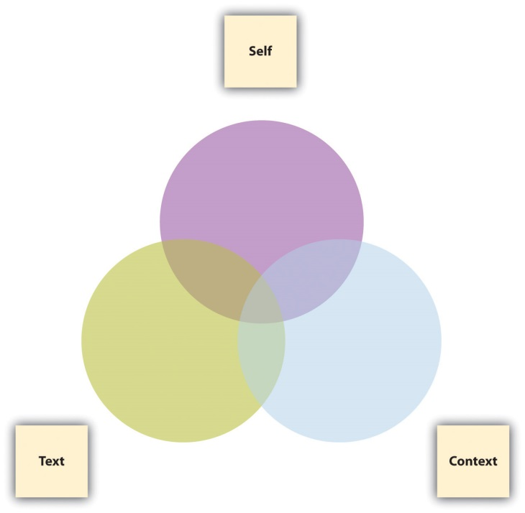

Asking the following questions about practically any kind of text will lead to a wealth of ideas, insights, and possible essay topics. As a short assignment in a journal or blog, or perhaps as a group or whole-class exercise, try out these questions by filling in the blanks with a specific text under your examination, perhaps something as common and widely known as “Wikipedia” or “Facebook” or “Google” (for ideas about where to find other texts, see the first exercise at the end of this section).

Twenty Questions about Self, Text, and Context
Self-Text Questions

- What do I think about ____________?
- What do I feel about ___________?
- What do I understand or what puzzles me in or about ____________?
- What turns me off or amuses me in or about ____________?
- What is predictable or surprises me in or about ____________?

Text-Context Questions
- How is ___________ a product of its culture and historical moment?
- What might be important to know about the creator of ___________?
- How is ___________ affected by the genre and medium to which it belongs?
- What other texts in its genre and medium does ___________ resemble?
- How does ___________ distinguish itself from other texts in its genre and medium?

Self-Context Questions

- How have I developed my aesthetic sensibility (my tastes, my likes, and my dislikes)?
- How do I typically respond to absolutes or ambiguities in life or in art? Do I respond favorably to gray areas or do I like things more clear-cut?
- With what groups (ethnic, racial, religious, social, gendered, economic, nationalist, regional, etc.) do I identify?
- How have my social, political, and ethical opinions been formed?
- How do my attitudes toward the “great questions” (choice vs. necessity, nature vs. nurture, tradition vs. change, etc.) affect the way I look at the world?

Self-Text-Context Questions

- How does my personal, cultural, and social background affect my understanding of ________?
- What else might I need to learn about the culture, the historical moment, or the creator that produced ___________ in order to more fully understand it?
- What else about the genre or medium of ___________ might I need to learn in order to understand it better?
- How might ___________ look or sound different if it were produced in a different time or place?
- How might ___________ look or sound different if I were viewing it from a different perspective or identification?

We’ve been told there’s no such thing as a stupid question, but to call certain questions “productive” is to suggest that there’s such a thing as an unproductive question. When you ask rhetorical questions to which you already know the answer or that you expect your audience to answer in a certain way, are you questioning productively? Perhaps not, in the sense of knowledge creation, but you may still be accomplishing a rhetorical purpose. And sometimes even rhetorical questions can produce knowledge. Let’s say you ask your sister, “How can someone as intelligent as you are do such self-destructive things?” Maybe you’re merely trying to direct your sister’s attention to her self-destructive behavior, but upon reflection, the question could actually trigger some productive self-examination on her part.

Hypothetical questions, at first glance, might also seem unproductive since they are usually founded on something that hasn’t happened yet and may never happen. Politicians and debaters try to steer clear of answering them but often ask them of their opponents for rhetorical effect. If we think of hypothetical questions merely as speculative ploys, we may discount their productive possibilities. But hypothetical questions asked in good faith are crucial building blocks of knowledge creation. Asking “What if we tried something else?” leads to the formation of a hypothesis, which is a theory or proposition that can be subjected to testing and experimentation.

This section has focused more on the types of genuinely interrogative questions that can lead to productive ideas for further exploration, research, and knowledge creation once you decide how you want to go public with your thinking. For more on using rhetorical and hypothetical questions as devices in your public writing, see Chapter 4 "Joining the Conversation".

KEY TAKEAWAYS
* At least two out of the following three elements are involved in critical inquiry: self, text, and context. When all three are involved, the richest questions arise.
* Expanding your notion of what constitutes a “text” will greatly enrich your possibilities for analysis and interpretation.
* Rhetorical or hypothetical questions, while often used in the public realm, can also perform a useful function in private, low-stakes writing, especially when they are genuinely interrogative and lead to further productive thinking.

EXERCISES
Use the Twenty Questions about Self, Text, and Context to develop a researched essay topic on one of the following types of texts. Note that you are developing a topic at this point. Sketch out a plan for how you would go about finding answers to some of the questions requiring research.

  - a. An editorial in the newspaper
  - b. A website
  - c. A blog
  - d. A television show
  - e. A music CD or video
  - f. A film
  - g. A video game
  - h. political candidate
  - i. A building
  - j. A painting or sculpture
  - k. A feature of your college campus
  - l. A short story or poem

2. Perform a scavenger hunt in the world of advertising, politics, and/or education for the next week or so to compile a list of questions. (You could draw from the Note 2.5 "Gallery of Web-Based Texts" in Chapter 2 "Becoming a Critical Reader" to find examples.) Label each question you find as rhetorical, hypothetical, or interrogative. If the questions are rhetorical or hypothetical, indicate whether they are still being asked in a genuinely interrogative way. Bring your examples to class for discussion or post them to your group’s or class’s discussion board.

- Apply the Twenty Questions about Self, Text, and Context to a key concept in an introductory course in which you are currently enrolled.

1.3 Slowing Down Your Thinking
LEARNING OBJECTIVES
1. Learn the benefits of thinking more slowly.
2. Learn the benefits of thinking of the world in smaller chunks.
3. Apply slower, more “small-bore” thinking to a piece of student writing.

Given the fast pace of today’s multitasking world, you might wonder why anyone would want to slow down their thinking. Who has that kind of time? The truth is that college will probably present you with more of an opportunity to slow down your thinking than any other time of your adult life. Slowing down your thinking doesn’t mean taking it easy or doing less thinking in the same amount of time. On the contrary, learning to think more slowly is a precondition to making a successful, meaningful contribution to any discipline. The key is to adjust your perspective toward the world around you by seeing it in much smaller chunks.

When you get a writing assignment in a broad topic area asking for a certain number of words or pages (let’s say 1,000 to 1,250 words, or 4 to 5 double-spaced pages, with 12-point font and 1-inch margins), what’s your first reaction? If you’re like most students, you might panic at first, wondering how you’re going to produce that much writing. The irony is that if you try to approach the topic from a perspective that is too general, what you write will likely be as painful to read as it is to write, especially if it’s part of a stack of similarly bland essays. It will inevitably be shallow because a thousand words on ten ideas works out to about a hundred words per idea. But if you slow down your thinking to find a single aspect of the larger topic and devote your thousand words to that single aspect, you’ll be able to approach it from ten different angles, and your essay will distinguish itself from the pack.
Let’s try this with an excerpt of student writing on high school dropouts that was conducted at warp speed. Either the writer was eager to complete the assignment or she hurried to a conclusion without examining the elements of her topic that she was taking for granted. Every sentence or phrase that could benefit from slower thinking in smaller chunks is set in bold blue font.

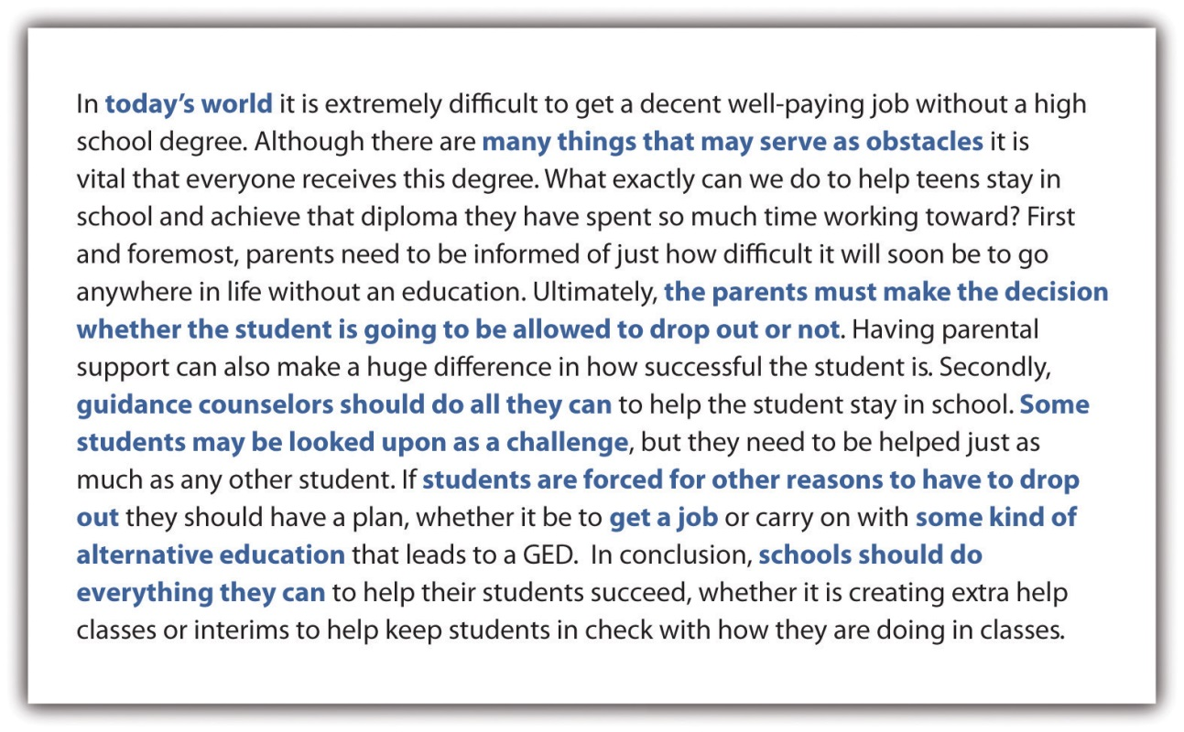

This example is not given to find fault with the student’s approach, however rushed it might have been. Each of the bold blue passages is not technically a mistake, but rather a missed opportunity to take a deeper, more methodical approach to a complicated problem. From this one paragraph, one could imagine as many as eight completely researched, full-length essays emerging on the following topics.

Missed Opportunity | Possible Essay Topic
“Today’s world” | A historical comparison with other job markets for high school dropouts
“Many things that may serve as an obstacle” or “students are forced for other reasons to have to drop out” | A study of the leading causes of the high school dropout rate
“The parents must make the decision whether the student is going to be allowed to drop out or not” | A study of the dynamics of parent-teen relationships in households where the teen is at risk academically
“Guidance counselors should do all they can” | An analysis of current practices of allocating guidance counseling to a wide range of high school students
“Some students may be looked upon as a challenge” | A profile of the most prominent characteristics of high school students who are at risk academically
“Get a job” | A survey of employment opportunities for high school dropouts
“Some kind of alternative education” | An evaluation of the current GED (General Educational Development) system
“Schools should do everything they can” | A survey of best practices at high schools across the country that have substantially reduced the dropout rate

The questions you’ve encountered so far in this chapter have been designed to encourage mindfulness, the habit of taking nothing for granted about the text under examination. Even (or especially) when “the text under examination” happens to be your own, you can apply that same habit. The question “What is it I am taking for granted about ____________?” has several variants:

- What am I not asking about _____________ that I should be asking?
- What is it in _____________ that is not being said?
- Is there something in ____________ that “goes without saying” that nonetheless should be said?
- Do I feel like asking a question when I look at ___________ even though it’s telling me not to?

Slowing down your thinking isn’t an invitation to sit on the sidelines. If anything, you should be in a better position to make a real contribution once you’ve learned to focus your communication skills on a precise area of most importance to you.

KEY TAKEAWAYS
- Even in a world of high-speed multitasking, thinking deliberately about small, specific things can pay great academic and professional dividends.
- Disciplines and professions rely on many participants thinking and writing about many small-bore topics over an extended period of time.
- Practically any text, especially an early piece of your writing or that of a classmate, can benefit from at least one variation on the question, “What is it I am taking for granted?”

EXERCISES
1. Take a piece of your writing from a previous class or another class you are currently taking, or even from this class, and subject it to a thorough scouring for phrases and sentences that exhibit rushed thinking. Set up a chart similar to the one that appears in this section, listing every missed opportunity and every possible essay topic that emerges from the text once your thinking is slowed down.
2. Now try this same exercise on a classmate’s piece of writing, and offer up one of your own for them to work on.
3. Sometimes texts demonstrate thinking that is sped up or oversimplified on purpose, as a method of misleading readers. Find an example of a text that’s inviting readers or listeners to take something for granted or to think too quickly. (You might look in the Note 2.5 "Gallery of Web-Based Texts" in Chapter 2 "Becoming a Critical Reader" to find examples.) Subject the example you find to the questions in this section. Bring the example and your analysis of it to class for discussion or include both the example and your analysis in your group’s or class’s discussion board. Choose from among one of the following categories or come up with a category of your own:

a. An editorial column
  - b. A bumper sticker
  - c. A billboard
  - d. A banner on a website
  - e. A political slogan or speech
  - f. A financial, educational, or occupational document
  - g. A song lyric
  - h. A movie or television show plotline
  - i. A commercial advertisement
j. A message from a friend or family member

1.4 Withholding Judgment
LEARNING OBJECTIVES
- Appreciate the value, power, and authority derived from paying attention to detail before moving on to evaluative judgment.
- Consider the danger of a judgment reached prematurely.
- Investigate the cultural and educational forces that may have encouraged you to rush to judgment.

We live in a culture that values taking a stance, having an opinion, making a judgment, and backing it up with evidence. Being undecided or even open-minded about an issue can be seen as a sign of weakness or sloppiness or even as a moral or ethical failing. Our culture also privileges action over the kind of reflection and contemplation this chapter is advocating.

If you’ve encountered mostly traditional writing instruction, you’ve probably been encouraged to make judgments fairly early in the writing process. Well before you have fully examined an issue, you’ve been told to “take a position and defend it.” You might make an effort to understand an issue from multiple sides (a process discussed in more detail in Chapter 3 "Thinking through the Disciplines", Section 3.2 "Seeing and Making Connections across Disciplines" and Chapter 3 "Thinking through the Disciplines", Section 3.3 "Articulating Multiple Sides of an Issue") only after you have staked your claim in a half-hearted effort to be “fair to both sides.”

If you’ve been subjected to standardized tests of writing ability (often key factors in decisions about college acceptance and placement and earlier, in assessments of competence at various levels of K–12 education), you’ve probably noticed they rely on essay prompts that put heavy emphasis on argumentation. Some evaluative rubrics for such essays require the presence of a thesis statement by the end of the introductory paragraph in order to earn a high score for organization.

Here’s an introductory paragraph of a student writer who has been trained by the “point–counterpoint” culture of sound bites and perhaps encouraged by writing teachers over the years to believe that he has very little time to get to his thesis statement.

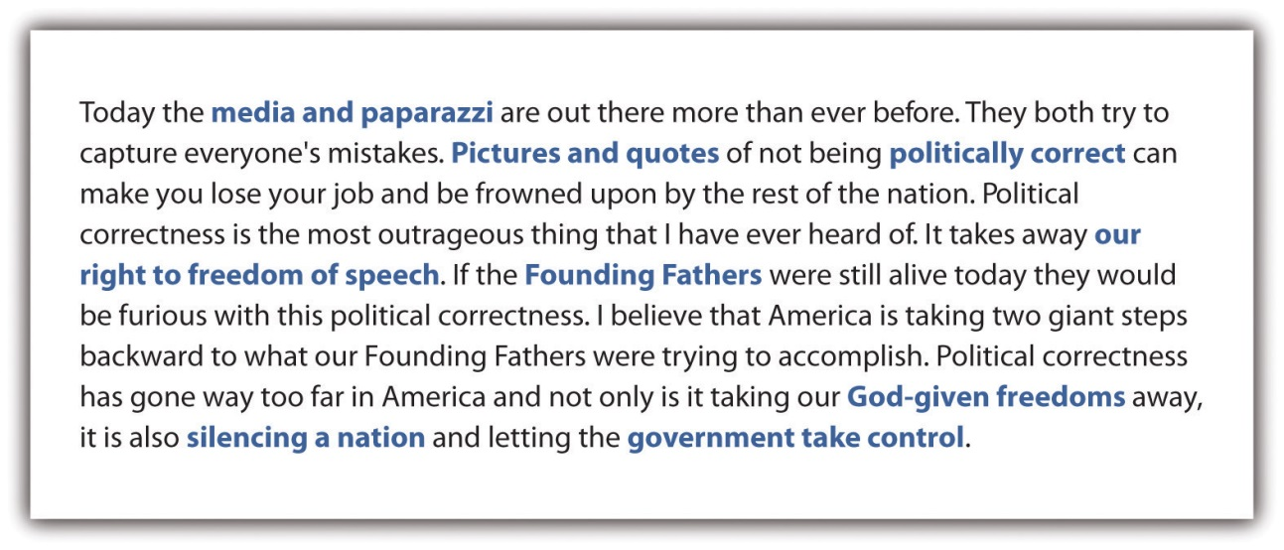

The rush to judgment has caused this student to fall into the same quick-thinking trap of the student in Section 1.3 "Slowing Down Your Thinking". The remedy (isolating the phrases worthy of further examination, indicated here, as in Section 1.3 "Slowing Down Your Thinking", with bold blue font) is similar. This student may yet make something useful out of his concerns about political correctness, but he will do so only by making a meaningful effort to withhold his judgment on what is actually a much more complicated issue.

Premature Judgment | Complicating Question
“Media and paparazzi” | What is the press’s motivation for insisting on political correctness?
“Pictures and quotes” | What examples can I find as test cases for analysis?
“Politically correct” | What is the definition and the history of this phrase?
“Our right to freedom of speech” | How does political correctness run counter to the First Amendment’s protection of speech?
“Founding fathers” | Did the founders debate matters of press freedom and appropriate speech?
“God-given freedoms” | What are the intersections between religion and the right to free speech?
“Silencing a nation” | Are there sensitive subjects we don’t address as a nation because of political correctness?
“Government takes control” | How might a government create an atmosphere of political correctness in order to control its people?

Much of the pressure to reach judgments prematurely comes from elements of society that do not necessarily have our best interests in mind. The last exercise of Section 1.3 "Slowing Down Your Thinking" hinted at the strategic reasons why corporations, politicians, ideologues, popular entertainers, authority figures, or even friends and family might try to speed up your thinking at precisely the moment when you should be slowing it down. While inaction and dithering can be cited as the cause of some of history’s worst moments, the “rush to judgment” that comes from rash thinking can be cited as the cause of many more. A good rule of thumb when you are asked to make an irrevocable judgment or decision is to ask yourself or your questioner, “What’s your hurry?”

KEY TAKEAWAYS
- Our sound-bite, point–counterpoint culture and even our reductive definitions of effective writing place a heavy emphasis on taking a position early and sticking to it.
- One must eventually take action after a period of contemplation, but history is full of examples of judgments made in haste.
- Withholding judgment, like slowing down your thinking, can be an effective strategy for revision and peer review.

EXERCISES
1. Take a piece of your writing from a previous class or another class you are currently taking, or even from this class, and look for phrases and sentences that suggest a “rush to judgment.” Set up a chart similar to the one that appears in this section, listing every possible essay topic that emerges from the complicating questions you write in response to each premature judgment.
2. Now try this same exercise on a classmate’s piece of writing and offer up one of your own for him or her to work on.
3. Compare the pace with which a writer makes a judgment in the each of the following rhetorical settings. Discuss whether you think there are certain conventions about making, presenting, and defending judgments in each of these genres. Draw from the Note 2.5 "Gallery of Web-Based Texts" in Chapter 2 "Becoming a Critical Reader" to find examples.

  - a. A television commercial for a political candidate, a pharmaceutical company, or an investment firm
  - b. A Supreme Court majority opinion
  - c. A presidential address on a topic of national security
d. A journal article in a field you are studying

Chapter 2
Becoming a Critical Reader
This chapter will help you put into practice the strategies of mindful and reflective questioning introduced in Chapter 1 "Writing to Think and Writing to Learn". After surveying a Note 2.5 "Gallery of Web-Based Texts", you will learn what can be accomplished from using critical thinking methods when reading texts closely and carefully. You will also see how a single text can be opened up through careful and close reading as a model for what can be done with texts from a wide variety of media and genres. You’ll learn to be attentive to not only what a text is trying to say but also how it is saying it. By deepening your understanding of the interactions among self, text, and context, you’ll come to appreciate how crucial your role in the critical reading process is, not only to your comprehension, but also to your genuine enjoyment of any text.

2.1 Browsing the Gallery of Web-Based Texts
LEARNING OBJECTIVES
1. Show how the web can be mined for a wealth of academically useful content.
2. Introduce the concept of writing essays based on free, web-based texts.
3. Explore how such texts lend themselves to critical inquiry.

Given that the focus of this chapter is on reading texts, the first section introduces a . Think of this alphabetical, annotated collection of websites as an alternative collection of readings to which you and your instructor can return at other points in the course. If your instructor is assigning a traditional, bound reader in addition to this handbook, these sites might be purely supplemental, but if not, they might serve as a storehouse from which to build a free do-it-yourself reader that could be central to the work you do in your composition course.

Regardless of how you use these archives of texts, they’re meant to inspire you and your instructor to go on a scavenger hunt for other authoritative collections on the web. If your instructor is using a course management system (like Blackboard) or a class-wide wiki, these sites could easily be lodged in a document library of external links, and you and your instructor could add sites as you discover (and annotate) them.

This collection of web-based archives, even though it references several million texts, merely scratches the surface of the massive amount of material that’s freely available on the web. Remember, too, that your college library has likely invested heavily in searchable academic databases to which you have access as a student. Faculty members and librarians at your institution may already be at work creating in-house collections of readings drawn from these databases. (For more on such databases, see , and consult your college’s library staff.)
Because these noncommercial, nonpartisan websites are sponsored by governmental and educational entities and organizations, they are not likely to disappear, but there are no guarantees. If links go dead, try your favorite search engine to see if the documents you’re seeking have been lodged elsewhere.

The selection principle for this gallery is that the sites listed should be free of cost, free of commercial advertisements, free of partisanship (though multiple sides are often presented), and free of copyright wherever possible. If you’re not bothered by ads, you’ll find a wealth of additional content, much of which will be very useful.

Finally, remember, just because these sites are free of charge and free of copyright doesn’t mean you don’t have to cite them appropriately if you end up using content from them in your writing. See of this book for information on how to document electronic texts. You and your instructor also need to be aware of any copyright restrictions on duplicating and redistributing content on these sites. These restrictions will usually be found at the site itself, but when in doubt, consult your college library staff.

Gallery of Web-Based Texts

Title: The Ad Council
URL: http://www.adcouncil.org
Brief description: Includes an archive of more than sixty-five years of public service advertising campaigns in print, radio, and television media.
Possible uses: Analyses of rhetorical technique in advertising; studies requiring historical context; comparisons of commercial and public-service marketing.
***
Title: American Experience
URL: http://www.pbs.org/wgbh/americanexperience
Brief description: Full-length documentaries produced by the Public Broadcasting System (PBS), many available for viewing online, with additional resources provided at each film’s website.
Possible uses: Studies requiring historical context, comparisons of documentary and popular filmmaking, and comparisons of education and entertainment.
***
Title: Arts and Letters Daily
URL: http://www.aldaily.com
Brief description: A clearinghouse of web-based content (from magazines, newspapers, and blogs) on culture and current affairs sponsored by the Chronicle of Higher Education, updated daily, and archived from 1998 to the present.
Possible uses: Essays on contemporary topics; studies of the style and ideological cast of a particular commentator or columnist; generating ideas for possible topics for further research.
***
Title: The Avalon Project: Documents in Law, History, and Diplomacy
URL: http://avalon.law.yale.edu/subject_menus/major.asp
Brief description: Yale University Law School’s collection of documents, including among many other items “Inaugural Addresses of the Presidents” (from which the demonstration text in is taken).
Possible uses: Cross-disciplinary writing projects in history, religion, and political science; analyses of rhetorical and argumentative strategies.
***
Title: Big Questions Essay Series
URL: http://www.templeton.org/signature-programs/big-questions-essay-series
Brief description: A growing collection from the nonprofit Templeton Foundation, made up of essays by writers from different disciplines and backgrounds on several “big questions” (about a dozen essays per question).
Possible uses: Essay assignments on “great questions” requiring citation of conflicting sources; exercises on exploring alternative points of view; analyses of how biases, assumptions, and implications affect argument and rhetoric.
***
Title: C-SPAN Video Library
URL: http://www.c-spanvideo.org/videoLibrary
Brief description: An archive of more than 160,000 hours of digitized video programming on C-SPAN since 1987, including thousands of political debates and campaign ads; also applicable for the education category (see library for hundreds of commencement addresses).
Possible uses: Analyses of political advertising and comparisons with other kinds of commercials; analytical summaries of ideological positions along the American political spectrum from 1987 to the present; analyses of argumentative technique in political debates.
***
Title: From Revolution to Reconstruction…and What Happened Afterwards
URL: http://www.let.rug.nl/usa/index.htm
Brief description: A collection of documents from American history from the colonial period to the present, sponsored by the United States Information Agency (USIA).
Possible uses: Analyses of rhetorical and argumentative strategies of documents in American history and government.
***
Title: Gallup
URL: http://www.gallup.com/home.aspx
Brief description: More than seventy-five years of polling data on myriad subjects, with constant updates from contemporary polls.
Possible uses: Analyses of American political and social trends from the 1930s to the present; comparisons with contemporaneous, parallel polls from other organizations; political science studies of polling methodology.
***
Title: Google Books
URL: http://books.google.com
Brief description: Includes not only in-copyright/in-print and in-copyright/out-of-print books for purchase but also out-of-copyright books as free downloads.
Possible uses: Access to free, out-of-print, out-of-copyright, older, book-length content for historical, sociological studies.
***
Title: The Internet Archive
URL: http://www.archive.org
Brief description: Created by The Internet Archive, a nonprofit organization founded in 1996 that is committed to preserving digitized materials, this collection includes not only websites in their original forms but also audio and video collections.
Possible uses: Historical analyses of websites since their inception; popular cultural analyses of film, television, radio, music, and advertising.
***
Title: The Living Room Candidate
URL: http://www.livingroomcandidate.org
Brief description: A collection of hundreds of television advertisements of presidential campaigns from 1952 to the present, sponsored and operated by the Museum of the Moving Image.
Possible uses: Analyses of the rhetoric of political television advertising across time (from 1952 to the present); comparisons between television and print advertising in politics; summaries of political party positions and ideologies.
***
Title: MIT Open Courseware
URL: http://ocw.mit.edu/index.htm
Brief description: One of the best collections of university lectures on the web, along with Yale’s (see Open Yale Courses).
Possible uses: Completely free access to complete lecture-based courses from some of the best professors on earth in almost every conceivable university subject.
***
Title: The National Archives Experience: Docs Teach
URL: http://docsteach.org
Brief description: Classroom activities, reading and writing assignments accompanied by document collections from the National Archives, each concentrating on a specific historical era.
Possible uses: Ready-made reading and writing assignment sequences of primary documents from American history; cross-disciplinary writing projects in history, religion, political science, and cultural geography.
***
Title: The Online Books Page
URL: http://digital.library.upenn.edu/books
Brief description: A collection of more than forty thousand free books, as well as an extensive e-archive of e-archives (see Archives and Indexes/General), edited by John Mark Ockerbloom at the University of Pennsylvania since 1993.
Possible uses: Access to free, out-of-print, out-of-copyright, older, book-length content for historical, sociological studies; cross-disciplinary writing projects in history, religion, political science, and cultural geography.
***
Title: Open Yale Courses
URL: http://oyc.yale.edu
Brief description: One of the best collections of university lectures on the web, along with MIT’s (see MIT Open Courseware).
Possible uses: Completely free access to complete lecture-based courses from some of the best professors on earth in almost every conceivable subject.
***
Title: Project Gutenberg
URL: http://www.gutenberg.org/wiki/Main_Page
Brief description: The most established collection of more than thirty-three thousand book-length works originally published in paper form, digitized and downloadable in a variety of formats, and free of American copyright.
Possible uses: Analyses of older, book-length literary texts; studies of specific historical and cultural phenomena.
***
Title: the Poetry Foundation
URL: http://www.poetryfoundation.org
Brief description: Thousands of poems and poetry-related material collected into a searchable archive, managed and operated by the Poetry Foundation.
Possible uses: Analyses of poems and poetic language; studies of specific themes as expressed through the humanities.
***
Title: The Smithsonian Institution Research Information System (SIRIS): Collections Search Center
URL: http://collections.si.edu/search
Brief description: A vast collection of more than 4.6 million books, manuscripts, periodicals, and other materials from the various museums, archives, and libraries of the Smithsonian Institution.
Possible uses: Historical and rhetorical analyses of texts and resources in a variety of disciplines in the arts and sciences.
***
Title: This I Believe
URL: http://thisibelieve.org
Brief description: A regular feature of National Public Radio (NPR) since 2006, a series of personal essays read aloud on a variety of topics, archived together with 1950s-era essays from a program of the same name hosted by Edward R. Murrow.
Possible uses: Comparisons of social issues across two historical periods (e.g., 2006 to the present vs. the 1950s); comparisons between the personal essay and other genres of exposition and exploration; comparisons between oral and written texts.
***
Title: The US Census Bureau
URL: http://www.census.gov
Brief description: A trove of demographic statistics and surveys with a variety of themes from the most recent census and those conducted previously.
Possible uses: Summaries, reports, and causal analyses of demographic trends in American society; evaluations of the uses of statistics as evidence; social science studies of polling methodology.

KEY TAKEAWAYS
- The web affords writing students and instructors countless opportunities to engage with texts in a variety of media and genres.
- The vast majority of web-based texts are available free of charge. A significant minority of publicly and privately funded sites are also free of advertisement and often free of copyright.
- Your status as a college student also puts you in a great position to make use of any online library databases to which your college subscribes.
- Even though web texts are easily accessible, they still need to be documented appropriately when used as part of a writing project.

EXERCISES
- Individually or in a group, go on a scavenger hunt for another web-based archive of texts that could be useful to your composition class as part of a no-cost alternative to a pricey print collection of readings. Try to meet the same criteria this handbook uses: the collection of texts should be free of charge, free of copyright restriction, free of partisanship, and free of advertising (except for sponsorship information in the case of nonprofit organizations). Write up an annotated entry on what you find, following the same format used in the .
- Individually or in a group, get to know the in more detail. Find and critically analyze five to ten individual texts from one archive. Your critical analysis should include answers to at least five of the questions in the list of questions about speaker, audience, statement, and relevance in the next section or at least five of the Twenty Questions about Self, Text, and Context in . Be prepared to present your findings in a class discussion, on the class discussion board, or on a class-wide wiki.
- Find two texts from two different archives in the that explore a similar theme or topic in different ways, either from two different ideological perspectives or through two different genres or media. Write an essay that compares and contrasts the two different texts.

2.2 Understanding How Critical Thinking Works
LEARNING OBJECTIVES
1. Learn how and why critical thinking works.
2. Understand the creative and constructive elements of critical thinking.
3. Add to the list of productive questions that can be asked about texts.

“Critical thinking” has been a common phrase in education for more than a quarter century, but it can be a slippery concept to define. Perhaps because “critical” is an adjective with certain negative connotations (e.g., “You don’t have to be so critical” or “Everybody’s a critic”), people sometimes think that critical thinking is a fault-finding exercise or that there is nothing creative about it. But defined fairly and fully, critical thinking is in fact a precondition to creativity.

Critical thinkers consider multiple sides of an issue before choosing sides. They tend to ask questions instead of accepting everything they hear or read, and they know that answers often only open up more lines of inquiry. Critical thinkers read between the lines instead of reading only at face value, and they also develop a keen sense of how their own minds operate. Critical thinkers recognize that much of the information they read and hear is a combination of fact and opinion. To be successful in college, you will have to learn to differentiate between fact and opinion through logic, questioning, and verification.

Facts are pieces of information that you can verify as true. Opinions are personal views or beliefs that may have very little grounding in fact. Since opinions are often put forth as if they were facts, they can be challenging to recognize as opinions. That’s where critical thinkers tend to keep questioning. It is not enough to question only the obviously opinionated material in a text. Critical thinkers develop a habit of subjecting all textual statements to a whole constellation of questions about the speaker (or writer), the intended audience, the statement itself, and the relevance of it.

Considering the speaker:

- Who is making this the statement?
- What are the speaker’s affiliations?
- How does the speaker know the truth of this statement?
- Considering the audience:
- Who is being addressed with this statement?
- What could connect the speaker of the statement with the intended audience?
- Would all people consider this statement to be true?
- Considering the statement:
- Can this statement be proven?
- Will this statement also be true tomorrow or next year?
- If this statement is true, what else might be true?
- Are there other possible interpretations of the facts behind this statement?

Considering relevance:
- What difference does this statement make?
- Who cares (and who should care)?
- So what? What now? What’s next?

Writers naturally write with some basic assumptions. Without a starting point, a writer would have no way to begin writing. As a reader, you have to be able to identify the assumptions a writer makes and then judge whether or not those assumptions need to be challenged or questioned. As an active reader, you must acknowledge that both writers and readers make assumptions as they negotiate the meaning of any text. A good process for uncovering assumptions is to try to think backward from the text. Get into the habit of asking yourself, “In order to make this given statement, what else must this writer also believe?”

Whether you recognize it or not, you also have biases and preconceptions on which you base many decisions. These biases and preconceptions form a screen or a lens through which you see your world. Biases and preconceptions are developed out of your life’s experiences and influences. As a critical thinker who considers all sides of an issue, you have to identify your personal positions and subject them to scrutiny.

Just as you must uncover assumptions—those of the writer as well as your own as a reader—to truly capture what you are reading, you must also examine the assumptions that form the foundation of your writing. And you must be prepared to do so throughout the writing process; such self-questioning can, in fact, be a powerful strategy for revision (as you’ll see in more detail in Chapter 8 "Revising", Section 8.1 "Reviewing for Purpose").

KEY TAKEAWAYS
- Far from being a negative or destructive activity, critical thinking is actually the foundation of creative, constructive thinking.
- Critical thinkers consider multiple sides of issues, before arriving at a judgment. They must carefully consider the source, the audience, and the relevance of any statement, making a special effort to distinguish fact from opinion in the statement itself.
- Biases and preconceptions are ideas based on life experiences and are common components of most everything you say, hear, or read.

EXERCISES
- Use the set of questions at the end of this section about the speaker, audience, statement, and relevance for a text of your choice from the Note 2.5 "Gallery of Web-Based Texts" in Section 2.1 "Browsing the Gallery of Web-Based Texts". Here are some promising avenues to pursue:
  - A public service announcement (PSA) campaign (Ad Council)
  - A “This I Believe” radio essay (This I Believe)
  - A television ad spot from a political campaign (The Living Room Candidate)
  - An entry in one of the debates on a “big question” (Big Questions Essay Series)
- Use those same questions for a reading from one of your other classes (even a chapter from a textbook) or a reading in your composition class assigned by your instructor.
- Go to the Smithsonian Institution (SIRIS) site in the Note 2.5 "Gallery of Web-Based Texts" and click on the Search Collections tab. Use the search phrase “personal hygiene advertisements” and then choose two of the ads that appear in the archive after you’ve browsed the dozens of hits. Apply this section’s questions to two ads you’ve chosen. Then get to know the search engine on the SIRIS site a little better by trying out a few search phrases of your own on topics of interest to you.

2.3 Reading a Text Carefully and Closely
LEARNING OBJECTIVES
- Demonstrate how to do a close reading on a selection from the Note 2.5 "Gallery of Web-Based Texts".
- Uncover the assumptions and implications of textual statements and understand how biases and preconceptions affect readers and writers.
- Show how a close reading of any statement is based on uncovering its assumptions, biases, preconceptions, and implications.

In this section, we’ll use an excerpt from one of the most famous inaugural addresses in American history, from John F. Kennedy in 1961, to demonstrate how to do a close reading by separating fact and opinion; uncovering assumptions, biases, and preconceptions; and pursuing the implications of textual statements. (The address is available in its entirety through the Note 2.5 "Gallery of Web-Based Texts" in Section 2.1 "Browsing the Gallery of Web-Based Texts", in text form at the Avalon Project, and in video form at the C-SPAN Video Library.)

To prepare yourself to develop a thoughtful, critical reading of a text like this, you might begin with the Twenty Questions about Self, Text, and Context from Chapter 1 "Writing to Think and Writing to Learn", filling in each blank with “Kennedy’s Inaugural Address.”

Twenty Questions about Self, Text, and Context
Self-Text Questions

- What do I think about Kennedy’s Inaugural Address?
- What do I feel about Kennedy’s Inaugural Address?
- What do I understand or what puzzles me in or about Kennedy’s Inaugural Address?
- What turns me off or amuses me in or about Kennedy’s Inaugural Address?
- What is predictable or surprises me in or about Kennedy’s Inaugural Address?

Text-Context Questions

- How is Kennedy’s Inaugural Address a product of its culture and historical moment?
- What might be important to know about the creator of Kennedy’s Inaugural Address?
- How is Kennedy’s Inaugural Address affected by the genre and medium to which it belongs?
- What other texts in its genre and medium does Kennedy’s Inaugural Address resemble?
- How does Kennedy’s Inaugural Address distinguish itself from other texts in its genre and medium?

Self-Context Questions

- How have I developed my aesthetic sensibility (my tastes, my likes, and my dislikes)?
- How do I typically respond to absolutes or ambiguities in life or in art? Do I respond favorably to gray areas or do I like things more clear-cut?
- With what groups (ethnic, racial, religious, social, gendered, economic, nationalist, regional, etc.) do I identify?
- How have my social, political, and ethical opinions been formed?
- How do my attitudes toward the “great questions” (choice vs. necessity, nature vs. nurture, tradition vs. change, etc.) affect the way I look at the world?

Self-Text-Context Questions

- How does my personal, cultural, and social background affect my understanding of Kennedy’s Inaugural Address?
- What else might I need to learn about the culture, the historical moment, or the creator that produced Kennedy’s Inaugural Address in order to more fully understand it?
- What else about the genre or medium of Kennedy’s Inaugural Address might I need to learn in order to understand it better?
- How might Kennedy’s Inaugural Address look or sound different if it were produced in a different time or place?
- How might Kennedy’s Inaugural Address look or sound different if I were viewing it from a different perspective or identification?

Note that most of these questions can’t be answered until you’ve made a first pass through the text, while others almost certainly require some research to be answered fully. It’s almost a given that multiple readings will be required to fully understand a text, its context, and your orientation toward it.

In the first annotation, let’s consider Roger (Student A) and Rhonda (Student B), both of whom read the speech without any advance preparation and without examining their biases and preconceptions. Take a look at the comment boxes attached to the excerpt of the first five paragraphs of Kennedy’s Inaugural Address.

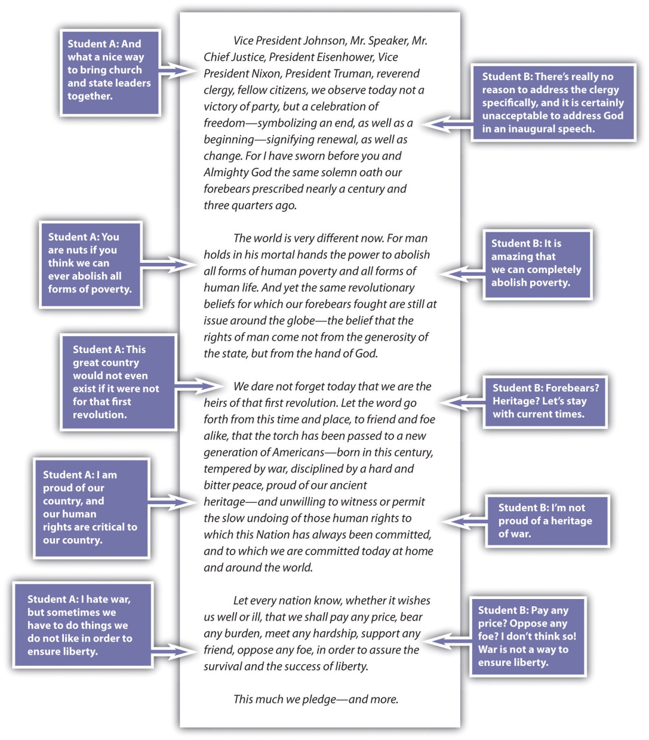

Roger does not have any problem with a lack of separation between church and state. Rhonda is unwilling to accept any reference to God in any government setting. Should Roger at least recognize the rationale for separating church and state? Should Rhonda recognize that while the founders of this country called for such a separation, they also made repeated reference to God in their writings?

Perhaps both Roger and Rhonda should consider that Kennedy’s lofty goal of eliminating poverty was perhaps an intentional rhetorical overreach, typical of inaugural addresses, meant to inspire the general process of poverty elimination and not to lay out specific policy.

Roger sees war as a necessary evil in the search for peace. Rhonda sees war as an unacceptable evil that should never be used as a means to an end. To hear what Kennedy is saying, Roger probably needs to consider options other than war and Rhonda probably needs to recognize that history has shown some positive results from “necessary” wars.

If Roger and Rhonda want to be critical thinkers or even if they want have a meaningful conversation about the text, they must think through and past their own personal biases and preconceptions. They must prepare themselves to be critical readers.

In the next set of annotations, let’s look at what you could do with the text by making several close readings of it, while also subjecting it to the preceding Twenty Questions. Perhaps your first annotation could simply be designed to separate statements of verifiable fact from those of subjective opinion.

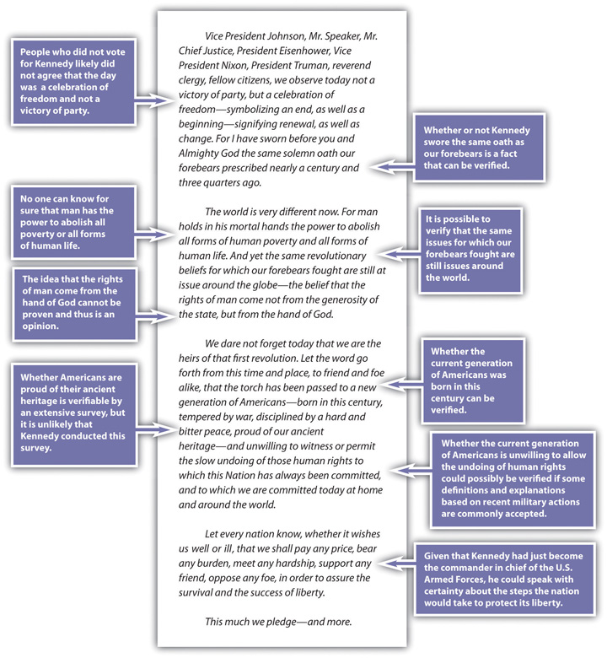

A careful reader who looks for assumptions and implications of statements will find plenty of them. For example, the beginning of Kennedy’s Inaugural Address includes many assumptions. In your second annotation, you might go on to target some of these assumptions and offer background thoughts that help you identify and understand these assumptions.

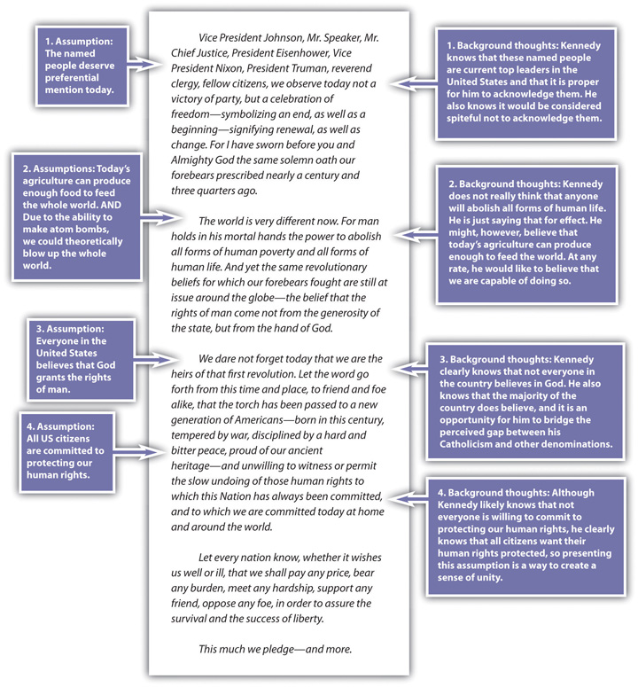

Just as you must try to trace a statement back to its underlying assumptions, you must also try to understand what a statement implies. Even when different readers are looking at the same text, they can sometimes disagree about the implications of a statement. Their disagreements often form the basis for their divergent opinions as readers.

Take Kennedy’s assumption that the named people at the beginning of his speech deserve preferential attention. Here are some possible implications of the statement you could come up with that result from that single assumption:

- People who voted for Nixon are reminded that their candidate did not get elected, which makes these people angry all over again.
- People who voted for Nixon feel somewhat comforted knowing that Nixon and Eisenhower are being recognized at the inauguration, and they are pleased that Kennedy is acknowledging them.
- Supporters of Kennedy hear his recognition of Nixon and Eisenhower as an acceptance of them, and thus they look more favorably on members of the opposing party.
- Supporters of Johnson appreciate that Kennedy mentions him first and believe that he is giving the most respect of all to Johnson.
- Those concerned about the relative youth of this new president appreciate the deference he shows to tradition by making this rhetorical gesture of salutation.
- Those suspicious of the power of the executive branch might wonder why Kennedy addresses the former presidents and vice president by name but gives only the title of the Supreme Court chief justice and the Speaker of the House.

You could add more to this list of possible implications, but notice how much you’ve done with the first paragraph of the speech already, simply by slowing down your critical reading process.

KEY TAKEAWAYS
- Virtually any statement carries a set of assumptions (what the writer or speaker assumes in order to make the statement) and implications (what the statement implies to readers or listeners).
- You need to be able to recognize biases and preconceptions in others and in yourself so you can form your ideas and present them responsibly.

EXERCISES
- Apply some of the critical thinking methods outlined in this section to another presidential inaugural address. For a complete collection, check out the Avalon Project in the Note 2.5 "Gallery of Web-Based Texts" at the beginning of the chapter. Click on “Inaugural Addresses of the Presidents” in the main directory. Videos of all inaugural addresses since Truman’s in 1948 can be found at the C-Span Video Library.
- Presidential inaugural addresses, having developed over more than two centuries, follow a certain set of unspoken rules of a highly traditional genre. After looking at three to five other examples of the genre besides Kennedy’s, list at least five things most inaugural addresses are expected to accomplish. Give examples and excerpts of those generic conventions from the three to five other texts you choose. Or try this exercise with other regularly scheduled, ceremonial addresses like the State of the Union.
- Watch at least one hour apiece of prime-time cable news on the Fox News Channel and MSNBC (preferably the same hour or at least the same night of coverage). Catalogue the biases, preconceptions, assumptions, and implications of the news coverage and commentary on the same topic during those two hours. If guest “experts” are interviewed, discuss their political ideologies as well.

Chapter 3
Thinking through the Disciplines

Most college writing has some basic features in common: a sense of ethical responsibility and the use of credible and credited sources, critical thinking, and sound argumentation. In addition to these common features, each academic discipline, over many generations, has developed its own specific methods of asking questions and sharing answers. This chapter will show you how to use the lenses of various academic disciplines to develop your writing, reading, and thinking.

3.1 Exploring Academic Disciplines
LEARNING OBJECTIVES
- Survey the landscape of academic disciplines.
- Appreciate how academic disciplines help shape how we understand the world.
- Understand that academic disciplines are constantly in flux, negotiating the terms, conditions, and standards of inquiry, attribution, and evidence.

The following table shows one version of the main academic disciplines and some of their branches.

Discipline | Branch Examples
Business | Accounting, economics, finance, management, marketing
Humanities | Art, history, languages, literature, music, philosophy, religion, theater
Natural and applied sciences | Biology, chemistry, computer science, engineering, geology, mathematics, physics, medicine
Social sciences | Anthropology, education, geography, law, political science, psychology, sociology

Since the makeup of the different branches is always in flux and since the history of any institution of higher education is complicated, you will likely find some overlapping and varying arrangements of disciplines at your college.

Part of your transition into higher education involves being aware that each discipline is a distinct discourse community with specific vocabularies, styles, and modes of communication. Later in your college career, you will begin your writing apprenticeship in a specific discipline by studying the formats of published articles within it. You will look for the following formal aspects of articles within that discipline and plan to emulate them in your work:

- Title format
- Introduction
- Overall organization
- Tone (especially level of formality)
- Person (first, second, or third person)
- Voice (active or passive)
- Sections and subheads
- Use of images (photos, tables, graphics, graphs, etc.)
- Discipline-specific vocabulary
- Types of sources cited
- Use of source information
- Conclusion
- Documentation style (American Psychological Association, Modern Language Association, Chicago, Council of Science Editors, and so on; for more on this, see Chapter 22 "Appendix B: A Guide to Research and Documentation")
- Intended audience
- Published format (print or online)

Different disciplines tend to recommend collecting different types of evidence from research sources. For example, biologists are typically required to do laboratory research; art historians often use details from a mix of primary and secondary sources (works of art and art criticism, respectively); social scientists are likely to gather data from a variety of research study reports and direct ethnographic observation, interviews, and fieldwork; and a political scientist uses demographic data from government surveys and opinion polls along with direct quotations from political candidates and party platforms.

Consider the following circle of professors. They are all asking their students to conduct research in a variety of ways using a variety of sources.

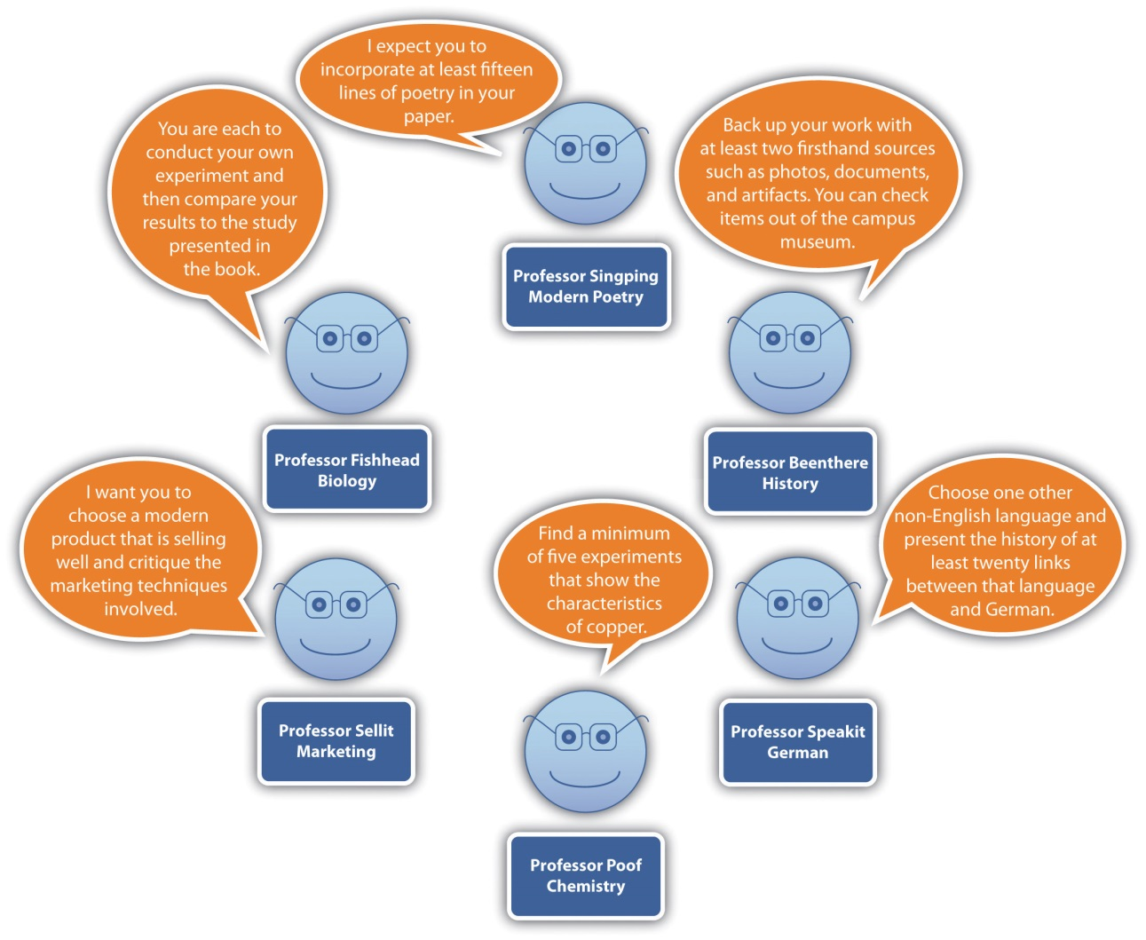

What’s required to complete a basic, introductory essay might essentially be the same across all disciplines, but some types of assignments require discipline-specific organizational features. For example, in business disciplines, documents such as résumés, memos, and product descriptions require a specialized organization. Science and engineering students follow specific conventions as they write lab reports and keep notebooks that include their drawings and results of their experiments. Students in the social sciences and the humanities often use specialized formatting to develop research papers, literature reviews, and book reviews.

Part of your apprenticeship will involve understanding the conventions of a discipline’s key genres. If you are reading or writing texts in the social sciences, for example, you will notice a meticulous emphasis on the specifics of methodology (especially key concepts surrounding the collection of data, such as reliability, validity, sample size, and variables) and a careful presentation of results and their significance. Laboratory reports in the natural and applied sciences emphasize a careful statement of the hypothesis and prediction of the experiment. They also take special care to account for the role of the observer and the nature of the measurements used in the investigation to ensure that it is replicable. An essay in the humanities on a piece of literature might spend more time setting a theoretical foundation for its interpretation, it might also more readily draw from a variety of other disciplines, and it might present its “findings” more as questions than as answers. As you are taking a variety of introductory college courses, try to familiarize yourself with the jargon of each discipline you encounter, paying attention to its specialized vocabulary and terminology. It might even help you make a list of terms in your notes.

Scholars also tend to ask discipline-related kinds of questions. For example, the question of “renewable energy” might be a research topic within different disciplines. The following list shows the types of questions that would accommodate the different disciplines:

- Business (economics): Which renewable resources offer economically feasible solutions to energy issues?
- Humanities (history): At what point did humans switch from the use of renewable resources to nonrenewable resources?
- Natural and applied sciences (engineering): How can algae be developed at a pace and in the quantities needed to be a viable main renewable resource?
- Social sciences (geography): Which US states are best suited to being key providers of renewable natural resources?

KEY TAKEAWAYS
- Most academic disciplines have developed over many generations. Even though these disciplines are constantly in flux, they observe certain standards for investigation, proof, and documentation of evidence.
- To meet the demands of writing and thinking in a certain discipline, you need to learn its conventions.
- An important aspect of being successful in college (and life) involves being aware of what academic disciplines (and professions and occupations) have in common and how they differ.

EXERCISES
- Think about your entire course load this semester as a collection of disciplines. For each course you are taking, answer the following questions, checking your textbooks and other course materials and consulting with your instructors, if necessary:

  - What kinds of questions does this discipline ask?
  - What kinds of controversies exist in this discipline?
  - How does this discipline share the knowledge it constructs?
  - How do writers in this discipline demonstrate their credibility?

- After you’ve asked and answered these questions about each discipline in isolation, consider what underlying things your courses have in common, even if they approach the world very differently on the surface.

- Based on the example at the end of this section, pick a topic that multiple disciplines study. Formulate four questions about the topic, one from each of any four different disciplines. Ideally choose a topic that might come up in four courses you are currently taking or have recently taken, or choose a topic of particular interest to you. Here are just a few examples to get you started:

  - Alcoholism
  - Child abuse
  - Poverty in developing nations
  - Fast food
  - Women in the workforce

- Drawing from the synopses of current research on the Arts and Letters Daily website (see the Note 2.5 "Gallery of Web-Based Texts" in Chapter 2 "Becoming a Critical Reader"), read the article referenced on a topic or theme of interest to you. Discuss how the author’s discipline affects the way the topic or theme is presented (specifically, the standards of inquiry and evidence).

3.2 Seeing and Making Connections across Disciplines
LEARNING OBJECTIVES
- Learn how to look for connections between the courses you are taking in different disciplines.
- Witness how topics and issues are connected across disciplines, even when they are expressed differently.
- Understand how to use disciplines to apply past knowledge to new situations.

Section 3.1 "Exploring Academic Disciplines" focused on the formal differences among various academic disciplines and their discourse communities. This section will explore the intellectual processes and concepts disciplines share in common. Even though you will eventually enter a discipline as an academic specialization (major) and as a career path (profession), the first couple of years of college may well be the best opportunity you will ever have to discover how disciplines are connected.

That process may be a rediscovery, given that in the early grades (K–5), you were probably educated by one primary teacher each year covering a set of subjects in a single room. Even though you likely covered each subject in turn, that elementary school classroom was much more conducive to making connections across disciplines than your middle school or high school environment. If you’ve been educated in public schools during the recent era of rigid standardization and multiple-choice testing conducted in the name of “accountability,” the disciplines may seem more separate from one another in your mind than they actually are. In some ways, the first two years of your college experience are a chance to recapture the connections across disciplines you probably made naturally in preschool and the elementary grades, if only at a basic level at the time.

In truth, all disciplines are strikingly similar. Together, they are the primary reason for the survival and evolution of our species. As humans, we have designed disciplines, over time, to help us understand our world better. New knowledge about the world is typically produced when a practitioner builds on a previous body of work in the discipline, most often by advancing it only slightly but significantly. We use academic and professional disciplines to conduct persistent, often unresolved conversations with one another.

Most colleges insist on a “core curriculum” to make sure you have the chance to be exposed to each major discipline at least once before you specialize and concentrate on one in particular. The signature “Aha!” moments of your intellectual journey in college will come every time you grasp a concept or a process in one course that reminds you of something you learned in another course entirely. Ironically the more of those “Aha!” moments you have in the first two years of college, the better you’ll be at your specialization because you’ll have that much more perspective about how the world around you fits together.

How can you learn to make those “Aha!” moments happen on purpose? In each course you take, instead of focusing merely on memorizing content for the purposes of passing an exam or writing an essay that regurgitates your professor’s lecture notes, learn to look for the key questions and controversies that animate the discipline and energize the professions in it. If you organize your understanding of a discipline around such questions and controversies, the details will make more sense to you, and you will find them easier to master.

KEY TAKEAWAYS
- Disciplines build on themselves, applying past knowledge to new situations and phenomena in a constant effort to improve understanding of the specific field of study.
- Different disciplines often look at the same facts in different ways, leading to wholly different discoveries and insights.
- Disciplines derive their energy from persistent and open debate about the key questions and controversies that animate them.

EXERCISES
- Arrange at least one interview with at least one of your instructors, a graduate student, or a working professional in a discipline in which you are interested in studying or pursuing as a career. Ask your interviewee(s) to list and describe three of the most persistent controversies, questions, and debates in the field. After absorbing the response(s), write up a report in your own words about the discipline’s great questions.
- Using a textbook or materials from another course you are taking, describe a contemporary controversy surrounding the ways a discipline asks questions or shares evidence and a historical controversy that appears to have been resolved.
- Using one of your library’s disciplinary databases or the Note 2.5 "Gallery of Web-Based Texts" in Chapter 2 "Becoming a Critical Reader", find a document that is at least fifty years old operating in a certain discipline, perhaps a branch of science, history, international diplomacy, political science, law, or medicine. The Smithsonian Institution or Avalon Project websites are excellent places to start your search. Knowing what you know about the current conventions and characteristics of the discipline through which this document was produced, how does its use of the discipline differ from the present day? How did the standards of the discipline change in the interim to make the document you’ve found seem so different? Have those standards improved or declined, in your opinion?

3.3 Articulating Multiple Sides of an Issue
LEARNING OBJECTIVES
- Explore how to recognize binary oppositions in various disciplines.
- Learn the value of entertaining two contradictory but plausible positions as part of your thinking, reading, and writing processes.
- Appreciate the productive, constructive benefits of using disciplinary lenses and borrowing from other disciplines.

Regardless of the discipline you choose to pursue, you will be arriving as an apprentice in the middle of an ongoing conversation. Disciplines have complicated histories you can’t be expected to master overnight. But learning to recognize the long-standing binary oppositions in individual disciplines can help you make sense of the specific issues, themes, topics, and controversies you will encounter as a student and as a professional. Here are some very broadly stated examples of those binary oppositions.

Discipline | Binary Oppositions (Binary A—Binary B)
Business | production—consumption
 | labor—capital
Natural and applied sciences | empiricism—rationalism
 | observer—subject
Social sciences | nature—nurture
 | free will—determinism
Humanities | artist—culture
 | text—context

These binary oppositions move freely from one discipline to another, often becoming more complicated as they do so. Consider a couple of examples:

- The binary opposition in the natural and applied sciences between empiricism (the so-called scientific method) and rationalism (using pure reason to speculate about one’s surroundings) originated as a debate in philosophy, a branch of the humanities. In the social sciences, in recent years, empirical data about brain functions in neuroscience have challenged rationalistic theories in psychology. Even disciplines in business are using increasingly empirical methods to study how markets work, as rationalist economic theories of human behavior increasingly come under question.
- The binary opposition between text and context in the humanities is borrowed from the social sciences. Instead of viewing texts as self-contained creations, scholars and artists in the humanities began to appreciate and foreground the cultural influences that helped shape those texts. Borrowings from business disciplines, such as economics and marketing, furthered the notion of a literary and artistic “marketplace,” while borrowings from the natural and applied sciences helped humanists examine more closely the relationship between the observer (whether the critic or the artist) and the subject (the text).

Of course, these two brief summaries vastly oversimplify the evolution of multiple disciplines over generations of intellectual history. Like the chart of binary oppositions, they’re meant merely to inspire you at this point to begin to note the connections between disciplines. Learning to think, write, and function in interdisciplinary ways requires practice that begins at the level of close reading and gradually expands into the way you interact with your surroundings as a college student and working professional.

For a model of how to read and think through the disciplines, let’s draw on a short but very famous piece of writing (available through the Avalon Project in the Note 2.5 "Gallery of Web-Based Texts"), Abraham Lincoln’s “Address at the Dedication of the Gettysburg National Cemetery,” composed and delivered in November of 1863, several months after one of the bloodiest battles in the American Civil War.

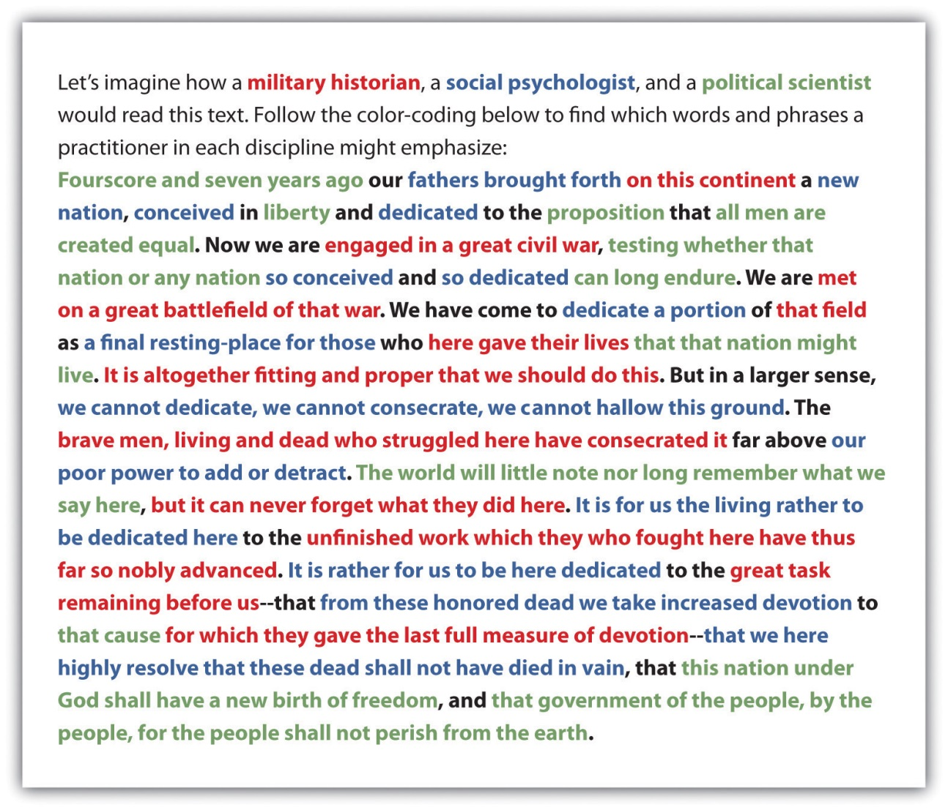

- A military historian (red passages) might focus on Lincoln’s rhetorical technique of using the field of a previous battle in an ongoing war (in this case a victory that nonetheless cost a great deal of casualties on both sides) as inspiration for a renewed, redoubled effort.
- A social psychologist (blue passages) might focus on how Lincoln uses this historical moment of unprecedented national trauma as an occasion for shared grief and shared sacrifice, largely through using the rhetorical technique of an extended metaphor of “conceiving and dedicating” a nation/child whose survival is at stake.
- A political scientist (green passages) might focus on how Lincoln uses the occasion as a rhetorical opportunity to emphasize that the purpose of this grisly and grim war is to preserve the ideals of the founders of the American republic (and perhaps even move them forward through the new language of the final sentence: “of the people, by the people, for the people”).

Notice that each reader, regardless of academic background, needs a solid understanding of how rhetoric works (something we’ll cover in Chapter 4 "Joining the Conversation" in more detail). Each reader has been trained to use a specific disciplinary lens that causes certain passages to rise to prominence and certain insights to emerge.

But the real power of disciplines comes when these readers and their readings interact with each other. Imagine how a military historian could use social psychology to enrich an understanding of how a civilian population was motivated to support a war effort. Imagine how a political scientist could use military history to show how a peacetime, postwar governmental policy can trade on the outcome of a battle. Imagine how a social psychologist could use political science to uncover how a traumatized social structure can begin to heal itself through an embrace of shared governance.

As Lincoln would say, “It is altogether fitting and proper that we should do this.”

KEY TAKEAWAYS
- Disciplines have long-standing binary oppositions that help shape the terms of inquiry.
- To think, read, and write in a given discipline, you must learn to uncover binary oppositions in the texts, objects, and phenomena you are examining.
- Binary oppositions gain power and complexity when they are applied to multiple disciplines.

EXERCISES
- Following the Gettysburg Address example at the end of this section, use three disciplinary lenses to color-code a reading of your choice from the Note 2.5 "Gallery of Web-Based Texts" in Chapter 2 "Becoming a Critical Reader".
- Find a passage in one of the textbooks you’re using in another course (or look over your lecture notes from another course) where the main discipline appears to be borrowing theories, concepts, or binary oppositions from other disciplines in order to produce new insights and discoveries.
- Individually or with a partner, set up an imaginary two-person dialogue of at least twenty lines (or two pages) that expresses two sides of a contemporary issue with equal force and weight. You may use real people if you want, either from your reading of specific columnists at Arts and Letters Daily or of the essayists at the Big Questions Essay Series (see the Note 2.5 "Gallery of Web-Based Texts" in Chapter 2 "Becoming a Critical Reader"). In a separate memo, indicate which side you lean toward personally and discuss any difficulty you had with the role playing required by this exercise.
- Show how one of the binary oppositions mentioned in this section is expressed by two writers in a discipline of your choosing. Alternatively, you can come up with a binary opposition of your own, backing it up with examples from the two extremes.
- Briefly describe how an insight or discovery applied past disciplinary knowledge to a new situation or challenge. How might you begin to think about addressing one of the contemporary problems in your chosen discipline?

Chapter 4
Joining the Conversation
Thus far we’ve established why it’s important to slow down your thinking and avoid rushing to judgment about topics. We’ve demonstrated how a close, careful, critical reading of texts can produce greater insights. We’ve explored the interplay among academic disciplines and shown how using various disciplinary lenses can lead us to see the world in different ways. We haven’t yet turned these private thinking exercises into public writing. It’s time to go public and join the conversation.

Because they have presented critical thinking strategies, the first three chapters have only occasionally touched on the stakes involved in actually presenting your ideas publicly. In this final chapter, you will learn what’s involved in using rhetoric to write for a specific audience and purpose.

4.1 Raising the Stakes by Going Public
LEARNING OBJECTIVES
- Appreciate the fact that rhetoric is value-neutral and ever present.
- Understand the relationship between dialectic and rhetoric.
- Learn about the differences between low-stakes private writing and high-stakes public writing.

The word rhetoric, like critical (from ), has taken on a negative connotation in recent years. Politicians are fond of using the (ironically rhetorical) technique of boasting that they will “not indulge in rhetoric,” or accusing their opponents of “being rhetorical,” as if it were possible to communicate at all without using rhetoric. Rhetoric is simply a value-neutral term for communication that has a purpose. It can be used in the service of good or evil, or something in between, but it is always used. Communicating publicly without using rhetoric is like driving across town without a car.
Just as you used writing to think in the first three chapters, when you write publicly in this chapter and beyond, you shouldn’t stop thinking. Sometimes public and academic writing is presented as a fixed, sterile transcript or translation of already completed thoughts. But the more faithfully you depict your thinking process in front of your readers, the more engaged your audience will be, and the more they will want to share in your journey.
Dialectic and Rhetoric

In , we explored how disciplines navigate between binary oppositions to sustain dialogue, debate, and the possibility of new discoveries. The classical term for sustaining a productive tension between binary oppositions is dialectic, from the Greek word meaning “dialogue.” We have been suggesting that you could use dialectic in your academic pursuits as a way of understanding concepts and perhaps even producing new insights.

A good working knowledge of the methods and strategies of rhetoric will put you in position to apply, translate, and convey publicly the insights you generate through dialectic thinking. In classical terms, dialectic and rhetoric were considered to be complementary counterparts. If you merely think dialectically without eventually using public rhetoric, your insights will be isolated and irrelevant. On the other hand, if you use only rhetoric without first going through some rigorously dialectical thinking, your communication will be undisciplined, shallow, overly partial and subjective, and lacking in perspective. An educated, ethical person needs to use both dialectic and rhetoric in order to engage fully with the world.

Moving from Low-Stakes to High-Stakes Writing

Let’s bring these ideas down to earth with an example of how a semiprivate journal entry was partially but not completely transformed into a piece of public communication in an academic setting. In the first couple of weeks of the semester, Zach, a first-year college writing student, wrote the following entry in his electronic writing journal (a space that had been set up for “semiprivate” communication between students and their instructor, with an understanding that the instructor would neither grade the entries nor comment on them unless invited to do so):

Two days ago, when my mother got laid off, I was notified that my paycheck was now, not only the primary and bread-winning income, but the ONLY income. This is really putting stress onto me and because of this means two of everything, for example two car payments, twice the insurance, the entire phone bill, and the entire rent amount.

Later in the term, when students were invited to post suggestions for the next year’s entering class of students on a class-wide wiki, Zach decided to go public with his story (embedded in his new, now public post).

Strategies for Success in Community College

Many incoming community college students enter into their freshman year with the part-time job that they acquired in their senior year of high school. For me, entering into the new college environment with a full-time job has been a bit of a hassle as well as being quite stressful. When I started my freshman year, my job paid my share of the rent and phone bill as well as my car payment and insurance payment.

Early in the semester, when my mother got laid off, I was notified that my paycheck was now, not only the primary and bread-winning income, but the ONLY income. This is really putting stress onto me and because of this means two of everything, for example two car payments, twice the insurance, the entire phone bill, and the entire rent amount.

When you start your college careers, you must pace yourself when you take your first semester of classes. It is best to put your job on the back burner. You do not want to start following me down the bumpy road of life. The path I have chosen has been extremely stressful. In choosing this path, I am close to not only losing my job but I am also dangerously close to failing out of some of my classes. A full-time job as well as being a full-time student is NOT recommended, especially for a first-time student.

Going public with his personal difficulty and addressing an audience (other than himself and his professor) has prompted Zach to begin considering in some detail the dialectic tensions many of his fellow students face between school and work, school and family, and family and work. This deepening of his thinking from pure narrative (“x happened, then y happened”) into analysis (“this is why x and y happened and how they relate to each other”) is an example of how rhetorical responsibility can raise the stakes and the quality of a piece of writing.

However, Zach hasn’t yet moved fully into a rhetorical mode with this post because he is still working through the various dialectics he has raised. He has actually gone public too early in the process, before he has come up with some reasonably meaningful and complete ideas to convey to his newly recruited audience. He has closed with an incontrovertibly true statement: “A full-time job as well as being a full-time student is NOT recommended, especially for a first-time student.” But he hasn’t yet worked out an alternative to that arrangement that also meets the needs of his family. The wiki post is, more realistically, step two of a multistep process. Now that he has an audience in mind and a clear sense of his dilemma, he needs to explore a realistic and sustainable solution to this problem on a wider scale.

KEY TAKEAWAYS
- Rhetoric is the public application of dialectical thinking.
- Low-stakes, private writing that explores the terms of a dialectic can be transformed into high-stakes, public writing meant for an audience, but that process may take several stages or drafts.
- The process of going public involves a balance between meeting your audience’s expectations and honoring your original thinking process.

EXERCISES
- Uncover a dialectic tension in a piece of your journal writing. Lay out a plan for how you could move from dialectic to rhetoric. How would you explore this dialectic further and ultimately present it rhetorically to an audience of your choosing? If appropriate, execute your plan.
- Review a piece of “finished” text, either an essay you’ve already produced for an audience or grade or a published piece by another writer. Identify a dialectic tension in the piece that was oversimplified or dismissed in the interest of “going public” prematurely. Use your findings to lay out a plan to move from rhetoric back to dialectic and then move back to a more balanced, effective, meaningful use of rhetoric.
- Revise the following semiprivate journal entry about juggling work, family, and school into a public wiki post for an audience of entering college students. Use the following steps:

  - Examine the journal for any dialectic tensions and identify them.
  - Decide whether you have fully worked out those dialectics in the current draft.
  - As you go public, figure out how to present the dialectics with rhetorical effectiveness.

- Sometimes going to school full time and trying to make money is difficult and to do it I have to juggle my responsibilities and manage my time appropriately. A big problem I have is when I am working I am often too exhausted to spend the necessary amount of concentration I need to on my school work. I work for my parents remodeling my house which includes a lot of physical labor such as painting, putting down flooring, refinishing cabinets, and so forth. These things drain a lot of energy out of me and make it hard to study and focus at night. I have been doing a mediocre job keeping up with school and work but would like to be able to make improvements in both without being so tired. To do this I started alternating between doing school work in the afternoons and working in the mornings. Instead of during a bunch of physical labor early in the day and tiring my self out by night time when it was time to do my homework I switched the two. I started my day out by making a list of all the homework I needed to do that day and then did half of it. After I completed half of my homework I would do the work I was suppose to around my house until everything that needed to be done that day was done. After I finished my work I took a break and ate. I left myself a couple hours to relax or socialize before I had to finish the rest of my homework. This schedule left me with a lot more energy at night and less homework to do which let me put more attention and focus into actually understanding the homework and completing the assignments. Alternating between different things depending on my energy level and time of day has been a helpful strategy for me to overcome my major time-management problem for this week.

4.2 Recognizing the Rhetorical Situation
LEARNING OBJECTIVES
- Outline and illustrate the elements of the rhetorical triangle.
- Explore the uses and abuses of rhetorical appeals.
- Show how to develop the habit of thinking rhetorically.

The term argument, like rhetoric and critical, is another term that can carry negative connotations (e.g., “We argued all day,” “He picked an argument,” or “You don’t have to be so argumentative”), but like these other terms, it’s really just a neutral term. It’s the effort to use rhetorical appeals to influence an audience and achieve a certain set of purposes and outcomes.

The Rhetorical Triangle
The principles Aristotle laid out in his Rhetoric nearly 2,500 years ago still form the foundation of much of our contemporary practice of argument. The rhetorical situation Aristotle argued was present in any piece of communication is often illustrated with a triangle to suggest the interdependent relationships among its three elements: the voice (the speaker or writer), the audience (the intended listeners or readers), and the message (the text being conveyed).

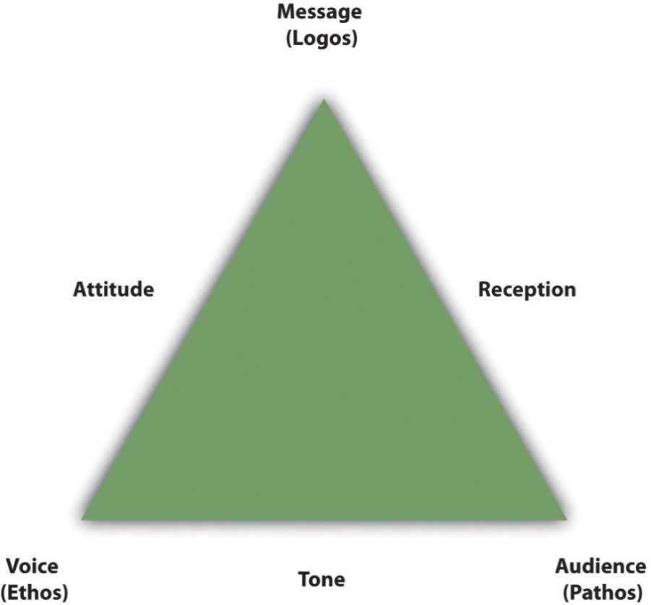

If each corner of the triangle is represented by one of the three elements of the rhetorical situation, then each side of the triangle depicts a particular relationship between two elements:

- Tone. The connection established between the voice and the audience.
- Attitude. The orientation of the voice toward the message it wants to convey.
- Reception. The manner in which the audience receives the message conveyed.

Rhetorical Appeals

In this section, we’ll focus on how the rhetorical triangle can be used in service of argumentation, especially through the balanced use of ethical, logical, and emotional appeals: ethos, logos, and pathos, respectively. In the preceding figure, you’ll note that each appeal has been placed next to the corner of the triangle with which it is most closely associated:

- Ethos. Appeals to the credibility, reputation, and trustworthiness of the speaker or writer (most closely associated with the voice).
- Pathos. Appeals to the emotions and cultural beliefs of the listeners or readers (most closely associated with the audience).
- Logos. Appeals to reason, logic, and facts in the argument (most closely associated with the message).
- Each of these appeals relies on a certain type of evidence: ethical, emotional, or logical. Based on your audience and purpose, you have to decide what combination of techniques will work best as you present your case.

When using a logical appeal, make sure to use sound inductive and deductive reasoning to speak to the reader’s common sense. Specifically avoid using emotional comments or pictures if you think your audience will see their use as manipulative or inflammatory. For example, in an essay proposing that participating in high school athletics helps students develop into more successful students, you could show graphs comparing the grades of athletes and nonathletes, as well as high school graduation rates and post–high school education enrollment. These statistics would support your points in a logical way and would probably work well with a school board that is considering cutting a sports program.

The goal of an emotional appeal is to garner sympathy, develop anger, instill pride, inspire happiness, or trigger other emotions. When you choose this method, your goal is for your audience to react emotionally regardless of what they might think logically. In some situations, invoking an emotional appeal is a reasonable choice. For example, if you were trying to convince your audience that a certain drug is dangerous to take, you might choose to show a harrowing image of a person who has had a bad reaction to the drug. In this case, the image draws an emotional appeal and helps convince the audience that the drug is dangerous. Unfortunately, emotional appeals are also often used unethically to sway opinions without solid reasoning.

An ethical appeal relies on the credibility of the author. For example, a college professor who places a college logo on a website gains some immediate credibility from being associated with the college. An advertisement for tennis shoes using a well-known athlete gains some credibility. You might create an ethical appeal in an essay on solving a campus problem by noting that you are serving in student government. Ethical appeals can add an important component to your argument, but keep in mind that ethical appeals are only as strong as the credibility of the association being made.

Whether your argument relies primarily on logos, pathos, ethos, or a combination of these appeals, plan to make your case with your entire arsenal of facts, statistics, examples, anecdotes, illustrations, figurative language, quotations, expert opinions, discountable opposing views, and common ground with the audience. Carefully choosing these supporting details will control the tone of your paper as well as the success of your argument.

Logical, Emotional, and Ethical Fallacies
Rhetorical appeals have power. They can be used to motivate or to manipulate. When they are used irresponsibly, they lead to fallacies. Fallacies are, at best, unintentional reasoning errors, and at worst, they are deliberate attempts to deceive. Fallacies are commonly used in advertising and politics, but they are not acceptable in academic arguments. The following are some examples of three kinds of fallacies that abuse the power of logical, emotional, or ethical appeals (logos, pathos, or ethos).

Logical Fallacies | Examples
Begging the question (or circular reasoning): The point is simply restated in different words as proof to support the point. | Tall people are more successful because they accomplish more.
Either/or fallacy: A situation is presented as an “either/or” choice when in reality, there are more than just two options. | Either I start to college this fall or I work in a factory for the rest of my life.
False analogy: A comparison is made between two things that are not enough alike to support the comparison. | This summer camp job is like a rat cage. They feed us and let us out on a schedule.
Hasty generalization: A conclusion is reached with insufficient evidence. | I wouldn’t go to that college if I were you because it is extremely unorganized. I had to apply twice because they lost my first application.
non sequitur: Two unrelated ideas are erroneously shown to have a cause-and-effect relationship. | If you like dogs, you would like a pet lion.
post hoc ergo propter hoc (or false cause and effect): The writer argues that A caused B because B happened after A. | George W. Bush was elected after Bill Clinton, so it is clear that dissatisfaction with Clinton lead to Bush’s election.
Red herring: The writer inserts an irrelevant detail into an argument to divert the reader’s attention from the main issue. | My room might be a mess, but I got an A in math.
Self-contradiction: One part of the writer’s argument directly contradicts the overall argument. | Man has evolved to the point that we clearly understand that there is no such thing as evolution.
Straw man: The writer rebuts a competing claim by offering an exaggerated or oversimplified version of it. | Claim—You should take a long walk every day. Rebuttal—You want me to sell my car, or what?

Emotional Fallacies | Examples
Apple polishing: Flattery of the audience is disguised as a reason for accepting a claim. | You should wear a fedora. You have the perfect bone structure for it.
Flattery: The writer suggests that readers with certain positive traits would naturally agree with the writer’s point. | You are a calm and collected person, so you can probably understand what I am saying.
Group think (or group appeal): The reader is encouraged to decide about an issue based on identification with a popular, high-status group. | The varsity football players all bought some of our fundraising candy. Do you want to buy some?
Riding the bandwagon: The writer suggests that since “everyone” is doing something, the reader should do it too. | The hot thing today is to wear black socks with tennis shoes. You’ll look really out of it if you wear those white socks.
Scare tactics (or veiled threats): The writer uses frightening ideas to scare readers into agreeing or believing something. | If the garbage collection rates are not increased, your garbage will likely start piling up.
Stereotyping: The writer uses a sweeping, general statement about a group of people in order to prove a point. | Women won’t like this movie because it has too much action and violence.  OR  Men won’t like this movie because it’s about feelings and relationships.

Ethical Fallacies | Examples
Argument from outrage: Extreme outrage that springs from an overbearing reliance on the writer’s own subjective perspective is used to shock readers into agreeing instead of thinking for themselves. | I was absolutely beside myself to think that anyone could be stupid enough to believe that the Ellis Corporation would live up to its commitments. The totally unethical management there failed to require the metal grade they agreed to. This horrendous mess we now have is completely their fault, and they must be held accountable.
False authority (or hero worship or appeal to authority or appeal to celebrity): A celebrity is quoted or hired to support a product or idea in efforts to sway others’ opinions. | LeBron James wears Nikes, and you should too.
Guilt by association: An adversary’s credibility is attacked because the person has friends or relatives who possibly lack in credibility. | We do not want people like her teaching our kids. Her father is in prison for murder.
Personal attack (or ad hominem): An adversary’s personal attributes are used to discredit his or her argument. | I don’t care if the government hired her as an expert. If she doesn’t know enough not to wear jeans to court, I don’t trust her judgment about anything.
Poisoning the well: Negative information is shared about an adversary so others will later discredit his or her opinions. | I heard that he was charged with aggravated assault last year, and his rich parents got him off.
Scapegoating: A certain group or person is unfairly blamed for all sorts of problems. | Jake is such a terrible student government president; it is no wonder that it is raining today and our spring dance will be ruined.

Do your best to avoid using these examples of fallacious reasoning, and be alert to their use by others so that you aren’t “tricked” into a line of unsound reasoning. Getting into the habit of reading academic, commercial, and political rhetoric carefully will enable you to see through manipulative, fallacious uses of verbal, written, and visual language. Being on guard for these fallacies will make you a more proficient college student, a smarter consumer, and a more careful voter, citizen, and member of your community.

KEY TAKEAWAYS
- The principles of the rhetorical situation outlined in Aristotle’s Rhetoric almost 2,500 years ago still influence the way we look at rhetoric today, especially the interdependent relationships between voice (the speaker or writer), message (the text being conveyed), and audience (the intended listeners or readers).
- The specific relationships in the rhetorical triangle can be called tone (voice–audience), attitude (voice–message), and reception (audience–message).
- Rhetorical appeals can be used responsibly as a means of building a persuasive argument, but they can also be abused in fallacies that manipulate and deceive unsuspecting audiences.

EXERCISES
- Apply what you’ve learned about the uses and abuses of rhetorical appeals (logos, pathos, and ethos) to a text from the in . For good examples from advertising, politics, history, and government, try the Ad Council, the Avalon Project, From Revolution to Reconstruction, The Living Room Candidate, or the C-SPAN Video Library. For example, The Living Room Candidate site allows you to survey television ads from any presidential campaign since 1952. You could study five ads for each of the major candidates and subject the ads to a thorough review of their use of rhetorical techniques. Cite how and where each ad uses each of the three rhetorical appeals, and determine whether you think each ad uses the appeals manipulatively or legitimately. In this case, subject your political biases and preconceptions to a review as well. Is your view of one candidate’s advertising more charitable than the other for any subjective reason?
- Find five recent print, television, or web-based advertisements and subject them to a thorough review of their use of rhetorical techniques. Determine whether you think each advertisement uses rhetorical appeals responsibly and effectively or misuses the appeals through fallacies. Identify the appeals employed in either case.
- In the following passage from Thomas Paine’s famous 1776 pamphlet, Common Sense, discuss Paine’s use of rhetorical appeals. Which of the three appeals (logos, pathos, or ethos) predominates, and why? For the context of this passage, go to From Revolution to Reconstruction in the and search for Paine, or click on http://www.let.rug.nl/usa/D/1776-1800/paine/CM/sense04.htm to go to the passage directly:

Europe is too thickly planted with kingdoms to be long at peace, and whenever a war breaks out between England and any foreign power, the trade of America goes to ruin, because of her connection with Britain. The next war may not turn out like the Past, and should it not, the advocates for reconciliation now will be wishing for separation then, because, neutrality in that case, would be a safer convoy than a man of war. Every thing that is right or natural pleads for separation. The blood of the slain, the weeping voice of nature cries, ’TIS TIME TO PART. Even the distance at which the Almighty hath placed England and America, is a strong and natural proof, that the authority of the one, over the other, was never the design of Heaven.

American colonists faced a dialectic between continuing to be ruled by Great Britain or declaring independence. Arguments in favor of independence (such as Paine’s) are quite familiar to students of American history; the other side of the dialectic, which did not prevail, will likely be less so. In the following passage, Charles Inglis, in his 1776 pamphlet, The True Interest of America Impartially Stated, makes a case for ending the rebellion and reconciling with Great Britain. At one point in the passage, Inglis quotes Paine directly (calling him “this author”) as part of his rebuttal. As in the preceding exercise, read the passage and discuss its use of rhetorical appeals. Again, which of the three appeals (logos, pathos, or ethos) predominates, and why? For a link to the entire Inglis document, search for Inglis in From Revolution to Reconstruction in the , or click on http://www.let.rug.nl/usa/D/1776-1800/libertydebate/inglis.htm to go to the link directly:

By a reconciliation with Britain, a period would be put to the present calamitous war, by which so many lives have been lost, and so many more must be lost, if it continues. This alone is an advantage devoutly to be wished for. This author says, “The blood of the slain, the weeping voice of nature cries, Tis time to part.” I think they cry just the reverse. The blood of the slain, the weeping voice of nature cries—It is time to be reconciled; it is time to lay aside those animosities which have pushed on Britons to shed the blood of Britons; it is high time that those who are connected by the endearing ties of religion, kindred and country, should resume their former friendship, and be united in the bond of mutual affection, as their interests are inseparably united.

4.3 Rhetoric and Argumentation
LEARNING OBJECTIVES
- Recognize the various methods, types, and aims of argumentation used in academic and professional texts.
- Understand how to adjust your approach to argumentation depending on your rhetorical situation and the findings of your research.

True argumentation is the most important kind of communication in the academic and professional world. Used effectively, it is how ideas are debated and shared in discourse communities. Argumentation holds both writers and readers to the highest standards of responsibility and ethics. It is usually not what you see on cable news shows or, sadly, even in presidential debates. This section will show how rhetoric is used in service of argumentation.

Induction and Deduction

Traditionally, arguments are classified as either inductive or deductive. Inductive arguments consider a number of results and form a generalization based on those results. In other words, say you sat outside a classroom building and tallied the number of students wearing jeans and the number wearing something other than jeans. If after one hour, you had tallied 360 students wearing jeans and 32 wearing other clothes, you could use inductive reasoning to make the generalization that most students at your college wear jeans to class. Here’s another example. While waiting for your little sister to come out of the high school, you saw 14 girls wearing high heels. So you assume that high heels are standard wear for today’s high school girls.

Deductive arguments begin with a general principle, which is referred to as a major premise. Then a related premise is applied to the major premise and a conclusion is formed. The three statements together form a syllogism. Here are some examples:

- Major premise: Leather purses last a long time.
- Minor premise: I have a leather purse.
- Conclusion: My purse will last a long time.
- Major premise: Tara watches a lot of television.
- Minor premise: Tara is a very good student.
- Conclusion: A teenager can be a good student even if he or she watches a lot of television.

Although these simple inductive and deductive arguments are fairly clean and easy to follow, they can be flawed because of their rigidity.
Let’s revisit the “college students wear jeans” argument. What if you happened to be counting jeans wearers on a day that has been declared Denim Appreciation Day? Or conversely, what if you had taken the sample on the hottest day of the year in the middle of the summer session? Although it might be true that most students in your sample on that day wore jeans to class, the argument as it stands is not yet strong enough to support the statement.

Now consider the purse argument. The argument is not strong since a variety of possible exceptions are obvious. First, not all leather purses last a long time since the leather could be strong, but the workmanship could be shoddy (challenge to major premise). Second, the quality of the leather in your particular purse could be such that it would not hold up to heavy use (challenge to minor premise). Third, a possible exception is that the argument does not take into account how long I have had my purse: even though it is made of leather, its lifespan could be about over. Since very few issues are completely straightforward, it is often easy to imagine exceptions to simplistic arguments. For this reason, somewhat complex argument forms have been developed to address more complicated issues that require some flexibility.

Types of Argumentation

Three common types of argumentation are classical, Toulminian, and Rogerian. You can choose which type to use based on the nature of your argument, the opinions of your audience, and the relationship between your argument and your audience.

The typical format for a classical argument will likely be familiar to you:

Introduction
  - Convince readers that the topic is worthy of their attention.
  - Provide background information that sets the stage for the argument.
  - Provide details that show you as a credible source.
  - End with a thesis statement that takes a position on the issue or problem you have established to be arguable.

- Presentation of position
  - Give the reasons why the reader should share your opinion.
  - Provide support for the reasons.
  - Show why the reasons matter to the audience.

- Presentation and rebuttal of alternative positions
  - Show that you are aware of opposing views.
  - Systematically present the advantages and disadvantages of the opposing views.
  - Show that you have been thorough and fair but clearly have made the correct choice with the stand you have taken.

- Conclusion
  - Summarize your argument.
  - Make a direct request for audience support.
  - Reiterate your credentials.

Toulminian argumentation (named for its creator, Stephen Toulmin) includes three components: a claim, stated grounds to support the claim, and unstated assumptions called warrants. Here’s an example:

- Claim: All homeowners can benefit from double-pane windows.
- Grounds: Double-pane windows are much more energy efficient than single-pane windows. Also, double-pane windows block distracting outside noise.
- Warrant: Double-pane windows keep houses cooler in summer and warmer in winter, and they qualify for the tax break for energy-efficient home improvements.

The purest version of Rogerian argumentation (named for its creator, Carl Rogers) actually aims for true compromise between two positions. It can be particularly appropriate when the dialectic you are addressing remains truly unresolved. However, the Rogerian method has been put into service as a motivational technique, as in this example:

- Core argument: First-semester college students should be required to attend three writing sessions in the college writing center.
- Common ground: Many first-semester college students struggle with college-level work and the overall transition from high school to college.

Link between common ground and core argument: We want our students to have every chance to succeed, and students who attend at least three writing sessions in the university writing lab are 90 percent more likely to succeed in college.

Rogerian argumentation can also be an effective standard debating technique when you are arguing for a specific point of view. Begin by stating the opposing view to capture the attention of audience members who hold that position and then show how it shares common ground with your side of the point. Your goal is to persuade your audience to come to accept your point by the time they read to the end of your argument. Applying this variation to the preceding example might mean leading off with your audience’s greatest misgivings about attending the writing center, by opening with something like “First-semester college students are so busy that they should not be asked to do anything they do not really need to do.”

Analytical and Problem-Solving Argumentation

Arguments of any kind are likely to either take a position about an issue or present a solution to a problem. Don’t be surprised, though, if you end up doing both. If your goal is to analyze a text or a body of data and justify your interpretation with evidence, you are writing an analytical argument. Examples include the following:

- Evaluative reviews (of restaurants, films, political candidates, etc.)
- Interpretations of texts (a short story, poem, painting, piece of music, etc.)
- Analyses of the causes and effects of events (9/11, the Civil War, unemployment, etc.)

Problem-solving argumentation is not only the most complicated but also the most important type of all. It involves several thresholds of proof. First, you have to convince readers that a problem exists. Second, you have to give a convincing description of the problem. Third, because problems often have more than one solution, you have to convince readers that your solution is the most feasible and effective. Think about the different opinions people might hold about the severity, causes, and possible solutions to these sample problems:

- Global warming
- Nonrenewable energy consumption
- The federal budget deficit
- Homelessness
- Rates of personal saving

Argumentation often requires a combination of analytical and problem-solving approaches. Whether the assignment requires you to analyze, solve a problem, or both, your goal is to present your facts or solution confidently, clearly, and completely. Despite the common root word, when writing an argument, you need to guard against taking a too argumentative tone. You need to support your statements with evidence but do so without being unduly abrasive. Good argumentation allows us to disagree without being disagreeable.

Research and Revision in Argumentation

Your college professors are not interested in having you do in-depth research for its own sake, just to prove that you know how to incorporate a certain number of sources and document them appropriately. It is assumed that extensive research is a core feature of a strong essay. In college-level writing, research is not meant merely to provide additional support for an already fixed idea you have about the topic, or to set up a “straw man” for you to knock down with ease. Don’t fall into the trap of trying to make your research fit your existing argument. Research conducted in good faith will almost certainly lead you to refine your ideas about your topic, leading to multiple revisions of your work. It might cause you even to change your topic entirely. (For more on research and revision in argumentation, see Chapter 7 "Researching" and Chapter 8 "Revising".)

Revision is part of the design of higher education. If you embrace the “writing to think” and “writing to learn” philosophy and adopt the “composing habits of mind” outlined in Chapter 1 "Writing to Think and Writing to Learn", Chapter 2 "Becoming a Critical Reader", Chapter 3 "Thinking through the Disciplines", and Chapter 4 "Joining the Conversation", with each draft, you will likely rethink your positions, do additional research, and make other general changes. As you conduct additional research between drafts, you are likely to find new information that will lead you to revise your core argument. Let your research drive your work, and keep in mind that your argument will remain in flux until your final draft. In the end, every final draft you produce should feel like a small piece of a vast and never ending conversation.

KEY TAKEAWAYS
- Argumentative reasoning relies on deduction (using multiple pieces of evidence to arrive at a single conclusion) and induction (arriving at a general conclusion from specific facts).
- You must decide which type of argumentation (classical, Toulminian, or Rogerian) is most appropriate for the rhetorical situation (voice, audience, message, tone, attitude, and reception).
- Analytical argumentation looks at a body of evidence and takes a position about it, while problem-solving argumentation tries to present a solution to a problem. These two aims of argumentation lead to very different kinds of evidence and organizational approaches.
- In argumentation, it’s especially important for you to be willing to adjust your approach and even your position in the face of new evidence or new circumstances.

EXERCISES
- Drawing from one of your college library databases or from the Note 2.5 "Gallery of Web-Based Texts" in Chapter 2 "Becoming a Critical Reader" (perhaps a couple of articles linked to ALDaily or one of the debates in the Big Questions Essay Series), find two texts you consider to be serious efforts at academic or professional argumentation. Write up a report about the types of argumentation used in each of the two texts. Answer the following questions and give examples to support your answers:

  - Does the text use primarily inductive or deductive argumentation?
  - Does it use classical, Toulminian, or Rogerian argumentation?
  - Is it primarily analytical or problem-solving argumentation?

- With your writing group or in a large-class discussion, discuss the types of argumentation that would be most appropriate and effective for addressing the following issues:

  - Capital punishment
  - Abortion
  - The legal drinking age
  - Climate change
  - Campus security

- Come up with a controversial subject and write about how you would treat it differently depending on whether you used each of the following:

  - Inductive or deductive reasoning
  - Classical, Toulminian, or Rogerian argumentation
  - An analytical or a problem-solving approach

4.4 Developing a Rhetorical Habit of Mind
LEARNING OBJECTIVES
- Get into the habit of thinking about the all texts in rhetorical terms.
- Learn about the statement of purpose and how it can be used as a tool for your future academic and professional writing.
- Develop a rhetorical habit of mind by enhancing your awareness of how language works.

The habit of thinking rhetorically starts with being comfortable enough with the rhetorical triangle to see it in practically every form of communication you produce and consume—not only those you encounter in academic settings but also those you encounter in everyday life. In several other chapters, you will make use of the elements (corners) and relationships (sides) of the rhetorical triangle, as well as the appeals associated with it. In Chapter 5 "Planning", you’ll see how to use the triangle in more detail to build a statement of purpose for specific writing projects by completing the following statements and returning to them as circumstances in your writing process change:

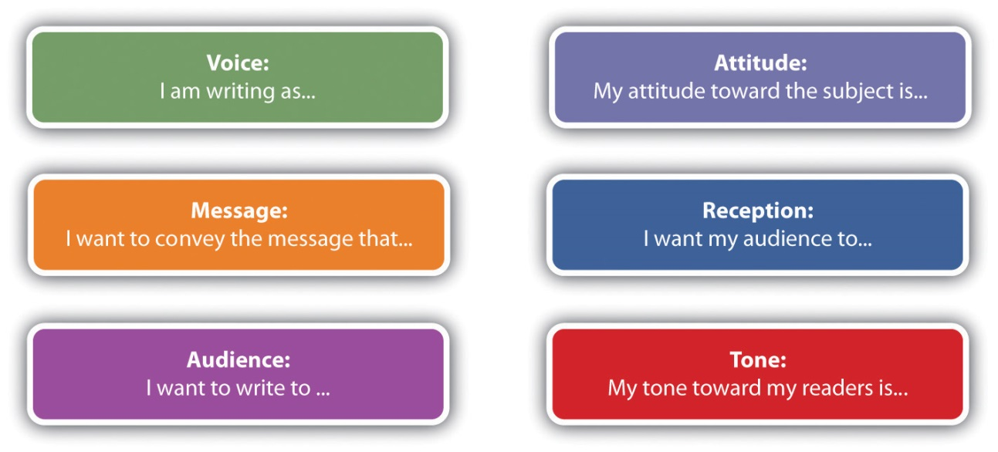

In Chapter 7 "Researching" and Chapter 8 "Revising", you’ll learn how to use the rhetorical triangle and the statement of purpose to plan and refine your research agenda, and in Chapter 12 "Professional Writing", you’ll even see how to apply these rhetorical tools to a job search.

Besides familiarizing yourself with the elements of the triangle and how they function, you’ll also need to consider the rhetorical moves writers make so you can begin to use language more creatively in your writing. Good writers learn to improvise with the language, to make it work both as a tool for thinking and as a vehicle for communication. Here are four categories of rhetorical moves you will encounter and begin to use as you develop a rhetorical habit of mind.

Rhetorical Move and Definition | Examples
Connotative language: Using a word beyond its denotation (or primary definition) to suggest or incite a desired response in readers. Sometimes a connotation can be a euphemism designed to make something sound better than it really is; at other times, a connotation can put a negative spin on something. | “welfare” (or “entitlement”)
 | “economic stimulus” (or “recovery”)
 | “death panel” (or “managed care”)
 | “pro-choice” (or “pro-abortion”)
 | “estate tax” (or “death tax”)
 | “global warming” (or “greenhouse effect”)
Figurative language: Using metaphors, similes, and analogies can help you and your readers uncover previously unseen connections between different categories of things (also discussed in Chapter 17 "Word Choice", Section 17.3.3 "Enhancing Writing with Figurative Language"). | “That professor’s lecture was like a metronome.” (Similes use like or as.)
 | “That test was a bear.” (Metaphors don’t.)
 | “The current panic in education about students’ addiction to texting and video games is reminiscent of concerns in earlier eras about other kinds of emerging technology.” (Analogies can lead to entire essay topics.)
Humorous language: Audiences who are entertained are more likely to receive your message. Within reason and boundaries of taste, there’s nothing wrong with using wit to help you make your points. Examples include plays on words (like puns, slang, neologisms, or “new words”), as well as more elaborate kinds of humor (such as parody and satire). | Recent additions to the dictionary (like “telecommuting,” “sexting,” and “crowdsourcing”) usually began as plays on words.
 | Parody and satire are ironic ways of imitating a subject or style through caricature and exaggeration.
 | Note: These kinds of humor require precise knowledge of your audience’s readiness to be entertained in this way. They can easily backfire and turn sour, but when used carefully, they can be extremely effective.
Metacognitive language: Thinking about your thinking (metacognition) can help you step outside yourself to reflect on your writing (the equivalent of “showing your work” in math). | “At this point, I’d like to be clear about my intentions for this essay…”
 | “Before I began this research project, I thought…but now I’ve come to believe…”

As you survey this table, remember that clear, simple, direct communication is still your primary goal, so don’t try all these techniques in the same piece of writing. Just know that you have them at your disposal and begin to develop them as part of your toolkit of rhetorical moves.

KEY TAKEAWAYS
- Developing a rhetorical habit of mind will help you consider voice, audience, message, tone, attitude, and reception in all the texts you read and write.
- The rhetorical habit of mind will also help you recognize rhetorical moves in four categories of language use: connotative, figurative, humorous, and metacognitive.
- In the process of developing the rhetorical habit of mind, you will also develop your creativity, sense of humor, and self-awareness.

EXERCISES
- Use the chart at the end of this section to find at least one example from each of the four categories of rhetorical moves in a reading of your choice. Be prepared to present your findings in a journal entry, a blog post, or as part of a group or class-wide discussion.
- Take a piece of your writing in progress and try to incorporate at least one rhetorical move from each category into it, using the chart at the end of this section as a guide.
- As the “knowledge handbook” portion of the Handbook for Writers comes to a close, it’s time to do an inventory of your composing habits of mind. In your writing journal or in a blog entry, list and describe at least three ways in which you have improved as a thinker, reader, or writer as a result of a concept or exercise you encountered in each of the first four chapters. Set one goal for yourself in each of these categories and outline how you intend to reach that goal by the end of your first year of college:

  - Writing to Think and Writing to Learn (Chapter 1 "Writing to Think and Writing to Learn")
  - Becoming a Critical Reader (Chapter 2 "Becoming a Critical Reader")
  - Thinking through the Disciplines (Chapter 3 "Thinking through the Disciplines")
  - Joining the Conversation (Chapter 4 "Joining the Conversation")

Chapter 5
Planning
The Beginning Steps
The composing habits of mind you developed in Chapter 1 "Writing to Think and Writing to Learn" through Chapter 4 "Joining the Conversation" should be applied to a writing process that works for you. When you start planning a writing project, you will need to understand the relationships among the three corners and the three sides of the rhetorical triangle described in Chapter 4 "Joining the Conversation": voice, message, and audience, as well as attitude, reception, and tone. After you have these core elements of the triangle in place, you are ready to map out your writing.

5.1 Choosing a Topic
LEARNING OBJECTIVES
- Recognize general topics that are too broad for a single writing assignment.
- Realize that you can and should massage a writing topic so that it interests you.
- Understand how to narrow a topic down to match your needs.

Life is simply too short not to write about topics that interest you. You don’t have to be an expert in a topic already, but you should be sufficiently interested in exploring it for a sustained period. Your readers will quickly pick up on your enthusiasm (or lack thereof) for a topic. Following up on personal interest can, at best, make a writing project fun, and at the very least, keep you (and your readers) from being miserable.

Most college writing instructors will not dictate too narrow a topic area, in part because they don’t have any interest in being bored and in part because they believe that topic generation is an important piece of the student writer’s job. But let’s explore a worst-case scenario, just to show how you can make practically any topic your own. Let’s say you are given an assignment to explore the history of South Dakota within a ten-page essay. Clearly, you can’t cover the whole state in ten pages. Rather, you would think about—and maybe research a little bit—aspects of South Dakota that might be interesting to you and your readers. Let’s say that you are a motorcycle enthusiast, and you are interested in Sturgis, South Dakota. Or perhaps your great-great-grandmother was a Dakota Indian, and you are interested in the Dakota Indian tribe. Or maybe you are an artist and you are interested in the corn mosaics on the Corn Palace in Mitchell, South Dakota. The point is that, if you think about South Dakota enough, you can find some direction of personal interest.

Example
Assigned Topic

The History of South Dakota

Personal Interest Direction

The Motorcycle Rallies in Sturgis, South Dakota

First Narrowing of Topic

The Acceptance by Locals of the Mass Influx of Motorcycles over the Years

Final Topic

The Sturgis Motorcycle Rally as Part of the Identity of Sturgis and the Surrounding Area

Once you choose a direction of interest, such as the motorcycle rallies in Sturgis, you still have to narrow this secondary topic into a topic that you can cover in ten pages and that has an interesting point. A method of moving from your general topic of interest to your final topic is to ask questions and let your answers guide you along. The following questions and answers show how this self-discussion could go.

Question #1: How do the Sturgis Rallies connect to the history of South Dakota?
Answer: The Sturgis Rallies have been going on for over seventy years, so they are part of the history of South Dakota.
Question #2: Over the years, how have the people of Sturgis felt about all those bikes invading their peaceful little city?
Answer: I bet there are people on both sides of the issue. On the other hand, a lot of people there make a great deal of money on the event.
Question #3: After over seventy years, has the event become such a part of the city that the bikes aren’t really seen as an invasion but rather more like a season that will naturally come?
Answer: It probably has become a natural part of the city and the whole surrounding area. That would be a good topic: The Sturgis Motorcycle Rally as Part of the Identity of Sturgis and the Surrounding Area.
You have begun to narrow your general topic down to a more manageable and interesting set of questions. Now it’s time to bring in the other elements of the rhetorical situation.

KEY TAKEAWAYS
- Before starting a writing project, you need to narrow the topic down so that it matches the length of the essay you are to write.
- Most writing topics can be viewed in a variety of directions, and when you are writing, you should take a topic in a direction that interests you.
- Self-discussion is a helpful method when trying to narrow a topic down to a manageable size.

EXERCISES
- Record the thought processes you would go through to narrow the writing topic “Thomas Edison” to a topic of interest to you for a ten-page assignment. Include the transcript of your self-talk and self-questioning process.
- Work with a partner. Together, talk through moving from the general topic “Television” to a specific topic that would work well for a five-page paper.
- With a partner or by yourself, narrow the following general topic areas to specific topics that would work in essays of approximately one thousand words:

  - Electoral Politics
  - Environmental Protection
  - The First Amendment
  - Campus Security

5.2 Freewriting and Mapping
LEARNING OBJECTIVES
- Recognize different ways to generate writing ideas.
- Understand how freewriting and mapping help generate writing ideas.
- Know how to create a map of writing ideas.

After you have settled on a topic, you are ready to explore general ideas that you will include when you start writing. You can generate these ideas with whatever brainstorming method works best for you, such as browsing the Internet to do an interconnected search from topic to topic, talking or texting with others, creating related visuals, asking yourself questions, freewriting and mapping. In this section, we will explore these latter two options.

Freewriting requires finding a quiet place to write without distraction. Most versions involve starting with a word or phrase (usually your topic) and writing (or typing) about it without stopping for five minutes. It’s helpful to set a timer for each round of freewriting. After the first five-minute period, you examine your text for any phrases or words that look interesting to you. Circle them (or if you are typing, highlight, italicize, bold, or underline them). In the second round, you freewrite for another five uninterrupted minutes on your choice of the most interesting word or phrase from your first freewrite. Sometimes even a third round can help you narrow the topic further. For each round of freewriting, you should be unconcerned about your writing’s grammar or mechanics, how it would look to an outside audience, or even whether it would make sense to anyone but you. Freewriting is all about idea generation and exploration.

Mapping is a great visual means of gathering your ideas. Also called clustering and branching or making a web, mapping lets you add as many ideas as you can think of and organize them as you go along. You have four general options for mapping.

- Use concept-mapping software such as Inspiration or SmartDraw.
- Use concept-mapping websites such as MindMeister (http://www.mindmeister.com/).
- Create your own circles and lines within a word processing program.
- Draw your map by hand.

No one option is superior to another. You should choose the option that works best for you. Using whichever option you choose, the point is to start with your main topic and then think of related subtopics and, for each subtopic, to think of supporting details resulting in a visual that shows the relationships between the key points of your writing plan. Since mapping is actually a visual brainstorming process, you do not have to generate your ideas in an orderly fashion. When you think of an idea, you can add it wherever it fits across the map.

In the concept-mapping software, you will be able to choose the level of the point you will add as well as the larger idea to which you want to attach each point. If you are creating your concept map structure yourself, make it clear to which level each addition belongs.

Study Figure 5.1 "Concept Map of Sturgis Motorcycle Rally" for clarification on how the process works. This map was made in Microsoft Word by creating circles, squares, and lines and placing them by hand into position. You can use all circles or all squares or whatever shape(s) you would like. This map uses a combination of squares and circles to make the subtopics stand out clearly from the details. This map also uses color to differentiate between levels.

Figure 5.1 Concept Map of Sturgis Motorcycle Rally
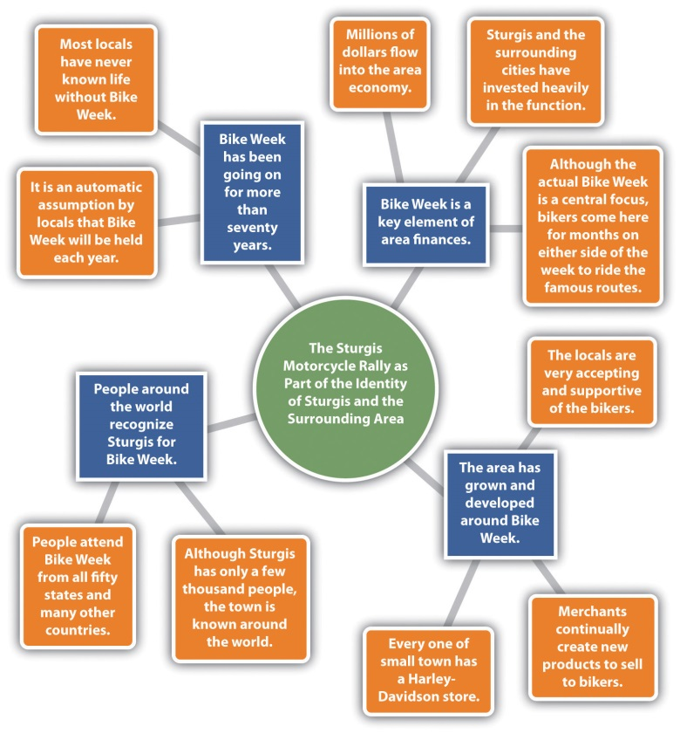

When the ideas stop flowing, put your map away and return to it later for another brainstorming session. Keep your freewrites and maps close at hand and feel free to add tidbits when they come to you. Get into the habit of keeping a writing pad and pen or pencil (or just your cell phone) next to your bed, so that you can jot down or text ideas as they come to you in the middle of the night. When you are comfortable that your map offers a good representation of the points you want to include in your paper, use it as a guide during the writing process.

KEY TAKEAWAYS
- To generate ideas for your writing, you can use whatever brainstorming method works well for you. Some common methods include browsing the Internet to do an interconnected search from topic to topic, talking or messaging with others, creating related visuals, asking yourself questions, freewriting, mapping, and outlining.
- Mapping is a method of visually generating ideas while showing the relationships between the ideas.
- You can create a map using software that is specifically designed for concept mapping, creating your own shapes and lines within a word processing program, or drawing your map by hand. The best method is the one that works best for you in a given situation.

EXERCISES
- Choose a topic of interest to you and freewrite for at least two five-minute rounds.
- Choose a topic of interest to you and create a map to show some ideas you might include if you were writing about the topic.
- Consider the different idea-generating methods noted in this section. Choose one of the methods and write a one-page essay explaining why that method would work well for you.
- Many concept-mapping software packages on the Internet offer a trial version. Locate and choose such software. Then, choose a topic and create a map of related ideas using the software.

5.3 Developing Your Purposes for Writing
LEARNING OBJECTIVES
- Know how to identify the ideal voice, audience, and message for a given topic.
- Explore the multiple purposes you have for writing.
- Recognize how your writing process depends on the relationship between voice and message (attitude), message and audience (reception), and voice and audience (tone).
- Learn how to use a statement of purpose as a tool for strategizing about, reflecting on, and presenting your work.

After you have settled on a specific writing topic, it’s time to return to some of the basic principles of rhetoric introduced in Chapter 4 "Joining the Conversation" so that you can think through your real purposes for writing and explore the key details of your rhetorical situation. This section will show you how to use both the corners and the sides of the rhetorical triangle as tools for thinking, planning, and writing. Notice how these choices you make about purpose, message, audience, and voice are never made in isolation.

- Purpose: You may think that purpose can be boiled down to one of these single verbs or phrases:

  - To analyze
  - To ask for support
  - To call to action
  - To clarify
  - To convince
  - To counter a previously stated opinion
  - To describe
  - To entertain
  - To inform
  - To make a request
  - To make people think
  - To persuade
  - To share feelings
  - To state an opinion
  - To summarize

However, your real purposes for writing are really more complicated, interesting, and dynamic than this simple list. Purpose involves all three sides and all three corners of the rhetorical triangle: not only do you want to make your audience feel or think a certain way about your message, but you also want to explore and refine your own thoughts and feelings about that message, and furthermore, you want to establish a certain kind of relationship with your audience through the act of conveying your message to them.

Audience: Sometimes your instructor will specify the audience for an essay assignment, but more often than not, this choice will be left up to you. If it’s your call, ask yourself, “Who would benefit the most from receiving this message?” Not asking that simple question, not choosing a specific audience for your essay, will be a missed opportunity to sharpen your skills as a communicator. By identifying your audience, you can conjecture how much your readers will know about your topic and thus gauge the level of information you should provide. You can determine what kind of tone is best for your audience (e.g., formal or informal, humorous or serious). Based on what you know about your audience, you can even decide the form you want your writing to take (e.g., whether to write a descriptive or more persuasive essay). Knowing your audience will guide many of the other choices you make along the way.

Message: Regardless of whether your topic is assigned to you or you come up with it on your own, you still have some room to develop your message. Be prepared to revise your message once you have fleshed out your own thinking about it (perhaps through asking and answering the Twenty Questions about Self, Text, and Context in Chapter 1 "Writing to Think and Writing to Learn") and sharpened your sense of audience and purpose thinking.

Voice: Regardless of whether you’re writing in an academic or a nonacademic context, you draw from a range of voices to achieve a variety of purposes. Each of the purposes listed above has an appropriate voice. If you are writing an essay to fulfill a class assignment, with your instructor as your primary if not exclusive audience, then your voice has pretty much been established for you. In such an instance, you are a student writing in a traditional academic context, subject to the evaluation of your instructor as an expert authorized to judge your work. But even in this most restrictive case, you should still try to develop a distinctive voice based on what you hope to accomplish through your writing.

Once you have identified your purposes and the corners of the rhetorical triangle, it’s time to do some preliminary thinking about the relationships between those corners—that is, the sides: voice and message (attitude), message and audience (reception), and voice and audience (tone). Finish the sentences below.

Figure 5.2 Your Rhetorical Situation

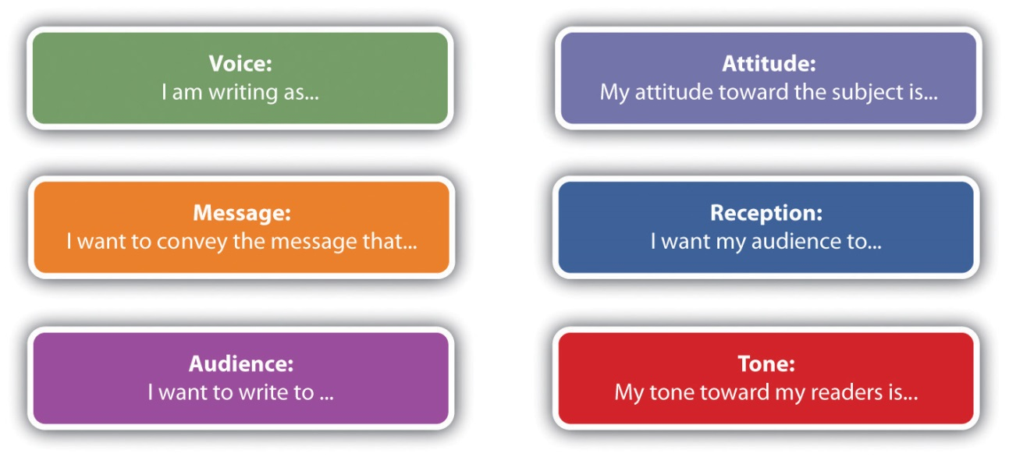

Near the beginning of the writing project, you could write up a preliminary statement of purpose based on how you complete these sentences and use it as a strategy memo of sorts:

Voice | I am writing as a person unfamiliar with South Dakota culture who has been assigned the task of writing about it.
Message | I want to convey the message that the Sturgis Motorcycle Rally is an interesting phenomenon of popular culture.
Audience | I want to write to my teacher and the other members of my writing group.
Attitude | My attitude toward the subject is pretty neutral right now, bordering on bored, until I find out more about the topic.
Reception | I want my audience to know that I know how to research and write about any topic thrown at me.
Tone | My tone toward my readers is semiformal, fairly objective, like a reporter, journalist, or anthropologist.

Because all the elements of the triangle are related to each other, all are subject to change when the direction of your work changes, so be open to the idea of returning to these questions several times over the course of your writing project. When you are ready to turn in your project, revise your preliminary statement of purpose into a final version, or writer’s memo, as a way of presenting and packaging your project, especially if your instructor invites such reflection and commentary.

Here’s an example of a writer’s memo submitted with the Sturgis Motorcycle Rally essay:

Voice | I am writing as a kind of social historian and observer of a specific example of popular culture.
Message | I want to convey the message that the Sturgis Motorcycle Rally has become an important part of the identity of Sturgis and the surrounding area.
Audience | I want to write to my instructor and classmates—but also to the citizens of Sturgis, South Dakota.
Attitude | My attitude toward the subject is neutral to positive. In general I think the rally has been good for Sturgis over the years.
Reception | I want my audience to understand and appreciate Sturgis Motorcycle Rally, and maybe to think about how something like it could work well in our community.
Tone | My tone toward my readers will be informal but informative, and occasionally humorous, to fit the craziness of Sturgis Motorcycle Rally.

KEY TAKEAWAYS
- When completing a class assignment, your instructor will often dictate a required writing form. When you are able to choose your own writing form, you should choose a form that you think would work well for your planned writing.
- Understanding your audience allows you to gauge the level of information you should provide, choose a tone you want to use, and decide the approach you want to take.
- Your purposes for writing include what you want to learn about your own message, how you want your audience to receive your message, and the kind of working relationship you want to establish with your audience.

EXERCISES
- Describe five possible topics you could use as the basis for an opinion essay.
- You are to writing an essay that is a call to action. List five topics you could write about.
- You are being asked to describe an important event in your childhood. What form of writing from the list in this section would be most appropriate?
- You are writing a letter of application for a college scholarship sponsored by a local business. For what audiences would you write the letter?
- You are writing an opinion essay and submitting it as a letter to the editor at your local newspaper. For what audiences would you write this letter?
- From the list of purposes in this section, choose a purpose that would match this assignment: Write a letter to the editor for the school paper detailing why your classmates should vote for you for class president.
- With your writing group, use the statement of purpose questions to sketch out the details on voice, message, audience, attitude, reception, and tone for the writing ideas you generated for Question 1 and Question 2 above.

5.4 Outlining
LEARNING OBJECTIVES
- Recognize that an outline allows you to visually see the relationships between ideas for a writing project.
- Understand that you can create an outline by hand but that using a computer provides useful conveniences.
- Understand the lettering and numbering system and the indenting system used in outlining.

Your instructor may make decisions about the form your essay will take, dictating whether you are supposed to write in a particular genre. But if you’re given some choice or flexibility about form, just as in the case of voice, audience, and message, you need to make the most of that responsibility. Regardless of who dictates form, you or your instructor, know what form your writing should take and make sure it suits the voice, audience, and message.

Some common forms of writing include the following:

- Argument
- Book review
- Case study
- Comparative analysis
- Critique
- Informative essay or report
- Lab report
- Opinion essay
- Personal narrative
- Persuasive essay
- Proposal
- Research report

An outline is another way to visually see the relationships between ideas you are gathering. You can create an outline by hand or on a computer. If you create one by hand, leave a blank space so you can fit additional ideas in within different areas. Using a computer for your outline is preferable since you can easily add ideas and move ideas around.

Start with your core idea as the beginning point of the outline. Then use roman numerals to add the subtopics followed by indented capital letters for the details. If you add finer details, you can use further-indented numbers for the next level and even-further-indented lowercase letters for a level after that. When using a computer, the preset tabs are most likely fine for the indenting.

The outline below relates to the map from the last section. It is simply another way to accomplish the same process of idea gathering. Notice that the writer here has made a sentence outline by writing out each element in a complete sentence. This strategy will help this writer move more easily from outline to essay draft.

The Sturgis Motorcycle Rally as Part of the Identity of Sturgis and the Surrounding Area

- Bike Week has been going on for more than seventy years.
  - It is an automatic assumption by locals that Bike Week will be held each year.
  - Most locals have never known life without Bike Week.
- Bike Week is a key element of area finances.
  - Millions of dollars flow into the area economy.
  - Sturgis and the surrounding cities have invested heavily in the function.
  - Although the actual Bike Week is a central focus, bikers come here for months on either side of the week to ride the famous routes.
- The area has grown and developed around Bike Week.
  - Every small town has a Harley-Davidson store.
  - Merchants continually create new products to sell to bikers.
  - The locals are very accepting and supportive of the bikers.
- People around the world recognize Sturgis for Bike Week.
  - People attend Bike Week from all fifty states and many other countries.
  - Although Sturgis has only a few thousand people, the town is known around the world.

As with the mapping process, once you have included all the ideas you have, take a break and return to your outline later. If, in the meantime, a thought comes to you, take a minute to add it. When you are satisfied with your outline, use it to guide your writing process. However, keep in mind that your outline is only a tool you are using, and you will vary from it when you have other ideas along the way.

KEY TAKEAWAYS
- Outlining uses roman numerals, numbers, letters, and indenting to visually show how ideas are related.
- You can create an outline by hand, but using a computer gives you much greater flexibility to add ideas and move ideas around.
- Within an outline, the numbering/lettering order is as follows:
- I.
- A.
- 1.
- a.

EXERCISES
- Using a topic of interest to you, create an idea outline for a short paper.
- Using a word processing program, present the following information in a short outline using at least two roman numerals and at least two capital letters. You will have to reorder the ideas so they make sense.

  - Topic: Technology should be a part of current-day education from kindergarten through all levels of college.
  - Ideas:

    - People need a natural comfort with technology before entering the workplace.
    - Students think in a technological way, so it’s wrong to pull them backward at school.
    - Students live in a technology age, so they should be educated in a technology age.
    - Students expect technology at school.
    - Students must experience using technology rather than just being told about it.
    - Even sixteen-year-olds are expected to be comfortable with computers on their very first jobs.
    - Most students use some types of technology at home.
    - Jobs ranging from waitresses to mechanics to nurses to lawyers require computer use.

Chapter 6
Drafting
More Involved Than Following a Map or Outline
Once you have created a map or outline or gathered your ideas in another way, you might think that the hardest part of the writing project is over, so now you can just follow your plan. However, the drafting process is actually much more complicated than that. You need to pay attention and think while you are writing and reading about your topic, so you notice meaningful changes you can make in your plan. You should continue to generate questions throughout the drafting and revising process. Even though you have a chosen topic, you need to formulate, support, and test your thesis (or main idea) and be prepared to modify it significantly in the face of new evidence or a change in your attitude toward the topic. You will also need to strive for an interesting, varied, appropriate, and mechanically sound approach to the paragraphs and sentences that will make up your essay.

6.1 Forming a Thesis
LEARNING OBJECTIVES
- Understand what a thesis is.
- Know the relationship between a topic, your opinion, and your thesis.
- Understand techniques for discovering how you are personally related to a topic.

Most academic writing includes a thesis, which is the main stance you decide to take toward your topic. Your thesis tells readers what your paper will be about. It also serves as a target you must ultimately hit as you write, though that target may move around quite a bit as you go through the drafting process. You might have an idea about your thesis early on, or you might only decide upon it once you have worked with your topic and plan for a while. You might continually tweak your thesis as you learn more and develop your opinions about your topic. This table shows how topics and personal stances relate:

Topic | Personal Stance
College students’ schedules | College students’ schedules should be set by the students, not by their parents.
Fallen logs in national parks | Fallen logs in national parks should be harvested rather than left to decay and increase the likelihood of forest fires.

Developing your personal stance is critical for several reasons. It narrows your topic to a final manageable level, and it makes the written work uniquely yours. Taking a personal stance gives you a point of view to develop, support, and defend. When you present your stance, it ultimately awakens emotions in your readers as they determine for themselves whether they agree or disagree with your stance.

If you have trouble deciding on a thesis, keep in mind that your thesis ties directly to the main purpose and audience of your writing project. It is the main point you want to make to your audience. Ask yourself how you personally relate to the topic. Take the college students’ schedules topic, for example. Your response to how you are personally related to the topic could be one of the following:

- I am a person with knowledge to share since my mother always set my college schedules for me resulting in me having little understanding about designing a schedule that works.
- I am an angry student since my father insisted on setting up my schedule, and my classes are all spread out in a way that will make my year miserable.
- I am an interested observer since my roommate’s mother always set her schedules and almost always ruined our plans to have some common free blocks of time.
- I have an opinion that I would like to share about “helicopter parents,” and this is a particularly good example of the phenomenon.
- This semester, after talking with an advisor, I sketched out the rest of the coursework in my major, and I see for the first time how everything’s going to fit together.

Once you see how you personally relate to your topic, you can then more clearly see what stance you want to take. Once you take a stance, work on wording it effectively, and you will have a working thesis.
KEY TAKEAWAYS
- A thesis is your personal stance toward the topic that you are writing about.
- The difference between a topic and a thesis is that a thesis involves taking a personal stance.
- You can determine your personal stance about a topic by asking yourself how you are personally related to it.

EXERCISE
1. For each of the following topics, think of a personal stance that might work for a thesis:

  - a. Student housing
  - b. Healthy food in restaurants
  - c. Online classes (and/or partially online or hybrid classes)
  - d. The future of hard-copy newspapers
e. Minimum age for college students

6.2 Testing a Thesis
LEARNING OBJECTIVES
- Understand why you should test your thesis.
- Use questions to test a thesis.

Now that you have formed your working thesis, you are ready to test it. The purpose of the test is to satisfy yourself that your thesis will work well. To test your satisfaction, answer the following questions. Read the tips if you need some help answering the questions.

QUESTIONS
Question #1: Is your proposed thesis interesting?

Tip: When you read the thesis statement, do you find yourself wondering about different aspects of the topic? In other words, do you want to know the answer to the thesis question? Do you think others will also want to know?

Question #2: Is your proposed thesis arguable?

Tip: If you are writing an argumentative essay and developing a thesis for a topic that is controversial, make sure you can also formulate in your head what the thesis for “the other side” would sound like.

Question #3: Is your proposed thesis specific enough?

Tip: Make certain that your thesis addresses a specific point about a specific person, place, idea, or situation. Do not proceed with vague wording, such as “all over the world,” “many people,” or “will cause problems.” Avoid relying too much on qualitative, superlative, or hyperbolic language, such as excellent, awesome, interesting, sad, or silly. Such words do not carry any concrete meaning.

Question #4: Is your proposed thesis manageable?

Tip: If you would have to research for two solid months to cover the breadth of the thesis, it is not suitable for a five-page paper. On the other hand, if a reader can understand the whole point simply by reading the thesis, the thesis is not suitable.

Question #5: Is your proposed thesis researchable?

Tip: Make sure you are confident that you will be able to find the information you need. Proceeding when you think you will have trouble finding enough information can cost you a lot of time if you come to a point where you think you have to start over.

Question #6: Is your proposed thesis significant to you and others?

Tip: If you choose a thesis that you care deeply about, others are likely to also find it significant. After you determine that your thesis is something about which you care deeply, you should double-check that your desired audience will also care.

After you have chosen a topic and a thesis and have begun work on the essay, you will be invested in your idea, so it won’t be as easy to answer these questions objectively. But doing so early on is worth the effort since the process will likely result in a more successful essay in the long run.

KEY TAKEAWAYS
- You should test your thesis for your satisfaction that your thesis will work well.
- To test a thesis, you need to ask questions to determine whether it is sufficiently interesting, arguable, specific, manageable, researchable, and significant.
- The thesis-testing process requires effort but will likely result in your satisfaction and a more successful essay.

EXERCISE
Each of the following six thesis-testing questions is followed by two sample theses. In each case, choose the thesis for which the answer to the question is “yes.” Explain why the option that wasn’t chosen does not receive a “yes” answer.
- Is your proposed thesis interesting?
  - Textbooks are unpleasant to read.
  - Students who have a steady love interest in college tend to receive higher grades.

- Is your proposed thesis arguable?
  - America’s foreign policy in the Balkans from 1991 to the present has had a stabilizing influence in the region.
  - The world would be a better place if we would just give peace a chance.

- Is your proposed thesis specific?
  - American toddlers who live with small pet dogs are more comfortable playing by themselves without the attention of a playmate or parent.
  - Girls who marry young have lifelong self-esteem problems.

- Is your proposed thesis manageable?
  - Native Americans in North America want to maintain old customs.
  - Music can actually provide a helpful studying background for some students.

- Is your proposed thesis researchable?
  - Milk chocolate doesn’t taste as good as it did when I was a kid.
  - Costa Rica’s declining cacao crop over the last twenty years has been caused by several factors: climate change, natural disasters, and a changing workforce.

- Is your proposed thesis significant?
  - Reality television and social networking sites have contributed to changes in how eighteen- to twenty-nine-year-olds view their own privacy.
  - Television provides an inexpensive and meaningful form of entertainment.

6.3 Supporting a Thesis
LEARNING OBJECTIVES
- Understand the general goal of writing a paper.
- Be aware of how you can create supporting details.
- Recognize procedures for using supporting details.

Supporting your thesis is the overall goal of your whole paper. It means presenting information that will convince your readers that your thesis makes sense. You need to take care to choose the best supporting details for your thesis.

Creating Supporting Details

Figure 6.1
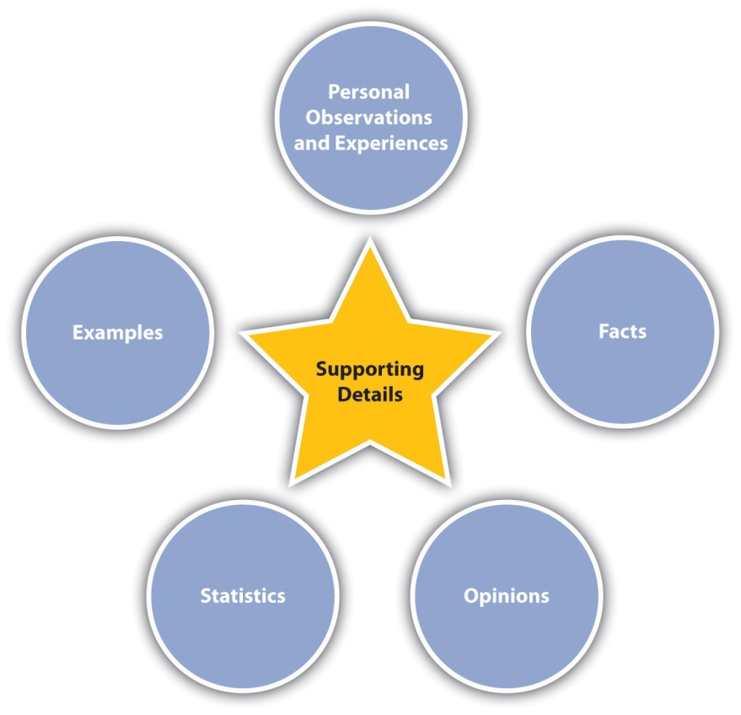

You can and should use a variety of kinds of support for your thesis. One of the easiest forms of support to use is personal observations and experiences. The strong point in favor of using personal anecdotes is that they add interest and emotion, both of which can pull audiences along. On the other hand, the anecdotal and subjective nature of personal observations and experiences makes them too weak to support a thesis on their own.

Since they can be verified, facts can help strengthen personal anecdotes by giving them substance and grounding. For example, if you tell a personal anecdote about having lost twenty pounds by using a Hula-Hoop for twenty minutes after every meal, the story seems interesting, but readers might not think it is a serious weight-loss technique. But if you follow up the story with some facts about the benefit of exercising for twenty minutes after every meal, the Hula-Hoop story takes on more credibility. Although facts are undeniably useful in writing projects, a paper full of nothing but fact upon fact would not be very interesting to read.

Like anecdotal information, your opinions can help make facts more interesting. On their own, opinions are weak support for a thesis. But coupled with specific relevant facts, opinions can add a great deal of interest to your work. In addition, opinions are excellent tools for convincing an audience that your thesis makes sense.

Similar to your opinions are details from expert testimony and personal interviews. Both of these kinds of sources provide no shortage of opinions. Expert opinions can carry a little more clout than your own, but you should be careful not to rely too much on them. However, it’s safe to say that finding quality opinions from others and presenting them in support of your ideas will make others more likely to agree with your ideas.

Statistics can provide excellent support for your thesis. Statistics are facts expressed in numbers. For example, say you relay the results of a study that showed that 90 percent of people who exercise for twenty minutes after every meal lose two pounds per week. Such statistics lend strong, credible support to a thesis.

Examples—real or made up—are powerful tools you can use to clarify and support your facts, opinions, and statistics. A detail that sounds insignificant or meaningless can become quite significant when clarified with an example. For example, you could cite your sister Lydia as an example of someone who lost thirty pounds in a month by exercising after every meal. Using a name and specifics makes it seem very personal and real. As long as you use examples ethically and logically, they can be tremendous assets. On the other hand, when using examples, take care not to intentionally mislead your readers or distort reality. For example, if your sister Lydia also gave birth to a baby during that month, leaving that key bit of information out of the example would be misleading.

Procedures for Using Supporting Details

You are likely to find or think of details that relate to your topic and are interesting, but that do not support your thesis. Including such details in your paper is unwise because they are distracting and irrelevant.
In today’s rich world of technology, you have many options when it comes to choosing sources of information. Make sure you choose only reliable sources. Even if some information sounds absolutely amazing, if it comes from an unreliable source, don’t use it. It might sound amazing for a reason—because it has been amazingly made up.

Figure 6.2

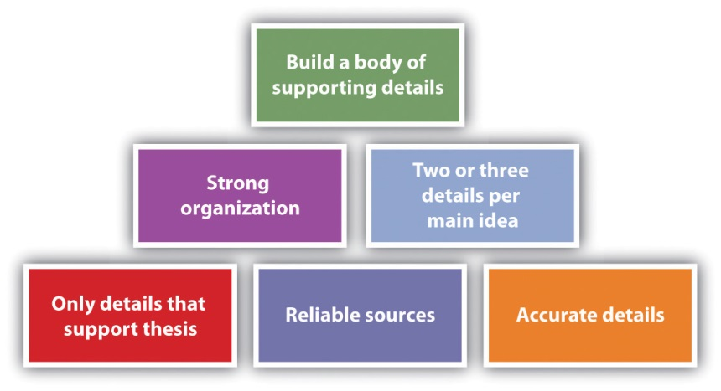

When you find a new detail, make sure you can find it in at least one more source so you can safely accept it as true. Take this step even when you think the source is reliable because even reliable sources can include errors. When you find new information, make sure to put it into your essay or file of notes right away. Never rely on your memory.

Take great care to organize your supporting details so that they can best support your thesis. One strategy is to list the most powerful information first. Another is to present information in a natural sequence, such as chronological order. A third option is to use a compare/contrast format. Choose whatever method you think will most clearly support your thesis.

Make sure to use at least two or three supporting details for each main idea. In a longer essay, you can easily include more than three supporting details per idea, but in a shorter essay, you might not have space for any more.

KEY TAKEAWAYS
- A thesis gives an essay a purpose, which is to present details that support the thesis.
- To create supporting details, you can use personal observations and experiences, facts, opinions, statistics, and examples.
- When choosing details for your essay, exclude any that do not support your thesis, make sure you use only reliable sources, double-check your facts for accuracy, organize your details to best support your thesis, and include at least two or three details to support each main idea.

EXERCISES
            - Choose a topic of interest to you. Write a personal observation or experience, a fact, an opinion, a statistic, and an example related to your topic. Present your information in a table with the following headings.

Topic:
Personal observation or experience
Fact
Opinion
Statistic
Example

            - Choose a topic of interest to you. On the Internet, find five reliable sources and five unreliable sources and fill in a table with the following headings.

Topic:
Reliable Sources | Why Considered Reliable | Unreliable Sources | Why Considered Unreliable

3. Choose a topic of interest to you and write a possible thesis related to the topic. Write one sentence that is both related to the topic and relevant to the thesis. Write one sentence that is related to the topic but not relevant to the thesis.

6.4 Learning from Your Writing
LEARNING OBJECTIVES
- Realize that it is normal for a writing project to come together differently than you initially planned.
- Know some unexpected situations that often happen during a writing project.
- Understand why and how to maintain a constant sense of critical inquiry as you write.

As you start writing, you are likely to discover that your ideas don’t always come together as you expected. The following list gives some examples of types of unexpected situations you might encounter:

- Some ideas you thought would expand into multiple paragraphs actually are not meaningful enough to receive that much space. You might have to do some additional brainstorming, research, or both to fill the unexpected extra space or adjust the scope of your topic by broadening it.

- Some ideas you thought would take only a paragraph or two turn out to take considerably more space. You might have to cut something out if you have a tight page limit or adjust the scope of your topic by narrowing it.

- As you write, you get additional ideas that change the direction you intended to take with some of your original ideas. Stop and rethink your direction and make adjustments so that your paper works well.

- Once you get started with your research, you might develop a different attitude about some of the facts you encounter. This change could alter your whole plan and thesis. Decide whether you want change your plan and thesis or incorporate the evolution of your thinking into the essay.

- You could discover that you need to do more research to clarify your ideas, support them, or both. This discovery is extremely common, so you might as well just plan on at least one round of additional, targeted, inquiry-based research after you start writing.

- You might find that you do not have the information you need to transition smoothly from one topic to the next. Take the time to flesh out and articulate the transitions between points and ideas that are probably already half-formed in your head.

- You might find that your writing doesn’t sound as professional as you would like it to sound. Slowly work through your paper replacing some of your more casual wordings with more formal wordings. Conversely, you might find that you need to adjust your tone to a less formal register to meet the needs of your chosen audience and purpose.

- As you are writing, you might realize that you have not included enough of your thoughts and opinions to make the work your own. Add some of your thoughts throughout the work.

- You might realize your writing sounds like a lot of different topics lined up and strung together haphazardly. If this happens, consider if you failed to slow your thinking down enough. Perhaps your topic is still too broad.

- You could realize that the topic on which you are currently focused should have been aligned with a previous idea. If this happens, stop and move things around. Continually pay attention to the organization so that, in the end, your paper flows well.

If you pay attention to your thoughts while you write, you are likely to find that your thoughts can lead to more good ideas. In other words, maintain constant critical inquiry about your content, your formatting, and your relationship to your main topic.

Some people tend to “write in the moment” without paying close attention to what they wrote a page ago or what they intend to write on the next page. If you are a person who tends to wander in this way, you should periodically stop and step back to consider how your writing direction is going.

As you write, make notes of all the points that come to your mind as they come so you don’t lose any of them before you can fully incorporate them into your writing or decide if you want to incorporate them.

KEY TAKEAWAYS
- Your writing projects will almost never come together exactly as you planned since many unexpected situations can occur, and at least some of them will have an impact on your writing direction.
- Some unexpected situations include ideas taking more or less space than you intended, ideas coming together differently than you planned, a change in your idea about what you want to include, missing transitions, writing that is too casual or formal, and ideas you decide should be in a different order.
- You will generate your best work if, instead of being an overly mechanical and rigid writer and thinker, you maintain constant critical inquiry while you write.

EXERCISES
- Choose a passage from a text you are reading for this course or another course, from an advertisement, or from a political speech. On a scale of zero to one hundred, determine the relative level of informality (zero) or formality (one hundred) in the text’s tone (defined in Chapter 4 "Joining the Conversation"). Next, rewrite the text to adjust the tone at least fifty points in one direction or the other.
- Choose a passage from a text you are reading for this course or another course, from an advertisement, or from a political speech. On a scale of zero to one hundred, determine the text’s attitude toward its subject matter (defined in Chapter 4 "Joining the Conversation"), with negative being zero, positive being one hundred, and neutral being fifty. Next, rewrite the text to adjust the attitude at least fifty points in one direction or the other, at the very least from negative to neutral, or from neutral to positive, and so on.
- Working with a partner, create a humorous presentation showing the traits of an overly mechanical and rigid thinker and writer.

6.5 Learning from Your Reading
LEARNING OBJECTIVES
- Understand what it means to read carefully and critically.
- Know how to read with an open mind.
- Recognize that, for a writing project, you should use careful, critical, and open-minded reading both with research material and with your writing.

It would probably not surprise you if your professor told you to read your research sources carefully and critically and with an open mind. It simply sounds like a logical, good idea. But how do you know if and when you are reading carefully and critically? Do you really know how to read with an open mind?

These are important questions to consider even when you can easily find what appears to be objective, unbiased, unfiltered information about your topic. Let’s return to the idea (from Chapter 1 "Writing to Think and Writing to Learn", Chapter 2 "Becoming a Critical Reader", Chapter 3 "Thinking through the Disciplines", and Chapter 4 "Joining the Conversation") about reading closely and carefully. Some sources for a writing assignment can be less than thrilling, so your mind might wander a bit or you might speed-read without really focusing. Reading without your full attention or speeding through the text without taking it in not only is a waste of your time but also can lead to critical errors. To use your time wisely, you should try some techniques for getting the most out of your reading. Anything that gets you physically involved, mentally involved, or both will probably help, such as the following ideas:

- Use sticky notes to mark points to which you want to return.
- Take notes.
- Ask questions while you read and then look for the answers.
- Copy and paste or type the parts that are relevant to your topic into a document saved as “Source Material for Essay.”

Once you are reading carefully, you are in the proper position to also read critically. To read critically does not mean to judge severely. Rather, it means to determine what the author’s intent or assumptions are, if the author’s points are adequate to support the intent or assumptions, and if the conclusions work. You have to decide what sense the text makes and whether the information in it will help support the points you are trying to make (or perhaps complicate them or even contradict them).

One key roadblock that can get in the way of reading critically is letting personal ideas and opinions cloud your judgment. To avoid this possible problem, you need to do your best to read your possible sources with an open mind. Don’t slam a door before you really know what’s behind it.

Along with reading other sources carefully, critically, and with an open mind, you should also apply these techniques to your work. By reading your work carefully as you are writing, you will see things you want to change. By reading your work critically and with an open mind, you can get a sense for the parts that are working well and those that aren’t.

KEY TAKEAWAYS
- To read carefully means to take your time and focus. To read critically means to make judgments about what you are reading and decide if the assumptions, support, and conclusions work.
- Reading with an open mind means putting your personal ideas and opinions aside so you can consider other ideas and opinions.
- You should apply the techniques of careful reading, critical reading, and reading with an open mind to both your research sources and your writing.

EXERCISE
- Choose a text you are reading for this course or for another course. Make sure the text includes some opinions that you do not hold, that are new or unfamiliar to you, or both. Print or copy the text so you can mark it up if needed to answer the following questions:

  - Choose one of the careful reading techniques in this section or in Chapter 2 "Becoming a Critical Reader". Use the technique to read your selection. Then discuss with your classmates whether you found the careful reading technique you used to be helpful.
  - Read the selection critically and write a paragraph sharing your critical judgment of the selection. Include your opinions about the article’s assumptions, support, and conclusions.
  - Create a three-column table with the following headings. For each idea in the first column, record your opinion and the opinion presented in the article.

New or unfamiliar ideas or ideas with which you disagree | Your opinions | Opinions presented in the article

6.6 Generating Further Questions
LEARNING OBJECTIVES
- Recognize that a writing plan is fluid, not set in stone.
- Understand that you can improve your writing plan by continually asking questions.
- Know the types of questions you can ask to improve your writing plan.

Even after you have your core plan in place and start to do some initial research, you should still be very flexible with your plan and let your research and critical thinking guide you. You can help solidify your plan by continually and repeatedly asking questions at all stages of the writing process. Some possible questions follow:

- Am I following the assignment guidelines?
- Do these details actually support these ideas?
- Am I truly representing my intended position?
- What aspects of this topic have I not covered that would add positively to my paper?
- Is my core topic a solid choice?
- What organizational structure would best present my ideas?
- Is a first-person, second-person, or third-person essay the most powerful form to use for this topic?
- What can I do to make my ideas matter to my audience?
- Exactly what is my purpose in pursuing this topic?
- Do my key points directly address my purpose?

Every time you make some adjustments to your topic, audience, purpose, or form, ask these same questions again until you stop adjusting and stop getting different answers to the questions.

KEY TAKEAWAYS
- A writing plan is the first step in shaping a writing project. The next step is to adjust and shape the plan to make the best possible end product.
- A core method of adjusting a writing plan is to systematically ask and answer questions about the plan until you stop getting different answers.
- When asking questions to adjust a writing plan, ask about all aspects of the writing project, including questions about the topic, audience, purpose, form, and assignment guidelines.

EXERCISES
            - Discuss how you would write a descriptive, informative essay for the following audiences on a subject in which you have a passionate interest:

- People who share your passion for and knowledge about the subject
  - People who have a passing knowledge and limited interest in the subject
  - People who know absolutely nothing about the subject and who might even be a little hostile toward it

2. Discuss how would you approach writing a descriptive, informative essay on the following subjects for the third audience listed in question 1 (people who know absolutely nothing about the subject and who might even be a little hostile toward it):

  - A violent video game
  - A controversial celebrity or politician
  - A reality television show

3. Let’s say you have a specific topic and audience in mind, category (a) from questions 1 and 2: people who share your passion for and knowledge about violent video games. Discuss how your plan for an essay would change based on the following purposes:

  - a) To persuade an audience that your favorite game is the best in its class
  - b) To inform an audience about some of the cutting-edge methods for reaching new levels in the game
  - c) To compare and contrast the features of the newest version of the game with previous versions
  - To analyze why the game is so appealing to certain demographic profiles of the population

6.7 Using a Variety of Sentence Formats
LEARNING OBJECTIVES
- Recognize the need for varied sentence formats.
- Know how to use variety to start sentences.
- Understand how to vary sentences by making changes within the sentences.

Varied sentences help create more interesting prose. Two key methods of varying your sentences are to use different starting techniques and to change the sentences from within. These two choices have some overlap, but for clarity, we’ll discuss them as separate options here.

Avoiding “The…The…The”

You have all read “The…The…The” and “There…There…There” and “I…I…I” texts. When almost every sentence of a text begins exactly alike, it develops a boring and monotonous rhythm. As a rule, within a given paragraph, you should try to avoid starting more than two sentences with the same word.

The need for varied sentence formats is a little less obvious but along the same lines. Even if you are starting all your sentences with different words, you could still fall into the trap of having every sentence use the same format, thus creating a similarly monotonous rhythm. Typical examples are sentences that all follow the simple subject format of subject–verb–object. Consider the sing-songy rhythm in this example:

Rover had a bone. Princess wanted it. He snarled at Princess. She snarled at Rover. Princess looked to her left. Rover followed her eyes. Princess snatched the bone. Rover started barking.

In the (rather extreme) example, no more than two sentences within the paragraph begin with the same word, but the sentence is still too rhythmic due to the similar format of each simple sentence.

One technique that will help you avoid using the same format is to make a conscious effort to vary your sentence constructions. Consider how the following formats provide interesting variation.

Sentence Constructions | Examples
Opening adverb | Slyly, Princess snatched the bone while Rover was looking away.
Conjunctive adverb | Rover thought he was guarding his bone; however, Princess was setting up her moment.
Coordinating conjunction | Rover had the bone, but Princess was determined to get it.
Dependent clause | While Rover was looking away, Princess snatched the bone.
Introductory phrase | Feeling jealous, Princess made a plan to get the bone.

Varying from the Inside

Along with changing the beginnings of sentences, you can add variety by combining sentences, adding words, expanding descriptions or ideas, and creating and moving clauses. Using all these techniques throughout a paper will create a nice mix of sentence formats.

Combining Sentences

Choosing exactly the right mix of sentence lengths can be challenging. If you use too many short sentences, your writing will be viewed as simplistic. If you use too many long sentences, your writing will be considered convoluted. Even if you use all medium-length sentences, your writing might be dubbed as monotonous. The trick is to use a variety of sentence lengths. If you find you have too many short, choppy sentences, you can combine some of them to add a little variety.

Two short, choppy sentences | Combined sentence
He snarled at Princess. She snarled at Rover. | Rover snarled at Princess, but she proved to be the alpha dog by snarling right back at him.

Adding Words

You can add variety and interest to your sentences by adding words to expand the sentences. This suggestion in no way means to add meaningless words to a sentence just to enlarge and change the sentence. Only add words when they add value to your work.

A short sentence | Value-adding words added to a short sentence
Rover had a bone. | Rover was gnawing on a bone in the corner of the yard under the cherry tree.

Expanding Descriptions or Ideas

This tactic is more specific than the “add words” tactic, but it can be coupled with it.

An existing sentence | Expanded descriptions and ideas
Rover was gnawing on a bone in the corner of the yard under the tree. | My Lab, Rover, was gnawing on a rawhide bone in the corner of the yard under the cherry tree.

Creating and Moving Clauses

Adding new clauses or moving existing clauses is another way to add interest and variety.

Sentence with a clause | Sentence with the clause moved
Rover was a large Labrador, and Princess was a small poodle who got the best of him. | Although Princess was a small poodle, she got the best of Rover, a large Labrador.

KEY TAKEAWAYS
- You should use a variety of sentence formats to create interesting text.
- Within a paragraph, plan to start no more than two sentences with the same word. Also, use more than one sentence format so you can avoid repetitive, monotonous text.
- Additional techniques you can use to vary sentences that do not necessarily relate to how you start the sentences include combining short sentences, adding words, expanding descriptions or ideas, and creating and moving clauses.

EXERCISES
- Rewrite the following paragraph using some of the sentence variation ideas in this section. After you are finished rewriting, identify the types of changes you made:

My family went on vacation. It was the summer after my first year of college. It was odd not to be in charge of my own actions. My parents were nice but always in charge. My brother and sister were fine with it. It wasn’t OK with me, though. It wasn’t OK with me to have to go to bed at 10:00 p.m. My idea would have been to go to town then. My parents said it was bedtime since we had to get up early to go hiking. It wasn’t my idea to go walking early! My next vacation might be with friends. It will be nice to go with my family again as long as it isn’t too soon.

- Rewrite this sentence so that it begins with an adverb:

My roommate found my cell phone.

- Rewrite this sentence so that it begins with an introductory phrase:

It is a long, interesting drive.

- Try writing a paragraph with the following sentence constructions: opening adverb, conjunctive adverb, coordinating conjunction, dependent clause, and introductory phrase.

6.8 Creating Paragraphs
LEARNING OBJECTIVES
- Recognize the overall key ideas involved in a good paragraph.
- Know how to use specialized paragraphs.
- Understand common organizational patterns for paragraphs and means of maintaining the internal integrity of paragraphs.

Each paragraph in a piece of writing has to function well independently so that the work as a whole comes together. This section presents a variety of ideas you should think about and methods you should consider using when writing paragraphs.

Starting with an Introduction or a Transition

Each paragraph needs to start with an introduction, a transition, or a combination of the two. The first sentence of a paragraph always has to help a reader move smoothly from the last paragraph. Sometimes two paragraphs are close enough in content that a transition can be implied without actually using transition words. Other times, specific transitions are needed. When no transition is used, an introductory sentence is needed so the reader knows what is going on. If a transition sentence is used, it is logical to follow it with an introductory sentence or to have one joint sentence.

Here are some examples:

- A transition sentence: Canned goods are not the only delicious foods available at a farmers’ market.
- An introductory sentence: Farmers’ markets feature a wide variety of fresh produce.
- A transition/introductory combination sentence: Along with canned goods, farmers’ markets also feature whatever produce is fresh that week.

Sticking to One Main Idea

By definition, all sentences in the paragraph should relate to one main idea. If another main idea comes up as you are drafting a paragraph, it is most likely time to start a new paragraph. If in revising a draft you notice that a paragraph has wandered into another main idea, you should consider splitting it into two paragraphs. The main idea should be clear and obvious to readers and is typically presented within the topic sentence. The topic sentence is, in essence, a one-sentence summary of the point of the paragraph. The topic sentence is often the first sentence in a paragraph, but it does not have to be located there.

Building around a Topic Sentence

While the main idea is presented within the topic sentence, the rest of the sentences in the paragraph support it. The other sentences should present details that clarify and support the topic sentence. Together, all the sentences within the paragraph should flow smoothly so that readers can easily grasp its meaning.

When you choose sentences and ideas to support the topic sentence, keep in mind that paragraphs should not be overly long or overly short. A half page of double-spaced text is a nice average length for a paragraph. At a minimum, unless you are aiming for a dramatic effect, a paragraph should include at least three sentences. Although there is really no maximum size for a paragraph, keep in mind that lengthy paragraphs create confusion and reading difficulty. For this reason, try to keep all paragraphs to no more than one double-spaced page (or approximately 250 words).

Structuring Specialized Paragraphs

Many of the same common patterns of organizing your writing and thinking are available at the paragraph level to help you make your case to support your thesis. Using these common patterns helps readers understand your points more easily.

Pattern | Explanation | Example
Analogy | Analogies are used to draw comparisons between seemingly unlike people, items, places, or situations. Writers use analogies to help clarify a point. | Walking down an aisle at a farmers’ market is like walking down the rows in a garden. Fresh mustard greens might be on one side and fresh radishes on another. The smell of green beans meshes with the smell of strawberries and the vibrant colors of nature are everywhere. You might find that you even have a little garden dirt on your shoes.
Cause and effect | Cause-and-effect paragraphs point out how one thing is caused by another and are used to clarify relationships. | You will find that your meals benefit greatly from shopping at the farmers’ market. You will eat fewer unnatural foods, so you will feel better and have more energy. The freshness of the foods will make your dishes taste and look better. The excitement of finding something new at the market will translate to eagerness to try it out within a meal. It won’t be long until you anticipate going to the farmers’ market as a way to enhance the quality of your meals.
Comparison and contrast | Comparison and contrast is simply telling how two things are alike or different. You can choose to compare and contrast by selecting a trait, explaining how each thing relates, and then moving on to another trait (alternating organization, as here). Or for more complex comparisons and contrasts, you can describe all the features of one thing in one or more paragraphs and then all the features of the other thing in one or more paragraphs (block organization). | Tomatoes purchased at the farmers’ market are almost totally different from tomatoes purchased in a grocery store. To begin with, although tomatoes from both sources will mostly be red, the tomatoes at the farmers’ market are a brighter red than those at a grocery store. That doesn’t mean they are shinier—in fact, grocery store tomatoes are often shinier since they have been waxed. You are likely to see great size variation in tomatoes at the farmers’ market, with tomatoes ranging from only a couple of inches across to eight inches across. By contrast, the tomatoes in a grocery store will be fairly uniform in size. All the visual differences are interesting, but the most important difference is the taste. The farmers’ market tomatoes will be bursting with flavor from ripening on the vine in their own time. The grocery store tomatoes are often close to flavorless. Unless you have no choice, you really should check out a farmers’ market the next time you’re shopping for fresh produce.
Definition | Definition paragraphs are used to clarify key word or concepts. | If you see a “pluot” at the farmers’ market, give it a try. It might seem odd to see a fruit you have never heard of before, but pluots are relatively new in the fruit world. A pluot is a hybrid fruit created from joining an apricot and a plum. Pluots range in size from that of a small apricot to that of a large plum. The outer skin varies in color from sort of cloudy golden to cloudy purplish. Overall, a pluot looks and tastes more like a plum than an apricot, although the skins are less tart than those of typical plums.
Description | You can use description to bring something to life so that the readers can get a clear impression of it. | The farmers who sell their wares at the farmers’ market near my house are as natural as their foods. They are all dressed casually so that they look more like they are hanging out with friends than trying to entice people to purchase something from them. The women aren’t wearing makeup and the men have not necessarily shaved in a few days. They are eager to share information and samples without applying any sales pressure. They are people with whom you would likely enjoy sitting around a campfire and trading stories.
Examples | Examples are commonly used to clarify a point for readers. | You will find some foods at the farmers’ market that you might not typically eat. For example, some farmers bring pickled pigs’ feet or mustard greens that taste like wasabi. Some vendors sell gooseberry pies and cactus jelly. It is not uncommon to see kumquat jam and garlic spears. The farmers’ market is truly an adventuresome way to shop for food.
Narration | Narration is writing that sounds like a story. You might use narration within a nonfiction paper as a means of personalizing a topic or simply making a point stand out. | Sauntering through the farmers’ market on a cool fall day, I happened upon a small lizard. Actually, my foot nearly happened upon him, but I stopped just in time to pull back and spare him. As I stooped to look at him, he scampered up over the top of a watermelon and out of sight. Glancing behind the melon, I saw that the lizard had a friend. I watched them bopping their heads at each other and couldn’t help but wonder if they were communicating. Perhaps the one was telling the other about the big brown thing that nearly crashed down upon him. For him, I expect it was a harrowing moment. For me, it was just another charming trip to the farmers’ market.
Problem–solution | A problem–solution paragraph begins with a topic sentence that presents a problem and then follows with details that present a solution for the problem. | Our farmers’ market is in danger of closing because a building is going to be constructed in the empty lot where it has been held for the past ten years. Since the market is such an asset to our community, a committee formed to look for a new location. The first idea was to close a street off for a few hours each Saturday morning. Unfortunately, the city manager nixed that idea since he believed that too many people would complain. Barry Moore suggested that the market could be held in the state park that is just a few miles out of town. Again, a government worker struck down the idea. This time, the problem was that for-profit events are not allowed in state parks. Finally, I came up with the perfect idea, and our government blessed the idea. Since the high school is closed on Saturday, we will be having the market in the school parking lot.

Using a Clear Organizational Pattern

Depending on your writing topic, you might find it beneficial to use one of these common organizational patterns.

Pattern | Explanation | Example
Process analysis | A process analysis paragraph is used to describe how something is made or to explain the steps for how something is done. | The first key to growing good tomatoes is to give the seedlings plenty of room. Make sure to transplant them to small pots once they get their first leaves. Even when they are just starting out in pots, they need plenty of light, air, and heat. Make sure to warm up the ground in advance by covering it in plastic sheeting for a couple of weeks. When you are ready to plant them in soil, plant them deeply enough so they can put down some strong roots. Mulch next, and once the stems of the tomato plants have reached a few inches in height, cut off the lower leaves to avoid fungi. Carefully prune the suckers that develop in the joints of the developing stems.
Chronological | Chronological arrangement presents information in time order. | As soon as I arrived at the farmers’ market, I bought a large bag of lettuce. I walked around the corner and saw the biggest, most gorgeous sunflower I had ever seen. So I bought it and added it to my lettuce bag. The flower was so big that I had to hold the bag right in front of me to keep it from being bumped. At the Wilson Pork Farm booth, I tasted a little pulled pork. You guessed it—I had to buy a quart of it. I went on with a plastic quart container in my left hand and my lettuce and flower in my right hand. I was handling it all just fine until I saw a huge hanging spider plant I had to have. Ever so gently, I placed my pulled pork container inside the spider fern plant pot. Now I was holding everything right in front of me as I tried to safely make my way through the crowd. That’s when I met up with little Willie. Willie was about seven years old and he was playing tag with his brother. I’m not sure where their mother was, but Willie came running around the corner and smacked right into me. You are probably thinking that poor Willie had pulled pork all over his clothes and an upside-down plant on his head. But no, not at all. That was me. Willie didn’t even notice. He was too busy chasing his brother.
General-to-specific | A common paragraph format is to present a general idea and then give examples. | The displays at the farmers’ market do not lack for variety. You will see every almost every kind of fresh, locally grown food you can imagine. The featured fruits on a given day might be as varied as pomegranates, persimmons, guava, jackfruit, and citron. Vegetables might include shiitake mushrooms, artichokes, avocados, and garlic. Some vendors also sell crafts, preserves, seeds, and other supplies suitable for starting your own garden.
Specific-to-general | The reverse of the above format is to give some examples and then summarize them with a general idea. | Your sense of smell is awakened by eighteen varieties of fresh roma tomatoes. Your mouth waters at the prospect of sampling the fresh breads. Your eye catches a glimpse of the colors of handmade, embroidered bags. You linger to touch a perfectly ripe peach. Your ears catch the strain of an impromptu jug band. A walk up and down the aisles of your local farmers’ market will engage all of your senses.
Spatial | A paragraph using spatial organization presents details as you would naturally encounter them, such as from top to bottom or from the inside to the outside. In other words, details are presented based on their physical location. | From top to bottom, the spice booth at our farmers’ market is amazing. Up high they display artwork painstakingly made with spices. At eye level, you see at least ten different fresh spices in small baggies. On the tabletop is located an assortment of tasting bowls with choices ranging from desserts to drinks to salads. Below the table, but out of the way of customers, are large bags of the different spices. Besides being a great use of space, the spice booth looks both professional and charming.

Maintaining Internal Integrity of Paragraphs

A paragraph is more than just a group of sentences thrown together. You need to make linkages between your ideas, use parallelism, and maintain consistency.

Pattern | Explanation | Example
Linkages | Paragraphs with linkages flow well so that readers can follow along easily. You need to present an idea and then link the rest of the ideas in the paragraph together. Do not leave any pulling together for your readers to do mentally. Do it all for them. | Not all the booths at a farmers’ market feature food. One couple has a booth that sells only fresh flowers. They display some flowers in antique containers and sell the flowers, the containers, or both. A clothesline above our heads displays a variety of dried flowers. A table holds about fifty vases of varying sizes, and they are all full of flowers. Some vases hold only one kind of long-stem flowers. Others hold mixtures of uncut flowers. Still others showcase gorgeous arrangements. Both the man and the woman wear a wreath of flowers on their heads. The whole display is so attractive and smells so fabulous that it really draws people in.
Parallelism | Parallelism means that you maintain the same general wording and format for similar situations throughout the paragraph so that once readers figure out what is going on, they can easily understand the whole paragraph. | The history of this farmers’ market followed a fairly typical pattern. It started out in the 1970s as a co-op of local farmers, featuring a small city block of modest tables and temporary displays every Saturday morning from April to October from 9 a.m. to 1 p.m. In the early 1990s, with the help of a grant from the city, the market expanded its footprint to a larger, more centrally located city block with ample parking. It benefited greatly from the installation of permanent booths, electrical outlets, and a ready water supply. These amenities drew far more customers and merchants. Its popularity reached unprecedented levels by 2000, when the city offered to help with the staffing needed to keep it open from 9 a.m. to 5 p.m. on Saturdays and from noon to 5 p.m. on Sundays. Recently, discussions began about how to open the market on weeknights in the summer from 5 p.m. to 8 p.m.
Consistency | A paragraph with consistency uses the same point of view and the same verb tense throughout. In other words, if you are using third person in the beginning of the paragraph, you use it throughout the paragraph. If you are using present tense to start the paragraph, you stick with it. | There comes a time each year when you must begin the all-important step of actually harvesting your vegetable garden. You will want to pick some of your vegetables before they are fully ripe. Eggplants, cucumbers, and squash fall into this category because they can further ripen once you have picked them. On the other hand, you will find that tomatoes, pumpkins, and most melons really need to ripen fully before you harvest them. You should also keep in mind that you will need plenty of storage space for your bounty. And if you have a good harvest, you might want to have a few friends in mind, especially as recipients for your squash and cucumbers.

Using Transitions

Transitions within paragraphs are words that connect one sentence to another so that readers can easily follow the intended meanings of sentences and relationships between sentences. The following table shows some commonly used transition words:

Commonly Used Transition Words
To compare/contrast | after that, again, also, although, and then, but, despite, even though, finally, first/second/third/etc., however, in contrast, in the same way, likewise, nevertheless, next, on the other hand, similarly, then
To signal cause and effect | as a result, because, consequently, due to, hence, since, therefore, thus
To show sequence or time | after, as soon as, at that time, before, during, earlier, finally, immediately, in the meantime, later, meanwhile, now, presently, simultaneously, so far, soon, until, then, thereafter, when, while
To indicate place or direction | above, adjacent to, below, beside, beyond, close, nearby, next to, north/south/east/west, opposite, to the left/right
To present examples | for example, for instance, in fact, to illustrate, specifically
To suggest relationships | and, also, besides, further, furthermore, in addition, moreover, too

Closing the Paragraph

Each paragraph needs a final sentence that lets the reader know that the idea is finished and it is time to move onto a new paragraph and a new idea. A common way to close a paragraph is to reiterate the purpose of the paragraph in a way that shows the purpose has been met.

KEY TAKEAWAYS
- A good paragraph should cover one main idea, be built around a topic sentence, follow a clear organizational pattern, have internal integrity, and include a final closing sentence.
- Specialized paragraphs are common writing patterns that you can use to help support your thesis. Some common examples include analogy, cause and effect, comparison/contrast, definition, description, examples, narration, opening and closing, problem and solution, and process explanation.
- Common organizational patterns include chronological, general-to-specific, specific-to-general, and spatial. Some methods of maintaining paragraph integrity include linking ideas, using parallel structure, being consistent, and transitioning.

EXERCISES
- Use cause and effect to write a paragraph about high humidity and rust.
- Choose a word with which you are unfamiliar and write a definition paragraph so that others will understand the meaning of the word. Make sure to choose a word about which you are able to write a whole paragraph.
- Choose a problem that is often discussed at election time and write a problem-and-solution paragraph presenting your ideas about the solution. Make sure to use facts to support any opinions you present.
- Draw from one of the readings from this course or from another course you are taking. Find at least five different kinds of paragraphs, using the labels provided and described in this section.

Chapter 7
Researching
Your Research Process
When you are given an assignment that requires you to conduct research, you should make an overall plan, choose search terms wisely, manage and evaluate the information you find, and make ethical choices regarding its use.

7.1 Organizing Research Plans
LEARNING OBJECTIVES
- Know how to begin a research project by examining the assignment closely and considering the genre(s) you will use.
- Understand how to make decisions about how and where you will research, what genre(s) you will use for writing, and how you will track your sources.
- Know how to create a schedule and understand how to start and use a research log.

In Chapter 5 "Planning" and Chapter 6 "Drafting", you learned about choosing and narrowing a topic to arrive at a thesis, and you learned that once you have a thesis, you can plot how you will accomplish your rhetorical purposes and writing goals. But sometimes just coming up with a thesis requires research—and it should. Opinions are cheap; theses are not. Remember how important it is to be flexible; plans can change, and you need to be prepared for unexpected twists and turns during the research process. Making decisions about the issues in this chapter will give you a solid beginning toward conducting research that is meaningful to you and to your readers.

Revisiting Your Assignment

As you prepare to start researching, you should review your assignment to make sure it is clear in your mind so you can follow it closely. Some assignments dictate every aspect of a paper, while others allow some flexibility. Make sure you understand the requirements and verify that your interpretations of optional components are acceptable

Figure 7.1

Choosing Your Genre(s)

Clarify whether your assignment is asking you to inform, to interpret, to solve a problem, or to persuade or some combination of these four genres. This table lists key imperative verbs that match up to each kind of assignment genre.
Key Words Suggesting an Informative Essay | Key Words Suggesting an Interpretive Essay | Key Words Suggesting a Persuasive Essay | Key Words Suggesting a Problem-Solving Essay
Explain  Define  Describe  Review | - Classify  - Analyze  - Compare  - Examine  - Explain | - Interpret  - Defend  - Determine  - Justify  - Refute | - Take a position  - Alleviate  - Assess  - Ease  - Propose  - Solve

If the assignment does not give you a clear idea of genre through the imperative verbs it uses, ask your instructor for some guidance. This being college, it’s possible that genre, like some other matters, is being left up to you. In such a scenario, the genre(s) you adopt will depend on what you decide about your purposes for writing. The truth is, genres blend into each other in real writing for real audiences. For example, how can you “take a position” about a social issue like teen pregnancy without doing some reporting and offering some solutions? How can you offer solutions to problems like climate change without first reporting on the severity of the problem, arguing for the urgency of the need for solutions, arguing that your solution is the best of several proposals, and finally arguing for your solution’s feasibility and cost effectiveness?

Take the case of Jacoba, who is given the following inquiry-based research assignment, a genre of academic writing that is becoming increasingly common at the college level:

In an essay of at least twenty-five hundred words, I want you to explore a topic that means something to you but about which you do not yet have a clear opinion. Unlike other “research papers” you may have been asked to write in the past, you should not have a clear sense of your position or stance about your topic at the outset. Your research should be designed to develop your thinking about your topic, not to confirm an already held opinion, nor to find “straw men” who disagree with you and whose ideas you can knock down with ease.

Make no mistake, by the end of this process, if you have chosen a topic about which you’re really curious and if you research with an open mind, you will have plenty to say. The final product may be submitted in any number of forms (possibilities include an interpretive report, a problem-solving proposal, a manifesto-like position statement) but it must be grounded in source work and it must demonstrate your ability to incorporate other voices into your work and to document them appropriately (using MLA standards). And like any other writing we have done in this course so far, you are responsible for determining the audiences you want to reach and the purposes you want to achieve.

In this assignment, Jacoba and her classmates are intentionally given very little direct guidance and very few explicit instructions from their instructor about how to proceed. After some class discussion and some initial brainstorming on her own, she decides he wants to research and write about the crisis in solvency in Social Security. Prior to researching, she isn’t exactly sure how she feels about the issue, much less about an appropriate audience or purpose. She just knows she’s worried about her own aging parents and feels they deserve what’s coming to them. At the same time, she’s rankled that, in her early twenties, she has no expectation of ever seeing any of the money that’s been coming out of her paycheck every two weeks. The combination of uncertainty and interest she feels about the topic actually makes it ideal for this kind of inquiry-based research project.

Using the tips in Chapter 4 "Joining the Conversation", Jacoba puts together two preliminary statements of purpose intentionally at odds with each other.

Table 7.1 Statement of Purpose I
Voice | I am writing as a daughter and young adult.
Message | I want to convey the message that we need to come up with realistic solutions for how Social Security needs to be fixed.
Audience | I want to write to people my parents’ age: 55 years old and up.
Attitude | My attitude toward the subject is positive toward Social Security and what it has meant to this country since the Great Depression.
Reception | I want my audience to have the tools they need to mobilize support for saving Social Security, for themselves, and for my generation.
Tone | My tone toward my readers will be concerned but determined to find solutions.

Table 7.2 Statement of Purpose II
Voice | I am writing as a concerned and informed citizen and voter.
Message | I want to convey the message that we need to come to terms with the fact that Social Security has outlived its usefulness and must be gradually phased out.
Audience | I want to write to members of Congress eager to reduce the size of government.
Attitude | My attitude toward the subject is negative toward the strain Social Security is placing on our budget deficit.
Reception | I want my audience to have the tools they need to persuade their colleagues in Congress to develop the political will to phase out Social Security.
Tone | My tone toward my readers will be respectful but assertive and persuasive.

Jacoba knows that these are just two of the possible purposeful paths she may take over the course of her research process. A change to any of the six elements of her chart will mean writing up another statement of purpose. Using a research log, she will periodically reflect on how each of the elements of her preliminary statements of purpose are affected by each new source she encounters.

Deciding How and Where You Will Research

Although you might think that you can accomplish all of your research online from the comfort of your home, you should at least begin by visiting your school library. Talk to a research librarian about your planned paper and get his or her advice. You will likely learn about some in-library sources that would be helpful. But you will also probably discover some online sources and procedures that will be very beneficial. Another technique you can use for learning about research options is to talk to fellow students who have recently completed research projects. As always, you might be surprised what you can learn by such networking. Primary sources, such as in-person interviews and observations, can add an interesting dimension to a researched essay. Determine if your essay could benefit from such sources.

Selecting a Writing Venue

Your writing venue might be predetermined for you. For example, you might be required to turn in a Microsoft Word file or you might be required to work on an online class site. Before you start, make sure you know how you will be presenting your final essay and if and how you are to present drafts along the way. Having to reroute your work along the way unnecessarily wastes time.

Setting Up a Method of Documenting Sources

You will need to document your sources as you research since you clearly do not want to have to revisit any of your sources to retrieve documentation information. Although you can use the traditional method of creating numbered source cards to which you tie all notes you take, it makes much more sense to create digital note cards. Most college library databases include options for keeping a record of your sources. Using these tools can save you time and make the research process easier. Such sites also allow you to take notes and tie each note to one of the citations. Make sure to explore the services that are available to you. If you haven’t seen a college library database in some time, you will be pleasantly surprised at all the time-saving features they provide.

You can also create your version of digital note cards simply by making a file with numbered citations and coding your notes to the citations. If you choose, you can go online and find a citation builder for assistance. Once you put a source’s information into the builder, you can copy and paste the citation into your citation file and into the citation list at the end of your paper. Your college library’s databases include tools that will help you build citations in American Psychological Association (APA), Modern Language Association (MLA), or other styles. Similar tools are also available with no college or university affiliation, but these tend to have ad content and can sometimes be less reliable. Another, less commercial option is an
Online writing lab (OWL). OWLs are college-level writing instruction sites managed by university writing programs and usually open to public use. The most famous and, according to many, still the best, is managed by the Purdue Writing Program: http://owl.english.purdue.edu. Bookmark this site on your computer for the rest of your college career. You won’t regret it.

Determining Your Timeline

Begin with the amount of time you have to complete your project. Create a research and writing schedule that can realistically fit into your life and allow you to generate a quality product. Then stick with your plan. As with many time consuming tasks, if you fall off your schedule, you are likely to find yourself having to work long hours or having to make concessions in order to finish in time. Since such actions will probably result in an end product of lesser quality, making and keeping a schedule is an excellent idea.

As a rule, when you make a schedule, it is best to plan to spend a little time each day as opposed to long blocks of time on a few days. Although, on a long project, you might find it beneficial to have some lengthy days, as a rule, long hours on a single project do not fit into one’s daily life very well.

As you schedule your time, plan for at least one spare day before the project is due as sort of an insurance policy. In other words, don’t set your schedule to include working through the last available minute. A spare day or two gives you some flexibility in case the process doesn’t flow along perfectly according to your plan.

If you plan to have others proofread your work, respectfully consider their schedules. You can’t make a plan that requires others to drop what they are doing to read your draft on your schedule.

Starting a Research Log to Track Your Ideas

A research log is a great tool for keeping track of ideas that come to you while you are working. For example, you might think of another direction you want to pursue or find another source you want to follow up on. Since it is so easy to forget a fleeting but useful thought, keeping an ongoing log can be very helpful. The style or format of such a log will vary according to your personality. If you’re the type of person who likes to have a strict timeline, the log could be a chronologically arranged to-do list or even a series of alarms and reminders programmed into your cell phone. If, on the other hand, you’re a bit more conceptual or abstract in your thinking, keeping an up-to-date statement of purpose chart might be the way to go.

KEY TAKEAWAYS
- When preparing to start a research paper, revisit your assignment to make sure you understand and remember all the guidelines. Then choose the writing genre that best fits the assignment guidelines and your statement of purpose. In some cases, you may elect to use a mix of writing to inform, to interpret, to persuade, and to solve a problem.
- As a rule, you should begin your research with a meeting with a college librarian to make sure you are aware of your research options. Also, as you begin a research project, you have to decide whether you will use a simple word processing document or a more complex format, such as an online class site set up by your instructor. At the very beginning of a project, you should also make a plan for documenting your sources so that you are organized from the start.
- Based on the desired length of your essay and the amount of research you have to do, plan a realistic schedule that you can follow. Create a research log to keep track of information you want to remember and address as you research.

EXERCISES
- Describe your research plans for this sample assignment:

In ten to fourteen pages, compare the leisure activities that would have been typical of your ancestors prior to coming to the United States to your current-day leisure activities. Upload each version of your work to the class site for peer editing and review. The final version of the project is due to File Exchange in three weeks.

Include essay genre and length, how and where you will research, your writing venue, a method of documenting sources, and a day-by-day timeline.

- Describe your research plans for this assignment:

In eight to ten double-spaced pages, take a stand on gay marriage and defend your position. Turn in a hard copy of your essay at the beginning of class one week from today.
Include essay genre and length, how and where you will research, your writing venue, a method of documenting sources, and a day-by-day timeline.

- Describe your research plans for this assignment that is due at the end of the semester:

Work with a team of four to six people and create an online collaboration site. Each of you should choose a different topic related to technology benefits and review the related information. Complete your first draft with at least four weeks left in the semester. Then have each of your teammates review and make suggestions and comment. Complete all peer reviewing prior to the last two weeks of the semester. Gather all the reviews and make edits as desired. Limit your final paper to thirty pages and publish it on the class site by the last day of the semester.

Include essay genre and length, how and where you will research, your writing venue, a method of documenting sources, and a day-by-day timeline.

- For each of the above projects, work with your writing group to develop at least one preliminary statement of purpose (indicating voice, audience, message, tone, attitude, and reception). Then change at least one element of the six and revise the statement of purpose accordingly. (See Chapter 5 "Planning" for more on compiling a statement of purpose.)

7.2 Finding Print, Online, and Field Sources
- LEARNING OBJECTIVES
- Understand the value of your university library to you as a researcher.
- Be aware of the different research options that are available online.
- Know that you might find some field sources helpful in your research.
- Be aware of other online tools that will help you in your research process.

Your status as a student grants you access to your college library, and it is in your best interest to use it. Whether you are using your library online or in person, you will most likely need some guidance so that you know the research options available and how to access them. If you are attending a traditional brick-and-mortar college, the quickest way to learn about your library options is to physically go to the library and meet with a librarian. If you are attending school mostly or completely online, look for online tutorials offered by your college library. College libraries still have print holdings that are worth checking out, but the landscape is quickly going digital. In recent years, libraries have been digitizing their print holdings and spending an increasing percentage of their budgets on acquiring better and richer academic databases with vast holdings you can use for most of your research needs.

Within the array of online options available to you, the academic databases to which your library subscribes are generally more authoritative because they have been edited and in many cases peer reviewed before being approved for publication. These sources often appeared in print before being collected in the database. However, databases can take you only so far in your research. If you have questions that need quick answers, especially involving facts or statistics, there’s nothing wrong with using popular search engines like Google or even online encyclopedias like Wikipedia, provided you use them critically. Confirm the truth of the information you find by finding corroboration from at least two other sources, and follow up on the sources listed in the sites to which you are directed. For more on evaluating online sources, see Section 7.5 "Evaluating Sources".

Along with the search engines, databases, and directories, the Internet also offers a variety of additional tools and services that are very useful to you as a researcher. Some of these options include citation builders and writing guides, dictionaries, thesauruses, encyclopedias, RSS feeds (providing subscriptions to specific blogs and podcasts), collections of famous quotations, government data, stock photo collections, collaboratively produced wikis and websites, and much more. An effective research project will likely combine source material from both academic databases and more popularly available online sites.

In addition to print and online sources, you might also wish to find some field sources, such as interviewing an expert, sorting through relevant documents, making observations, or attending an event that relates to your topic. For example, if you are researching the effects of inclusion on third grade students with special needs, you could add meaningful information to your paper by speaking with a local educator who has reviewed achievement scores before and after they have received inclusion services.

KEY TAKEAWAYS
- You should use your school library services as a starting point for your research project. Your library staff can direct you to the most appropriate online databases for your project.
- The Internet includes a variety of directories, databases, and search engines that provide excellent sources for academic research.
- Some of the useful online tools for researchers include citation builders, dictionaries, thesauruses, RSS feeds, quotation sites, writing guides, government sites, stock photo collections, wikis, and blogs.
- Field sources, such as interviews, documents, observations, and events, often provide meaningful information for research papers.

EXERCISES
- Provide contact information, including personal name(s), for school library staff you could turn to for help when you start a research project.
- Using an annotated bibliography format, list five academic library databases and the URLs for five nonacademic sites that you could use to locate sources for a research paper. For each address, provide a paragraph explaining what the source offers.
- Once you’ve gotten to know more about your library’s online databases, use what you already know about popular search engines to decide which would be an easier method of finding reliable, trustworthy sources for the following information: an academic database or a popular search engine?
  - rates of military service in the United States since World War II
  - arguments in favor of and against the existence of climate change
  - studies on the effects of television viewing on infants
  - average age of first marriage among men and women every year since 1960
  - proposed solutions to unemployment
  - the highest grossing films of the last twenty years
- Indicate three research topics of interest to you. Then describe a field source for each topic that you could use as a resource.

7.3 Choosing Search Terms
LEARNING OBJECTIVES
- Understand how to use synonyms and topic components to expand a search.
- Know how to use multiple words, quotation marks, asterisks, question marks, and parentheses to improve your search results.
- Recognize how to use “AND,” “OR,” and “NOT” to strengthen a keyword search.

Whether you are searching research databases or conducting general online searches, the search terms and phrases you use will determine what information you find. Following some basic search term guidelines can make the process go smoothly.

When searching for articles within a database, start by using keywords that relate to your topic.

Example: alternative energy

To expand your search, use synonyms or components of the initial search terms.

Synonym Example: renewable energy

Components Example: algae energy, wind energy, biofuel

Another technique you can use is to refine the presentation of your search terms using suggestions in the following table.

Use multiple words. | Use multiple words to more narrowly define your search. | renewable energy instead of energy
Use quotation marks. | Place quotation marks around two or more words that you want to search for only in combination, never individually. | “renewable energy”
Use “AND” to connect words. | Use “AND” between words when you want to retrieve only articles that include both words. | algae AND energy
Use “OR” to choose one or the other. | Use “OR” to find information relating to one of two options but not both. This option works well when you have two terms that mean the same thing and you want to find articles regardless of which term has been chosen for use. | ethanol OR ethyl alcohol
Use “NOT” to eliminate likely options. | Use “NOT” to eliminate one category of ideas you know a search term will likely generate. | algae NOT food
Use “*” or “?” to include alternate word endings. | Use “*” or “?” to include a variety of word endings. This process is often called using a “wildcard.” | alternate* energy
 |  | alternate? energy
Use parentheses to combine multiple searches. | Use parentheses to combine multiple related terms into one single search using the different options presented in this table. | (renewable OR algae OR biofuel OR solar) AND energy

When you find a helpful article or Internet site, look for additional search terms and sources that you can follow up on. If you don’t have time to follow up on them all when you find them, include them in your research log for later follow-up. When possible, copy and paste terms and links into your log. When you have to retype, take great care with spelling, spacing, and most of all, attributing direct quotations to their original source.

The aforementioned tips are general ideas for keyword searching. When you are searching within a database or a certain search engine, pay attention to any search tips or help screens that present methods that work well with the specific database or search engine. For example, you may have the option to narrow your search to “full text” entries only or to refine it to texts published within a certain time frame.

KEY TAKEAWAYS
- A quick and easy way to increase your search results is to try synonyms of your initial search term, such as “ethanol” for “ethyl alcohol.” A similar step is to try components of an idea, such as “wood,” “ethanol,” and “algae” when you are searching for biofuel.
- You can use special techniques to more accurately target your search. Using multiple words will typically narrow your search more specifically to the information you want. For example, “ethyl alcohol” will bring up a wide range of uses of ethyl alcohol, such as fuel, drinking alcohol, chemistry, and lotions. A search for “ethyl alcohol as fuel” will limit the results to only the use of ethyl alcohol as fuel. Similarly, the use of quotation marks will limit search results to a complete term rather than to individual parts of a term. For example, within quotations, “algae energy” returns only results that include both words. Following a word with an asterisk or a question mark invites results including alternate endings of the word. And using parentheses allows you to combine multiple searches.
- Using “AND” allows you to make sure a search includes identified words. Inserting “OR” between two words lets you conduct two individual searches at once. Placing “NOT” between two words excludes all results including the second word.

EXERCISES
- Write a search term you could use if you wanted to search for sites about the Eisenhower family, but not about Dwight Eisenhower.
- Write a search term that would work to find sites about athlete graduation rates but not about nonathlete graduation rates or other information about athletes.
- Brainstorm a list of search terms to use when researching the topic “television violence.” Include all the techniques from this section at least once. After finding at least ten sources, work with your writing group to develop at least three different statements of purpose (specifying your desired voice, audience, message, tone, attitude, and reception) for possible research projects of eight to ten pages. Discuss how the sources you found in each case affected your decisions about purpose.

7.4 Conducting Research
LEARNING OBJECTIVES
- Understand that attitude and stamina are important when writing a research paper.
- Grasp the importance of keeping an open mind and reading critically.
- Know when to read a source completely and when to read selectively.
- Understand that different genres require distinct kinds of research.

When you are researching for an essay, your attitude and stamina are key to your success. If you let either of these issues get out of hand, you can seriously weaken your project. Before you begin what is essentially a month-long relationship with a topic, you should choose something that interests you, something about which you have an opinion. Even when it is on a topic you care deeply about, researching is often tedious and demands stamina. Assume from the beginning that the project will be time consuming and sometimes exhausting, so make sure to allot the needed time and energy to complete it.

If you feel strongly about a topic, you might find it a challenge to keep your attitude in check and to read your sources with an open mind. It is critical not to let your personal opinions drive the information you choose to include. Try to create a well-rounded paper. If all the sources you find appear to agree with your viewpoints, actively search out a different viewpoint to strengthen your paper. Or consider changing your path entirely because if there really isn’t a range of sources out there, you’re probably not working with an arguable topic. (See Chapter 6 "Drafting", Section 6.2 "Testing a Thesis" for more on how to test a thesis or topic for whether it is arguable.)
Along with keeping an open mind (attitude) and keeping to a schedule (stamina), you should, of course, read critically, using some of the guidelines discussed in Chapter 2 "Becoming a Critical Reader". In other words, you should evaluate the arguments and assumptions authors make and, when appropriate, present your evaluations within your paper. You can include biased information if you choose, but be certain to note the bias. This move might be appropriate in a persuasive essay if you are taking issue with a source with which you disagree. But be careful not to settle for too easy a target in such an essay. Don’t pick on a fringe voice in the opposing camp when there’s a more reasonable argument that needs to be dealt with fairly. If a source is simply too biased to be useful even as an opposing argument, then you may choose not to include it as part of your essay. Your basic principle of selection for a source, regardless of whether you agree with it as a matter of opinion, should be based on whether you think the information includes sound assumptions, meaningful evidence, and logical conclusions.

You also need to pose productive questions throughout the process, using some of the guidelines in Chapter 1 "Writing to Think and Writing to Learn". If you are writing on a topic about which you already have a very clear stance, consider whether there is common ground you share with your ideological opponents that might lead to a more productive use of your time and theirs. In general, persuasive essays are more effective if they also solve problems instead of just staking out an inflexible position based on a core set of inflexible assumptions. It’s not that you shouldn’t write about abortion or capital punishment if these issues mean something to you. It’s just that you don’t want to go down the same path that’s been followed by millions of students who have come before you. So how do you ask fresh questions about classic topics? Often by rewinding to the causes of the effects people typically argue about or simply by pledging to report the facts of the matter in depth.

Old Question about Classic Topic | New Questions about Classic Topic
Is abortion acceptable under any circumstances? | - What forms of sexual education have been shown to be effective with teens most at risk of unplanned pregnancies?  - What are some of the social and cultural causes of unplanned teen pregnancies?
Is capital punishment acceptable under any circumstances? | - What are states doing to ensure fair and thorough trials for capital crimes?  - What are the results in the capital crime rate in states that have imposed moratoriums on capital punishment?  - What is the relative average cost to conduct a capital prosecution and execution versus life imprisonment without parole?
Is censorship acceptable under any circumstances? | - What is the recent history of legislative and judicial rulings on First Amendment issues?  - What are the commercial motivations of advertisers, music, television, and film producers to push the boundaries of decency?

KEY TAKEAWAYS
- Attitude and stamina are key issues when writing a research paper.
- Attitude issues include keeping an open mind, reading critically, and handling biased information.
- Stamina issues include giving the needed time and energy and thoroughly reading all relevant sources.
- Good research processes also require the ability to read critically and pose productive questions, two of the composing habits of mind from Chapter 1 "Writing to Think and Writing to Learn", Chapter 2 "Becoming a Critical Reader", Chapter 3 "Thinking through the Disciplines", and Chapter 4 "Joining the Conversation".
EXERCISES
- Choose a persuasive research topic of interest to you about which you already have a strong opinion. Find four sources:
  - One that agrees with your stance and presents a nonbiased view
  - One that agrees with your stance and presents a biased view
  - One that disagrees with your stance and presents a nonbiased view
  - One that disagrees with your stance and presents a biased view
- For the two biased sources from question 1, print out a copy of each source or copy and paste the text into a Word document. In the margins, either by hand or by using Insert Comment, identify moments that help show why you consider each source to be biased.
- Using the chart in Section 7.4 "Conducting Research" come up with questions to ask for each genre of a research essay for the following topics:
  - Policies to combat global warming
  - Decline in the marriage rate
  - Impact of video games on student learning
  - Gender roles in the middle school years
  - Counterterrorism strategies in the current administration
7.5 Evaluating Sources
LEARNING OBJECTIVES
- Know how to ascertain if the information a source offers is relevant to your topic and current enough to use.
- Comprehend whether information is objective, reasonable and accurate.
- Understand how to determine if a source is credible.

Returning to Jacoba’s project, we can see that each type of genre she might use to write her essay on Social Security will require different questions to ask, sources to pursue, evidence and support to use.

Genre | Informative Essays | Interpretive Essays | Persuasive Essays | Problem-Solving Essays
Questions to ask | What are the present facts about Social Security and its solvency? | What has Social Security meant to American history, culture, politics, and government? | Should Social Security be saved or phased out? | Assuming it’s worth saving, how can we preserve Social Security in a way that doesn’t put us in more debt?
Types of sources | Government budget figures, projections, and reports | Historical records from the 1930s forward | Editorials and position papers from policy experts and think tanks | Articles and book-length works on fiscal policy and government entitlements
Evidence and support | Demographics, actuarial tables, and economic statistics | Political speeches and advertisements, congressional and presidential records | Arguments from Social Security proponents and opponents | Policy recommendations and proposals

The more Jacoba reflects on the kind of research she wants to spend her time conducting and the kind of writing she’s most comfortable doing, the better off she’ll be.

When you evaluate a source, you need to consider the seven core points shown in Figure 7.2.

Figure 7.2
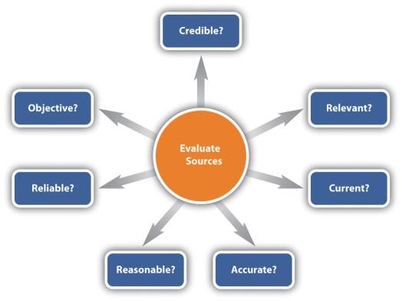

A source is relevant if it can contribute to your paper in a meaningful way, which might include any of the following:

- Supplies support for core argument(s)
- Adds a sense of authority to your argument(s)
- Contributes background information
- Provides other viewpoints
- Offers definitions and explanations that your audience will need for clarification

When determining if a source is current enough to use, a general rule of thumb is that a source must be no more than ten years old. In some situations, very few sources exist that were published within the last ten years, so older sources can be used as long as you explain why the use of the older sources is acceptable and meaningful. Or perhaps you may be using older sources to establish a historical record of thoughts and statements on your issue in question.

Before you use a source, you need to satisfy yourself that the information is accurate. In print sources, you can use the author (if known) and the publisher to help you decide. If you think the author and publisher are legitimate sources, then you are probably safe in assuming that their work is accurate. In the case of online information, in addition to considering the author and publisher, you can look at how long ago the site was updated, if evidence is provided to back up statements, and if the information appears to be thorough. For either print or online sources, you can check accuracy by finding other sources that support the facts in question.
You can deem a source to be reasonable if it makes overall sense as you read through it. In other words, use your personal judgment to determine if you think the information the source provides sounds plausible.
Reliable sources do not show bias or conflict of interest. For example, don’t choose a toy company’s site for information about toys that are best for children. If you are unsure about the reliability of a source, check to see if it includes a list of references, and then track down a sampling of those references. Also, check the publisher. Reliable publishers rarely involve themselves with unreliable information.

A source is objective if it provides both sides of an argument or more than one viewpoint. Although you can use sources that do not provide more than one viewpoint, you need to balance them with sources that provide other viewpoints.

.edu | Educational
.com | Commercial, for-profit, business
.gov | Government
.mil | Military
.net | Network
.org | Not-for-profit organization

A credible source is one that has solid backing by a reputable person or organization with the authority and expertise to present the information. When you haven’t heard of an author, you can often judge whether an author is credible by reading his or her biography. If no biography is available, you can research the author yourself. You can also judge the credibility of an online source by looking at address extension. As a rule, you need to be aware that .com sites are commercial, for-profit sites that might offer a biased viewpoint, and .org sites are likely to have an agenda. Take precautions not to be fooled by an address extension that you think would belong to a credible source. Always think and read critically so you aren’t fooled.

KEY TAKEAWAYS
- A source is relevant to your topic if it supports your argument, adds a sense of authority to your argument, contributes background information, provides a different viewpoint, or offers key knowledge the audience will need. As a general rule, unless you are working with a subject that requires some historical research, a source should be no older than ten years.
- Information within a source needs to be accurate, reasonable, reliable, and objective. Accurate means that the facts are correct, reasonable means it makes basic sense to you, reliable means it is without bias or conflict of interest, and objective means it presents more than one viewpoint.
- A source is credible if the source has the expertise to present the information.

EXERCISES
- Choose a research topic of interest to you. Find one source that is both related to the overall topic and relevant to your specific topic. Describe the relevant role the source could make (support, authority, background, viewpoints, or knowledge). Find a second source that is related to the overall topic but not as relevant to your specific topic.
- Find a source that you think is not acceptable due to not being accurate, reasonable, reliable, or objective. Share the source with your classmates and explain why you have deemed the source as unacceptable.
- Choose a research topic of interest to you. Find two sources with information that relate to your topic—one that is credible and one that is not credible. Explain what makes one credible and the other not credible.

7.6 Taking Notes
LEARNING OBJECTIVES
- Understand the three types of note taking and when to use each.
- Know how to organize your notes and back up your work.
- Plan to include your sources and take care not to plagiarize.

Some students view taking notes as a mindless procedure they have to go through to write a paper. Such an attitude is detrimental since good notes are a core factor that helps determine if you will write a good research project. In fact, next to building a solid research plan, the note taking process is perhaps the most critical part of your prewriting process.

Using Three Types of Note Taking

When you are completing a research paper, you will use three types of note taking: summarizing, paraphrasing, and quoting. Since, at the note taking stage, you do not know for sure how you will use the information you find, you will not know for sure which kind of notes to take for which sources. Use the following general guidelines to decide:

- Summarize lengthy information that will add to your paper without including the smaller details.

- Paraphrase information and details that will serve as significant support for your core points but that isn’t so eloquently stated that you want to use the exact words. Also, paraphrase texts with vital details that are simply too lengthy to quote.

- Use quotations to emphasize important information that will be very impressive or poignant and that will serve its purpose best if the original words are used. Keep in mind that no more than about 10 percent of your paper should be quoted text. Your paper should be in your words with a few quotations as opposed to a collection of quotations connected with your words. (For examples of each kind of use of source material, see Section 7.7 "Making Ethical and Effective Choices".)

You will use most of the information you find in either a summarized or paraphrased format. So use those formats as you write. Make your best guess about how you will want to use the information. Do not ever copy and paste from a source directly into your working files unless you intend to use the information as an exact quotation. If you do intend to use an exact quotation, use the quotations when you take the initial note.

Organizing Your Notes

Traditionally, notes were taken by hand on note cards and then filed by topic until you were ready to sort them out and put them in the order you would use them. Once the note cards were in order, you could begin typing your paper and inserting the information from the cards into the correct spots. You could still use that method if you want to. But to do so would add, depending on the size of your paper, hours, days, or weeks to the process. Since you most likely are not interested in increasing the amount of time needed to write your paper, you should keep your notes in a computer file (backed up elsewhere). Doing so will allow you to use copy and paste features to assemble and rearrange your notes. The digital format also allows you to easily add information as desired.

To organize your notes as you take them, assign each subtopic to a separate section within a file or to a separate file. Sorting your notes so that like topics are grouped together will help streamline the writing process.

Backing Up Your Work

Crashing computers can cause serious loss of data, so make sure you back up your work. You can use a variety of methods of backing up your work, including the following:

- Use a conventional hard drive backup system.
- Copy your work onto a flash drive.
- Post your work to an online site, such as a wiki, so that you can access it from any computer.
- Send your work to an online e-mail address (yours or someone else’s) so you can access it from any computer.

If you do not have a method of backing up your data, periodically print your work so that you won’t lose as much if you have a crash. You could then probably scan the pages using a text format and have the data back in your computer quite quickly. Even if you have to rekey the information to get it back into the computer, that process will be much faster than starting completely over.

Including Your Sources

As you take notes, make sure to include the source for each piece of information. Keep the complete citation in a master reference list that is either at the end of your paper or in a separate reference file. In addition, within your notes, insert the information you need for an in-text reference. (See Chapter 22 "Appendix B: A Guide to Research and Documentation" for correct formatting of in-text references within the different citation styles.) Including the necessary in-text information within your notes is another way of cutting down the time needed to write your paper.

For all notes you take, record the page(s) where you found the information. Doing so will assure you have the information at hand if you need it for your reference. In addition, having the page numbers readily available will allow you to easily revisit sources. So that you do not inadvertently leave a page number where you do not want it, add bolding and color to your page numbers to make them stand out.

Taking Care Not to Plagiarize

As noted earlier, you should copy and paste only information that you intend to quote. By limiting your copying and pasting to quoted materials, you are not prone to forgetting that some text is copied and end up plagiarizing without intending to do so. If you find it helpful, you can add a colored notation identifying each piece of information as a quotation, summary, or paraphrase. As with the page numbers, by using colored text, you can avoid copying and pasting your tags into your paper as you write. For an example of this kind of color-coding approach, see the annotated bibliography in Section 7.8 "Creating an Annotated Bibliography".

Another method of inadvertent plagiarism is to paraphrase too closely. You can avoid this pitfall by reading a paragraph and then, without looking back, writing about the paragraph. Unless you have a photographic memory, this method will result in you rewording the idea. When you finish writing, look back to make sure you included all aspects of the original text and to clarify that you depicted the ideas accurately.

When you are planning to quote an author’s exact words, follow these guidelines:

- If possible, copy and paste the quotation so you know you have not made any inadvertent changes.
- Be very careful not to change any word orders, word choices, spellings, or punctuations.
- Use quotations.
- If you choose to omit any words from the quotation, indicate this omission by replacing the words with ellipses (…).
- If you add additional words to the quotation, place them within square brackets ([]).

KEY TAKEAWAYS
- When you take notes, you will either summarize, paraphrase, or quote all the information. You will summarize when the small details are not important, paraphrase when the details are important but the words are not eloquent, and quote when the information is both important and eloquent.
- Organize your notes by topic either within one file or in one file for each topic. Back up your work by using a backup hard drive or a flash drive, posting it to a wiki, sending it to an online e-mail address, or printing it out.
- Create a master list of your references. Also, include in-text reference information and page numbers with each note you take. To make sure you do not plagiarize, only copy and paste when you are quoting. Paraphrase or summarize all other information. When you are paraphrasing, read the information, look away, and type it in your own words. Then check back to make sure your version is accurate. When you are quoting, take care to use the text exactly as you find it unless you use brackets to indicate additions or ellipses to indicate omissions.

EXERCISES
- Find and print a research paper that interests you. Using three colors of highlighters, make a key identifying colors used for summaries, paraphrases, and quotations. Then read through the paper and the highlighters to identify the different types of information within the paper.
- Explain how you would back up your work at the end of a work session on a research paper.
- Choose a detail from this section to use as a quotation with some words added and some words left out. Write the quotation using square brackets and ellipses.

7.7 Making Ethical and Effective Choices
LEARNING OBJECTIVES
- Know how to differentiate between common knowledge and proprietary ideas.
- Understand how to summarize, paraphrase, and cite sources.
- Recognize whether material is available for use.

Three keys to referencing others’ ideas ethically are to know the difference between common knowledge and proprietary ideas, to be aware of how to properly summarize and paraphrase, and to understand the correct methods for citing sources. In addition, you need to make sure that material is available for use at any level.

Differentiating between Common Knowledge and Proprietary Ideas

Common knowledge is that bank of information that most people know. Such information does not require a citation. One way to identify such information is to note that it is presented in multiple sources without documentation. Another identification method is to realize that you, along with most people you know, are aware of the information. For example, you can write that “Cheyenne is the capital of Wyoming” without needing a reference. On the other hand, if you were to note that there is a high rate of divorce in Cheyenne, you would need to cite that detail. Data about the divorce rate in Cheyenne are proprietary ideas.

Properly Summarizing and Paraphrasing

When you summarize, you should write in your own words and the result should be substantially shorter than the original text. In addition, the sentence structure should be your original format. In other words, you should not take a sentence and replace core words with synonyms.
You should also use your words when you paraphrase. Paraphrasing should also involve your own sentence structure. Paraphrasing might, however, be as long or even longer than the original text. When you paraphrase, you should include, in your words, all the ideas from the original text in the same order as in the original text. You should not insert any of your ideas.

Both summaries and paraphrases should maintain the original author’s intent and slant. Taking details out of context to suit your purposes is not ethical since it does not honor the original author’s ideas.
Study the examples in the following table for clarification between summarizing, paraphrasing, quoting, and plagiarizing.

Original text | Some dramatic differences were obvious between online and face-to-face classrooms. For example, 73 percent of the students responded that they felt like they knew their face-to-face classmates, but only 35 percent of the subjects felt they knew their online classmates. In regards to having personal discussion with classmates, 83 percent of the subjects had such discussions in face-to-face classes, but only 32 percent in online classes. Only 52 percent of subjects said they remembered people from their online classes, whereas 94 percent remembered people from their face-to-face classes. Similarly, liking to do group projects differs from 52 percent (face-to-face) to 22 percent (online) and viewing classes as friendly, connected groups differs from 73 percent (face-to-face) to 52 percent (online). These results show that students generally feel less connected in online classes.
Summarized text | Students report a more personal connection to students in face-to-face classes than in online classes.
Paraphrased text | Study results show a clear difference between online and face-to-face classrooms. About twice as many students indicated they knew their classmates in face-to-face classes than in online classes. Students in face-to-face classes were about two-and-a-half times more likely to have discussions with classmates than were students in online classes. Students in face-to-face classes were about twice as likely to remember classmates as were students in online classes. Students in face-to-face classes viewed group projects as positive about two-and-a-half times more often than did students in online classes. Students in face-to-face classes saw class as a friendly place 73 percent of the time compared to 52 percent for online classes. Summing up these results, it is clear that students feel more connected in face-to-face classes than in online classes.
Quoted text | The study showed that personal discussions are much more likely to take place in face-to-face classes than in online classes since “83 percent of the subjects had such discussions in face-to-face classes, but only 32 percent in online classes.”
Plagiarized text | Some major differences were clear between Internet and in-person classrooms. For example, 73 percent of the study participants felt they were acquainted with their in-person classmates, but only 35 percent of the participants indicated they knew their distance classmates.

Correctly Citing Sources

Citing sources is critical since you do not want to be guilty of stealing ideas from others, and using others’ intellectual property without giving them credit is, indeed, a form of stealing. A bonus that comes with citing sources is that aligning others’ ideas with your ideas adds credibility to your ideas and helps establish your ethos. Also, when you address more than one viewpoint, you strengthen your viewpoint.

In order to know exactly how you should cite sources, you need to know the reference style you will be using. The most popular formats are American Psychological Association (APA), Modern Language Association (MLA), Chicago, and Council of Science Editors (CSE). You can read more about these different styles and others in .

Regardless of which citation style you use, you should follow the following general guidelines:

- Enclose all direct quotations in quotation marks and cite the source within the text, including page number, author, and year (if your style requires all these parts) so it is very clear where you acquired the information.
- When you summarize or paraphrase text, do not use quotations, but note the author and year (or other required information depending on the citation style) either as part of the sentence or in parentheses following the sentence to clearly note that the ideas belong to someone else.
- At the end of your paper, include a complete list of references, each properly cited using the required citation style.

Making Sure Material Is Available for Use

As you are searching for sources, be sure to determine that you can ethically use the material. As a rule, you can reference most text as long as you properly cite it. Images are another issue. When you search online for images, you will find many private and for-profit sources. You should not use these images without contacting the source and requesting permission. For example, you might find a picture of a darling little boy from someone’s personal unprotected photo page or a good picture of an orderly closet from a company’s web page. Using such photos just because you can access them is not ethical. And citing the source is not adequate in these situations. You should either obtain written permission or forgo the use of such images.

KEY TAKEAWAYS
- Common knowledge is information that most people know and that is available in many sources. Common knowledge does not have to be cited. Proprietary ideas are those that belong to someone else and must be cited.
- Summarized information must be cited, should be written in your words, should be true to the author’s intent, and should be much shorter than the original text. Paraphrased information should be cited, should include all the core points of the original text, should be written in your words, should be true to the author’s intent, and should be about as long as the original text.
- Take care to put exact quotations within quotation marks and to reference all borrowed ideas; use the citation style you are required to use.
- You should determine if you can ethically use content from a source, especially in the case of images. You can usually reference text ethically by citing it correctly, but it is wise to have signed consent when using visual content.

EXERCISES
- Consider these two sentences:
  - The KOA system is a large camping organization in the United States.
  - KOA campers and staff take part in many public service activities.

Explain whether each of these statements is common knowledge or proprietary and why.

- Online, find a source on a topic of interest to you. Copy a paragraph from the source. Summarize the paragraph. Paraphrase the paragraph. Finally, write a paragraph about the passage that includes a direct quotation from it.

7.8 Creating an Annotated Bibliography
LEARNING OBJECTIVES
- Know how to deal with a new source by bookmarking it and creating an annotated bibliography for it.
- Understand the information you need to create a citation and annotated bibliography.
- Know how to use an annotated bibliography as a tool for probing research questions in more depth.

To make the best use of your research time, thoroughly read each source that is clearly relevant and document all the pieces you might use from it so that you will have a good chance of not having to revisit it. But just in case, take care to bookmark the site (and additionally save it to a folder set up for your research project) so you can easily return to it later and collect the needed information.
Your research log should include an annotated bibliography of the sources you plan to use. Each entry should include the following elements:

- The complete citation information (in the format the assignment requires)
- A summary or paraphrase of the contents of the source in your words
- The direct quotations you may end up using (with page or paragraph numbers)
- Additional strategy notes about how you plan to use the source (For more on quoting, summarizing, and paraphrasing, see .)

For the citation, gather the following components:

- Name of author, editor, sponsoring organization, discussion group, or list
- Title of article or subject line of discussion
- Title of journal or site that has published the article
- Version number or issue number, if applicable
- Date of publication
- Date you accessed the site

If a source does not appear to be as relevant as you initially thought it would be, document the situation in your log and move on. Don’t try to jam it into the essay just because you spent time tracking it down. Good researchers and good writers know they’ll encounter a few dead ends and bad leads.

Here are a couple of entries Antonio makes in his annotated bibliography for an essay he is writing on head injuries in football. Using the same search terms (“helmets,” “NFL,” and “head injuries”), a search of Academic Search Complete in his college library nets him entries 1, 2, and 4, and a search on Google nets him entry 3. Drawing from the color-coding suggestion in , Antonio distinguishes between direct quotation (red), paraphrase (blue) and summary (purple), by using different font colors for each.

Figure 7.3
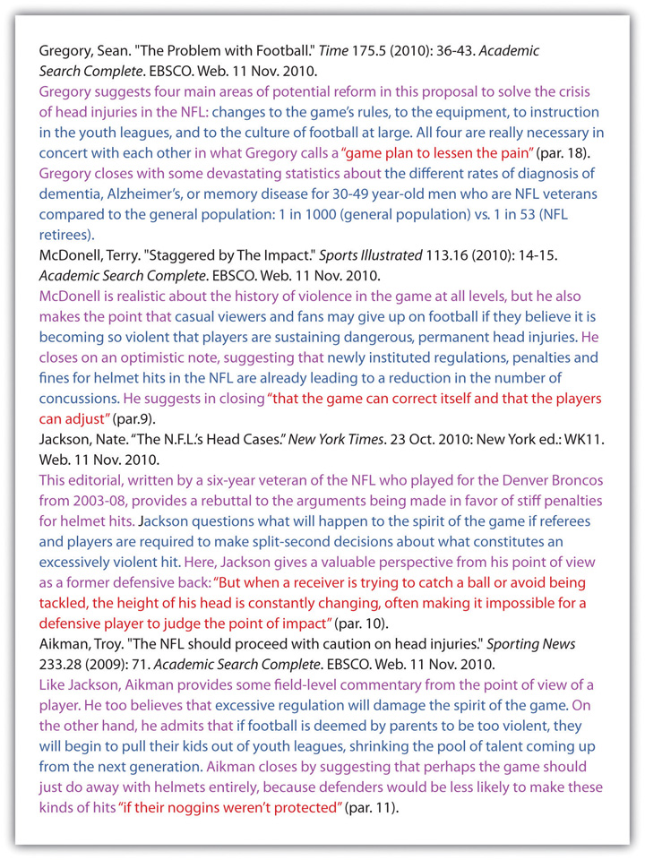

KEY TAKEAWAYS
- Create a folder and place a bookmark for each new online source in it so you can easily return to it. Also, create a citation for each source when you first encounter it.
- When citing an online source, find the following pieces of information: name of author, editor, or sponsoring organization; title of article; title of journal or site that has published the article; version or issue number; and date of publication and access date.

EXERCISES
- Choose a research topic of interest to you. Find a related website and find the following pieces of information: name of author, editor, or sponsoring organization; title of article; title of journal or site that has published the article; version or issue number; date of publication or access date.
- Choose a research topic of interest to you. Find a related online blog.
- Choose a research topic of interest to you and set up a related RSS feed.
- Choose a research topic of interest to you. Find a related government site.
- Choose a research topic of interest to you. Online, find a related photo, video, and table.
- With your writing group sharing a couple of computers, amass several sources for Jacoba’s essay on Social Security and write up an annotated bibliography.
- Using Antonio’s essay idea on helmet hits in the NFL, draw up two statements of purpose that differ from each other in at least three of the six concerns (voice, audience, message, tone, attitude, or reception).

7.9 Managing Information
LEARNING OBJECTIVES
- Understand how to proceed once you think you are finished taking notes.
- Know how to make an outline from your notes.
- Recognize the process of evaluating your outline.

Pause for a few moments before beginning to amass your information into a first draft. Return to your statement(s) of purpose. Have any of the elements (voice, audience, message, tone, attitude, reception) changed as a result of your research? If so, write up an intermediate statement of purpose, and use it as a guide as you draft and as the basis for a writer’s memo you may be asked to submit with your draft.

Once you think you have an ample supply of materials, read through your subtopic files and consider the order of the different pieces. Consider the points you want to make in relation to the information you have found and begin typing comments between your notes to assure you have a solid plan in place when you start to make your outline.

Create an outline that begins with your thesis (or message). Include the subtopics as key elements. Under each subtopic, list your supporting points you have researched as well as the ideas you plan to add. When you are finished, evaluate your outline by asking questions such as the following:

- Do I want to tweak my planned thesis based on the information I have found?
- Do all of my planned subtopics still seem reasonable?
- Did I find an unexpected subtopic that I want to add?
- In what order do I want to present my subtopics?
- Are my supporting points in the best possible order?
- Do I have enough support for each of my main subtopics? Will the support I have convince readers of my points?
- Do I have ample materials for the required length of the paper? If not, what angle do I want to enhance?
- Have I gathered too much information for a paper of this length? And if so, what should I get rid of?
- Did I include information in my notes that really doesn’t belong and needs to be eliminated? (If so, cut it out and place it in a discard file rather than deleting it. That way, it is still available if you change your mind once you start drafting.)
- Are my planned quotations still good choices?

KEY TAKEAWAYS
- After you think you are finished taking notes, read through your notes and reorder them as needed.
- Create an outline using your thesis, subtopics, and supporting details.
- Evaluate your outline by reflecting on your thesis, adjusting the subtopics, tweaking your supporting points, considering your quantity of information, looking at the relevancy of the different details, and contemplating the effectiveness of your planned quotations.

EXERCISES
Choose the best choice for each question.
- Once you are finished taking notes, you should
  - start writing immediately.
  - read through your notes and put them in an order that will work.
  - make sure, when you write, to use all the information you have found.
- Your outline should begin with
  - your thesis (or message).
  - your best quotation.
  - your most interesting subtopic.
- If you have notes that are relevant, but do not fit within the planned subtopics
  - delete those notes.
  - you know that you did unneeded research.
  - consider adding a subtopic.
- Once you begin to make your outline, you should
  - tweak your thesis based on information you have learned.
  - eliminate all information that does not directly support your thesis.
  - use only your original ideas.

Chapter 8
Revising
Reviewing, Editing, Proofreading, and Making an Overview
Every time you revise your work substantially, you will be conducting three distinct functions in the following order: reviewing for purpose, editing and proofreading, making a final overview.
8.1 Reviewing for Purpose
LEARNING OBJECTIVES
- Understand why and when to review for purpose.
- Be prepared to use self-questioning in the purpose review process.

Although you will naturally be reviewing for purpose throughout the entire writing process, you should read through your first complete draft once you have finished it and carefully reconsider all aspects of your essay. As you review for purpose, keep in mind that your paper has to be clear to others, not just to you. Try to read through your paper from the point of view of a member of your targeted audience who is reading your paper for the first time. Make sure you have neither failed to clarify the points your audience will need to have clarified nor overclarified the points your audience will already completely understand.

Figure 8.1
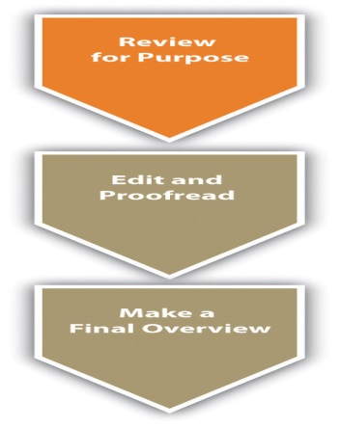

Revisiting Your Statement of Purpose

Self-questioning is a useful tool when you are in the reviewing process. In anticipation of attaching a writer’s memo to your draft as you send it out for peer or instructor review, reexamine the six elements of the triangle that made up your original statement of purpose (voice, audience, message, tone, attitude, and reception):

Voice: Does it sound like a real human being wrote this draft? Does my introduction project a clear sense of who I am? Honestly, would someone other than my paid instructor or assigned peer(s) read beyond the first paragraph of this essay?

Audience: Does my writing draw in a specific set of readers with a catchy hook? Do I address the same audience throughout the essay? If I don’t, am I being intentional about shifting from one audience to another?

Message: Are my main points strong and clear? Do I have ample support for each of them? Do my supporting details clearly support my main points?

Tone: Am I using the proper tone given my audience? Is my language too casual or not professional enough? Or is it needlessly formal and stiff sounding? Does my tone stay consistent throughout the draft?

Attitude: Will my organization make sense to another reader? Does my stance toward the topic stay consistent throughout the draft? If it doesn’t, do I explain the cause of the transformation in my attitude?

Reception: Is my goal or intent for writing clear? How is this essay likely to be received? What kind of motivation, ideas, or emotions will this draft draw out of my readers? What will my readers do, think, or feel immediately after finishing this essay?

Handling Peer and Instructor Reviews

In many situations, you will be required to have at least one of your peers review your essay (and you will, in turn, review at least one peer’s essay). Even if you’re not required to exchange drafts with a peer, it’s simply essential at this point to have another pair of eyes, so find a classmate or friend and ask them to look over your draft. In other cases, your instructor may be intervening at this point with ungraded but evaluative commentary on your draft. Whatever the system, before you post or trade your draft for review, use your answers to the questions in Section 8.1 "Reviewing for Purpose".1 to tweak your original statement of purpose, giving a clear statement of your desired voice, audience, message, tone, attitude, and reception. Also, consider preparing a descriptive outline showing how the essay actually turned out and comparing that with your original plan, or consider writing a brief narrative describing how the essay developed from idea to execution. Finally, include any other questions or concerns you have about your draft, so that your peer reader(s) or instructor can give you useful, tailored feedback. These reflective statements and documents could be attached with your draft as part of a writer’s memo. Remember, the more guidance you give your readers, regardless of whether they are your peers or your instructor, the more they will be able to help you.

When you receive suggestions for content changes from your instructors, try to put aside any tendencies to react defensively, so that you can consider their ideas for revisions with an open mind. If you are accustomed only to getting feedback from instructors that is accompanied by a grade, you may need to get used to the difference between evaluation and judgment. In college settings, instructors often prefer to intervene most extensively after you have completed a first draft, with evaluative commentary that tends to be suggestive, forward-looking, and free of a final quantitative judgment (like a grade). If you read your instructors’ feedback in those circumstances as final, you can miss the point of the exercise. You’re supposed to do something with this sort of commentary, not just read it as the justification for a (nonexistent) grade.

Sometimes peers think they’re supposed to “sound like an English teacher” so they fall into the trap of “correcting” your draft, but in most cases, the prompts used in college-level peer reviewing discourage that sort of thing. (For more on the peer review process and for a list of Twenty Questions for Peer Review, see Chapter 11 "Academic Writing", Section 11.3 "Collaborating on Academic Writing Projects".) In many situations, your peers will give you ideas that will add value to your paper, and you will want to include them. In other situations, your peers’ ideas will not really work into the plan you have for your paper. It is not unusual for peers to offer ideas that you may not want to implement. Remember, your peers’ ideas are only suggestions, and it is your essay, and you are the person who will make the final decisions. If your peers happen to be a part of the audience to which you are writing, they can sometimes give you invaluable ideas. And if they’re not, take the initiative to find outside readers who might actually be a part of your audience.

When you are reviewing a peer’s essay, keep in mind that the author likely knows more about the topic than you do, so don’t question content unless you are certain of your facts. Also, do not suggest changes just because you would do it differently or because you want to give the impression that you are offering ideas. Only suggest changes that you seriously think would make the essay stronger.

KEY TAKEAWAYS
- You should review for purpose while you are writing, after you finish your first draft, and after you feel your essay is nearly complete.
- Use self-questioning to evaluate your essay as you are revising the purpose. Keep your voice, audience, message, tone, attitude, and reception in mind as you write and revise.
- When you are reviewing a peers’ essay, make only suggestions that you think will make the essay stronger. When you receive reviews from instructors or peers, try to be open minded and consider the value of the ideas to your essay.
EXERCISES
- Find multiple drafts of an essay you have recently completed. Write a descriptive outline of at least two distinct drafts you wrote during the process.
- For a recently completed essay, discuss how at least one element of your statement of purpose (voice, audience, message, tone, attitude, or reception) changed over the course of the writing process.

- With your writing group, develop five questions you think everyone in your class should have to answer about their essay drafts before submitting them for evaluation from a peer or your instructor.

8.2 Editing and Proofreading
LEARNING OBJECTIVES
- Understand why editing and proofreading is important even for careful writers.
- Recognize the benefits of peer editing and proofreading and the similarities between editing and proofreading your work and the work of others.
- Know how to edit and proofread for issues of both mechanics and style.

When you have made some revisions to your draft based on feedback and your recalibration of your purpose for writing, you may now feel your essay is nearly complete. However, you should plan to read through the entire final draft at least one additional time. During this stage of editing and proofreading your entire essay, you should be looking for general consistency and clarity. Also, pay particular attention to parts of the paper you have moved around or changed in other ways to make sure that your new versions still work smoothly.

Although you might think editing and proofreading isn’t necessary since you were fairly careful when you were writing, the truth is that even the very brightest people and best writers make mistakes when they write. One of the main reasons that you are likely to make mistakes is that your mind and fingers are not always moving along at the same speed nor are they necessarily in sync. So what ends up on the page isn’t always exactly what you intended. A second reason is that, as you make changes and adjustments, you might not totally match up the original parts and revised parts. Finally, a third key reason for proofreading is because you likely have errors you typically make and proofreading gives you a chance to correct those errors

Figure 8.2

Editing and proofreading can work well with a partner. You can offer to be another pair of eyes for peers in exchange for their doing the same for you. Whether you are editing and proofreading your work or the work of a peer, the process is basically the same. Although the rest of this section assumes you are editing and proofreading your work, you can simply shift the personal issues, such as “Am I…” to a viewpoint that will work with a peer, such as “Is she…”

As you edit and proofread, you should look for common problem areas that stick out, including the quality writing components covered in Chapter 15 "Sentence Building", Chapter 16 "Sentence Style", Chapter 17 "Word Choice", Chapter 18 "Punctuation", Chapter 19 "Mechanics", and Chapter 20 "Grammar": sentence building, sentence style, word choice, punctuation, mechanics, and grammar (Chapter 15 "Sentence Building" through Chapter 20 "Grammar"). There are certain writing rules that you must follow, but other more stylistic writing elements are more subjective and will require judgment calls on your part.

Be proactive in evaluating these subjective, stylistic issues since failure to do so can weaken the potential impact of your essay. Keeping the following questions in mind as you edit and proofread will help you notice and consider some of those subjective issues:

- At the word level: Am I using descriptive words? Am I varying my word choices rather than using the same words over and over? Am I using active verbs? Am I writing concisely? Does every word in each sentence perform a function?
- At the sentence level: Am I using a variety of sentence beginnings? Am I using a variety of sentence formats? Am I using ample and varied transitions? Does every sentence advance the value of the essay?
- At the paragraph and essay level: How does this essay look? Am I using paragraphing and paragraph breaks to my advantage? Are there opportunities to make this essay work better visually? Are the visuals I’m already using necessary? Am I using the required formatting (or, if there’s room for creativity, am I using the optimal formatting)? Is my essay the proper length?

KEY TAKEAWAYS
- Edit and proofread your work since it is easy to make mistakes between your mind and your typing fingers, as well as when you are moving around parts of your essay.
- Trading a nearly final version of a draft with peers is a valuable exercise since others can often more easily see your mistakes than you can. When you edit and proofread for a peer, you use the same process as when you edit and proofread for yourself.
- As you are editing and proofreading, you will encounter some issues that are either right or wrong and you simply have to correct them when they are wrong. Other more stylistic issues, such as using adequate transitions, ample descriptive words, and enough variety in sentence formats, are subjective. Besides dealing with matters of correctness, you will have to make choices about subjective and stylistic issues while you proofread.

EXERCISES
- Write a one-page piece about how you decided which college to attend. Give a copy of your file (or a hard copy) to three different peers to edit and proofread. Then edit and proofread your page yourself. Finally, compare your editing and proofreading results to those of your three peers. Categorize the suggested revisions and corrections as objective standards of correctness or subjective matters of style.
- Create a “personal editing and proofreading guide” that includes an overview of both objective and subjective issues covered in this book that are common problems for you in your writing. In your guide, include tips from this book and self-questions that can help you with your problem writing areas.

8.3 Making a Final Overview
LEARNING OBJECTIVES
- Understand the types of problems that might recur throughout your work.
- Know when you should conduct isolated checks during a final overview.
- Understand how to conduct isolated checks.

While you are managing the content of your essay and moving things around in it, you are likely to notice isolated issues that could recur throughout your work. To verify that these issues are satisfactorily dealt with from the beginning to the end of your essay, make a checklist of the issues as you go along. Conduct isolated checks of the whole paper after you are finished editing and proofreading. You might conduct some checks by flipping through the hard-copy pages, some by clicking through the pages on your computer, and some by conducting “computer finds” (good for cases when you want to make sure you’ve used the same proper noun correctly and consistently). Remember to take advantage of all the editing features of the word processing program you’re using, such as spell check (described in more detail in Chapter 19 "Mechanics", Section 19.1 "Mastering Commonly Misspelled Words") and grammar check. In most versions of Word, for instance, you’ll see red squiggly lines underneath misspelled words and green squiggly lines underneath misuses of grammar. Right click on those underlined words to examine your options for revision.

Figure 8.3

The following checklist shows examples of the types of things that you might look for as you make a final pass (or final passes) through your paper. It often works best to make a separate pass for each issue because you are less likely to miss an issue and you will probably be able to make multiple, single-issue passes more quickly than you can make one multiple-issue pass.

- All subheadings are placed correctly (such as in the center or at the beginning of a page).
- All the text is the same size and font throughout.
- The page numbers are all formatted and appearing as intended.
- All image and picture captions are appearing correctly.
- All spellings of proper nouns have been corrected.
- The words “there” and “their” and “they’re” are spelled correctly. (Or you can insert your top recurring error here.)
- References are all included in the citation list.
- Within the citation list, references are all in a single, required format (no moving back and forth between Modern Language Association [MLA] and American Psychological Association [APA], for instance).
- All the formatting conventions for the final manuscript follow the style sheet assigned by the instructor (e.g., MLA, APA, Chicago Manual of Style [CMS], or other).

This isn’t intended to be an all-inclusive checklist. Rather, it simply gives you an idea of the types of things for which you might look as you conduct your final check. You should develop your unique list that might or might not include these same items.

KEY TAKEAWAYS
- Often a good way to make sure you do not miss any details you want to change is to make a separate pass through your essay for each area of concern. You can conduct passes by flipping through hard copies, clicking through pages on a computer, or using the “find” feature on a computer.
- You should conduct a final overview with isolated checks after you are finished editing and proofreading the final draft.
- As you are writing, make a checklist of recurring isolated issues that you notice in your work. Use this list to conduct isolated checks on the final draft of your paper.

EXERCISE
Complete each sentence to create a logical item for a list to use for a final isolated check. Do not use any of the examples given in the text.

- All the subheadings are…
- The spacing between paragraphs…
- Each page includes…
- I have correctly spelled…
- The photos are all placed…
- The words in the flow charts and diagrams…

Chapter 9
Designing
The Right Look
Using design options, you can vary the look of your written work. You can make design choices based on your personal preferences, requirements, purpose, and audience. You have many options regarding both text formatting and use of visuals.

9.1 General Text Formatting Considerations
LEARNING OBJECTIVES
- Understand the overall page layout options.
- Recognize fonts that suit your needs.
- Use text features, such as headings and lists, to enhance your work.

Think about a résumé, an event flyer, a page in a research paper, a business letter, and a page in a novel. All these items start out exactly the same—as a blank page. The second step is typically also the same—text is added. The third step, however, differs, as the text formatting is varied to create the desired look. Based on requirements or audience expectations, you will sometimes want to conform to conventions. Other times, you can employ more personal choices. For example, an essay conforming to the American Psychological Association (APA) or Modern Language Association (MLA) style sheet (discussed in Chapter 10 "Publishing") has very rigid requirements regarding font choice, margin size, subhead formatting, and placement of page numbers. Likewise, as discussed in Chapter 12 "Professional Writing", Section 12.1 "Writing Business Letters", a business letter has some audience-expected features, such as date, name and address of person receiving the letter, greeting, introduction, body, closing, salutation, signature, and contact information for the sender of the letter. A business letter, however, does have a bit more flexibility than a paper written in APA style does since you can vary some aspects, such as your font choices and margins. On the other hand, a business letter written in an unusual or silly font will not likely be well received, so you’ll want to make choices with audience expectations in mind.

Choosing Formatting Options

As you begin to design a document, you will need to consider the basic layout, margins, line spacing, and alignment on the page. If none of these options matter to you, you can simply accept the default choices of the software you are using. For most documents, however, you will likely want to make some changes from the default settings. You might even want to change your default settings to match the desired format of your most frequently used document type.

Basic Layout

You will need to decide the best basic layout for your document. For example, if you are writing a novel, you will likely want to use straight text in paragraphs. But if you are creating a comparison of three novelists’ treatments of the same topic, you might want to use columns or a chart. If you are creating a flyer, you might prefer strategically placed text boxes (for more on flyers, see Chapter 14 "Public and Personal Writing", Section 14.2 "Creating Flyers and Brochures"). You will make your layout and formatting choices based on set requirements or your personal choices regarding the visual effects you want to convey to your readers.

White Space

White space is the area on a page (hard-copy or digital) that is not covered with text or images. Keep in mind that well-used white space makes a page more visually appealing and easier to read. White space, of course, is not always white; on a blue sheet of paper, or against a blue backdrop on a web page, white space is blue. Regardless of color, a balance of white space and text makes a page easier and more inviting to read.

When you are free to make your white-space choices, use white space to set headings and subheadings off from the main text. Use either 1½ or double spacing for the text body to provide a little white space between the lines of text, and use one-inch margins all around. Using columns is another way to create white space. Columns allow you to place considerable amounts of text on a page without creating an overwhelming appearance.

Margins, Line Spacing, and Indents

You can also set margins and line spacing to manage the amount of white space in a document. In some situations, such as a specific academic research or professional setting, you are likely to encounter specific guidelines regarding margin widths and line spacing. In many situations, however, you will be able to choose your margins and spacing. Apply logic as you make these choices so that your document can function to your best advantage. For example, if you or someone else will need space to add notes or edits, use double or triple spacing and wide margins. On the other hand, if you need the text to fit within a tight spot, tighten both the margins and line spacing. Keep in mind that the tighter the text is, the less inviting it is to read. Indenting is another option when making basic layout plans. Again, some situations require it and others leave it up to your discretion.

Alignment on Page

Alignment choices can also affect the overall look of a page of text. With most word processing software, you can choose to align text to the left, to the right, or to the center. You can also justify text, which is sort of a combination of the other three options:

Figure 9.1
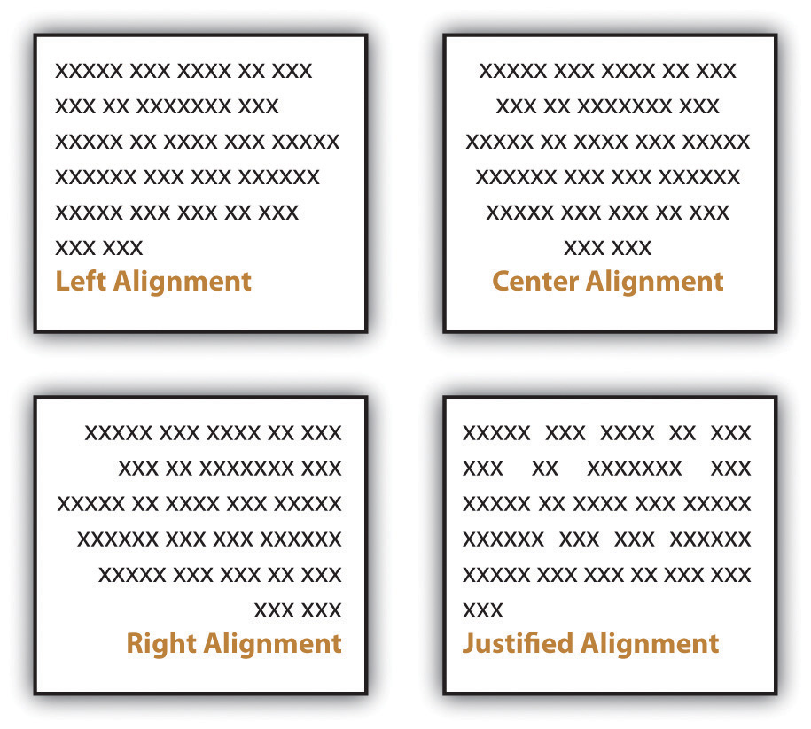

Most business and academic documents use left alignment as the standard format. The other three options are used less often but can provide effective alternatives in specific situations. For example, you will usually center-align text on a title page; you will typically right-align the page numbers in a table of contents, and you might justify text when you want to fit the maximum amount of text within the given space (such as within a newspaper article). Both center-aligned text and right-aligned text should be used sparingly since they are difficult to read in large amounts.

Appendices

Detailed information that would interrupt the flow of your document is better placed in an appendix than in the flow of your text. Using appendices makes it easier for readers to read your text, and they set apart details that some readers might not want to read or might want to read independently from the main body of text. If you have one item to place in an appendix, title it “Appendix,” and refer to it as such in the text. If you have more than one document to place in appendices, label them “Appendix A,” “Appendix B,” and so on. As with images, always refer to the appendices at the relevant point in the text, but do not repeat the bulk of the content within the text. The following are examples of information typically relegated to an appendix:

- Budget/cost figures
- Consent forms
- Full-page images
- Institutional Research Board (IRB) approval
- Large tables
- Letters
- Long lists
- Questionnaires

Using Text Features

Along with basic layout choices, you can control the look and feel of a document using certain text features. As with the other formatting options, you should base your choices based on your personal preferences, requirements, and audience expectations.

Headings and Subheadings

You can use headings and subheadings to break up text to make it easier to read. Keep two points in mind when you are deciding whether to use headings and subheadings: consistency and organization. Your headings should follow a consistent pattern in regards to both parallelism and content hierarchy, and the headings should help the readers see the relationships between parts of the text.

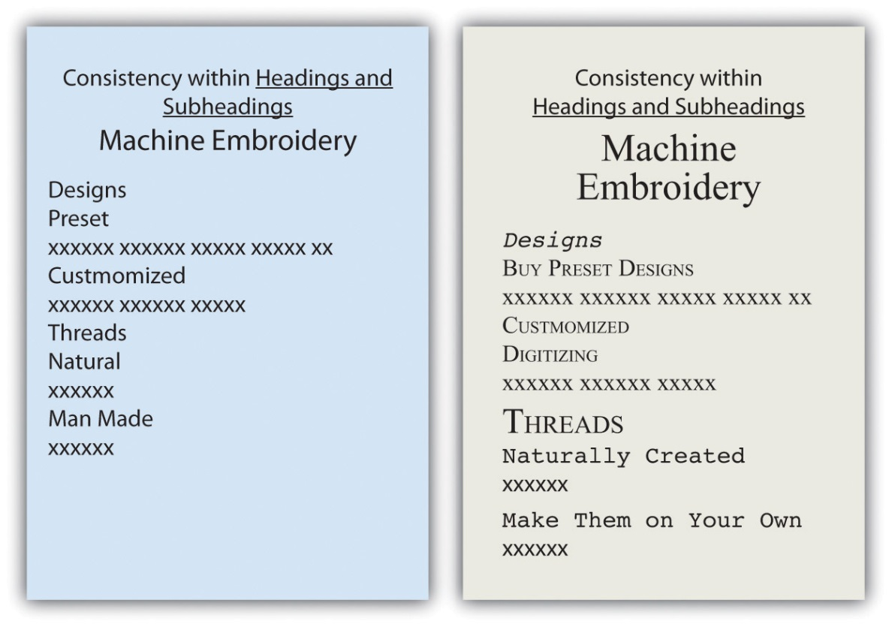

Headings and subheadings also provide a means of organizing text into categories that help readers comprehend the relationship between parts of the text both during a thorough read and when quickly glancing over the text. Clearly, headings and subheadings are not appropriate in some situations, such as within business letters and in documents that are only a couple of paragraphs long.

Take efforts to create short, informative headings and subheadings. Within a document, maintain consistency for headings and subheadings. For example, you might choose to make all the main headings gerund phrases (e.g., Using Text Features) and all the subheadings questions (e.g., Will Visual Text Features Help?). Also, use the same font features for each level of heading to create consistency. In some situations, your heading format is preset. Other times, you have choices. In both situations, you should maintain parallel format across each level.

Fonts

Today’s word processors typically offer a wide variety of font choices. You should choose a font that meets your needs. For example, a research paper might require the use of the Times New Roman font for ease of reading, an invitation might look best in a swirly script for fanciness, and a poster
often demands a dark, heavy font for distance viewing. Two common fonts that are widely used in professional and academia settings are Times New Roman and Arial.

Figure 9.3
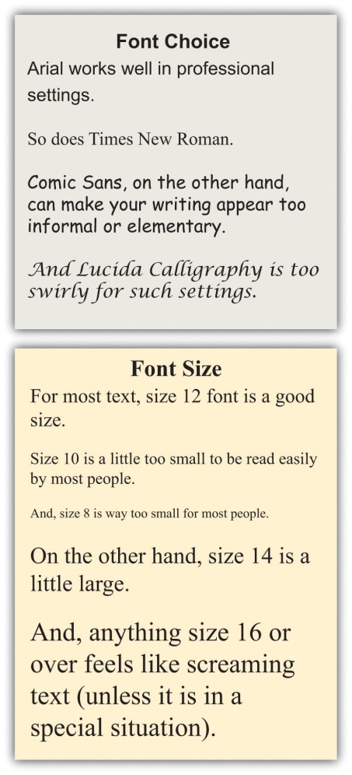

Typically, you should use 12-point font for standard text. Headings might be a size or two larger. In the absence of required sizes, you should use standard sizes to make your text easy to read.

Other Text Features

Along with font choices and sizes, you can also enhance your text using visual text features, such as those that follow. You can use the features in many ways, such as to call attention to text, to set text apart, and to make text easier to read at a glance.

- Bolding
- Italicizing
- Underlining
- Shading
- All caps
- Small caps
- Color
- Lists (such as this one)

As a rule, you should use these features sparingly so you do not diminish their effects. Exceptions to this general rule are some of the features that have specific, set uses. For example, standard format requires that you write acronyms in all caps and titles of books in italics.

Achieving a Clean Look

Although you do want to take steps to break up the text on a page, you do not want your pages to look cluttered. To create a clean look, keep your features to a minimum.

- Use only one or two images on a page. Although images help the readability of a page, a page needs a balance of text and images.
- Use only one or two lists per page. Although lists help make a page look clean, too many lists makes a page look like one big list.
- Use headings only for broad topics and subtopics. A page with too many subheadings looks cluttered and choppy.
- Use a maximum of three different fonts per page, but try to use only one or two.
- Use standard fonts, such as Arial or Times New Roman, for your text. Swirly, fancy fonts are hard to read in large amounts and will make your text look cluttered.

Use comfortable font sizes, such as 10- or 12-point font for text body, 14-point font for subheadings, and between 20- and 24-point font for titles. Using fonts that are too large makes your text “scream,” and using fonts that are too small makes your text unappealing.

KEY TAKEAWAYS
- Written assignments in academic and professional settings are both likely to have set requirements. If you do not have specific requirements, choose formats that fit your need, such as columns, paragraphs, or strategically placed text boxes. Set your margins, line spacing, and indents to suit your needs. Decide whether you want your text left aligned, centered, right aligned, or justified.
- You can control the look and feel of your written work by consistently using headings and subheadings and choosing fonts and font sizes carefully.
- You can create interesting effects in your text by using visual text features, such as bolding, italicizing, underlining, all caps, small caps, color, and lists.

EXERCISES
- Create a flyer to advertise a product that you want to promote. (The product can be fictional or actual.) On a separate page, explain your choices of basic layout, margins, line spacing, indents, alignment, subheadings and headings, font choice, font size, and at least three visual text features. (See Chapter 14 "Public and Personal Writing", Section 14.2 "Creating Flyers and Brochures" for more guidance on designing flyers.)
- Find five very different examples of text either in hard copy or online. If you find something online, print out the page. Create a table showing how the five samples are alike and different based on basic layout, margins, line spacing, indents, alignment, subheadings and headings, font choice, font size, and visual text features.
- Make a list of ten different reasons you might create text. List the five reasons at the top of a ten-column page. Down the side of the table, write basic layout, margins, line spacing, indents, alignment, subheadings and headings, font choice, font size, and visual text features. Fill in the table showing some logical choices for each type of writing.

9.2 Creating and Finding Visuals
LEARNING OBJECTIVES
- Learn to be a critical consumer and producer of visual images to meet your needs.
- Understand the proper ways to use images created by others.

It may be a cliché to say “a picture is worth a thousand words,” but the truth is that visual images have power. Types of visuals include the following:

- Photos
- Tables
- Charts
- Line graphs
- Pie charts
- Flow charts
- Concept clarification diagrams
- Stock photos

Incorporating lists, tables, and images is another way to break up daunting blocks of text with a combination of text-breaking images and white space. You can add white space by presenting your lists vertically rather than running them horizontally across the page as part of a sentence. Also, you can leave enough white space around images to frame the images and separate them from the text.

Besides white space, there are other considerations to keep in mind when choosing visuals. When possible, use a variety of types of visuals, but remember that any visuals you use should enhance the content of the text. For example, only add photos if viewing the photos will clarify the text. Near each visual, explain its purpose. Do not expect your readers to figure out the values of the visuals on their own. However, when you explain the purpose, do not explain it so thoroughly that readers have no reason to look at the visuals. For example, you should either list out the types of visuals or use a diagram such as the one shown and say “Use a variety of visuals, such as those shown in the box at right.” Do not both list out the options in your text and show them visually in a textbox.
You have three basic choices for finding visuals to use in your work. You can search the Internet, use photos you have taken, or create images by hand or on the computer.

The Internet is a powerful tool that you can use in several ways to find visuals to complement your work. If you simply click on “images” for your topic in a search engine, you will generate both royalty-free and protected images. However, if you include a term such as “stock images,” “stock photos,” or “royalty-free images” along with your topic, you will be able to narrow your search to royalty-free items. For example, if you are writing on the topic of the effect of television on children, you might search for “television children stock images.” Such a search will generate many options that could support a claim about the mesmerizing effect of television on children or the lack of physical activity involved in watching television.

Many services provide photos for use in publications. In these situations, you have to pay for the use of the photos and cite your source. Any pictures you take yourself are clearly royalty-free for your use. Taking a clear, meaningful picture that would be appropriate for use in your work is possible. For example, if you have children of your own or have friends or relatives who have small children, you could easily find an opportunity to take a photo such as Figure 9.4. To avoid rights issues, ask any human subjects included to sign a waiver giving you permission to use their likenesses. In the case of minors, you would obviously need to ask their guardians to sign the permission form.

Here’s an example of a typical waiver:

Permission Form for Use of Human Likeness
I give Joe Student permission to use my likeness [or the likeness of _______ for whom I have guardian or parental responsibility] in his paper entitled “Paper Title.” I understand that this paper could possibly appear in print or digital form as part of educational knowledge or research.
Signature___________________________ Date___________________________

Similarly, pictures taken by friends or relatives could be available for your use as long as you get signed permission to use the photo as well as signed permission from any human subjects in the photo. Although it might seem silly to ask your sister, for example, to give you signed permission to use her photo or image, you never know what complications you could encounter later on. So always protect yourself with permissions.

A third option is to create your visuals. You do not have to be an artist to successfully choose this option. You can use computer programs to generate very professional looking charts, graphs, tables, flow charts, and schematic images. The following examples show just a fraction of your options when using standard word processing software programs.

Figure 9.5
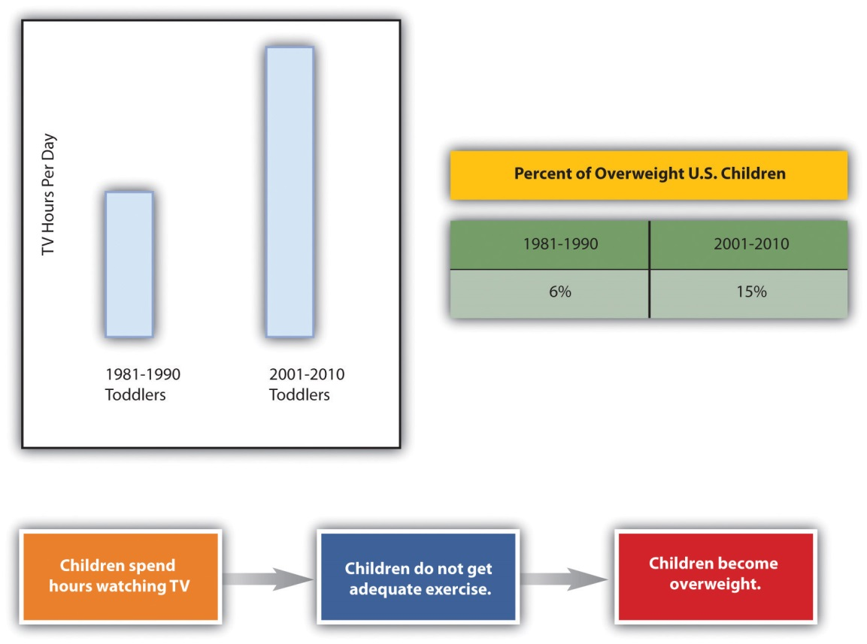

When you create graphics, make sure to group the components. If you find that your graphics are not holding together when viewed on other computers or in other programs, save each graphic in a separate JPEG file and use the JPEGs in your paper.

Since you will most likely submit your work in a digital format, you will probably not have to be concerned with the quality of photos you choose to use. On the other hand, if you do have to submit a paper in hard copy and are incorporating photos, make sure to use a printer with photo-quality capabilities.

Subject your visuals to the same level of scrutiny as your writing. Keep in mind that if you find one person who has a problem with one of your visuals, there will be others who also take exception. On the other hand, remember that you can never please everyone, so you will have to use your judgment.

Consider all your options as you choose whether to find existing visuals, take photos, or create visuals or a combination of the three possibilities. There is no right choice as long as the images you choose add value to your work.

KEY TAKEAWAYS
- You can satisfy your need for images in your work by purchasing photos or images, taking photos, or creating images.
- You can freely use images you create or pictures that you take with a camera. If you choose to use images created by others or pictures taken by others, you should either secure permission or cite your source.
- If you create your images, make sure they are in a format that will work well, such as a JPEG.

EXERCISES
- Search online and then choose a source of professional images. Explain the process and cost for using the images.
- Write a two-page paper on a topic of your choosing. Insert at least three photos you have taken into the paper.
- Using word processing software, create an image, such as a flow chart or graph, on a topic of your choice. Save your completed image as a JPEG.

9.3 Incorporating Images, Charts, and Graphs
LEARNING OBJECTIVES
- Know how to insert images into a body of text.
- Understand the role of visual rhetoric in argument and other genres of communication.
- Be aware of standard guidelines for choosing images.

Charts and graphs have long been part of research papers. With the growth of computer capabilities that can capture the world visually, research papers today typically include more charts, graphs, and images than those produced in previous years.

Physically Placing Images into Text

When you insert an image into your text, you must make some physical decisions. One of the most common choices is to place the image to the right or left of your text.

Figure 9.6
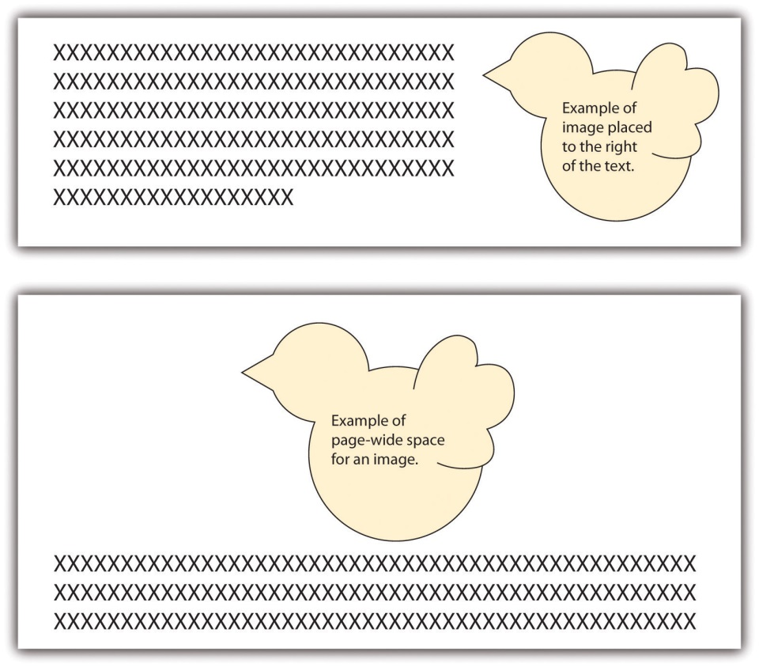

Another choice is to move the text down to create page-wide space for the image. In such situations, the image is typically placed above the related text. This format is usually used at the beginning of a document where the image treatment doesn’t break up the text.

Uses and Abuses of Visual Rhetoric

You should choose visuals to advance your argument rather than just to decorate your pages. Just as you would not include words that are fluff, you should not include meaningless images.

Also, just as you aim to avoid the use of fallacies in your text, you also need to be careful not to use fallacious visuals. (See Chapter 4 "Joining the Conversation", Section 4.3 "Rhetoric and Argumentation" for more on fallacies.) For example, if you were arguing for or against the proposition that big dogs make good pets for families, you might show a picture of a Rottweiler. Figure 9.7 shows how the “for” side could choose a docile example (Rottweiler A), while the “against” side could choose a ferocious example (Rottweiler B) in order to support their respective claims.
Thanks to common programs such as Photoshop, you can easily alter a photo, but make sure to do so ethically. For example, say that you are making an argument that the Moser Company unfairly hires only young people and disposes of employees as they age. You decide to show a photo of some of the employees to make your point. You crop the original photo in Figure 9.7 (Moser Company A) into the version shown as Moser Company B. This cropping choice would be an example of a faked, misleading photo and would be unethical.

More than likely, you have seen tables or graphs that paint a reality that is not exactly accurate. For example, the two graphs in Figure 9.7 could be used as proof that “twice as many” high school teachers as grade school teachers choose to use computer-driven whiteboards. Graph A seems to support this statement nicely. If you look at Graph B, however, you realize that the entire sample includes only three teachers, so “twice as many” means, literally, two out of three—an inadequate sample that leads to neither impressive nor convincing data. Be very careful not to misrepresent data using tables and graphs, whether knowingly or accidentally.

Weighing Your Options for Visuals

Visuals, like oral or written text, can make ethical, logical, and emotional appeals. (See Chapter 4 "Joining the Conversation", Section 4.2 "Recognizing the Rhetorical Situation" for more on rhetorical appeals.) Two examples of ethical appeals are a respected logo and a photo of the author in professional dress. Graphs, charts, and tables are examples of logical appeals. For the most part, nearly all visuals, because they quickly catch a reader’s eye, operate on an emotional level—even those that are designed to make ethical and logical appeals.

Consider the following options as you choose visuals for your work:

- Choose visuals that your audience will understand and appreciate. Besides adding information, visuals can help you establish common ground with your audience.
- Think about the possible emotional reactions to your visuals and decide if you they are reactions you want to evoke.
- Make sure you choose ethically when using images to make an ethical appeal. For example, it is unacceptable to use an agency for credibility if you do not have the access rights, or the suggested connection is not real.
- Make sure you present the information accurately and in a balanced way when using images such as charts and tables to create a logical appeal.
- Look for visuals that are royalty-free or create your own, unless you are prepared to pay for visuals.
- Spend some time browsing through possible visuals in hopes of seeing something that makes a claim that works with your argument if you do not know what claim you are trying to make with a visual. (A caveat: You can fritter away a lot of time looking for visuals, so don’t browse for visuals at the expense of reading and writing.)
- Make sure you choose visuals that align with the ethical standards of your work, because visuals can sway readers quickly. If your text is solidly ethical, but your picture(s) are inflammatory, you might compromise the ethics of your whole work.
- Keep captions brief if you need to use them. Some images carry meaning without any explanation. If you can’t keep the caption brief, you probably need a different visual or better context for the visual in the text of your essay.

KEY TAKEAWAYS
- When inserting images, you can wrap text to provide rectangle white space, tightly fitting white space, or paper-width white space.
- Visual elements of communication are especially powerful rhetorical tools that can easily be abused but can also be used responsibly and effectively.
- Commercial (or political) messages presented visually can easily mislead consumers (or voters), but it is much more difficult to take advantage of someone who knows how visual rhetoric works.

EXERCISES
- Create one page of text. Insert an image to the right of the text, one to the left, and one across the width of the page.
- Collect ten websites and advertisements. Examine each for use of visual rhetoric. Identify any instances where the websites and ads have used visual appeals unethically.
- Write a journal or blog entry or a short essay that addresses some or all the following questions:
  - How do you present yourself visually to others on social networking sites like Facebook?
  - What kind of profile picture did you choose, and how did you decide on it?
  - How often do you change your profile picture and why?
  - How do friends of yours present themselves to the world through such sites?
  - What would you say are the main types (or genres) of social networking site profile pictures?
  - What are the messages each genre is trying to convey?

Chapter 10
Publishing
The Final Step
Every time you share a final version of your work, even if it’s only with your instructor and classmates, you are publishing it. The last step in writing an essay is deciding how to publish your work. You might be given specific directions from your instructor; you might take your directions from specific style guides, such as the American Psychological Association (APA) or Modern Language Association (MLA); or you might be free to make your choices about document design. Whichever category your project falls into, the first section in this chapter will give you some helpful ideas. The remaining two sections will present some tips for digital presentations and for presenting orally.

10.1 Choosing a Document Design
LEARNING OBJECTIVES
- Be aware of general format choices.
- Know basic American Psychological Association (APA) format choices.
- Know basic Modern Language Association (MLA) format choices.

Chapter 9 "Designing" explores general and specific aspects of designing your written work, including margins, line spacing, indentation, alignment, headings, subheadings, fonts, visual text, images, charts, graphs, and text wrapping. In this section, you will learn about the document design requirements of two of the most common style sheets: those from the American Psychological Association (APA) and the Modern Language Association (MLA). (For more on citation and documentation formats from these and other style sheets, see Chapter 22 "Appendix B: A Guide to Research and Documentation".)

Following APA Document Design Guidelines

Order of Pages

APA requires the following set order of pages with each listed page on the list starting on a new page. If your paper does not require one or more of the pages, skip over those pages, but maintain the order of the pages you do use.

- Title page
- Abstract
- Body
- Text citations
- Footnotes (If used, these may be placed at bottom of individual pages or placed on a separate page following the citations.)
- Tables too large to place within the text body can be included in this position
- Figures too large to place within the text body can be included in this position
- Appendices

Title Page

A double-spaced title page should include the required information centered on the top half of the page. The title page information can vary based on your instructor’s requests, but standard APA guidelines include either the title, your name, and your college name or the title, your name, the instructor’s name, the course name, and the date.

Page Numbers and Paper Identification

Figure 10.1
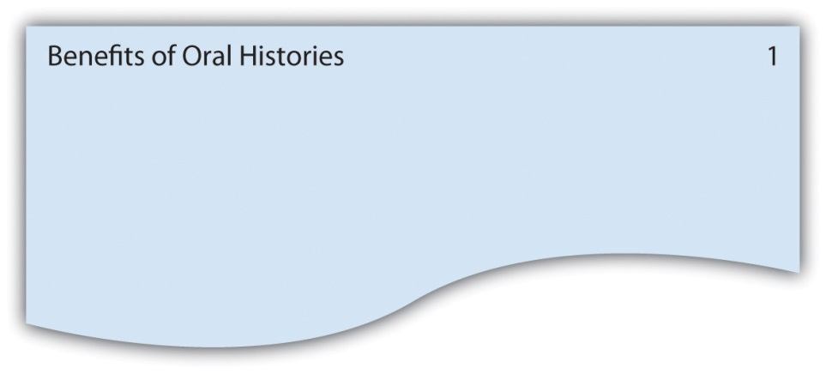

Page numbers should be placed at the top, right margin one-half inch down from the top of the page. Across from the page number, flush left, include the title of the paper in a running head. If the title of the paper is lengthy, use an abbreviated version in the running head.

Margins

Make margins one inch on both sides and top and bottom.

Headings and Subheadings

Use double spacing with no additional returns. Before you decide where to place your headings, you have to decide how many levels of headings you will have. Typically, you will have two or three levels, but you might have as many as five levels. Keep in mind that the title does not count as a heading level, you should use the levels consistently, and you must have a minimum of two headings at each level. See Figure 10.2 for examples of formatting for different numbers of headings levels.

Figure 10.2
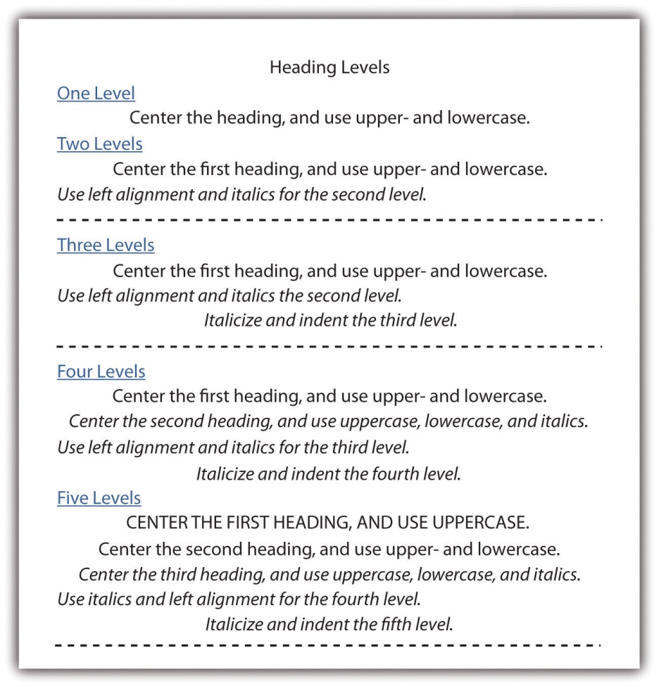

Fonts

Use 12-point Times New Roman.

Paragraph Indentations

Indent the first word of each paragraph from five to seven spaces.

Line Spacing

Double-space all text, including titles, subheadings, tables, captions, and citation lists.

Spacing after Punctuation

Space once after punctuation within a sentence, such as commas, colon, and semicolons, and twice after end punctuation.

Following MLA Document Design Guidelines

Order of Pages

MLA requires the following set order of pages with each listed page on the list starting on a new page. If your paper does not require one or more of the pages, skip over those pages, but maintain the order of the pages you do use.

- Body of text
- Notes
- Citation list
- Appendices

Title Page

No title page is needed unless your instructor requests it. Instead of a title page, MLA requires that you double-space your name, instructor’s name, course name or number, and the date at the top left. Next, continuing to double space, center the title on the page and start your text under the title.

Page Numbers and Paper Identification

Figure 10.3

Page numbers should be placed at the top, right margin one-half inch down from the top of the page. Before the page number, use your last name in a running head.

Margins

Make margins one inch on both sides and top and bottom.

Headings and Subheadings

Use double spacing with no additional returns. Use the heading formats in Figure 10.4 for up to five headings. If you have only two headings, use only the first two formats and so on.

Typically, you will have two or three levels, but you might have as many as five levels. Keep in mind that the title does not count as a heading level, you should use the levels consistently, and you must have a minimum of two headings at each level.

Figure 10.4
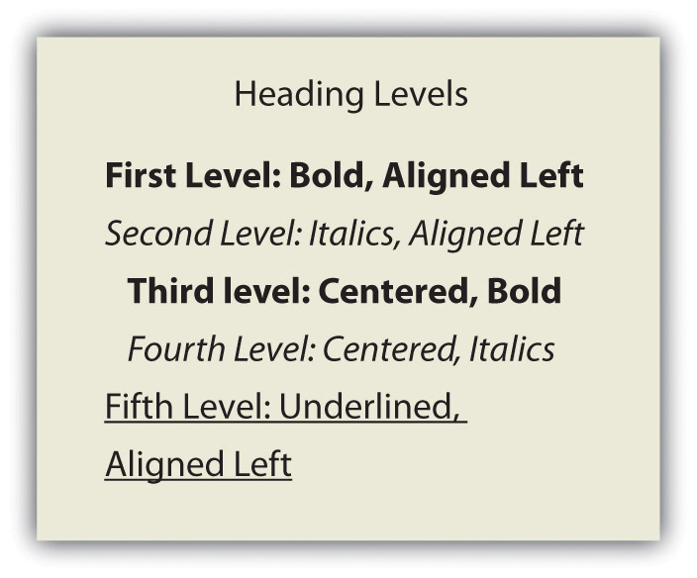

Fonts

Choose a font that is straight forward with no curly flairs or other “fancy” twists, such as Times New Roman or Arial. Use 12-point font.

Paragraph Indentations

Indent the first line of each paragraph one-half inch from the left margin by using the tab key (rather than spacing over).

Line Spacing

Double-space all text, including titles, subheadings, tables, captions, and citation lists.

Spacing after Punctuation

Leave only one space after all punctuation (both inside and at the end of sentences).

KEY TAKEAWAYS
- In absence of set design requirements, make design choices that result in ample white space, value-adding images, a variety of images, consistent headings that help organize the content for the reader, contrast used to identify important aspects, detailed information being presented in appendices, and a clean overall look. (See Chapter 9 "Designing" for general guidelines.)
- Along with many other details on citation and documentation covered in Chapter 22 "Appendix B: A Guide to Research and Documentation", APA style sheet guidelines include a set order of pages, requirements for a title page, page number and page identification format, margin widths, heading formats, font choice and size, paragraph indenting, line spacing, and spacing after punctuation.
- MLA style sheet guidelines include specifics in the same categories as do the APA guidelines, with the exception of a title page since MLA does not require one.

EXERCISES
Read each guideline and identify it as a general guideline, an APA guideline, or an MLA guideline.
- Use ample white space.
- When using five levels of headings, the first level should be in uppercase.
- The first page should be the title page.
- The author’s last name is placed in the running head with the page number.
- Make sure your paper has a clean look.
- Indent the first sentence in a paragraph a distance of one-half inch.
- The paper title should be included in the header with the page number.
- Insert two spaces after every sentence.
- The fifth heading level should be aligned left and underlined.

10.2 Developing Digital Presentations
LEARNING OBJECTIVES
- Recognize that PowerPoint slides are useful for creating digital presentations.
- Know that you can develop digital presentations in class wikis, in Word files that are submitted through e-mail, in course management systems, in personal websites, and on films posted on the Internet or burned to a DVD.
- Understand how links, video segments, and audio pieces are used in digital presentations.

As technology advances, the options for digital presentations continue to grow. Digital presentations refer to methods of presenting your work in the virtual world without using paper. Some of the most common current options are included in this section. All the options can take advantage of links to other parts of the document as well as links to related locations on the Internet. Using such links is one way to take advantage of the capabilities available in digital work. The internal links allow readers to instantly access other sections of your paper. External links lead to related text, videos, or audio pieces that are located on the Internet. Most of these digital options also allow you to embed video or audio segments so that the reader can simply click on a button or arrow to activate the segments. (For more on what’s at stake when you write for and publish on the web, also see .)

Creating PowerPoint Slides

PowerPoint is Microsoft Office software that has nearly become a standard presentation software. When you create PowerPoint slides to present your paper, you should use a small number of slides, typically less than ten. The slides should cover the most important aspects of your paper and should be at least somewhat visual in nature. PowerPoint also presents the option of textual and visual animation as well as audio components. In an effort to keep your slides as visual as possible, place bullets next to sentences whenever possible. Also, use fonts that are large enough for a group to read from a screen: 28 points or larger for base text and at least 36 points for headings.

Allow for ample white space on each slide. Without making the pages overwhelming, use color and visuals to add interest to the slides. If you do not have value-adding images, tables, or graphs that you can use, you can add color to the background, to text, or to text boxes.

You can add your voice and other audio to your slides. And you can create a slideshow that you can turn on and run automatically, presenting visuals and sound simultaneously. These capabilities allow you to create your entire presentation and run it without actually saying a word during the presentation. If you intend to run an automatic presentation, make sure you go through practice runs until the entire presentation works as you intend it to work.

Submitting Files Electronically

Chances are, you will create your paper using Microsoft Word, which has nearly evolved into the standard word processing software in higher education. If you’re not working in Word, save your file as a Word document or in a Word-like format your instructor and peers are likely to be able to open. You will likely be asked to submit your major essays digitally as e-mail attachments or through a digital dropbox, file exchange, or assignment area within the course management system your instructor or college is using, such as Blackboard. If you are asked to submit your essays digitally, you should assume your instructor and peers will be reading your work on a computer screen and quite possibly online. Therefore, your work can include links and imbedded audio and video components. If, on the other hand, you are asked to submit your essays in hard copy, you can’t make the same assumptions about how it is likely to be read and assessed. There’s nothing wrong with asking for permission to submit your work digitally if you prefer for it to be assessed in that context.

Posting on a Personal Website

You could present your work on your personal website using web features, such as homepages, navigation buttons, links to other sites, buttons that activate audio and video segments, and overall visual presentations. As a college student, you should only present your work this way when instructed to do so by your instructor. Since not all students have a personal website, this option is still not widely used as a means of presenting college work; however, some instructors are moving in this direction, especially as digital portfolios become an increasingly common expectation. (For more on digital portfolios, see , .)

Working on a Class-Wide Wiki

Your instructor might have an online class site where you and your classmates can post your papers, review each other’s work, and edit your work. When the due date arrives, your instructor would then read your final version. In this case, your entire paper would function as a digital presentation. Your instructor can read through your paper, follow your links, and listen or watch video and audio segments you have included. Keep in mind that, unlike a course management system requiring a password and enrollment in the course, both personal websites and class-wide wikis may well be visible to anyone using the web. This fact should cause you some concern about the content you share and the way you choose to present yourself and your identity, but it can also provide a meaningful opportunity to write for external, real audiences.

Filming a Digital Presentation

Using video filming equipment, you could film yourself presenting your work and capture both audio and video. You could then upload your presentation to the Internet (via a common video sharing site like YouTube) or you could burn it to a DVD. If you want your digital films to include a variety of multimedia options, you would have to learn how to incorporate such features using the equipment available to you.

KEY TAKEAWAYS
- When using a PowerPoint slide to present your paper, you should use less than ten slides to cover the important aspects of your paper. PowerPoint presentations can include textual and visual animation as well as voice and other audio. PowerPoint gives you the opportunity to create an entire presentation and run it as a slideshow without you saying a word.
- When you present your work digitally, you typically have the option of linking one part of your work to another or linking your work to relevant locations on the Internet. Within digital presentations, you can also often embed video and audio pieces.
- You can digitally share your work by submitting Word files as e-mail attachments; using a digital dropbox, file exchange, or assignment features on course management systems; posting files on your personal website; using class wikis; or filming your presentation and then posting it on the Internet or burning it to a DVD.

EXERCISES
- Create two PowerPoint slides that contain the same basic information. Make one slide that uses the visual preparation suggestions in and one that does not use those suggestions. Ask your classmates to identify the good and bad points about your two slides.
- Create a PowerPoint slide that includes both audio and visual components. Demonstrate your slide’s functions for your classmates.
- Write a two-page Word essay and include an internal link from the first page to a point on the second page and an external link to an Internet site. Demonstrate your links for your classmates and explain why the links are meaningful.

10.3 Presenting Orally
LEARNING OBJECTIVES
- Be aware of the different choices you should make for an oral-only presentation; an oral, camera-image presentation; or an oral, in-person presentation.
- Understand how to effectively use a PowerPoint as a presentation tool.
- Know how to prepare for and give a presentation

In public speaking, keep in mind that you are trying to achieve the golden middle ground between impromptu (off-the-cuff) speaking that can lead to a chaotic and unorganized mess versus completely robotic reading from a large body of text, which will put your audience to sleep. That middle ground is called extemporaneous speaking, based on the technique of speaking from notes.

You can present orally in person or online. If you present orally online, you can do so with just sound or with the use of a camera that allows your listeners to see you. Many laptops include built-in cameras and microphones that make it surprisingly easy for you to create a social, visual presence.

Whether you are presenting in person or online, you need to set yourself up to present without having to remember everything you want to say. One way to create prompters that you can use very smoothly is to use PowerPoint slides that you can show as you talk and that can prompt your memory about what you want to say. When you use a PowerPoint in this way, you only see information your audience is looking at so you never have a problem with trying to look at your notes too much. One grave pitfall to this method is the tendency to read from the PowerPoint slides, which can be very boring for your audience, who also presumably can read. A good oral presentation from PowerPoint should be just as extemporaneous as one delivered from note cards.

If using a PowerPoint is not an option, you can present orally using note cards. When using cards, number them to assure they are in the proper order. Since you don’t want to read your cards, don’t write out your entire speech on the cards. Instead use only cues and place one idea per card so that you can turn to the next card as you transition to the next idea. On your note cards, use text that is large enough for you to easily read at a glance. On the back of the card, add additional details in a smaller font in case you must check out information beyond the basic cue.

When you use a PowerPoint, you can have built-in visuals, but when you use cards, you need to consider adding visuals in the form of items, posters, images on a computer screen (local file or one found on the Internet), handouts, and so on. Display visuals or pass out handouts when you want your audience to look at them, otherwise they are likely to be checking out your visuals when you want them to be listening to you.

Keep your audience members in mind when you plan your presentation. Based on their knowledge of your topic, interest in your topic, and attitudes about your topic, decide how basic, how long, and how in-depth your presentation will be.

The amount of preparation you put into the speech in advance will make all the difference. Allow ample time to practice your oral presentation several times. If you are presenting in person or with a computer camera, you might want to record it or practice it in front of a mirror so you can visually see how your presentation comes across and can make desired adjustments. If you have a tendency to talk quickly all the time or when you are nervous, practice talking at a slower pace so your audience will have an easier time following you. Make sure you can consistently talk loudly enough for the whole audience to hear you. If your voice isn’t loud enough, consider using a microphone since an audience that cannot hear quickly becomes unhappy.

While you are practicing, keep track of the amount of time your presentation takes so you can lengthen it or shorten it as needed to meet requirements. If feasible, stand while you present so you will make the strongest possible impression. If you are presenting in person, face your audience and make eye contact with your audience members.

Plan to open your presentation with an attention-grabbing comment, visual, activity, joke, story, or situation. If you capture your audience’s attention at the very beginning, you have a chance of keeping it throughout your presentation. On the other hand, if you lose the audience’s attention at the beginning, it will be very difficult to regain it.

Keep in mind that you do not have to share every detail of your essay in an oral presentation based on it. Choose a few highlights and focus on them in an effort to give a general idea about your work. Speak directly and personally to your audience, using first-person and second-person pronouns like “I,” “you,” and “we.” Use simple sentences that are easy to follow and include visuals of unfamiliar terms. Stay in tune with your audience so you know when they are keenly interested and would appreciate additional elaboration as well as when they are losing interest, which signals that it would be wise to move onto the next topic.

Conclude your presentation by referring back to the interest-grabbing opener or offering another appropriate anecdote or memorable quotation, phrase, comment, or image. When you finish presenting, ask your audience members if they have any questions. If possible, allow as much time as needed to address all questions. Then thank your audience for their attention to your presentation.

If you are nervous about your presentation, keep in mind that nervousness is normal and that it can help bring energy to your presentation. And implement the following ideas to help you remain calm and in control:

- Know your material thoroughly so you can easily immerse yourself in talking about it. Then remind yourself that you know the materials and will easily be able to share what you know.
- Write out your opening sentence or two so you get started on track even if you plan to speak extemporaneously for the balance of the speech.
- Stay with your plan. If you nervously start talking aimlessly, you can easily find yourself beginning with points that belong in different parts of your presentation and have a difficult time getting back on track to present your information in the intended order.
- Get all ready and then sit down and relax. Do not start immediately following a frenzied setup period.

When you are presenting online, keep the following tips in mind:

- Practice so that your timing is smooth, you know for sure how to use the technology, and your presentation appears polished. If you are using a PowerPoint, make sure each point matches up with the PowerPoint slide that is showing.
- Do not read PowerPoint slides. Your audience can read for themselves. Use your slides to enhance what you are saying.
- Make sure that you have everything you need right by your computer so that you do not have to leave the computer (or the camera) at any time. You can write a script for each slide and read the script while also adding related commentary as it makes sense.
- Keep in mind that your audience cannot benefit from any of your facial expressions or body movements if they cannot see you. And even if you are using a camera, they might not be able to see you clearly enough to get information sent through expressions or movements. So be very careful to use words vividly to convey your complete message.
- Talk slowly and enunciate clearly to give your audience the best possible chance of understanding you. People often have trouble understanding speech over the Internet.
- Make sure your audience members know how to get your attention during the presentation if you are planning to allow them to ask questions.
- Look directly at the camera to give the effect of eye contact with your audience members in video presentations.
- Keep in mind that everything you say and every noise you make, such as the screech of a scooting chair, can be heard or seen by the audience. Also, if you have a camera, remember that every facial expression and other things you do can possibly be seen.
- Be relaxed and professional, and most of all, be yourself. You’re not filming a major motion picture or putting on a Broadway show. Think about the kind of voice and image you would want to listen to online or in person.

KEY TAKEAWAYS
- You can present orally in person, online with visuals, and online without visuals.
- A PowerPoint can be an asset to a presentation both as an avenue for presenting visuals and as a method of having presentation cues available as you speak.
- When preparing for a presentation, keep your audience in mind, allow time to practice, and plan for an interesting introduction and conclusion.
- When presenting online, make sure you know how to use the technology, use a PowerPoint, take extra care to enunciate clearly, and keep in mind that your audience members can see and hear everything you do and say even though you can’t see them.

EXERCISES
- Use the information in this section to complete each of these statements.
  - A PowerPoint can be an asset to both online and in-person presentations because…
  - If you are using note cards, you should put one idea on each card because…
  - During your presentation, you should move onto a new topic sooner than planned if you notice your audience…
  - You should practice both in-person and online presentations several times because…
  - If you are nervous, make sure to stay with your plan because…
  - You should take extra care to enunciate clearly when you are presenting online because…
- Watch an hour or so of C-SPAN whether live on television or by going to the massive archive of public speeches on http://www.c-span.org. Compare at least three speakers and determine which one is most effective at finding the “golden middle ground” of speaking extemporaneously.

Chapter 11
Academic Writing
Writing as a College Student
As a college student, you have been writing for years, so you probably think that you have a clear understanding about academic writing. High school and college writing, however, differ in many ways. This chapter will present some of those core differences along with a general overview of the college writing process.

11.1 Meeting College Writing Expectations
LEARNING OBJECTIVES
- Understand and describe differences between high school and college writing.
- Recognize some of the core principles and values of higher education.

If you’re like most first-year college students, you’re probably anxious about your first few writing assignments. Transitioning from being a successful high school writer to being a quality college writer can be difficult. You have to adjust to different learning cultures. You have to accept that college writing is different from high school writing and come to understand how it is different.
These students relay a typical range of first-year college experiences:

Emma: I always got As on my high school papers, so I thought I was a good writer until I came to college and had to completely rewrite my first paper to get a C–.

Javier: I received an F on my first college paper because I “did not include one original thought in the whole paper.” I thought I was reporting on information I had researched. I didn’t know that I was supposed to add my own thoughts. Luckily, the professor had a policy to throw out each student’s lowest grade of the semester.

Danyell: The professor in my Comp 101 class said that he didn’t want us turning in anything meaningless or trite. He said that we were to show him that we had critical thought running through our heads and knew how to apply it to the readings we found in our research. I had no idea what he was talking about.

Pat: I dreaded my first college English class since I had never done well in English classes in high school. Writing without grammatical and mechanical errors is a challenge for me, and my high school teachers always gave me low grades on my papers due to all my mistakes. So I was surprised when I got a B+ on my first college paper, and the professor had written, “Great paper! You make a solid argument. Clean up your grammar and mechanics next time and you will get an A!” Suddenly it seemed that there was something more important than grammar and punctuation!

What’s “Higher” about Higher Education?

Despite the seeming discrepancy between what high school and college teachers think constitutes good college writing, there is an overall consensus about what is “higher” about higher education.

Thinking with flexibility, depth, awareness, and understanding, as well as focusing on how you think, are some of the core building blocks that make higher education “higher.” These thinking methods coupled with perseverance, independence, originality, and a personal sense of mission are core values of higher education.

Differences between High School and College Culture

The difference between high school and college culture is like the difference between childhood and adulthood. Childhood is a step-by-step learning process. Adulthood is an independent time when you use the information you learned in childhood. In high school culture, you were encouraged to gather knowledge from teachers, counselors, parents, and textbooks. As college students, you will rely on personal assistance from authorities less and less as you learn to analyze texts and information independently. You will be encouraged to collaborate with others, but more to discuss ideas and concepts critically than to secure guidance.

How the Writing Process Differs in College

It’s important to understand that no universal description of either high school or college writing exists. High school teachers might concentrate on skills they want their students to have before heading to college: knowing how to analyze (often literary) texts, to develop the details of an idea, and to organize a piece of writing, all with solid mechanics. A college teacher might be more concerned with developing students’ ability to think, discuss, and write on a more abstract, interdisciplinary level. But there are exceptions, and debates rage on about where high school writing ends and college writing begins.

KEY TAKEAWAYS
- Requirements and expectations for high school and college writing vary greatly from high school to high school and college to college.
- Some general differences, however, are fairly consistent: College students are expected to function more independently than high school students are. College students are encouraged to think with a deep awareness, to develop a clear sense of how they think, and to think on a more abstract level.

EXERCISES
- Write a brief essay or a journal or blog entry about your personal experience with higher education so far. Consider, especially, what sort of misconceptions you have discovered as you compare your expectations with reality.
- Study the following two sets of writing standards. The first is the result of a recent nationwide project to create core standards for language arts students in eleventh and twelfth grades. It outlines what students should be able to do by the time they graduate high school. The second describes what college writing administrators have agreed students should be able to do by the time they finish their first year of college writing courses. What differences do you see? What might account for those differences? How well do you think your skills match up with each set of standards?
  - Common Core State Standards Initiative English Language Arts Standards for Grades 11 and 12: http://www.corestandards.org/the-standards/english-language-arts-standards/writing-6-12/grade-11-12
  - Council of Writing Program Administrators (WPA) Outcomes Statement for First-Year Composition: http://www.wpacouncil.org/positions/outcomes.html

11.2 Using Strategies for Writing College Essays
LEARNING OBJECTIVES
- Use time-management skills to lay out a work plan for major writing assignments.
- Develop strategies for reading college assignments strategically.

As a college student, you must take complete responsibility for your writing assignments. Your professors are assessing your ability to think for yourself, so they’re less likely to give you ready-made templates on how to write a given essay. This lack of clarity will be unsettling, but it’s part of an important growth process. By using strategies, you can systematically approach each assignment and gather the information you need for your writing requirements.

Plotting a Course for Your Writing Project

Once you know you have an upcoming writing project, you have some basic decisions to make. The following list of questions will lead you to make some preliminary choices for your writing project. (To learn more, see Chapter 5 "Planning", Section 5.3 "Developing Your Purposes for Writing".)

What am I trying to accomplish? Writing can serve a variety of purposes, such as to explain, to persuade, to describe, to entertain, or to compare. Your assignment might specifically dictate the purpose of the writing project. Or the assignment might simply indicate, for example, that you are to show you understand a topic. In such a situation, you would then be free to choose a writing purpose through which you could demonstrate your understanding.

Who do I want my readers to be? Traditionally the audience for a college student’s paper has been the instructor, but technology is rapidly changing that. Many instructors actively make use of the web’s collaborative opportunities. Your fellow students (or even people outside the class) may now be your audience, and this will change how you approach your assignment. Even if your instructor is the only person who will see your finished product, you have the right (and even the responsibility) to identify an ideal reader or readership for your work. Whoever your audience is, take care to avoid writing too far above or too far beneath their knowledge or interest level.

What am I writing about? Your topic might be set by your instructor. If so, make sure you know if you have the option of writing about different angles of the topic. If the topic is not preset, choose a topic in which you will be happy to immerse yourself.

What’s my position on this topic? Analyze your ideas and opinions before you start the writing project, especially if the assignment calls for you to take a position. Leave room for new ideas and changes in your opinion as you research and learn about the topic. Keep in mind that taking a stand is important in your efforts to write a paper that is truly yours rather than a compilation of others’ ideas and opinions, but the stand you take should evolve from encounters with the opinions of others. Monitor your position as you write your first draft, and attend to how it changes over the course of your writing and reading. If your purpose is to compare ideas and opinions on a given topic, clarifying your opinion may not be so critical, but remember that you are still using an interpretive point of view even when you are “merely” summarizing or analyzing data.

How long does this piece of writing need to be? How much depth should I go into? Many assignments have a predetermined range of page numbers, which somewhat dictates the depth of the topic. If no guidance is provided regarding length, it will be up to you to determine the scope of the writing project. Discussions with other students or your instructor might be helpful in making this determination.

How should I format this piece of writing? In today’s digital world, you have several equally professional options for completing and presenting your writing assignments. Unless your professor dictates a specific method for awareness and learning purposes, you will probably be free to make these format choices. Even your choice of font can be significant.

How or where will I publish this piece of writing? You are “publishing” every time you place an essay on a course management system or class-wide wiki or blog, or even when you present an essay orally. More likely than not, if your writing means something to you, you will want to share it with others beyond your instructor in some manner. Knowing how you will publish your work will affect some of the choices you make during the writing process.

How should my writing look beyond questions of format and font? College essays used to be completely devoid of visuals. Nowadays, given the ease of including them, an essay that does not include visuals might be considered weak. On the other hand, you do not want to include a visual just for the sake of having one. Every visual must be carefully chosen for its value-adding capacity. (To learn more about visuals, see Chapter 9 "Designing", Section 9.3 "Incorporating Images, Charts, and Graphs".)

Planning the basics for your essay ahead of time will help assure proper organization for both the process and the product. It is almost a certainty that an unorganized process will lead to an unorganized product.

Reading Assignments Closely and Critically

A close and careful reading of any given writing assignment will help you sort out the ideas you want to develop in your writing assignment and make sense of how any assigned readings fit with the required writing.
Use the following strategies to make the most of every writing assignment you receive:

Look for key words, especially verbs such as analyze, summarize, evaluate, or argue, in the assignment itself that will give clues to the genre, structure, and medium of writing required.

Do some prewriting that establishes your base of knowledge and your initial opinions about the subject if the topic is predetermined. Make a list of ideas you will need to learn more about in order to complete the assignment.

Develop a list of possible ideas you could pursue if the topic is more open. (For more about choosing a topic, see Chapter 5 "Planning", Section 5.1 "Choosing a Topic".)

Use the following strategies to help you make the most of readings that support the writing assignment:

Make a note if you question something in any assigned reading related to the writing assignment.

Preview each reading assignment by jotting down your existing opinions about the topic before reading. As you read, monitor whether your preconceived opinions prevent you from giving the text a fair reading. After finishing the text, check for changes in your opinions as result of your reading.

Mark the locations of different opinions in your readings, so you can easily revisit them. (For more on how this works with research, see Chapter 7 "Researching", Section 7.8 "Creating an Annotated Bibliography".)

Note the points in your readings that you consider most interesting and most useful. Consider sharing your thoughts on the text in class discussions.

Note any inconsistencies or details in your readings with which you disagree. Plan to discuss these details with other students or your professor.

Above all, when questions or concerns arise as you apply these strategies, take them up with your professor directly, either in class or during office hours. Making contact with your professor by asking substantive questions about your reading and writing helps you stand out from the crowd and demonstrates that you are an engaged student.

Connecting Your Reading with Your Writing

College writing often requires the use of others’ opinions and ideas to support, compare, and ground your opinions. You read to understand others’ opinions; you write to express your opinions in the context of what you’ve read. Remember that your writing must be just that—yours. Take care to use others’ opinions and ideas only as support. Make sure your ideas create the core of your writing assignments. (For more on documentation, see Chapter 22 "Appendix B: A Guide to Research and Documentation", Section 22.5 "Developing a List of Sources".)

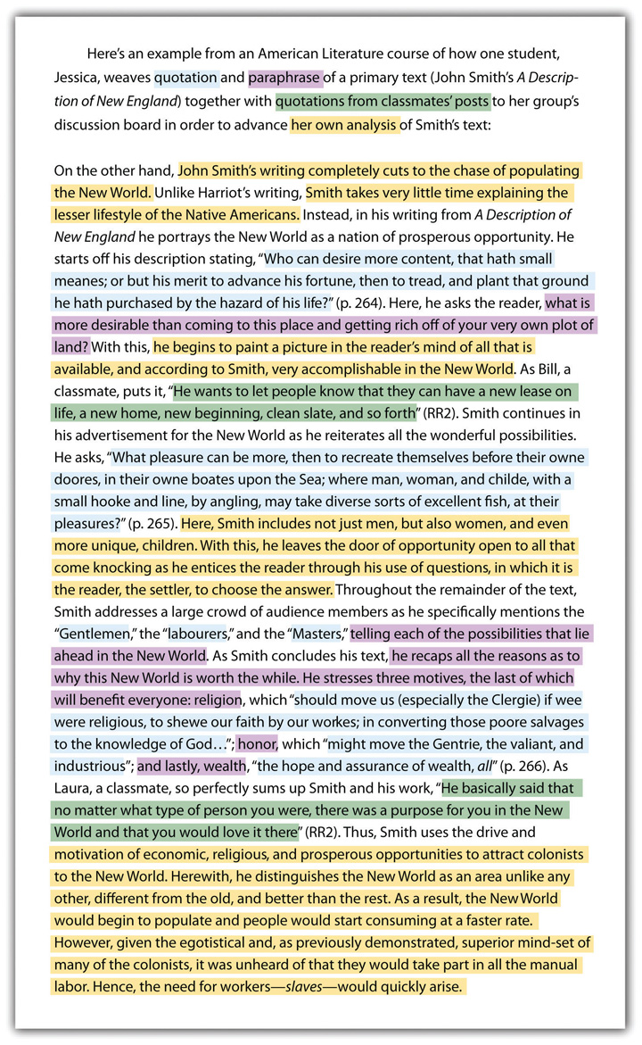

Sharing and Testing Your Thinking with Others

Discussion and debate are mainstays of a college education. Sharing and debating ideas with instructors and other students allows all involved to learn from each other and grow. You often enter into a discussion with your opinions and exit with a widened viewpoint. Although you can read an assignment and generate your understandings and opinions without speaking to another person, you would be limiting yourself by those actions. Instead it is in your best interest to share your opinions and listen to or read others’ opinions on a steady, ongoing basis.

In order to share your ideas and opinions in a scholarly way, you must properly prepare your knowledge bank. Reading widely and using the strategies laid out in the Section 11.2.3 "Connecting Your Reading with Your Writing" are excellent methods for developing that habit.

Make sure to maintain fluidity in your thoughts and opinions. Be prepared to make adjustments as you learn new ideas through discussions with others or through additional readings. You can discuss and debate in person or online, in real time or asynchronously. One advantage to written online discussions and debates is that you have an archived copy for later reference, so you don’t have to rely on memory. For this reason, some instructors choose to develop class sites for student collaboration, discussion, and debate.

KEY TAKEAWAYS
- The assignments you receive from your instructors in college are as worthy of a close and careful reading as any other texts you are assigned to read. You can learn to employ certain strategies to get the most out of the assignments you are being asked to perform.
- Success in college and life depends on time- and project-management skills: being able to break large projects into smaller, manageable tasks and learning how to work independently and collaboratively.

EXERCISE
For every assignment you receive with an open topic, get into the habit of writing a journal or blog entry that answers the following four questions:

- What are some topics that interest you?
- What topics will fit within the time frame you have for the project?
- Of the possible topics, which have enough depth for the required paper?
- For which topics can you think of an angle about which you are passionate?

Figure 11.1
Sample Assignment with Student Annotations
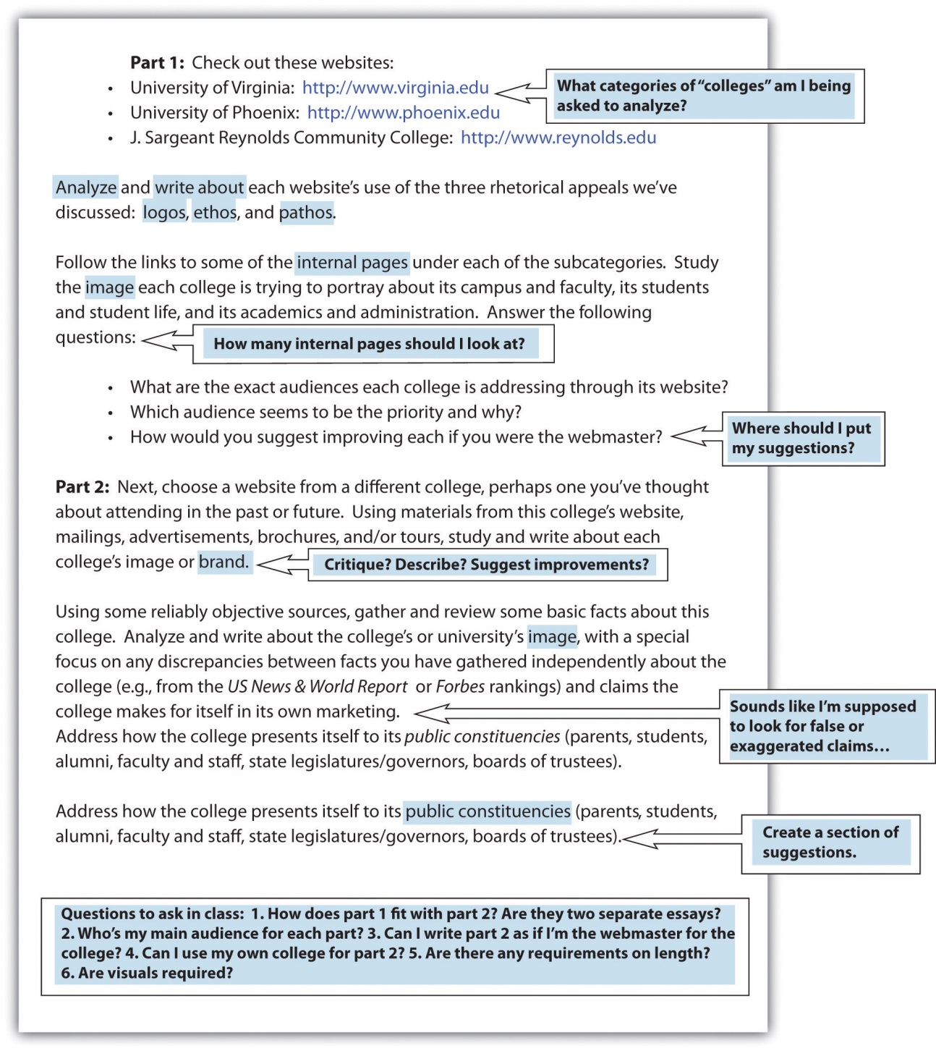

11.3 Collaborating on Academic Writing Projects
LEARNING OBJECTIVES
- Understand how cooperative and collaborative learning techniques, with the help of technology, can enhance college-level writing projects.
- Learn how to give and receive effective and meaningful feedback.

How do you feel about group projects in your college classes? Are you like many students who resist group projects because you prefer to work alone? Do you know why college-level work often requires collaboration and how that collaborative work might be conducted differently than how it’s done in a K–12 environment?

Different Types of Group Work

You might not think of a typical writing assignment as a group project, but you begin collaborating on a writing assignment the moment you discuss your topic with someone else. From there, you might ask classmates to read your paper and share their opinions or to proofread your work. Some students form study groups to assure they have reviewers for their work and to have a collaborative atmosphere in which to work. These are just a few examples of effective college students voluntarily engaging in collaboration.

Choosing to collaborate is not always left up to you, since some instructors often require it, whether through simple group discussion boards or through more complex interactions, such as a semester-long project. Whether or not it starts out as something that’s required, or “part of your grade” for the course, collaboration is something successful college students eventually learn to do on their own.

If your instructor gives you a collaborative writing assignment, don’t assume the worst possible outcome, where one or two people end up doing all the work. Decide and document who will do what and when it will happen. As a group, you are taking on nearly total responsibility for the project when you are involved in a collaborative learning situation. Because of their complexity, collaborative writing projects still tend to be fairly uncommon, but they are becoming increasingly popular ways of developing and testing your collective ability to think, work, and communicate interdependently as part of a team—certainly an essential skill in the workplace.

The Dynamics of Interpersonal Communication

If collaboration is required, making a plan at the beginning of the assignment is essential. Decide if you will meet in person, online, or both. If the level of collaboration is at the reviewing and proofreading level, agree on a date to turn in or post drafts for review and set a clear timeline for completing reviews. For more involved collaborative efforts, such as a joint paper or project, begin by agreeing on a vision for the overall project. Then set up a schedule and split up the work evenly and equally, but with a sense of strategy as well. Figure out each other’s strengths and play to them. Make sure the schedule allows for plenty of time to regroup in case a group member does not meet a deadline.

During group meetings, discuss the direction and scope of the overall project as well as individual components. If any group members are struggling with their parts of the project, keep in mind that the success of all depends on the success of each, so meet to address problems. When group members disagree—and there will almost always be some differences of opinion—talk through the problems with a willingness to compromise while being careful to protect the overall integrity of the assignment. Choose an individual deadline for completion that allows time for all group members to read through the draft and suggest further revisions. If your project includes a presentation, make sure to leave time to plan that as well. Decide if one or more people will present and schedule at least one practice session to assure the group members are happy with the final presentation.

General Group Work Guidelines

- Make sure the overall plan is clear. A group project will only come together if all group members are working toward the same end product. Before beginning to write, make sure the complete plans are fleshed out and posted in writing on the group website, if one is available. Within the plan, include each member’s responsibilities.
- Keep an open mind. You will undoubtedly have your ideas, but listen to other ideas and be willing to accept them if they make sense. Be flexible. Don’t insist on doing everything your way. Be tolerant. Hold back from criticizing others’ errors in an insulting way. Feel free to suggest alternatives, but always be polite. If you think someone is criticizing you unfairly or too harshly, let it go. Retaliating can create an ongoing problem that gets in the way of the project’s completion.
- Be diplomatic. Even if you think a coparticipant has a lousy idea and you are sure you have a better idea, you need to broach the topic very diplomatically. Keep in mind that if you want your opinion to have a fair hearing, you’ll need to present it in a way that is nonoffensive.
- Pay attention. Make sure you know what others are saying. Ask for clarification when needed. If you are unsure what someone means, restate it in your words and ask if your understanding is correct.
- Be timely. Don’t make your coparticipants wait for you. As a group, agree to your timing in writing and then do your part to honor the timeline. Allow each person ample time to complete his or her part. Tight schedules often result in missed deadlines.

Managing Consistency of Tone and Effort in Group Projects

Human nature seems to naturally repel suggestions of change from others. It is wise to remember, however, that no one is a perfect writer. So it is in your best interest to welcome and at least consider others’ ideas without being defensive. Guard against taking feedback personally by keeping in mind that the feedback is about the words in your paper, not about you. Also show appreciation for the time your classmate took to review your paper. If you do not completely understand a suggestion from a classmate, keep in mind the “two heads are better than one” concept and take the time to follow up and clarify. In keeping with the reality that it is your paper, in the end, make only the changes with which you agree.

When you review the work of others, keep the spirit of the following “twenty questions” in mind. Note that this is not a simple checklist; the questions are phrased to prevent “yes” or “no” answers. By working through these questions, you will develop a very good understanding about ways to make the writer’s draft better. You’ll probably also come up with some insights about your draft in the process. In fact, you’re welcome to subject your draft to the same review process.

When you have an idea that you think will help the writer, either explain your idea in a comment box or actually change the text to show what you mean. Of course, only change the text if you are using a format that will allow the author to have copies of both his or her original text and your changed version. If you are working with a hard copy, make your notes in the margins. Make sure to explain your ideas clearly and specifically, so they will be most helpful. Do not, for example, note only that a sentence is in the wrong place. Indicate where you think the sentence should be. If a question comes into your mind while you are reading the paper, include the question in the margin.

Twenty Questions for Peer Review

- What sort of audience is this writer trying to reach? Is that audience appropriate?
- What three adjectives would you use to describe the writer’s personality in the draft?
- How well does the draft respond to the assignment?
- What is the draft’s purpose (to persuade? to inform? to entertain? something else?) and how well does it accomplish that purpose?
- Where is the writer’s thesis? If the thesis is explicit, quote it; if it is implicit, paraphrase it.
- What points are presented to support the thesis?
- How do these points add value in helping to support the thesis?
- How does the title convey the core idea in an interesting way?
- How does the paper begin with a hook that grabs your attention? Suggest a different approach.
- How effectively does the writer use visuals? How do they add value?
- Where else could visuals be used effectively? Suggest specific visuals, if possible.
- How are transitions used to help the flow of the writing? Cite the most effective and least effective transitions in the draft.
- Is the draft free of errors in punctuation and grammar? If not, suggest three changes. If there are more than three errors, suggest where in this handbook the writer could find assistance.
- How varied are the sentence styles and lengths? Give one example each of a short, simple sentence and a long, complex sentence in the draft.
- What point of view is used throughout the paper?
- How well does the conclusion wrap up the thesis? What else could the conclusion accomplish?
- How are subheadings used, if they are used?
- What are the strongest points of the draft?
- What are the weakest points of the draft?
- What else, if anything, is confusing?

Assessing the Quality of Group Projects

Instructors assess group projects differently than individual projects. Logically, instructors attribute an individual assignment’s merits, or lack thereof, completely to the individual. It is not as easy to assess students fairly on what they contributed individually to the merits of a group project, though wikis and course management systems are making individual work much easier to trace. Instructors may choose to hold the members of a team accountable for an acceptable overall project. Beyond that, instructors may rely on team members’ input about their group for additional assessment information.

For an in-depth collaborative project, your instructor is likely to ask all students in the group to evaluate their own performance, both as individuals and as part of the larger group. You might be asked to evaluate each individual group member’s contributions as well as the overall group efforts. This evaluation is an opportunity to point out the strong and weak points of your group, not a time to discuss petty disagreements or complain about group plans that did not go your way. Think about how you would feel if group members complained about your choices they did not like, and you can easily see the importance of being flexible, honest, and professional with group evaluations. For a clear understanding of how an instructor will grade a specific collaborative assignment, talk to the instructor.

KEY TAKEAWAYS
- Online tools and platforms like course management systems and wikis allow students to collaborate by sharing information and by editing, revising, and publishing their finished work.
- Collaborative learning approaches are increasingly prevalent in higher education, as colleges attempt to prepare students for the demands of increasingly collaborative work environments.

EXERCISES
- If the writing course in which you are currently enrolled is not using a wiki, write a rationale to your instructor for how the course might benefit from having such a collaborative platform. (Check out two of the most popular wikis for which free educational versions are currently available: http://www.wikispaces.com and http://www.pbworks.com.) Include an evaluative comparison in your proposal and suggest to your class and instructor which would be the best to use for your writing course and why. Make sure you take into account how you would observe the syllabus and assignments currently in place for your course, and consider how they might be adjusted to meet the demands of a more collaborative context.
- As part of your proposal, you could set up a free wiki online and create a one-page essay explaining the process of setting up a free wiki. Publish your essay in your wiki and then give the rest of the class and your instructor permission to see your essay. If your writing course is already using a wiki, consider how you would draw up a similar proposal to an instructor in another discipline. For example, how would a history, biology, psychology, business, or nursing course benefit from a wiki?
- Choose an essay you have written for a previous assignment in class. Exchange the paper with a classmate. If possible, exchange an electronic version rather than a hard copy. Answer each of the “Twenty Questions for Peer Review” in this section. When necessary, make notes in the margins of the paper (by using Insert Comment if you are working in Word, then resaving the draft before returning it electronically).

Chapter 12
Professional Writing
Writing as a Component of Success
You probably know someone who has said, “I’m a lousy writer, but it doesn’t matter since I don’t write for a living and I’m not an English teacher.” You might have even made such a comment yourself. In reality, good writing can help you from the moment you apply for a job throughout your time in the workforce. And regardless of whether you are writing in academic or professional settings, good writing involves an awareness of voice, audience, and message.

12.1 Writing Business Letters
LEARNING OBJECTIVES
- Recognize key parts of a business letter.
- Learn the block format of a business letter.
- Understand the professional nature of a business letter.

You might think that people living in the age of technology do not need to learn business letter skills. After all, in today’s professional world, e-mails have replaced business letters as the primary mode of communication. However, many formal situations are still best handled with business letters, whether they are sent on paper or as an attachment to an e-mail.

When writing a business letter, if you use business letterhead that includes the company address and other contact information, you do not need to incorporate that information within the letter. The most common format of business letters, the block format, uses one-inch margins with all content flush against the left margin, including the body paragraphs. Some less common forms do use indentation. Business letters include the following parts, as shown in this sample:

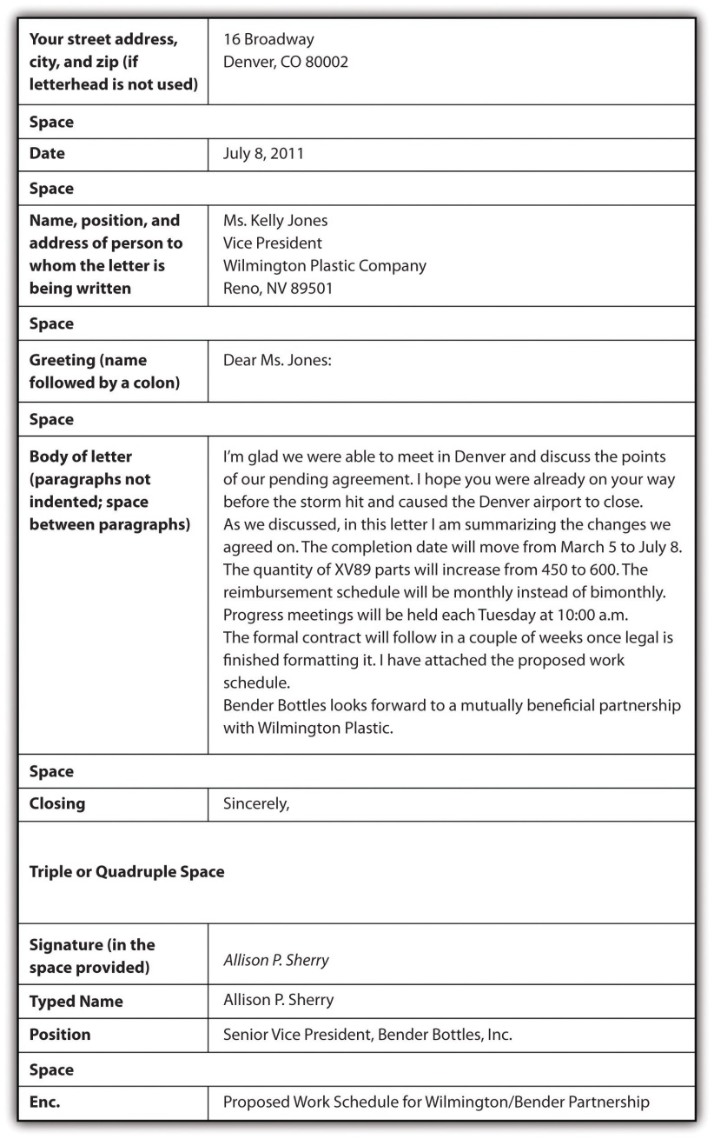

When writing a business letter, keep these tips in mind:

- Do not use slang.
- Be professional.
- Be concise and to the point.
- Mention a personal connection, if you have one, briefly at the beginning of the letter to create a personalized introduction.
- Use the abbreviation “Enc.” or the word “Enclosed” prior to a list of papers that are included with the business letter.
- Proofread for grammar, punctuation, and spelling.
- Make sure that a letter attached to an e-mail is in a document format that your recipient also uses.
- Use a person’s name in the greeting whenever possible. If you have no way of acquiring a name, use “Dear Sir or Madam” or similar generic, but professional, wording.

KEY TAKEAWAYS
- The block format is the most common form of a business letter.
- Business letters, whether sent in hard copy or digitally, should include date; name, position, and address of recipient; greeting; body; closing; signature; typed name; position of sender; and enclosure list if there are any enclosures.
- Business letters should be formal in tone, concise, free of errors, and personalized at a professional level.
- Business letters are often attached to e-mails. In such cases, make certain the recipient has the necessary software to open the letter.

EXERCISES
- Demonstrate your understanding of business letter techniques by writing a realistic mock business letter.
- Collect a sample of business letters you receive in the mail over the next few weeks. Bring the samples to class and share them with your group; look for differences and similarities in format and tone.

12.2 Writing to Apply for Jobs
LEARNING OBJECTIVES
- Recognize visual features of a résumé.
- Recognize content components of a résumé.
- Understand how to target a cover letter.

As part of the process of applying for any job in any profession beyond the entry level, you are likely to have to produce two main written documents: a résumé and a cover letter or letter of application. Writing these documents well is often a key determiner in whether you get the job. To illustrate, we’ll follow a student, Joey Williams, through these two key professional writing challenges. Joey is a recent graduate of a master’s degree program in public relations who is seeking a position at a graphic design firm

Creating Solid Résumés

Common résumé formats vary with types of jobs and with the times, but regardless of the type of position you are seeking, your résumé should include some key features and some key information.

Key Résumé Features

Effective résumés have the following features:

- They are meticulously edited (absolutely no errors).
- The subheadings stand out and are short enough to be read at a glance (one or two words).
- Ample white space is used.
- Lists are parallel.
- Bolding is used sparingly.
- One easy-to-read font is uniformly used throughout.
- The font is size 12.
- The résumé is available both in digital and hard-copy form.
- Formatting on a digital résumé holds when it is opened in others’ computers. This formatting should be straight type without tabbing, tables, italics, bolding, columns, or indenting. If it’s included as an attachment, it should be in a Microsoft Word file. A second option is to visually create the résumé as desired and then capture it in a PDF file.
- The résumé is confined to one page unless you are in a profession that requires additional pages or unless you are at a more advanced professional level that requires a more extensive résumé.
- The most recent information is presented first within each category.
- Standard résumé paper is used unless the specific profession calls for something different.
- Accomplishments are presented in nonwordy formats.
- Action verbs are used to describe accomplishments.
- Contact information is clearly visible at the top of the résumé.
- Key words that searchers in your professional field are likely to use are included in résumés that are posted online. (After your contact information, include a “key words” section or weave the keywords into your accomplishments.)

Key Résumé Information

Every résumé should include the following information:

- professional name
- address
- phone number
- e-mail address
- work experience (i.e., places of employment)
- accomplishments at each place of employment
- education
- These résumé components are optional:
- personal interests
- references
- dates of education and work experience
- address for personal website
- employment objective (a good strategy if you want to tailor your résumé for a certain job description)
- fax number
- awards and honors

To ensure that your résumé is both current and appropriate for the position, you should search online for similar sample résumés. You should also run your résumé past the career placement services at your college and any people you know who are working in your field of interest. Here’s Joey’s generic résumé:
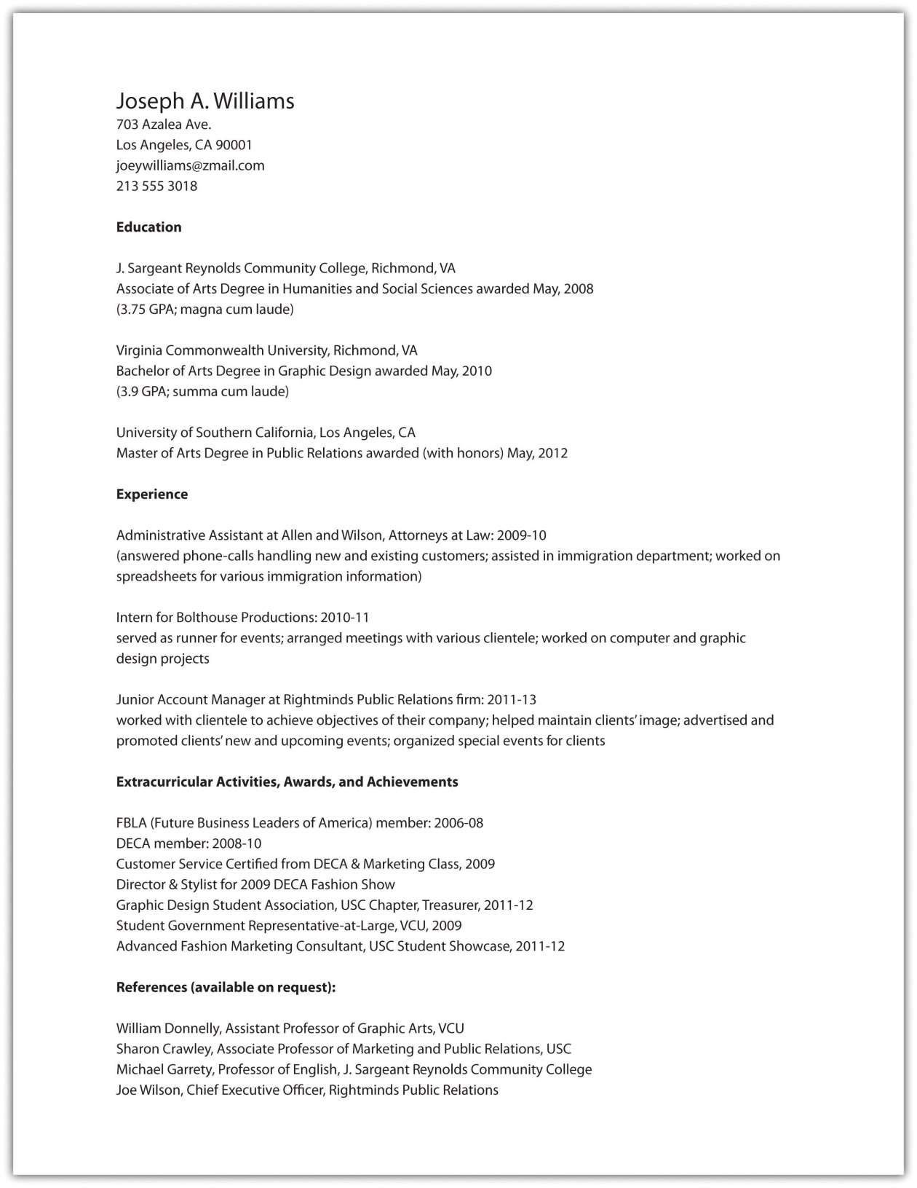

Writing Targeted Cover Letters

Along with sending a résumé when applying for a job, you will almost always want to send a cover letter. This suggestion holds true in both hard-copy and digital situations. A hard-copy cover letter should be formatted as a standard, typed business letter (for a sample, see Chapter 12 "Professional Writing", Section 12.1 "Writing Business Letters"). A digital cover letter should be either typed directly into a given window or copied and pasted into the window. If you copy and paste, check to make sure that the formatting holds.

When the job market is tight, just getting an interview is a major hurdle. Facing dozens and sometimes even hundreds of applicants, employers are looking for reasons to cut down their pool of potential interviewees. Don’t give them a reason not to interview you by writing a vaguely worded, overly general letter of application or résumé, especially when you can easily revise and tailor your approach to each position for which you are applying.

To target a cover letter means to write it specifically for an identified job. You can gather information to target your cover letter by looking carefully at the job description and by studying the company’s website. Let’s look at an example of an online job description that has caught Joey’s attention:

Video Game PR—Assistant Account Executive

About the Job

GolinHarris is a leading international public relations firm and winner of PRWeek’s Large PR Agency of the Year 2010, 2010 Best Places to Work by the Los Angeles Business Journal, and numerous industry awards.

Our western region headquarters, based in Los Angeles, is currently seeking an ambitious and motivated PR professional to join our team as an Assistant Account Executive. The successful candidate will play an integral role and receive valuable hands-on experience by working on our Nintendo account. We are launching exciting programs in the next few weeks and this opportunity will not last long. Avid gamers are encouraged to apply now.

The candidate we seek will perform fundamental PR tasks such as aiding in production of media-related materials, pitching program highlights to the media, monitoring for quality and quantity of media coverage and managing client publications and resources materials.

What Do You Need to Be Considered?

- 2 years of work experience in PR required, agency and video game background is preferred
- Applicants with only internship experience will not be considered
- A passion for communications and consumer issues
- Stellar AP-style writing abilities
- A Bachelor’s degree
- Social media experience
- Local applicants preferred

About Us

As a member of the Interpublic Group (IPG), GolinHarris partners with a network of the communication industry’s best strategists across a variety of disciplines, including sports marketing, consumer research, branding, special events and advertising. We collaborate with these partners to continually advance our clients’ businesses.

At GolinHarris we recognize that there is much more to life than just work. Our benefits program has been designed to help GolinHarris employees and their families stay healthy, balance personal and career priorities, and build a solid and secure future. We offer a great workplace, culture, competitive salary, health care benefits (medical, dental and vision insurance), 401k and more.

GolinHarris is an Equal Opportunity Employer. EEO/AA.M/F/D/V.

Source: GolinHarris

As Joey prepares his cover letter, he’ll need to include, in three or four paragraphs, information about himself and his fitness for the position that complement what his résumé already reveals. Typical contents of the paragraphs of his cover letter might include the following:

First Paragraph

- The job for which he is applying
- How he learned of the job
- A statement clearly and succinctly indicating why he is well suited for the job

Second Paragraph

- Some current, relevant experiences that show he has a good background for the job. This should be where he places the most significant points he has to offer.

Third Paragraph

- Other relevant job experiences or education. This is where he puts what might be considered his “second level” of important points.

Fourth Paragraph

- A statement about wanting to have an opportunity to discuss the job
- An offer to send references as needed
- Request to be contacted and a reiteration of his main contact information (most likely a phone number or an e-mail address or both)

Keep in mind that your cover letter is the first chance to present yourself and often the only chance. Besides being sure to include the most pertinent and valuable information you have to offer, be very careful that your letter is grammatically correct with no punctuation or spelling errors. Proofread it carefully yourself, and then, even if you think the letter is perfect, ask a trusted acquaintance to proofread it. Errors in this kind of high-stakes writing situation can be fatal to your chances of achieving your desired goal: getting your foot in the door professionally.

As he is planning his cover letter, Joey decides to apply what he has learned in his academic writing career to this all-important professional challenge. Thus, before writing, he fills out the statement of purpose he used six years before when he was a first-year college student:

Voice | I am writing as a young, eager, well-educated, and flexible individual who wants to be a part of the GolinHarris team.
Message | I want to convey the message that I will bring extensive gaming, graphic design, and public relations experience and credentials to the position.
Audience | I want to write to the human resources department or hiring manager at GolinHarris.
Attitude | My attitude toward the subject is positive and confident, but also somewhat deferential, humble, and respectful of authority.
Reception | I want my audience to give me an interview because they realize they’ve got a hot local prospect who’s perfect for the job.
Tone | My tone toward my readers is professional, but creative, enthusiastic, and cutting-edge.

Armed with his statement of purpose, Joey writes the following cover letter:

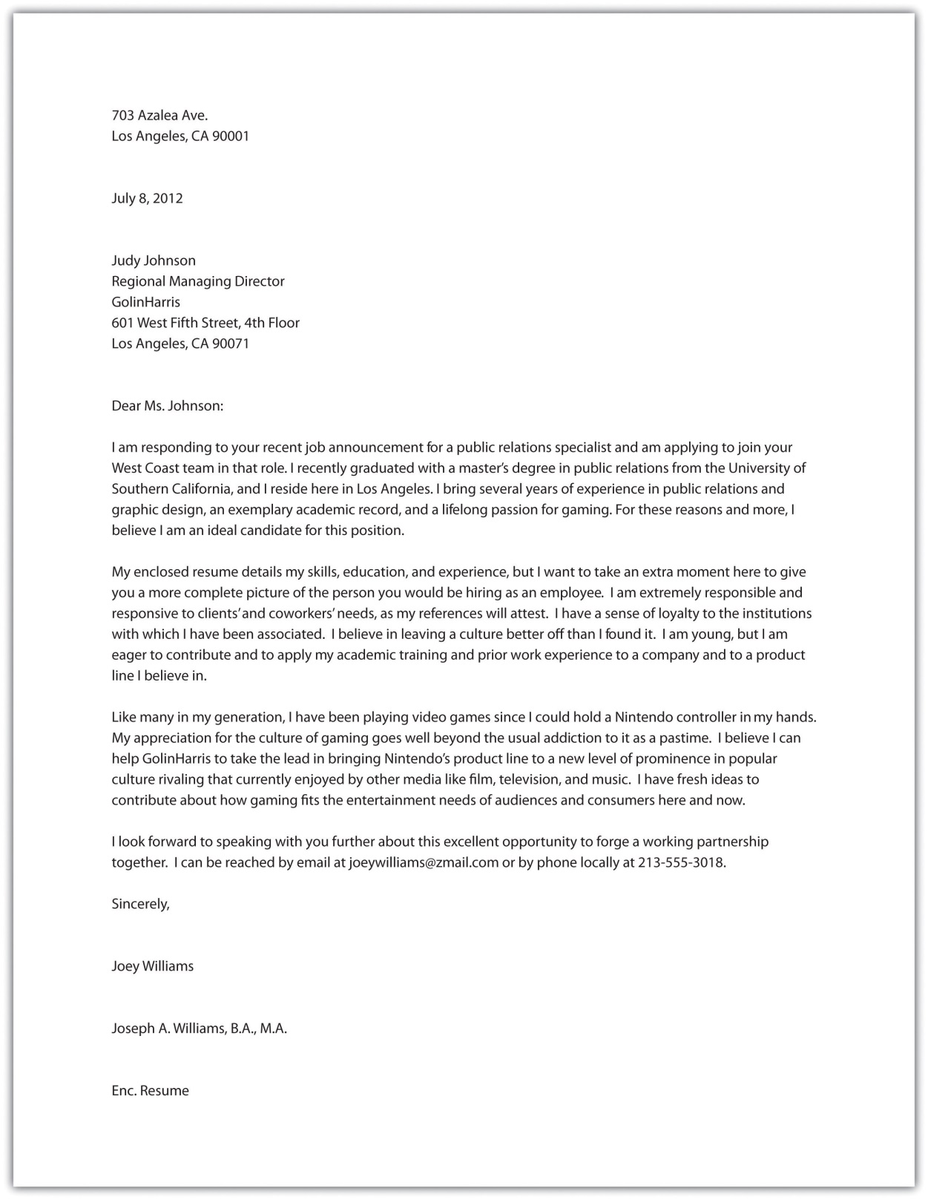

KEY TAKEAWAYS
- The visual elements of résumés are important, including subheadings, white space, paper choice, font choice, and limited use of font features.
- Your résumé should be available in both print format and digital format. Digital résumés must have very little formatting. A PDF version can sometimes be used instead of a nonformatted option.
- All résumés should include your professional name, address, phone number, e-mail address, work experience, and education. You might also choose to include your personal interests, references, website address, objective, fax number, and awards and honors.
- You should always include a paper or digital cover letter with your résumé. Your cover letter should include three or four paragraphs that include the position for which you are applying, the most relevant experiences you have had that make you a good candidate for the job, a request to discuss the job, and your contact information.
- Of all the types of writing you do, perhaps none requires more meticulous attention to detail and editing than résumés and cover letters.

EXERCISES
- Create a résumé that you could use when applying for a specific position. Generate both a paper version and a digital version.
- Find a position description for a job that interests you and fits your current or prospective skills. Write a cover letter that you could send with your résumé to apply for that job. Before you write your cover letter, use the job description as a guide for filling out a statement of purpose.
- Working with your writing group, search online for a collection of job descriptions. Using an agreed-on selection from your sample, assign each member of your writing group the task of designing a résumé and cover letter to meet the needs of that description (with each group member “applying” under an assumed name). Then compare the submissions and determine which two applicants should be interviewed as finalists. Explain the reason for your choices.

12.3 Composing Memos
LEARNING OBJECTIVES
- Recognize the typical usage for memos.
- Understand the parts of a memo.

A memo is less formal than a business letter but more formal than an e-mail. Memos are usually sent within a company addressing a single issue or meeting and are typically short. A common feature of memos is the heading followed by a colon. Memos typically include the following set components.

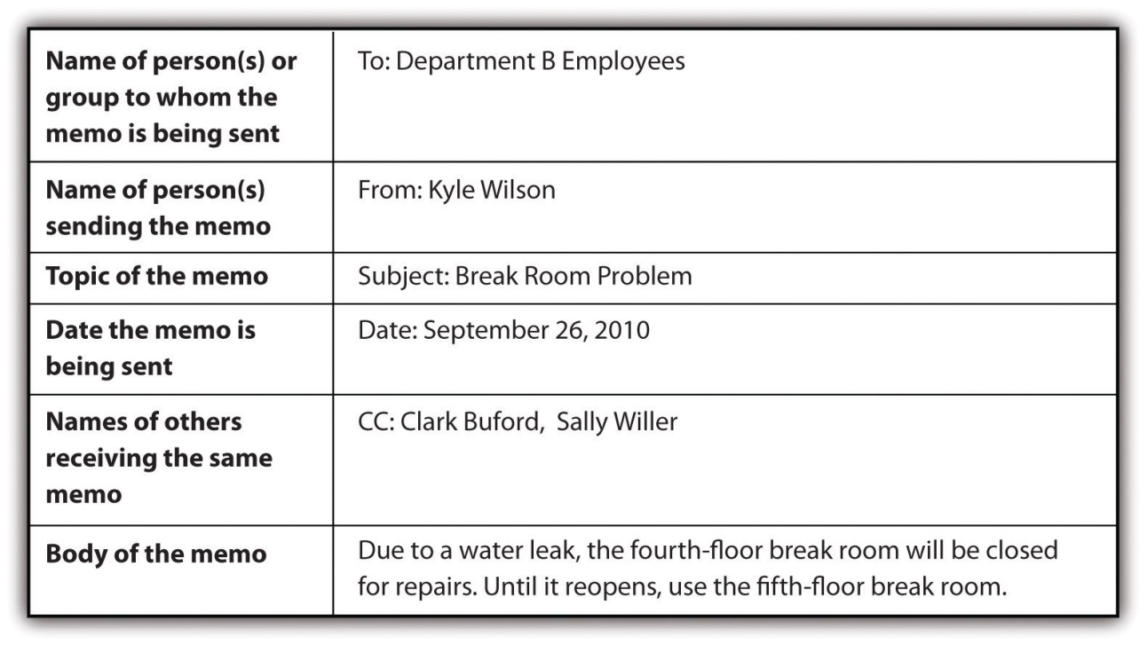

Companies often have blank memo forms in digital and hard-copy formats.

Figure 12.1 Example of a Blank Memo Form
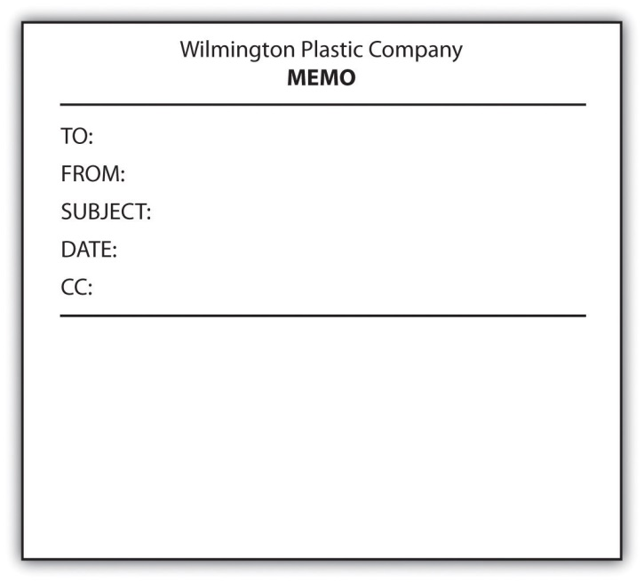

KEY TAKEAWAYS
- Typically memos are short, are used for internal company matters, and cover a single issue.
- Typically memos include six parts: to, from, subject, date, carbon copy, and body text.

EXERCISES
- Make a list of five reasons a person might use a memo at work instead of sending an e-mail or mailing a business letter to employees.
- Create a memo form in your computer. Use your form to create a handwritten memo and a typed memo.
- Use a memo template for the next writer’s memo you submit with a college writing project. (See Chapter 5 "Planning" for more on how to develop a writer’s memo and a statement of purpose that describes message, audience, voice, attitude, reception, and tone.)

12.4 E-mail and Online Networking
LEARNING OBJECTIVES
- Recognize the dos and don’ts of business e-mails.
- Recognize online networking opportunities other than e-mailing.
- Describe ways to use online networking (other than e-mailing) for business purposes.

Online networking refers to a variety of methods of talking to others over the Internet, including e-mailing. Since e-mailing is so common and has been around longer than the other methods, it will be dealt with as a separate entity here.

Using E-mail in the Workplace

E-mailing started small in the 1960s and became more widespread by the 1990s. Today the idea of going a day without e-mails is incomprehensible to many people, both professionally and personally. Even though most working people in the United States have both personal and work e-mail, workplace e-mail guidelines make the two quite different. Failing to follow these guidelines for workplace e-mails can have a range of ramifications from mild embarrassment to termination from your job. The following guidelines are general and most of them will apply in most workplaces. You are likely to find, however, that your workplace has its own guidelines that you will need to learn and follow.

Here are some general workplace e-mail guidelines:

- Make sure your writing has no grammatical, spelling, or punctuation errors and no typos. Any e-mail, whether it is sent internally or externally, reflects not only on the person sending it but also on the organization employing that person.
- Use standard wording, spelling, punctuation, and capitalization. Do not use any of the abbreviated, casual text that is common in personal online communications.
- Use a subject line that targets the key point of the e-mail so that the subject line can be a helpful sorting or searching tool.
- Be concise.
- Be courteous.
- Use jokes sparingly since they are often misunderstood.
- Use short paragraphs. Large blocks of digital text are difficult to read.
- Type in upper- and lowercase letters. Writing in all capital letters is perceived as shouting and writing in all lowercase letters is difficult to read.
- Keep in mind that electronic text is very easy to share with few or many. Don’t put anything in an e-mail that would be problematic if shared beyond your intended recipient.
- Most e-mail systems allow you to design and include a signature at the end of your e-mails, with the company name, your title, your e-mail address, and your phone number. Unless you are writing to a colleague with whom you have daily contact, plan to include your signature.
- When e-mailing a business acquaintance you do not know well, use a standard business letter greeting (“Dear Jack” or “Dear Mr. Wichel”) and closing (“Sincerely”). When you do know the person well, you can relax the greeting and closing a little if doing so would mesh with the culture of your company.
- Keep in mind that different computers and e-mail programs receive e-mail text differently. Do not rely on text features, such as bolding, italicizing, color, and underlining, to carry meaning.
- Clean up forwarded e-mails so that old e-mail components are not included unnecessarily or unintentionally.
- Take great care with your tone. A good way to check that your tone comes off accurately is to reread your e-mail aloud once you are finished writing it. If you sense that you are sending or replying to an e-mail out of anger or frustration, enforce an overnight cooling-off period before clicking the send button.
- If you make changes in your e-mail, reread the whole e-mail when you are finished to make sure you made any needed adjustments to accommodate the changes.
- Avoid using your work e-mail for personal messages, and especially avoid sending any messages or attachments that could be considered vulgar, offensive, or inappropriate. Keep in mind that all work e-mail might be monitored.
- Try not to send unusually large attachments that might clog the in-boxes of colleagues and coworkers, and keep your mailbox clean, so you don’t overtax the server space of your organization.

Using Other Online Networking

The e-mail guidelines in also apply to other online networking situations. Whether you use other online networking tools will depend on your company. Having a general awareness of some of the other options is helpful when you join a company.

Table 12.1 Some Other Online Networking Options
Networking Tool | Description
Blogs | Short for weblog, a blog is a personal online journal. Since blog content can show up in Internet searches, many businesses now maintain blogs as a means of sharing information with customers.
Niche networking sites | Specialty networking sites, such as for quilters, surfers, or vegans, serve as a hub for sharing ideas.
Podcasts | You can record and post audio files for others to download by subscription through a Real Simple Syndication (RSS) feed.
Professional networking sites | Pay sites or sites with ad content can be used by job seekers to post their skills, by employers to find employees with needed skills, or by employees to network with others in the same field.
Social networking sites | Initially used only for personal interchanges, these are now also used by many businesses as a means of reaching out to customers.
Video sites | You can create video files and upload them onto the Internet for others to view.
Wikis | You can use these websites to collaborate on projects with invited group members. On such sites, group members at many different physical locations can work together by adding their input on a single document.
White-space social networking sites | These company networking sites are meant for internal communication and are not open to the public.

KEY TAKEAWAYS
- Business e-mails are online communications that are similar in many ways to business letters.
- To avoid misunderstandings, jokes should not be used in business e-mails.
- Due to the ease of sharing electronic text, you should make sure that your e-mail content will not embarrass you or cause other problems for you.
- Aside from e-mail, many other online networking opportunities abound, including blogs, niche networking sites, podcasts, professional networking sites, social networking sites, video sites, wikis, and white-space social networking sites.

EXERCISES
- Reword the following e-mail subject lines in a more concise manner.
  - Meeting at four o’clock for all departments members involved in the new product line.
  - A faculty meeting will be held on Tuesday to discuss the new teacher lounge.
  - Five customers have complained today that they have not received their orders.
  - Delvin is out sick today so you need to find someone to cover for him.
  - Our new blown glass vendor is offering some phenomenal deals.

- Explain the problem with the following e-mail.
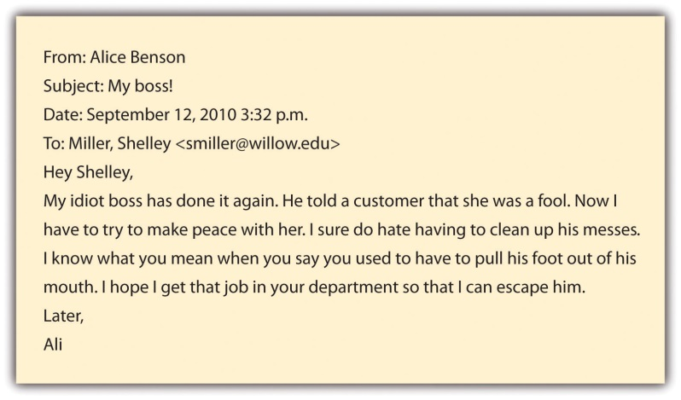

- Choose an online networking tool from among the many available on the web and write a brief report explaining how it works.

Chapter 13
Writing on and for the Web
Writing in the Digital World
The digital world has permanently altered written communication. Copying and pasting ease the sharing and transferring of large blocks of text. Independent and joint editing of text is much easier and much less time consuming. Searching for specific parts of a long text is quick and easy. Checking for plagiarism takes only a few seconds.

Multimodal compositions can be created by incorporating visual and auditory material into written texts. The following sections provide a general overview of composing in web-based environments, creating websites, collaborating online, creating e-portfolios, and using web links.

13.1 Composing in Web-Based Environments
LEARNING OBJECTIVES
- Recognize situations where you might compose for the web.
- Differentiate between casual and formal online writings.
- Understand proper and improper online writing based on each individual situation.

Both as a student and in other aspects of your life, you are likely to write information and publish it on the Internet. Some examples of possible Internet writing that many people take part in are chat rooms, social networking sites like Facebook, voice over Internet protocol (VOIP) platforms like Skype, e-mail, mobile cellular texts, online distance-learning coursework (such as assignments, group projects, and discussion forums), blogs and responses to blogs, instant messages, wikis, nonacademic discussion forums, web-based memorial sites, responses to online newspaper articles, and job applications. Given that few of these media or genres existed a generation ago, it’s patently absurd to argue that “people don’t write (or read) anymore,” and it’s difficult to argue that writing teachers shouldn’t try to account for what’s at stake when you write on and for the web.

Like every other kind of written communication, how you write on the web depends on the purpose of the specific situation. In reality, you’ve probably developed a pretty good system for running your web-based communication through an almost unconscious version of the statement of purpose questions from Chapter 5 "Planning". If you have an unlimited text plan and maintain at least one profile on a social networking site, you concern yourself with matters of voice, message, audience, tone, attitude, and reception hundreds of times a day. At the very least, students and teachers ought to be trying to learn together how to apply or translate the sophisticated rhetorical strategies you use in your casual communication to your more serious academic and professional endeavors.

Because you are often multitasking while texting or using the web and because of the speed and convenience of electronic communication, this realm is prone to carelessness. In casual situations, rules are minimal and you can use very casual language that includes abbreviations, slang, and shortcuts. Your use of a casual tone depends solely on whether your audience will understand what you are saying. Writing for school or work does not fall into the casual category. In these situations, you cannot use abbreviations, slang, and shortcuts. In fact, you need to use proper punctuation, grammar, and capitalization. You should also use traditional writing rules and a more formal tone when responding to diverse populations and serious situations.

Whether writing in a casual or formal situation, always be aware of the population that has access to your content. Also keep in mind that even if you are writing on a semiprivate venue like a class-wide course management system or on an invitation-only wiki, your digital text can easily be copied by someone with access and forwarded to someone without access. So don’t write anything that could embarrass or cause problems for you or others.

Due to the nonprivate nature of the Internet, you should not provide full contact information. Depending on the situation, you might choose to use your full name (such as in an online class or on a memorial condolence site) or you might choose to use a pseudonym (such as in a response to a blog or to an online newspaper article). Only give your phone number and address when you are on very secure sites. Never post your social security number online. If you have a legitimate request for your social security number, call and give it over the telephone.

KEY TAKEAWAYS
- In the online environment, casual situations call for different writing techniques than do formal situations.
- Do not post information on the Internet you do not want to be public.
- In the online environment, take care to protect your personal information. Share your full name only in formal situations. Provide your phone number and address only on secure sites. And do not post your social security number online at all.

EXERCISES
- Examine your profile on a social networking site like Facebook. (Chances are, you have one.) Run your page, posts, and profile through the statement of purpose questions in Chapter 5 "Planning" on message, audience, voice, attitude, reception, and tone. Now do the same with sites of five close friends.
- Scroll through the text messages you’ve sent and received in the last week. What do you notice about how you manage your tone, attitude, and reception differently depending on the message you are trying to convey, the audience you are trying to reach, and the voice you are trying to project?
- Identify each of the following as a forum that could be considered casual or formal and thus worthy of a casual or formal tone:
  - chat room
  - social networking site like Facebook
  - e-mail message
  - instant message
  - wiki
  - memorial condolence site
  - an employment opportunity site
- Rewrite the following ideas in your words in two different ways: one that would work for a casual online post and one that would work for a formal online post.
  - An explanation of your plans for later this afternoon
  - A description of your college plans
  - An overview of a topic that interests you

13.2 Creating Websites
LEARNING OBJECTIVES
- Understand how to make a website aesthetically pleasing and well organized.
- Understand steps to take to make a website work well.
- Understand how to make a website accomplish its purpose.

You may have occasion to create websites for professional, personal, or academic reasons. Whether you create a site to supplement a résumé, to serve as a common, virtual family meeting place, or to showcase individual or collaborative work you’ve done for a class, you should follow some basic guidelines to make sure your website is aesthetically pleasing and well organized, so that it functions well and accomplishes its purpose.

Making a Website Aesthetically Pleasing

Use relevant photos, graphics, and font variations to give your site interest. Leave plenty of white space. A crowded web page is not inviting. Use an easily readable font and font size with ample leading. Small tight text is hard to read and many Internet searchers will skip such a site and move on to the abundance of other choices. Take care when choosing background and font colors. Make sure your background does not engulf the text making it hard to read. As a rule, make your background light and your text dark. Take care when choosing background effects. A very busy background can detract from your content.

Making a Website Well Organized

Plan for little or no scrolling. Instead include clearly marked navigation links to move to different parts of the information. Include navigation links to all parts of the website from all pages so a person never feels stuck on a page. Design an overall look that holds from page to page to give your website consistency. Use an easily recognizable format for navigation links so that they clearly stand out.

Making a Website Work Well

Use images that are between forty and one hundred kilobytes to ensure clear images that are easily and quickly loaded on most people’s computers. Since one hundred kilobytes is the maximum suggested size, you will have your best luck if you stay well below that level. Match your level of use of technology tools to your needs. Don’t add features just to try to make your site impressive. Remember that the more features you add, the more likely it is that someone will have trouble with your site. Some people’s computers will have trouble with very involved opening pages that include audio and video. If you choose such an opening page, also include an override button for people who can’t or don’t want to view the opening page. Make sure all the links and paths are very obvious and that they all work smoothly.

Making a Website Accomplish Its Purpose

Make sure the home page is uncluttered and clearly states the purpose of the website. This is the main chance you have of attracting attention. Make the website as visual as possible. The more quickly a person can glance through web content, the more likely the person is to take in the information. You can make a site visual by including subheadings that stand out, relevant images, short blocks of text, white space between blocks of text, and numbered or bulleted lists. Keep the website up to date. Depending on the content and purpose of the website, keeping it up to date could be a daily, weekly, or monthly chore. Consider that a site that is out of date ceases to be visited. Include a contact link so viewers can reach you. Remember that anyone with Internet can access your site. Take care with the information you post. Always assume that your instructors, employers, parents, or friends will see it.

KEY TAKEAWAYS
- You can make website aesthetically pleasing by including relevant images, white space, easily readable fonts, background and font colors that work well together, and a nondistracting background.
- You can create a website that works well by keeping image sizes small, using only needed features, leading off with a simple opening page (or including an override button on a complicated opening page), and creating navigation links that are obvious and work smoothly.
- You can create a well-organized website by minimizing scrolling, using clearly marked navigation links, including navigation links on all web pages, and using a consistent appearance throughout.
- You can make sure your website accomplishes its purpose by starting with an uncluttered home page that clearly presents the website’s purpose, making the site visual, keeping the site up to date, including your contact information, and remembering that the site can be viewed by the public.

EXERCISES
- Choose an existing website and evaluate it based on the standards outlined in this section. Rate its aesthetics, its organization, its functionality, and the extent to which it achieves its intended purpose.
- In a Word file, create a mock front page for a website and describe plans for linked pages.
- Create an actual website based on your plans in Exercise 2. For the purposes of this exercise, free sites like Weebly, Wix, Google Sites, PBWorks, or Wikispaces will suffice to get you started. In a designer’s memo, discuss the choices you made to enhance the site’s aesthetics, organization, and functionality and the extent to which it achieves its intended purpose.

13.3 Collaborating Online
LEARNING OBJECTIVES
- Understand general group work guidelines.
- Identify technology factors in an online collaborative site.
- Recognize special social aspects of working in an online group.

Both education and business regularly take advantage of online collaboration. In education, students are often asked to collaborate online to discuss course readings, to work on group projects, or to edit each other’s work. In business, employees often work together online to brainstorm and develop ideas and projects. The online environment allows people who are in different physical locations to work together virtually. In addition, online collaboration sites allow everyone to keep track of each participant’s contributions.

Some basic etiquette rules apply to all online collaboration situations. You will notice that many of the rules hold true for any group work situation. (See Chapter 11 "Academic Writing", Section 11.3 "Collaborating on Academic Writing Projects" for more on general guidelines for working collaboratively in academic settings.)

The Role of Technology in Group Project Design

Technology has introduced a whole array of platforms and tools for group projects. Course management systems, such as Moodle, Blackboard, or eCampus, tend to excel as spaces to post course materials and external links, to conduct group discussion boards, to provide for electronic submission of essays, and to manage records like grades, calendars, announcements, and deadlines.

The following is an example of how a richer kind of threaded small-group class discussion about possible connections between video games and violent behavior can be conducted online, even in a face-to-face class. This discussion was conducted after each of the seven students in a writing group had posted their initial response to a couple of opposing readings on the subject. In order to keep the online conversation going, the students were asked to respond to at least one group member’s initial post, using the following questions:

- What patterns do you notice about your group members’ or classmates’ responses to the readings?
- Where do you notice differences in opinion between your responses and those of your group members or classmates, or among their responses?
- What are any possible clarifications and interpretations of specific moments from texts that group members or classmates seem to be having trouble with?
- Which texts (or which aspects of texts) still warrant special attention before the class moves on to the next unit of assigned readings? Be specific about what you want your group members or classmates to discuss. What additional questions do you have about the readings?
- What ideas do you have for ways specific group members or classmates could use their responses to develop their understanding of the questions into a full-fledged essay?

Do you think the following threaded discussion opens up new avenues of exploration for the students involved? Think about how the debate progressed in this online environment, and consider how it might have operated differently if conducted face-to-face in a traditional, oral class discussion.

- Bill: In response to Amber’s post: Do you think that violence in video games causes the violent action or do you think that it just adds fuel to the fire? I play violent video games, but I don’t go around hitting people and blowing things up. I was in the Marines for the last five years and never shot anyone. So my belief is that these people are already messed up in the head. I think the lack of morals in teens comes from parents not being able to punish their children as they see fit resulting in a generation of misbehaved misfits who have grown up undisciplined. My suggestion would be for parents to monitor their children’s use of video games and explain the difference between games and real life.
- Amber: As I read other people’s posts I see most people say no. Well I still stand by my opinion on the whole thing. I didn’t say that everyone who plays violent video games will make them a violent person. I just think that violent video games have the potential to play a role in children’s minds today in the United States. Not every person who plays these violent video games will have a negative effect on their minds. I don’t think that people should stop playing violent video games, but I do think that young children today should not play them as much or until they are old enough. I will always think that violent video games will lead to violence in a child’s mind because they see it on these games played.
- Adam: Having read other students’ posts, I can tell that there are those who say yes and those who say no, but to those who say yes I have to ask, Would you rather someone release their anger and rage on real people or virtual avatars that have no feelings, have no sense of pain, feel no fear, or anything? All I’m asking is, If there are going to be people with violent behaviors, would you rather the result be virtual or real?
- Brandy: I noticed that several of my other group members noticed the lack of concrete evidence on the yes side of the argument. Two of them, I believe, brought up something that I had forgotten could be possible. It may be that violent games children play bring out the violent and aggressive side in them that already existed but lay somewhat dormant, for lack of a better description. I can’t imagine a mentally stable child being driven out of his or her balanced mind-set of some sort of common sense and morality and a distinction between reality and a virtual world simply and solely by a violent game. If anything I believe it would, as Jamal said, “desensitize a person,” but not turn that child into an aggressive child.
- Malcolm: Violent video games will be a problem when presented to individuals who already have a problem waiting to come out. A hundred years ago, without video games around, there was still influence from books to trigger acts of violence. Not everyone that read books found the desire to act violently, but some people found glorification of violence in books, enough for it to suggest to them that it was the right thing to do. This is no different from video games today.
- Jamal: As my classmate, Amber, brought up, there could be a negative impact on young children. My thought, though, is that the level of reality that the game takes on could be a factor. Games that are trying very hard to look real and have all the lifelike components of war, gang life, or even mercenaries could be a little over the top for some ages. It is the same reason you do not let an eight-year-old watch SAW or something like that. They are unable to process that kind of information without having a nightmare or at least looking under the bed.
- Becky: After reflecting more on the issue, and everyone’s responses, I’m also unable to say yes or no to the argument. I still don’t see any value to these kinds of games and think they serve no positive purpose, but I can’t confidently say that violent video games lead directly to violent actions. There are just too many other factors that require recognition. Just as the no responses claim that those committing violent acts are already “messed up” and cannot differentiate between right and wrong because they were not taught so, the same idea can be flipped to suggest that violent video players who were taught certain values will not commit violent acts. Where is the control group? I don’t see how either side can present a solid story with so many variables.

Because course management systems are not really designed for collaborative composition courses, they’re not really ideal for group writing projects. Wikis, another type of collaborative technology tool, are beginning to replace course management systems for certain kinds of collaboration because they can make group work much more convenient, visible, and meaningful. Professors can set up a wiki as a free online collaborative platform that offers workspace for class-wide group or individual projects. Within a site, individuals can have private workspaces to which other students do not have access unless the site “owner” invites them. Students can use a wiki to gather notes and compile a writing project from beginning to end. Within a wiki, students can save all versions of a draft allowing for retrieval of previous information. Being able to save different versions also allows multiple students to edit, for example, Pete’s draft so that Pete can then access all the edits and choose the changes he wishes to make.

Since each student has a private log-in and password, wikis can easily keep track of who made what changes and when the changes were made. You can even use the settings on your wiki account to have it send you an e-mail whenever someone adds something to your space. Students and teachers can also upload files and place links on the wiki to relevant materials elsewhere on the Internet, such as to an American Psychological Association (APA) or Modern Language Association (MLA) citation builder. Wikis also offer a platform for publishing the final version of a project for viewing by the instructor, other classmates, and even the general public, if desired.

Online Collaborative Sites and Group Projects

Group work is often lopsided and unfair—a few tend to do most of the work. Do your fair share. You would be ill advised to try shirking your part of the work in an online situation since the collaboration program will keep track of each participant’s contributions.

Most sites will maintain all versions of a document or file being drafted collaboratively. As a rule, you should always work in the most current version unless the group mutually decides to revert to a previous version.
Determine which group member is best able to complete different technology aspects of the project, such as scanning, uploading, and creating diagrams. If all members of the group are expected to perform certain technological tasks, make sure the learning curve is not too steep by writing explicit directions. Discussing such aspects up front will make the project go more smoothly.

Social Aspects of Working in an Online Group Situation

If the group seems to be going around in circles, consider a conference call (over the computer or by telephone). With an in-person (or at least synchronous) conversation, you can often straighten out issues that are difficult to handle through chains of e-mails.

On the other hand, if you need to talk to only one member of the group, do so through e-mail. Save the group site for communication intended for the whole group.

Keep in mind that written words do not include voice intonations or facial expressions and are thus more easily misunderstood than are in-person spoken words. If a group member’s comment strikes you the wrong way, give the person the benefit of the doubt instead of being defensive.

KEY TAKEAWAYS
- Most standard group work guidelines apply to online collaboration.
- Some technology factors that affect online collaboration include the tracking of participating individuals, the need to work in the current version of a project, and an awareness that members of the group most adept at technology should be tapped to handle or teach those aspects.
- Online collaboration creates some unique social issues, such as general confusion that requires a face-to-face or phone conversation, more narrowly private issues that require the use of e-mail, or easily misunderstood communication that requires giving other group members the benefit of the doubt.

EXERCISES
Respond to each of the following issues that tend to come up in online writing groups.
- One member posts this message: “This project is not working. We should start over completely.” You think that the project is a good one but that the group needs to do more in-depth planning. How would you respond to the post?
- One member’s contributions are ridden with typos and spelling errors. What would you say or do?
- Both you and another member said you could do the scanning, so you split the scanning between the two of you. The scans are due tomorrow and you are having trouble getting your scanner to work. What would you say or do?
- A group member posts this remark: “What were you thinking? I’m not sure what the page you just posted even means.” How would you respond?

13.4 Creating an E-portfolio
LEARNING OBJECTIVES
- Recognize that many aspects of a hard-copy portfolio are applicable to an online portfolio.
- Understand situations that are unique to online portfolios.
- Choose components to create your portfolio.

Just a few years ago, a portfolio, or collection of your work, would most likely have been a collection of printed papers arranged in a file folder or hand-bound into a booklet. Today you are more likely to create an e-portfolio, a digital collection of your work that is usually accessible to others online. Whether paper or digital, the purpose of a portfolio remains for you to showcase and reflect upon your skills.

General Portfolio Guidelines

As with any other kind of communication, base your portfolio planning on your reasons for building one. Run the portfolio through the statement of purpose questions from Chapter 5 "Planning". For example, you might design a portfolio to apply for admission or scholarships to colleges, to apply for a job, to network with other professionals in your field, to complete a school assignment, to collect your artistic work, or to explore a personal interest. The following guidelines are useful for all portfolios, regardless of whether they are designed to meet an academic, professional, aesthetic, or social purpose:

- Consider carefully your choices of what to include (known as artifacts) and choose those that showcase the most impressive variety of your skills. If you are a writer, showcase different writing skills or a progression in the development of your writing skills (showing “before” and “after” drafts). If you are a salesperson, showcase different types of sales accomplishments.
- Keep the number of choices under ten in an employment portfolio so that a prospective employer could reasonably look at all the options. If you have multiple categories, such as writing samples, work accomplishments, and volunteer experiences, you could consider having up to ten items within each category.
- Read through all the choices to make sure you are 100-percent pleased about the content. Do not rely on memory to tell you that an item is OK to use.
- Label and date each selection.
- Create an explanation of each chosen item.
- Make sure all your selected items are free of errors.
- Arrange your selections from most to least impressive unless you have a reason to arrange them differently, such as in chronological order, keeping in mind that someone might start through your portfolio and not finish it.

Electronic Portfolio Guidelines

Follow these guidelines to take better advantage of the forms, functions, and features an online environment can bring to portfolios:

- Create an introductory page with links to the other pages. Make sure the introductory page is short enough to minimize scrolling.
- Consider establishing or incorporating some kind of social presence (perhaps with an appropriate photo or with an audio or video greeting) on the introductory page. Make sure your tone (the relationship between your portfolio’s voice and your audience) achieves an appropriate level of formality, depending on the working relationship you already have with your audience.
- Include a one-line description of each link as a preintroduction to the portfolio item when you list the links on the introductory page.
- Choose whether to include multimedia pieces, such as video and audio clips, depending on the capabilities of the site where you are posting your portfolio.
- Convert each page or file to a PDF file or a JPEG so that you can be assured that the formatting will remain fixed. After you create each PDF file or JPEG, open it to make sure it converted properly.
- Traverse your e-portfolio thoroughly when you’re finished building it to check out all the links and make sure everything is working and looks OK. Then ask a friend to do the same on a different computer. Ideally you should road test the portfolio from both a PC and a Mac platform. By road testing, you are effectively anticipating your portfolio’s reception (the relationship between your audience and the message you are conveying).
- Include a link to a self-profile as well as a link to your résumé.
- Keep your e-portfolio up to date. This task is especially important if your e-portfolio is posted where others can access it without your knowledge.

KEY TAKEAWAYS
- The contents and design (or voice) of your portfolio will depend on its message and audience.
- The general purpose of all portfolios is to showcase your skills, so you should choose your artifacts accordingly.
- You should carefully read through all pieces of your portfolio to make sure they are free of errors and convey your intended message, so that your portfolio will be received favorably.
- As a rule, convert all pieces to PDF files or JPEGs so that the format is locked and you can insert them into your portfolio tool.
- Add multimedia components to your portfolio by incorporating images, videos, and audio clips.
- Add information about you, including a self-profile and a résumé.
- When finished building your portfolio, traverse the entire site to ensure all the links are working and everything looks as expected.

EXERCISES
- Say you were going to create an e-portfolio to use in a job search. In order of significance, make a list of ten items you could include.
- Say you are going to create an e-portfolio to showcase your educational experiences. Create an introductory page for your e-portfolio.
- With your writing group, find five samples of e-portfolios online. Create a compare-and-contrast chart detailing the aspects you like and do not like. Include links to the URLs of the five e-portfolios in the left-hand column of the chart and be prepared to lead the class through a tour of your findings.

13.5 Using Web Links Effectively
LEARNING OBJECTIVES
- Know what a link is, what a typical link looks like, and what the purposes for links are.
- Be aware of how you can create links in different situations.
- Recognize whether a link has longevity.

Links are placed within digital texts to reroute readers to other locations. They have a wide range of purposes based on where and why they are used. You can use links to organize a page, to save space on a page, to add interest to your text, to incorporate someone else’s ideas into your work, to provide conveniences for your reader, and to complement text in other creative ways. Most often, links are in blue font that is underlined once or twice. You can, however, choose to present links in other ways, such as by using buttons, images, or nonunderlined text. Your main consideration when making a style choice for a link is that it be immediately recognizable as a link. Here are some common types of links:

Where Link Is Used | Why Link Is Used | Examples
In a Microsoft Word file | To quickly move to other parts of the file, such as from a table of contents | Chapter 1 "Writing to Think and Writing to Learn"
In a Microsoft Word file | To open a website | http://www.flatworldknowledge.com
In a Microsoft Word file | To open an e-mail window with the linked e-mail in the “To” line | pwilson@swbell.net  OR  Send Paul a message
In a blog | To alert readers to related information that is on other websites | http://www.flatworldknowledge.com  OR  (an image or photo alone or with words)
In an e-mail | To open a website, video, data file, or PowerPoint | http://www.flatworldknowledge.com  OR  http://www.youtube.com/watch?v=9WXpUjKexwk  OR  JanesData.docx  OR  wildday.pptx
On a website | To lead readers to other parts of the website | About Us
On a website | To alert readers to related information at other addresses | http://www.flatworldknowledge.com  OR  http://www.youtube.com/watch?v=9WXpUjKexwk

You can typically copy and paste a web address or an e-mail address into your main text to make it a hyperlink automatically, or you can link to a website using the Insert menu of your word processing program. You can choose to insert a bookmark (e.g., internal links from one section to another section of the same file) instead of a hyperlink. Whether linking to a website, an e-mail address, another part of the same document, or another file entirely, you will be given the option of naming the link so that it appears the way you want it in your main text. Remember that a link to another file will not work for outside readers unless the file to which you are linking is actually on the web.

When you choose to create a link to a website, use your best judgment to determine if the link will remain intact for the duration of your need. In other words, if you are putting a link in a paper to turn in for a class assignment, you need to feel relatively certain that the link will remain active until your paper is graded. On the other hand, if you are inserting a link into a website or a blog you are producing or managing, you will need to be reasonably certain that the link will be live for a longer period. In such situations, you should periodically make sure the link is still active. Dead links frustrate readers, and they reflect badly on your website’s credibility and currency.

KEY TAKEAWAYS
- Links are used in digital text to reroute readers to other locations. You should make links very obvious so readers see them easily. Links are typically blue, underlined text but can be text in other formats, buttons, images, and other options.
- You can create many links simply by copying and pasting a web address or an e-mail address into your text. Within a software application, you will sometimes have to use the software’s method of link formation.
- You should do your best to make sure you are not using dead links. Try to choose links that will last as long as you need to use them. Check that a link works when you initially use it. Then, in long-term-use situations such as a website, periodically check that your links are still good.

EXERCISES
- Open a new file on your computer and create these three kinds of links: an internal file link (or bookmark), a website link, and an e-mail link. Make one of the links in standard blue, underlined format, one in a different text format, and one in an image format.

- Find at least three links that you could place in each column of this table.

Links That Will Likely Only Be Good for a Short Time, Such as Days or Weeks | Links That Will Likely Be Good for up to a Year | Links That Will Likely Be Good on a Long-Term Basis, Such as for Years

Chapter 14
Public and Personal Writing
Some Specific Writing Forms
As with other types of writing, purpose, message, audience, voice, attitude, reception, and tone are key factors to consider when you compose newsletters, flyers, brochures, ads, and personal letters. You will also discover that each of these types of writing has developed certain formatting standards over the years, regardless of whether they are produced in digital or print form.

14.1 Writing Newsletters
LEARNING OBJECTIVES
- Understand purposes and expectations for newsletters.
- Identify typical formats for newsletters.
- Recognize typical components of newsletters.

Newsletters are used by companies, schools, families, and other groups. It may well be that we are witnessing the tail end or the last gasp of the traditional newsletter now that they are increasingly being produced with word processing templates and distributed electronically via e-mail and websites. But even if that’s true, the processes of designing and distributing electronic newsletters are much the same as those used by website designers using more sophisticated templates and technology. And even if they are someday completely replaced by other means of getting out information about an organization, whatever replaces newsletters will borrow many of the same rhetorical techniques.

When you are designing a newsletter, give serious thought to the amount of content and amount of researched articles you want to include. Keep in mind that unless you can sustain the level of the first few issues of your newsletter, subsequent issues will appear to have declined in quality. You need to be able to maintain your initial newsletter plan in order to protect your organization’s image. On the other hand, you should always be open to feedback from your audience to help keep your newsletter on track and evolving with your audience’s needs. Announcing that you are making changes and improvements based on audience feedback is an excellent way to build trust and rapport with your readership.

Each newsletter is unique based on its purpose and the needs of its intended audience, but regardless of whether they appear in hard-copy or electronic form, they have some general features in common (shown in the following lists).

Typical Purposes for Newsletters
- to develop and maintain a network
- to inform
- to promote a group

Typical Formats for Newsletters
- text in columns
- large blocks of text broken up by graphics
- inviting visual layout
- integrated color
- digital or paper media
- ample margins of varying widths
- active voice

Typical Audience Expectations for Newsletters
- current information
- publication on an ongoing, timely basis
- information relevant to core topic
- short articles
- contributions by members
- ads for topic-related products
- consistent look across pages and issues
- most important information on front page
- easily readable and error-free text

Typical Components of Newsletters
- title on front page, possibly in a banner
- group identification
- date
- volume and issue
- headings and subheadings
- news about members
- schedule of relevant events
- photos
- developer contact information (phone number, web address, e-mail address)
- repeated features from issue to issue

KEY TAKEAWAYS
- Newsletters are often used to maintain a network among a group and to keep the group informed. Sometimes newsletters also help promote a group.
- Newsletters typically present active-voice text in columns with integrated graphics, color, and margin choices helping develop an inviting visual layout. Newsletters are published either on paper or electronically.
- Typical newsletter audiences expect newsletters to contain current information in short articles that are relevant to the group purpose. Audiences also expect newsletters to present the most important information on the front page, include contributions by members, feature relevant ads, display a consistent look using easily readable and error-free text, and be published in a timely manner.
- Newsletters tend to include a title, group identification, date, volume and issue, headings and subheadings, news about members, event schedules, photos, and developer contact information.

EXERCISES
- Create the front page of a newsletter that would be of interest to some of your college classmates. Employ at least 90 percent of the typical newsletter features discussed in this section.
- Find an existing newsletter and evaluate it based on the features discussed in this section.
- Using your favorite word processing program’s newsletter template, determine which would be best for the following audiences, purposes, and contexts:
  - an elementary school’s parent-teacher association (PTA)
  - a fantasy football league
  - a nonprofit, charitable relief organization
  - a small company with twenty employees
  - an alumni group at a large state university

14.2 Creating Flyers and Brochures
LEARNING OBJECTIVES
- Recognize the similarities and differences between flyers and brochures.
- Understand the typical purposes and formats for brochures.
- Know what audiences expect from brochures and understand typical components of brochures.

Flyers and brochures are both used to attract attention and to promote or persuade based on their content. Despite their common purpose, flyers and brochures have many differences. A brochure tends to be a more formal piece that is used on a long-term basis. A flyer is more casual and tends to be used for a single event at a single point in time. Also, a flyer requires fonts large enough to be read at a distance when the flyer is posted. Since brochures usually have a longer shelf life, more care, expertise, and meticulous editing typically go into their creation. Brochures have more standard features than flyers, as shown in the following lists.

Like newsletters, brochures and flyers may be dying a slow but steady death, first by the move away from ink and paper and now by more compelling electronic means of getting out time-sensitive information. But interestingly, in all these cases, the first generation of electronic, replacement versions of the print genre still copy many of its features, and certainly, proper and effective use of rhetorical technique is still of paramount importance.

In some cases, especially when the identity of the targeted audience is not predetermined, the hard-copy form of a brochure or flyer is still preferable. Sometimes a brochure includes a full-size flyer on the inside panels resulting in a combination of brochure and flyer. Such flyers typically do not use the larger flyer fonts since they are not designed to post or to be read from a distance. Decide how your folds will fall before you start so you can create your layout as two full-size sheets of paper to use for front and back. When you choose paper for a brochure, make sure it folds nicely.

The following lists present some typical features of brochures and flyers.

Typical Purposes for Brochures
- to promote sales
- to promote interest
- to inform
- to announce something

Typical Formats for Brochures
- inviting visual layout (the content is most important, but first the reader’s attention must be captured)
- bulleted lists instead of dense text
- color strategically placed to draw reader’s eye
- ample white space, but no wasted space
- folded format (trifold is standard)
- small margins on each folded face
- two or three small chunks of text per fold
- two or three plain, simple sentences per chunk of text
- a maximum of three fonts
- standard font sizes—headings: 14–16, text: 12, captions: 10
- publication on high-quality paper or distribution electronically as an attached file

Typical Audience Expectations for Brochures
- one-time publication with possible updates at a later time
- information can be years old
- short text pieces on each face
- easily readable text
- consistent look across folds
- enough information for easy follow-up

Typical Components of Brochures
- attention-drawing front panel including main point and call to action (the top third is the most critical if the brochure will be in a rack)
- most important information on inside front panel
- headings and subheadings (use these liberally but strategically; they will serve as guides to the deeper content, but they will also be the only part some readers will read)
- meaningful graphics with good printing resolution
- hours of operation (if applicable)
- phone number and web address for more information

KEY TAKEAWAYS
- Both flyers and brochures are used to attract attention, but flyers are more casual and typically used for a single event, so less care and expertise typically go into their development.
- Purposes for brochures include to increase sales or commercial traffic, to promote interest in an organization, to inform, and to announce something.
- Brochure formats should be highly visual with compact chunks of text using a maximum of three fonts. Heading fonts should be 14–16 points, main text should be 12 points, and captions should be 10 points. Brochures, like flyers and newsletters, are usually printed on high-quality paper, but they are sometimes distributed electronically.
- People who pick up brochures typically assume they might be published once and used for years. People also expect brochures to include short pieces of easily readable, error-free text, a consistent flow from fold to fold, and ample information for easy follow-up.
- The front panel of a brochure must capture a reader’s attention. If a brochure will be placed in a rack with other brochures, the top third of the brochure is the part that will show; thus this part of the brochure is the most important for capturing a reader’s attention. The inside front panel is where the key information should be placed. Headings, subheadings, and graphics help create the look of a brochure.

EXERCISES
- Work with a partner. Choose a topic for a brochure. Use a word processing program’s brochure template to create a trifold, two-sided brochure on your topic.
- Create a flyer to promote a one-time event that is related to the topic of the brochure.
- For each of the following scenarios, determine which would be best: a newsletter, flyer, or brochure:
  - five-kilometer fun run for charity
  - monthly summary of activities for a charitable organization’s local chapter
  - requirements for graduation in a college curriculum

14.3 Developing Ads
LEARNING OBJECTIVES
- Understand purposes for ads.
- Recognize formats and components for ads.
- Realize what audiences expect from ads.

Advertising is an ever-changing form of persuasion that reaches us through every conceivable medium: print, radio, television, cinema, public space, and the Internet. Regardless of how they reach us, ads use rhetorical techniques to catch our attention. As consumers we are well aware of the power of effective advertising, and elsewhere in this handbook, especially in Chapter 1 "Writing to Think and Writing to Learn", Chapter 2 "Becoming a Critical Reader", Chapter 3 "Thinking through the Disciplines", and Chapter 4 "Joining the Conversation", you will find material on how to read advertisements as persuasive texts, but this section is more about producing than consuming ads. You don’t have to be a professional advertising copywriter to have the need or occasion to make ads. The guidelines shown in the following lists can apply to any medium.

Typical Purposes for Ads
- to sell
- to persuade
- to inform

Typical Formats for Ads
- inviting visual layout
- brief main headings
- subheadings if needed (often not used in ads)
- color used for interest without being overwhelming
- ample white space to avoid a cluttered look
- font sizes based on audience needs
- a maximum of two fonts
- digital, paper, or other media

Typical Audience Expectations for Ads
- ads that require little or no work to view
- ads that load quickly
- ads that can be read in no more than a couple of seconds
- font that can easily be read at typical distance
- message that is apparent at a glance
- message that tests personal logic or challenges conventional wisdom
- enough information for easy follow-up

Typical Components of Ads
- main slogan or position presented in about seven words or fewer (often using only key words, not complete sentences)
- power words that draw emotions, such as free, easy, exciting, and delicious
- terms not used in similar ads
- relevant images that can carry a message with only a few accompanying words
- images that will load quickly in digital ads
- explanation of value of featured product, service, or idea
- information about purchasing or learning more
- company or institution name

KEY TAKEAWAYS
- Regardless of medium, ads all require the same basic design techniques.
- Purposes for ads include to sell, to persuade, and to inform.
- Ad formats include a visual layout with a heading, color, white space, and one or two fonts.
- Audiences expect the message of an ad to be apparent at a glance with little or no work on their part, without having to wait for anything to upload or having to read much. Even though audiences do not want to expend effort to get the message from an ad, they nonetheless evaluate the ad, if only on a subliminal level.
- An ad typically includes seven or fewer power words that draw on viewers’ emotions and aren’t used in other similar ads, as well as an image that can carry the message with only the help of the few words. An ad also typically includes positive features of the product, service, or idea and information about purchasing or learning more.

EXERCISES
- Select three existing ad campaigns in a specific product area and evaluate the campaigns based on the criteria presented in this section.
- Make up an imaginary fourth brand in the same product area you studied in Question 1 and design an advertising campaign to promote your brand.
- Study how a single brand is marketed differently across several media or several markets. Come up with a campaign for an existing brand that extends it into a new medium or a new market.

14.4 Writing Personal Letters
LEARNING OBJECTIVES
- Know the purposes of personal letters and what people expect from personal letters.
- Understand the typical formats of personal letters.
- Recognize typical components of personal letters.

Personal letters might seem to be a quaint form in the twenty-first century, and there’s no question they have an old-fashioned feel to them. But it’s precisely their unusual, almost rare nature that can make them so powerful. The very act of taking the trouble to find a stamp, envelope, and postal address elevates the importance of your message as the sender. As the recipient, when you open your mailbox and find a personal letter from someone, you tend to honor the care that person has taken to communicate with you in this medium. Imagine being the only job applicant who writes a personal letter of thanks for an interview, or the only former student who writes a personal letter of thanks for a letter of recommendation. Yes, it’s quaint and old-fashioned, but it can also be a very effective way of distinguishing yourself from the crowd. And sending a personal letter to a close friend in a time of need or celebration can still be just the right thing to do.

Personal letters are just that—personal. Hence you can create them in any way you like. You should, however, keep in mind that once you write and send a personal letter, it becomes a permanent, tangible written record, even more so than an e-mail or a post on a friend’s social networking site. So make sure you write information and use a written format with which you want to be permanently associated.

The following lists present some typical features of personal letters.

Typical Purposes for Personal Letters
- to inform
- to keep in touch
- to share
- to persuade

Typical Formats for Personal Letters
- casual, conversational wording
- correct spelling
- casual use of punctuation, capitalization, and grammar
- personal and interesting details
- handwritten or typed format
- traditional or electronic distribution
- indented paragraphs

Typical Audience Expectations for Personal Letters
- typing or handwriting is easy to read
- messages is easy to understand
- references are familiar

Typical Components of Personal Letters
- date
- salutation
- introduction
- body
- conclusion
- closing
- signature

KEY TAKEAWAYS
- You are free to create your version of a personal letter, as long as your audience can understand it and you are happy with it as a permanent record associated with you.
- Personal letters are written to inform, to keep in touch, to share, and to persuade.
- People expect personal letters to be easy to read and understand.
- Personal letters typically use casual, conversational writing with reasonably good mechanics. Personal letters include personal and interesting details, are either handwritten or typed, and use indented paragraphs.
- Typical components of a personal letter include a date, greeting, introduction, body, conclusion, closing nicety, and signature.

EXERCISES
- Write a personal letter within a text box in a word processing program. Then label the components of the letter.
- Write a one-page personal letter. Exchange letters with a partner, and use the criteria in this section to evaluate your partner’s personal letter.
- How would you commemorate the following events in the life of a close friend who lives on the other side of the country? Would you send that friend a personal letter, an e-mail, or a text message or post a message on the wall of her social networking page? Discuss the implications of your choices of medium.
  - the birth of her first child
  - her wedding
  - the death of her grandmother
  - her big promotion at work
  - her graduation from college

Chapter 15
Sentence Building
The Foundation of Most Writing
The sentence is the foundation of prose writing. A thorough understanding of core sentence structure and sentence elements is essential to your success as a writer. This chapter will present some basic sentence-building guidelines.

15.1 Incorporating Core Sentence Components (Avoiding Fragments)
LEARNING OBJECTIVES
- Recognize fragments.
- Convert fragments to complete sentences.
- Write complete sentences.

A complete sentence includes two core components: a subject and a predicate. Fragments are essentially dependent clauses that cannot stand on their own. They result when you attempt to write a sentence without one of those two core components. You can use these pointers to recognize fragments:

When you read a sentence, ask yourself, “Who (or what) did what?” If you can answer that question, you are reading a sentence. If not, you are reading a fragment. Test these examples:

Where are you?
I am asking you where you are.
I can answer the question, so it’s a sentence.

Sandra ate lunch early.
Sandra ate her lunch early.
I can answer the question, so it’s a sentence.

After the shelf came loose.
Something happened after the shelf came loose, but I don’t know what.
I can’t answer the question, so it’s a fragment.

Fell near the door.
I know something fell, but I don’t know who or what fell.
I can’t answer the question, so it’s a fragment.

Fill in this blank with your sentence: Did you know that _________? If the completed question makes sense, you are reading a sentence. If it doesn’t make sense, you are reading a fragment.

Test these examples:

Lost my earring.
Did you know that lost my earring?
The test doesn’t make sense, so the original is a fragment.

The dog with the white paws near the gate.
Did you know that the dog with the white paws near the gate?
The test doesn’t make sense, so the original is a fragment.

Someone left the window open.
Did you know that someone left the window open?
The test makes sense, so the original is a sentence.

Spaghetti squash is a great substitute for pasta.
Did you know that spaghetti squash is a great substitute for pasta?
The test makes sense, so the original is a sentence.

When you have a group of sentences within a paragraph, read the sentences backward so that no sentence can gain information from the preceding sentence. This technique will help sentence fragments stand out since they will not make sense alone.

Ultimately all these pointers are designed to get you into the habit of asking whether your sentences stand on their own. If you have problems with writing fragments, perform these tests until recognizing what constitutes a sentence becomes second nature to you. When you recognize a fragment, you can turn it into sentence by adding the missing component. Try these examples:

- This fragment has no subject: Giggling and laughing all the way to school. One possible way to add a subject and turn this fragment into a sentence: The girls were giggling and laughing all the way to school.

- This fragment has no predicate: A brand new iPhone with all kinds of apps. One possible way to add a predicate and turn this fragment into a sentence: A brand new iPhone with all kinds of apps isn’t cheap!

Just as sentences require a subject and a predicate, they also have boundaries. See Chapter 18 "Punctuation", Section 18.3 "Eliminating Comma Splices and Fused Sentences" and Chapter 18 "Punctuation", Section 18.4 "Writing with Semicolons and Colons" for guidelines on how to avoid fused sentences and comma splices and for options on how to punctuate between independent clauses.

KEY TAKEAWAYS
- A sentence must have both a subject and a predicate.
- You can use some simple tests to check to see if an intended sentence is actually a fragment.

EXERCISES
- Choose three sentences from this section and remove the subjects to create fragments. Then replace the subjects with different subjects.
- Choose three sentences from this section and remove the predicates to create fragments. Then replace the predicates with different predicates.
- Decide whether each of the following items is a sentence or a fragment. For each fragment, identify whether the subject or predicate is missing and then rewrite each fragment so that it is a sentence.
  - Broke his leg when he fell off his bike.
  - Which way are you going to go?
  - With her long, dark hair; her flowing dress; and her high heels.
  - Walked for an hour after the rain started.
- Beth lives east of the high school but north of where I live.

15.2 Choosing Appropriate Verb Tenses
LEARNING OBJECTIVES
- Understand the simple verb tenses: past, present, and future.
- Recognize the progressive, perfect, and perfect progressive verb tenses.
- Correctly use the different verb tenses.

The tense of a verb usually gives readers a sense of time. In other words, verb tense explains if the action in the sentence took place previously (past tense), is taking place right now (present tense), or will take place some time in the future (future tense). Tense also can indicate continual or recurring action (progressive), action that has completely taken place as of a certain time (perfect), and action that began in the past but continues or recurs through the present time (perfect progressive).

Verbs also have different forms for the different pronouns and numbers. In other words, first person (I, we) might require a different verb form from second person (singular you, plural you) and third person (he, she, it, they), and whether the pronoun is singular (I, you, he, she, it) or plural (we, you, they) can also make a difference in the verb form used.

Table 15.1 Verb Tenses for the Regular Verb “Look” and the Irregular Verb “Eat”
Tense | Number and Person | Past | Present | Future
Simple  Past: main verb + -ed or irregular variations  Present: main verb  Future: will or shall + main verb | First-person singular | I looked. | I look. | I will look.
 |  | I ate. | I eat. | I will eat.
 | First-person plural | We looked. | We look. | We will look.
 |  | We ate. | We eat. | We will eat.
 | Second-person singular | You looked. | You look. | You will look.
 |  | You ate. | You eat. | You will eat.
 | Second-person plural | You looked. | You look. | You will look.
 |  | You ate. | You eat. | You will eat.
 | Third-person singular | He looked. | He looks. | He will look.
 |  | She ate. | She eats. | She will eat.
 | Third-person plural | They looked. | They look. | They will look.
 |  | They ate. | They eat. | They will eat.
Progressive  Verb + -ing and a form of the verb “to be”  Past: was, were  Present: am, is, are  Future: will be | First-person singular | I was looking. | I am looking. | I will be looking.
 |  | I was eating. | I am eating. | I will be eating.
 | First-person plural | We were looking. | We are looking. | We will be looking.
 |  | We were eating. | We are eating. | We will be eating.
 | Second-person singular | You were looking. | You are looking. | You will be eating.
 |  | You were eating. | You are eating. | You will be looking.
 | Second-person plural | You were eating. | You are eating. | You will be eating.
 |  | You were looking. | You are looking. | You will be looking.
 | Third-person singular | He was looking. | He is looking. | He will be looking.
 |  | She was eating. | She is eating. | She will be eating.
 | Third-person plural | They were looking. | They are looking. | They will be looking.
 |  | They were eating. | They are eating. | They will be eating.
Perfect  Past participle and a form of the verb “to be”  Past: had  Present: has, have  Future: will have | First-person singular | I had looked. | I have looked. | I will have looked.
 |  | I had eaten. | I have eaten. | I will have eaten.
 | First-person plural | We had looked. | We have looked. | We will have looked.
 |  | We had eaten. | We have eaten. | We will have eaten.
 | Second-person singular | You had looked. | You have looked. | You will have looked.
 |  | You had eaten. | You have eaten. | You will have eaten.
 | Second-person plural | You had looked. | You have looked. | You will have looked.
 |  | You had eaten. | You have eaten. | You will have eaten.
 | Third-person singular | He had looked. | He has looked. | He will have looked.
 |  | She had eaten. | She has eaten. | She will have eaten.
 | Third-person plural | They had looked. | They have looked. | They will have looked.
 |  | They had eaten. | They have eaten. | They will have eaten.
Perfect progressive  Verb + -ing and a form of the verb “to be”  Past: had been  Present: has been, have been  Future: will have been | First-person singular | I had been looking. | I have been looking. | I will have been looking.
 |  | I had been eating. | I have been eating. | I will have been eating.
 | First-person plural | We had been looking. | We have been looking. | We will have been looking.
 |  | We had been eating. | We have been eating. | We will have been eating.
 | Second-person singular | You had been looking. | You have been looking. | You will have been looking.
 |  | You had been eating. | You have been eating. | You will have been eating.
 | Second-person plural | You had been looking. | You have been looking. | You will have been looking.
 |  | You had been eating. | You have been eating. | You will have been eating.
 | Third-person singular | He had been looking. | He has been looking. | He will have been looking.
 |  | She had been eating. | She has been eating. | She will have been eating.
 | Third-person plural | They had been looking. | They have been looking. | They will have been looking.
 |  | They had been eating. | They have been eating. | They will have been eating.

KEY TAKEAWAYS
- The simple verb tenses are past, present, and future.
- Progressive tenses use a form of the verb “to be” along with the -ing form of the verb to indicate continual or recurring action.
- Perfect tenses use a form of the verb “to be” along with the past participle form of the verb to indicate action that took place before a certain time.
- Perfect progressive tenses use a form of the verb “to be” along with the -ing form of the verb to indicate action that began in the past and continues or recurs through the present time.

EXERCISES
- Identify the verb tense used in each of the following sentences:
  - I have heard that saying before.
  - Joey seemed uncomfortable when he was at my house yesterday.
  - You will be running in the second heat this afternoon.
  - Lois is writing a letter to the editor.
  - By ten o’clock tonight, we will have been walking for twenty hours.
- Write three sentences using simple tense, three using progressive tense, three using perfect tense, and three using perfect progressive tense. Make sure to include each of the following variations at least once: past, present, future, first person, second person, third person, singular, and plural.

15.3 Making Sure Subjects and Verbs Agree
LEARNING OBJECTIVES
- Locate subjects and verbs in sentences.
- Determine whether subjects and verbs agree in number and person.
- Write sentences with proper agreement between the subjects and verbs.

By the time you reach college, you probably have a fairly well-developed sense of whether a sentence sounds right. In fact, that’s one of the main reasons why you should get into the habit of reading your drafts aloud before you submit them for peer or instructor review. Or better yet, ask a friend to read your draft back to you. You’ll be surprised how many careless errors you catch just from hearing them.

One key aspect that can make a sentence sound incorrect is if the subject and verb do not agree. In properly written sentences, the subjects and verbs must agree in number and person. Agreeing in number means that a plural subject is matched up with the plural form of the verb. Although the plural of a noun often ends in -s, it is the singular of a verb that usually ends in -s.

Examples
The rabbit hops all around the cage. (singular subject and verb)
The rabbits hop all around the cage. (plural subject and verb)

Agreeing in person means, for example, a third-person noun must be matched with the proper third-person verb. This chart shows first, second, and third person for a few present-tense verbs. As you can see, most of the verbs are the same in all columns except for the third-person singular. The verb “to be” at the bottom also varies in the first-person singular column. So to match subjects and verbs by person, you could choose, for example, to say “I am,” but not “I are.”

Table 15.2 A Few Present-Tense Verbs
First-Person Singular: I | First-Person Plural: We | Second-Person Singular: You | Second-Person Plural: You | Third-Person Singular: He, She, It | Third-Person Plural: They
walk | walk | walk | walk | walks | walk
laugh | laugh | laugh | laugh | laughs | laugh
rattle | rattle | rattle | rattle | rattles | rattle
fall | fall | fall | fall | falls | fall
think | think | think | think | thinks | think
am | are | are | are | is | are

Examples
It rattles when the wind blows. (third-person subject and verb)
I think I am a funny person. (first-person subject and verb)

Each of the following sentences represents a common type of agreement error. An explanation and a correction of the error follow each example:

- Pete and Tara is siblings.

A subject that includes the word “and” usually takes a plural verb even if the two nouns are singular.

The sentence should read “Pete and Tara are siblings.”

- Biscuits and gravy are my favorite breakfast.

Sometimes the word and connects two words that form a subject and are actually one thing. In this case, “biscuits and gravy” is one dish. So even though there are two nouns connected by the word “and,” it is a singular subject and should take a singular verb.

The sentence should read “Biscuits and gravy is my favorite breakfast.”

- The women who works here are treated well.

Relative pronouns (that, who, and which) can be singular or plural, depending on their antecedents (the words they stand for). The pronoun has the same number as the antecedent. In this case, “who” stands for “women” and “women” is plural, so the verb should be plural.

The sentence should read “The women who work here are treated well.”

- One of the girls sing in the chorus.

A singular subject is separated by a phrase that ends with a plural noun. This pattern leads people to think that the plural noun (“girls” in this case) is the subject to which they should match the verb. But in reality, the verb (“sing”) must match the singular subject (“one”).

The sentence should read “One of the girls sings in the chorus.”

- The data is unclear.

The words “data” and “media” are both considered plural at all times when used in academic writing. In more casual writing, some people use a singular version of the two words.

The sentence should read “The data are unclear.”

- The basketball players with the most press this month is the college men playing in the Final Four tournament.

In some sentences, like this one, the verb comes before the subject. The word order can cause confusion, so you have to find the subject and verb and make sure they match.

The sentence should read “The basketball players with the most press this month are the college men playing in the Final Four tournament.”

- I is ready to go.

A subject and verb must agree in person. In this case, “I” is a first-person noun, but “is” is a third-person verb.

The sentence should read “I am ready to go.”

- What we think are that Clyde Delber should resign immediately.

Words that begin with “what” can take either a singular or a plural verb depending on whether “what” is understood as singular or plural. In this case, “we” collectively think one thing, so the verb should be singular even though “we” is plural.

The sentence should read “What we think is that Clyde Delber should resign immediately.”

- Either the dog or the cats spends time on this window seat when I’m gone.

The word “or” usually indicates a singular subject even though you see two nouns. This sentence is an exception to this guideline because at least one of the subjects is plural. When this happens, the verb should agree with the subject to which it is closest.

The sentence should read “Either the dog or the cats spend time on this window seat when I’m gone.”

- Molly or Huck keep the books for the club, so one of them will know.

The word “or” usually indicates a singular subject even though you see two nouns. An exception to this guideline is that if one of the subjects is plural, the verb should agree with the subject to which it is closest.

The sentence should read “Molly or Huck keeps the books for the club, so one of them will know.

- The wilderness scare me when I think of going out alone.

When a singular noun ends with an -s, you might get confused and think it is a plural noun.

The sentence should read “The wilderness scares me when I think of going out alone.”

- Each of the girls are happy to be here.

Indefinite pronouns (anyone, each, either, everybody, and everyone) are always singular. So they have to always be used with singular verbs.

The sentence should read “Each of the girls is happy to be here.”

KEY TAKEAWAYS
- You have to be able to identify the subject and verb within a sentence to know for sure that they agree.
- Some sentence formats make it easy to choose an incorrect verb. Knowing these types of sentence formats can help you be alert so you can avoid these common problems.
- Since a surprisingly high percentage of agreement errors come from carelessness and a failure to proofread, you should get into the habit of reading your drafts aloud to listen for constructions that don’t sound right.

EXERCISES
- Write one sentence showing the correct use of each of the guidelines presented in the tips within this section. (twelve total sentences)
- Mark the subject and verb in each of the following sentences. Then identify the number and person for each subject/verb combination.
  - We remember them every year at this time.
  - The media are hungry for anything that sells news.
  - You dance like someone who has had a lot of training.
  - Denver or Salt Lake City sells the most of our ice sculptures each year.
  - I, of all your siblings, am least likely to judge you.
- These sentences have number errors, person errors, or both. Rewrite each sentence so that it is error free.
  - The people in the town supports the local theater.
  - Five cups are enough for a double recipe.
  - Anna and Jonah runs after classes each day.
  - The luckiest group was the math students who took the test first hour.
  - Everybody are glad to help in a situation like this one.

15.4 Avoiding Misplaced Modifiers, Dangling Modifiers, and Split Infinitives
LEARNING OBJECTIVES
- Recognize misplaced modifiers, dangling modifiers, and split infinitives.
- Correct misplaced modifiers, dangling modifiers, and split infinitives.
- Write sentences that do not include misplaced modifiers, dangling modifiers, and split infinitives.

Consider this sentence: “For her birthday, Megan received an attractive woman’s briefcase.” The modifier “attractive” is in an awkward position. The person who wrote this sentence most likely intended to suggest that the briefcase was attractive. However, people reading it or listening to it might easily assume that the briefcase was intended for (or already belonged to) an attractive woman.

Three categories of modifier problems include misplaced modifiers, dangling modifiers, and split infinitives. These three categories, explained in the following subsections, are all similar because they all involve misplacing words or phrases. Understanding the differences between these categories should help you be on the lookout for such mistakes in your writing and that of your peers.

Misplaced Modifiers

The easiest way to clarify which word is being modified in a sentence is to place the modifier close to the word it modifies. Whenever possible, it is best to place a modifier immediately before or after the modified word.
Read the following example of a misplaced modifier, note the point of confusion, and review the correction.

Example 1
The malfunctioning student’s phone beeped during class.

Misplaced modifier: “malfunctioning”

Modifying link: “phone” (not “student”)

Point of confusion: The writer wants to say that the student had a malfunctioning phone that beeped during class, not that the student was malfunctioning.

Rewritten link: The student’s malfunctioning phone beeped during class.

Dangling Modifiers

Often a dangling modifier modifies the subject of a sentence, but the placement of the modifier makes it seem as though it modifies another noun in the sentence. Other times, a dangling modifier actually modifies someone or something other than the subject of the sentence, but the wording makes it appear as though the dangling modifier modifies the subject. The resulting image conveyed can often be rather confusing, humorous, or just embarrassing.

Read the following examples of dangling modifiers, note the point of confusion in each case, and review the possible corrections. Note that there is often more than one correct way to rewrite each sentence.

Example 1
The child was climbing the fence that always seemed adventuresome.

Misplaced modifier: “that always seemed adventuresome”

Modifying link: “child” (not “fence”)

Point of confusion: The wording makes it sound as if the fence is adventuresome, not the child.

Rewritten link:
The child, who always seemed adventuresome, was climbing the fence.
OR
The adventuresome child was climbing the fence.

Example 2
Reading in the porch swing, giant mosquitoes attacked me.

Misplaced modifier: “Reading in the porch swing”

Modifying link: Implicit “I” (not “mosquitoes”)

Point of confusion: The wording makes the sentence sound as if the mosquitoes are reading on the porch swing, not the speaker.

Rewritten link:
While I was reading on the porch swing, giant mosquitoes attacked me.
OR
Giant mosquitoes attacked me while I was reading on the porch swing.

Example 3
After being found in the washing machine, the dog eagerly played with his favorite chew toy.

Misplaced modifier: “After being found in the washing machine”

Modifying link: “toy” (not “dog”)

Point of confusion: This sentence is supposed to say that the toy, not the dog, was found in the washing machine.

Rewritten link:
After the dog’s favorite chew toy was found in the washing machine, he eagerly played with it.
OR
The dog eagerly played with his favorite chew toy after it was found in the washing machine.

Split Infinitives

Spliting infinitives refers to placing a word between “to” and a verb, as in “Miss Clark set out to clearly define the problem.” Technically, you should not place the word “clearly” between “to” and “define.” This grammar rule came about in the eighteenth century when people held Latin up as the language standard. Since Latin did not have two-word infinitives, such as “to define,” grammarians wanted to preserve the unity of the two-word infinitives in an effort to make English more Latin-like. The use of split infinitives, however, has become increasingly common over the decades (e.g., “to boldly go where no man has gone before”—Star Trek, 1966). In fact, split infinitives are gaining acceptance in professional and academic writing as well. For your purposes, knowing what split infinitives are will help you know your options as a writer.

Example 1
I’m going to quickly run to the store so I’ll be back when you get home.

Infinitive link: “to run”

Splitter link: “quickly”

Rewritten link: I’m going to run to the store quickly so I’ll be back when you get home.

Example 2
Helen thought Mr. Beed said to loudly sing, but he actually said to proudly sing.

Infinitive link: “to sing” (twice)

Splitter link: “loudly”; “proudly”

Rewritten link: Helen thought Mr. Beed said to sing loudly, but he actually said to sing proudly.

KEY TAKEAWAYS
- Misplaced modifiers can cloud the meaning of a sentence due to poor placement of key phrases within the sentence.
- Dangling modifiers attribute a description to the wrong noun because of being placed in the wrong place in a sentence.
- Split infinitives are acceptable in many writing situations, but you should understand them so you can avoid them when you need to.

EXERCISES
- Each of the following sentences has a misplaced modifier, dangling modifier, or split infinitive. Identify each occurrence and then rewrite the sentences to eliminate the modifier problems and the split infinitives.
  - While eating lunch, a mouse ran by my foot.
  - A kid ran by, leading a bulldog wearing a ball uniform.
  - Alex decided to calmly ask for a raise.
  - Hopping around the backyard, I saw a tiny bunny.
  - While typing my paper, the computer froze.
- Write a sentence that includes the following ideas. Make sure not to include any misplaced or dangling modifiers.
  - you finished the main course
  - you ate pie and ice cream for dessert
  - you ate the dessert after the main course
- Write a sentence that includes the following ideas. Make sure not to include any split infinitives.
  - to complete
  - definitely
  - my homework
- by tonight

15.5 Preventing Mixed Constructions
LEARNING OBJECTIVES
- Recognize sentences with mixed construction problems.
- Correct sentences with mixed construction problems.

Switching grammatical direction midway through a sentence can result in writing mixed constructions, which make a sentence difficult to understand. Mixed constructions often take place when you start out a sentence with a thought, shift your thinking midway through it, and then fail to reread your completed or revised thought upon completing the sentence. Another common cause of mixed constructions is the revision process itself, especially as it occurs in word processing. When you are proofreading and making changes, it is easy to change a part of a sentence without realizing that the change does not mesh with the rest of the construction. Sometimes mixed construction sentences can be fixed by moving words around, adding words to the sentence, or both. Other times, the best repair is to turn the sentence into two or more sentences.

Look at the following examples of mixed constructions, and consider the confusion that could result.

Example 1
Stripping, sanding, and painting, I will turn this chest into a real treasure.

Correction
Stripping, sanding, and painting this chest will turn it into a real treasure.
OR
This chest will turn into a real treasure once I’ve stripped, sanded, and painted it.

Example 2
Although the swimmers practiced twice a day, lost their first six meets.

Correction
Although the swimmers practiced twice a day, the team still lost its first six meets.
OR
The swimmers practiced twice a day, but the team still lost its first six meets.

KEY TAKEAWAYS
- Starting a sentence with one grammatical format and ending with another creates an awkward mixed construction that does not work.
- You can usually avoid mixed construction problems by proofreading your finished work.
- Take extra care to read over each sentence as you are revising since the process of revision often results in mixed constructions.

EXERCISE
- Rewrite these sentences to eliminate the mixed constructions:
  - After the Bears won the basketball game, because they played their best ball of the season.
  - Whether in online or face-to-face classes, therefore college students can benefit from a teacher-free discussion area.
- Police work requires an ability to handle difficult situations will probably do well in this type of work.

15.6 Connecting Pronouns and Antecedents Clearly
LEARNING OBJECTIVES
- Recognize pronoun antecedents.
- Identify antecedents as singular or plural.
- Match antecedents and pronouns.

Matching a pronoun with its antecedent in terms of number (singular or plural) can be tricky, as evidenced in sentences like this one:

- Each student should do their own work.
- Since student is singular, a singular pronoun must match with it. A correct, but rather clunky, version of the sentence is the following:
- Each student should do his or her own work.
- To avoid pronoun and antecedent problems, you should take three steps:
- Identify the antecedent.
- Determine if the antecedent is singular or plural.
- Make sure the antecedent and pronoun match, preferably by making both plural if possible.

Antecedent Identification

The antecedent is the noun the pronoun represents in a sentence. When you see a pronoun, you should be able to understand its meaning by looking at the rest of the sentence. Look at the following sentence:

The Smiths picked apples for hours, and they put them in large boxes. The antecedent for “they” is “the Smiths.” The antecedent for “them” is “apples.”
Read each of the following sentences and note the antecedent for each pronoun.

- LaBeth fell on the floor and found out it was harder than she thought. it—floor; she—LaBeth
- The women chatted as they jogged along with their pets. they—the women; their—the women’s
- When Abe lost his gloves, he backtracked looking for them. his—Abe’s; he—Abe; them—gloves

As sentences become more complicated or whole paragraphs are involved, identifying pronoun antecedents might also become more complicated. As long as pronouns and antecedents are used properly, however, you should be able to find the antecedent for each pronoun. Read the following sentences and note the antecedent for each pronoun.

The ancient Mayans targeted December 12, 2012, as a momentous day that marks the end of a 5,126-year era. Today scholars speculate about what the Mayans expected to happen on that day and if they (the Mayans) saw it (December 12, 2012) as a time for celebration or fear. Some say that the end of an era would have been a cause for celebration. Others view it (December 12, 2012) as an impending ominous situation due to its (December 12, 2012’s) unknown nature. At any rate, you (the reader) can rest assured that many scholars will be paying attention as the upcoming date draws near.

Singular versus Plural Antecedents

When you are writing and using pronouns and antecedents, begin by identifying whether the antecedent is singular or plural. As you can see by looking at the following table, making this determination is sometimes not as easy as it might seem.

Antecedent | Singular or Plural? | Explanation
dog | Singular | Common singular nouns function as singular antecedents.
singers | Plural | Common plural nouns function as plural antecedents.
everybody | Singular | Indefinite pronouns sometimes function as antecedents. Since they refer to nonspecific things or people, their number can be ambiguous. To solve this problem, indefinite pronouns are treated as singular. Other indefinite pronouns include anyone, each, everyone, someone, and something.
team | Singular | Words that stand for one group are singular even though the group includes plural members.
team members | Plural | By very definition, the members in a group number more than one, so the term is plural.
coat and hat | Plural | When two or more nouns are joined by “and,” they create a plural entity.
coat or hat | Singular | When two or more nouns are joined by “or,” the singular or plural determination of such an antecedent is based on the last-mentioned noun. In this case, “hat” is mentioned last and is singular. So the antecedent is singular.
coat or hats | Plural | Since the last-mentioned noun in this set is plural, as an antecedent this set would be plural.
coats or hat | Singular | Since the last-mentioned noun in this set is singular, as an antecedent this set would be singular, even though the set includes a plural noun. (Note: as a matter of style, try to avoid this arrangement by using the “singular or plural” sequence for your antecedents.)

Antecedent and Pronoun Matches

Antecedents and pronouns need to match in terms of number (singular or plural) and gender. For purposes of clarity, try to keep a pronoun relatively close to its antecedent. When the antecedent is not immediately clear, make a change such as rearranging the words, changing from singular to plural, or replacing the pronoun with a noun. Each of the following sentences has an antecedent/pronoun matching problem. Read each sentence and think about the problem. Then check below each example for a correction and an explanation.

Number (Singular or Plural)

Original: The singer kept a bottle of water under their stool.

Revision: Angela, the singer, kept a bottle of water under her stool.

Explanation: Since “singer” is singular, the pronoun must be singular. In this situation, to say “his or her” sounds odd, so the best choice would be to revise the sentence to clarify the gender of the singer.

Original: Each student should complete their registration for next semester by October 5.

Revision: Students should complete their registration for next semester by October 5.

Explanation: Often, as in this situation, the best solution is to switch the subject from singular to plural so you can avoid having to use “his or her.”
Original: Everyone should do what they think is best.

Revision: Everyone should do what he or she thinks is best.
OR
All employees should do what they think is best.

Explanation: Indefinite pronouns are treated as singular in the English language even when they have an intended plural meaning. You have to either use a singular pronoun or revise the sentence to eliminate the indefinite pronoun as the antecedent.

Original: To compete in the holiday tournament, the team took their first airline flight as a group.

Revision: To compete in the holiday tournament, the team took its first airline flight as a group.

Explanation: Collective nouns are singular since they represent, for example, one team, one crowd, or one family. Although the pronoun “it” is used for nonhuman reference, it can also be used to reference a singular collective noun that involves humans.

Original: Neither Cathy nor the Petersons wanted to give up her place in line.

Revision: Neither Cathy nor the Petersons wanted to give up their place in line.

Explanation: In situations involving “or” or “nor,” the antecedent must match the noun closest to the pronoun, which in this case is Petersons. Since Petersons is plural, the pronoun must be plural.

Original: The dogs and the cat ate all its food immediately.

Revision: The dogs and the cat ate all their food immediately.

Explanation: When joined by “and,” compound antecedents are plural and, therefore, take a plural pronoun.

Gender

Original: Each member is responsible for his own dues and registration.

Revision: Each member is responsible for his or her own dues and registration.
OR
Members are responsible for their own dues and registration.

Explanation: Using “he,” “his,” or “him” as a universal singular pronoun is no longer acceptable. Either use both a masculine and a feminine pronoun as in the first revision or change the noun to plural and use a plural pronoun as in the second revision. Stylistically, pluralizing is preferable. See Chapter 16 "Sentence Style" for more on how to avoid sexist language.

KEY TAKEAWAYS
- Match pronouns and antecedents by number (singular or plural) and gender.
- Collective nouns and indefinite pronouns are both considered singular even when they appear to refer to multiple members or components.
- Turning a singular subject into a plural subject is often the best way to handle a number problem between a subject and a pronoun.

EXERCISES
- Paying attention to the world around you, find at least five examples of pronoun/antecedent errors. Show the error and explain why it is a problem.
- Use each of these pronouns in a sentence with an antecedent: their, they, he, her, and it.
- Rewrite the following sentences to eliminate the pronoun/antecedent agreement problems:
  - Ask any teacher and they will tell you that their students aren’t thinking of anything but spring break.
  - I don’t know when this letter or the five letters I received last week were written since there is no date on it.
  - Everyone should look at his own form and make sure they are completed correctly.

Chapter 16
Sentence Style
Why Sentence Style Matters
Imagine a world where all music was in a single monotone, all paintings were the same shade of green, and all dancing consisted of one slow dance step. Writing with only one kind of sentence style would fit nicely into that world. In truth, music, art, and dance gain much beauty and interest from wide variation. You, as a writer, also have the option to vary your sentence style strategically. This chapter will help you vary sentence lengths and styles and choose when to write in active and passive voice. You will also learn how to use subordination, coordination, and parallelism to achieve emphasis and balance, how to control for sexist and offensive language, and how to manage the mood of the verbs in your writing.

16.1 Using Varied Sentence Lengths and Styles
LEARNING OBJECTIVES
- Understand the value of varied sentence lengths within a body of text.
- Use a variety of sentence beginnings and endings.
- Recognize different sentence styles.

Text written with only one type of sentence is boring for readers. To make your texts more interesting, you should use sentences of varying lengths, with different openings and endings, and with a variety of structures.

Featuring Short Sentences

Short sentences, when not overused, can be used to emphasize an idea and catch a reader’s attention. Notice how the ideas expressed through the following short sentences grab your attention more than the same ideas do when embedded in longer sentences.

Ideas separated into shorter sentences: My mother wants me to spend next weekend with her and my two aunts. They all talk nonstop. I am sure I would be nothing more than a fly on the wall while they talk about all the family members. I am simply not going!

Ideas embedded in longer sentences: My mother wants me to spend next weekend with her and my two aunts who all talk nonstop. I am sure I would be nothing more than a fly on the wall while they talk about all the family members, so I am simply not going!

But you need to be careful to choose your short sentences strategically so that they carry emphasis without making your writing appear unsophisticated. A third option might be to use one longer sentence and break up the other one into two shorter sentences

Combining Short Sentences

Since an abundance of short sentences will give a simplistic appearance to your writing, you don’t want to use an excessive number of them close together. You can combine short sentences as a means of explaining an idea or a connection between two ideas. When you combine two complete sentences, you have to choose to either subordinate one of the ideas to the other or coordinate the two ideas by giving them equal weight. Your choice should always reflect the intended emphasis and causality of the two initial sentences.

Example
Two short sentences: My television is broken. It is Karen’s fault.
Sentence combination that maintains intended emphasis and causality: Because of Karen, my television is broken.

Incorporating Sentences of Varying Lengths

Text of varying lengths is easier to read than text where the sentences are all about the same length. A whole page of extremely long sentences is overwhelming. Try reading a high-level academic paper on a scientific topic. The sentences are often long and involved, which results in difficult reading. A whole page of very short sentences, on the other hand, is choppy and seems unsophisticated.

Consider the following text that begins the first chapter of Mark Twain’s A Tramp Abroad. Twain begins with a long sentence (thirty-three words), follows with a medium-length sentence (seventeen words), and closes with two short sentences (six and five words, respectively). This mix of sentence lengths creates text that flows smoothly and is easy to read.

One day it occurred to me that it had been many years since the world had been afforded the spectacle of a man adventurous enough to undertake a journey through Europe on foot. After much thought, I decided that I was a person fitted to furnish to mankind this spectacle. So I determined to do it. This was in March, 1878.

Now read a different version of the same paragraph. Notice how the short sentences sound choppy and juvenile.

I was thinking one day. I thought of something the world hadn’t seen lately. My thought was of an adventurous man. The man was on a walking trip through Europe. I thought some more. Then I decided that I should take such a trip. I should give the world something to watch. So I determined to do it. This was in March 1878.

Here’s another version of the same paragraph written in one long and rather overwhelming sentence.

One day it occurred to me that it had been many years since the world had been afforded the spectacle of a man adventurous enough to undertake a journey through Europe on foot, so after much thought, I decided that I was a person fitted to furnish to mankind this spectacle, and it was in March 1878 that I decided I was determined to do it.

Diversifying Your Sentence Openers and Endings

Like making all your sentences the same length, starting all your sentences in the same format—say, with “the” or “there”—could result in seriously boring text. Even if you vary your openings slightly but still follow the basic subject–verb–object format every time, you’re missing an opportunity to make your sentences more interesting. Study how the following techniques for varying the sentence openers add interest.

Example 1
All sentences begin with one or two words:

Original: The girl was terribly upset when her purse was stolen. There wasn’t anything that could get the image out of her mind. The thief was running when he grabbed her purse. The girl didn’t see him coming and was caught off guard. The girl fell down and never got a good look at him.

Revision: [Reverse the sentence.] Having her purse stolen upset the girl terribly. [Start with the key issue.] Her mind held onto the image and would not let it go. [Add an adverb.] Unfortunately, she didn’t see him coming and was so caught off guard that she fell down and never got a good look at him.

Example 2
Sentences begin with a variety of words but all follow the subject–verb–object format:

Original: The young woman got up off the ground. Then she ran to her dorm room in a state of shock. She got in the elevator without looking at anyone. She started crying as soon as she walked into her room. Her roommate held her hand and tried to get her to calm down. Some friends from down the hall showed up.

Revision: The young woman got up off the ground. [Rearrange to create an introductory phrase.] In a state of shock, she ran to her dorm room. [Insert an adjective at the beginning.] Frightened, she got in the elevator without looking at anyone. [Choose an unusual subject for the sentence.] Tears came as soon as she walked into her room. [Rearrange to create an introductory phrase.] In an effort to calm her down, her roommate held her hand. [Add some new content at the beginning of the sentence.] As timing would have it, some friends from down the hall showed up.

By placing a key word or phrase at the end of a sentence, you can also hold readers’ attention as they wait for the full meaning to unfold. This approach of building to a climax places added emphasis on an idea.

Example 1
The old battle-ax looked like she was about to start yelling at everybody, so I held my breath right up until the moment she broke into a wide grin.

The whole family gathered around the computer waiting for my sister to say the words we’d been waiting to hear for fifteen months—that she was coming home.

Including Sentences with Differing Structures
Just as you need to use a variety of sentence openers to keep text interesting, you should vary your sentence structure. The types of clauses you use are key factors in varying your sentence structure. Look at the following table for an overview.

Table 16.1 Varying Sentence Types Based on Clauses
Sentence Type | Number and Type of Clauses | Example [Independent Clauses Underlined, Dependent Clauses in Bold]
Simple sentence | One independent clause | Ted threw the bat.
Compound sentence | Two independent clauses | Ted threw the bat, and it hit the umpire.
Complex sentence | One independent clause and one or more dependent clauses | While wincing in pain, the umpire ejected Ted, causing the manager to protest.
Compound-complex sentence | At least two independent clauses and at least one dependent clause | Losing control of his emotions, Ted threw the ball, and it nearly hit the umpire too.

KEY TAKEAWAYS
- Using a variety of sentence lengths helps make text interesting.
- Varying your sentence beginnings helps keep texts from being too monotonous.
- Using a mix of sentence structures makes text more inviting and engaging.
- You can use short sentences to create emphasis.
- You can add emphasis by placing key words and terms at the ends of sentences and as the last word in a series.
- You can also add emphasis to a sentence with paired ideas by strategically aligning words with the ideas.

EXERCISES
- Write a series of three sentences that include two longer sentences and a shorter sentence used for emphasis. Vary the placement of the shorter sentence in the sequence and consider the effect on the sentence.
- Combine the following two sentences into one sentence where the relationship between the two ideas is emphasized: In size, Idaho is the fourteenth-largest state in the United States. In population, Idaho ranks thirty-ninth in the United States.
- Write a sentence with a series where the last item in the series is the most impressive or startling.
- Compare “hourly workers” and “salary workers” in a sentence using either like words or paired words to emphasize the two ideas.
- Write a paragraph about a childhood memory. Include about one-third short sentences (seven or fewer words), one-third medium sentences (between twelve and twenty-four words), and one-third long sentences (more than twenty-five words). Include at least ten sentences. After each sentence, include the number of words in parentheses.
- Write a paragraph about something you have done during the last couple of weeks. Do not use more than two sentences with the same format or opening phrasing. Include at least eight sentences.
- Write a paragraph about your family. From Table 16.1 "Varying Sentence Types Based on Clauses", use each of the four sentence types at least once. After the paragraph, include a chart showing each of the sentence types and your matching usage.

16.2 Writing in Active Voice and Uses of Passive Voice
LEARNING OBJECTIVES
- Differentiate between active and passive voice.
- Write in active voice.
- Know when and how to use passive voice.

Sydney J. Harris, a Chicago journalist, said, “We have not passed that subtle line between childhood and adulthood until we move from the passive voice to the active voice—that is, until we have stopped saying, ‘It got lost,’ and say, ‘I lost it.’” Besides being a rite of passage in human development, routinely using active voice also marks growth in your writing ability.

As a college writer, you need to know when and how to use both active and passive voice. Although active voice is the standard preferred writing style, passive voice is acceptable, and even preferred, in certain situations. However, as a general rule, passive voice tends to be awkward, vague, and wordy.

Recognizing Active and Passive Voice

Lack of awareness or understanding of passive voice may cause you to use it regularly. Once you fully grasp how it differs from active voice, passive voice will begin to stand out. You will then recognize it when you use it as well as when others use it.

To use active voice, you should make the noun that performs the action the subject of the sentence and pair it directly with an action verb.
Read these two sentences:

Matt Damon left Harvard in the late 1980s to start his acting career.
Matt Damon’s acting career was started in the late 1980s when he left Harvard.

In the first sentence, “left” is an action verb that is paired with the subject, “Matt Damon.” If you ask yourself “Who or what left?” the answer is “Matt Damon.” Neither of the other two nouns in the sentence—”Harvard” and “career”—left anything.

Now look at the second sentence. The action verb is “started.” If you ask yourself “Who or what started something?” the answer is again “Matt Damon.” But in this sentence, “career” has been placed in the subject position, not “Matt Damon.” When the doer of the action is not in the subject position, the sentence is in passive voice. In passive voice constructions, the doer of the action usually follows the word “by” as the indirect object of a prepositional phrase, and the action verb is typically partnered with a version of the verb “to be.”

Look at the following two passive voice sentences. For each sentence, note the noun in the subject position, the form of the verb “to be,” the action verb, and the doer of the action.

Example 1
The original screenplay for Good Will Hunting was written by Matt Damon for an English class when he was a student at Harvard University.

Example 2
As an actor, Matt Damon is loved by millions of fans worldwide.
Put the following four sentences to the test in order to determine the voice of each: Is the doer in the subject position paired with an action verb (active voice) or placed as an indirect object of a prepositional phrase after a version of the verb “to be” (passive voice) and a verb in past perfect tense?

- Matt Damon and Ben Affleck grew up together and are still colleagues and friends today. (active)
- An Oscar was given to Matt Damon and Ben Affleck for the Good Will Hunting script. (passive)
- Jason Bourne, a character from the novels of Robert Ludlum, was played several times by Matt Damon. (passive)
- Besides acting in the Bourne movies, Matt also played the title character in Good Will Hunting, Saving Private Ryan, and The Talented Mr. Ripley. (active)

Using Action Verbs to Make Sentences More Interesting

Two sentences can generally say the same thing but leave an entirely different impression based on the verb choices. For example, which of the following sentences gives you the most vivid mental picture?

A bald eagle was overhead and now is low in the sky near me.
OR
A bald eagle soared overhead and then dove low, seemingly coming right at me.

As a rule, try to express yourself with action verbs instead of forms of the verb “to be.” Sometimes it is fine to use forms of the verb “to be,” such as “is” or “are,” but it is easy to overuse them (as in this sentence—twice). Overuse of such verbs results in dull writing.

Read each of the following sentences and note the use of the verb “to be.” In your head, think of a way to reword the sentence to make it more interesting by using an action verb. Then look at how each revision uses one or more action verbs.

Examples
Original: A photo was snapped, the tiger was upset, and Elizabeth was on the ground.

Revision: Elizabeth innocently snapped the photo and the lion let out a roar that sent Elizabeth scrambling backward until she fell down.

Original: A giraffe’s neck is long and thin, but it is as much as five hundred pounds in weight.

Revision: A giraffe’s neck wanders far above its body and often weighs as much as five hundred pounds.

Original: An elephant is able to drink eighty gallons of water and is likely to eat one thousand pounds of vegetation in a day.

Revision: In one day, an elephant slurps down eighty gallons of water and grinds away one thousand pounds of vegetation.

You might have developed a tendency to use another rather dull and unimaginative form of passive voice, by starting sentences with “there is,” “there are,” “there were,” “it is,” or “it was.” Read each of the following examples of this kind of passive voice construction. In your head, think of a way to reword the sentence to make it more interesting by using an action verb. Then look at how each sentence can be revised using an action verb.

Examples
Original: There are thousands of butterflies in the Butterfly House.

Revision: Thousands of butterflies flitter around in the Butterfly House.

Original: There were four giraffes eating leaves from the trees.

Revision: Four giraffes ripped mouthfuls of leaves from the trees.

Using Action Verbs Alone to Avoid Passive Voice

Even though the passive voice might include an action verb, the strength of the action verb is lessened by the structure of the sentence. Also, the passive voice tends to create unnecessary wordiness. Read the following sentences and think of a way to reword each using an action verb in active voice. Then study the suggested revision in each case.

Examples
Original: The zebras were fed by the zoo workers. (eight words)

Revision: The zoo workers fed the zebras. (six words)

Original: Water was spewed in the air by the elephant. (nine words)

Revision: The elephant spewed water in the air. (seven words)

Original: The home of the hippopotamus was cleaned up and made tidy by Hank the Hippo Man. (sixteen words)

Revision: Hank the Hippo Man cleaned up and tidied the hippopotamus’s home. (eleven words)

Writing in the Active Voice

Once you completely understand the difference between active and passive voice, writing in active voice becomes easy. All you have to do is to make sure you always clearly say who or what did what. And if you notice you are using forms of the verb “to be” with your action verb, look closely at the reason. If you are writing in progressive tense (“Carrie is walking to my house”) or perfect progressive tense (“Melissa will have been married for four years by then”), you will need to use such helping verbs, even in active voice. (See Chapter 15 "Sentence Building", Section 15.2 "Choosing Appropriate Verb Tenses" for more information on progressive and perfect progressive tenses.)

Using Passive Voice

Sometimes passive voice actually is the best option. The point is to only use passive voice when you consciously decide to do so. Consider the following acceptable uses of passive voice.
- When you don’t know who or what is responsible for the action: Example: Our front door lock was picked. Rationale: If you don’t know who picked the lock on your front door, you can’t say who did it. You could say a thief broke in, but that is an assumption. You could, theoretically, find out that the lock was picked by a family member who had forgotten to take a key.
- When you want to hide the person or thing responsible for the action, such as in a story: Example: The basement was filled with a mysterious scraping sound. Rationale: If you are writing a story, you might logically introduce a phenomenon without revealing the person or thing that caused it.
- When the person or thing that performed the action is not important: Example: The park was flooded all week. Rationale: Although you would obviously know that the rainwater flooded the park, it is not important to say so.
- When you do not want to place credit, responsibility, or blame: Example: A mistake was made in the investigation that resulted in the wrong person being on trial. Rationale: Even if you think you know who is responsible for a problem, you might not want to expose the person.
- When you want to maintain the impression of objectivity: Example: It was noted that only first graders chose to eat the fruit. Rationale: Research reports in certain academic disciplines attempt to remove the researcher from the results, to avoid saying, for example, “I noted that only first graders….”
- When you want to avoid using a gendered construction and pluralizing is not an option (see Section 16.3 "Using Subordination and Coordination" for more on nonsexist language):
Example: If the password is forgotten by the user, a security question will be asked.
Rationale: This construction avoids the need for “his or her” (as in “the user forgets his or her password”).

KEY TAKEAWAYS
- In active voice, the subject of the sentence completes the action. In passive voice, the action is performed by someone or something other than the subject of the sentence.
- As a rule, you should write using the active voice in order to make sentences more interesting.
- One way to avoid dull sentences is to avoid starting sentences with wording such as “there are,” “there was,” and “it is.”
- Using action verbs without the verb “to be” creates stronger, active voice sentences.
- Some specific situations call for the use of the passive voice.

EXERCISES
- Pay attention to material you read over one week. From the things you read, collect at least ten examples of sentences written in passive voice. Take the sentences you collected and rewrite them in the active voice.
- Choose one of the examples of acceptable uses of passive voice cited in this section and write a sample paragraph demonstrating that usage.
- Rewrite each of these sentences using an action verb in active voice:
  - There were five guys sharing a pizza on the back patio.
  - Jane is at her parents’ house for the weekend.
  - The movie was enjoyed by all of us.
  - It was a long night when the three of us decided to build a set of bunk beds.
  - The bus ride from here to Chicago is long and bumpy.

16.3 Using Subordination and Coordination
LEARNING OBJECTIVES
- Learn how to use subordination to include main ideas and minor ideas in the same sentence.
- Learn how to use coordination to include two or more ideas of equal weight in a single sentence.
- Within a single sentence, learn to keep subordinated ideas to a minimum.

Subordination and coordination are used to clarify the relative level of importance or the relationship between and among words, phrases, or clauses within sentences. You can use subordination to arrange sentence parts of unequal importance and coordination to convey the idea that sentence parts are of equal importance.

Subordination

Subordination allows you to convey differences in importance between details within a sentence. You can use the technique within a single sentence or to combine two or more smaller sentences. You should always present the most important idea in an independent clause and use dependent clauses and phrases to present the less important ideas. Start each dependent clause with a subordinating conjunction (e.g., after, because, by the time, even though, if, just in case, now that, once, only if, since, though, unless, until, when, whether, while) or a relative pronoun (e.g., that, what, whatever, which, whichever, who, whoever, whom, whomever, whose). These starters signal the reader that the idea is subordinate. Here’s a sentence that uses a relative pronoun to convey subordination:

- I will come to your house or meet you at the gym, whichever works best for you.

- The core idea is that I will either come to your house or meet you at the gym. The fact that you’ll choose whichever option works best for you is subordinate, set apart with the relative pronoun “whichever.”

- In the next example, two smaller sentences are combined using the subordinating conjunction “because”:

- Smaller sentence 1: The number of students who live at home and take online college classes has risen in the past ten years.
- Smaller sentence 2: The rise has been due to increased marketing of university online programs.
- Larger sentence using subordination (version 1): The number of students living at home and taking online college classes has risen in the past ten years because of increased marketing of university online programs.
- Larger sentence using subordination (version 2): Because of increased marketing of university online programs, the number of students living at home and taking online courses has risen in the past ten years.

Coordination

Some sentences have two or more equal ideas. You can use coordination to show a common level of importance among parts of a sentence, such as subjects, verbs, and objects.

Examples
Subject example: Both green beans and asparagus are great with grilled fish.

Verb example: We neither talked nor laughed during the whole two hours.

Object example: Machine embroidery combines the beauty of high-quality stitching and the expediency of modern technology.
The underlined ideas within each sentence carry equal weight within their individual sentences. As examples of coordination, they can be connected with coordinating conjunctions (and, but, for, nor, or, so, yet) or correlative conjunctions (both…and, either…or, just as…so, neither…nor, not…but, not only…but also, whether…or).

Controlling Emphasis

You likely use subordination and coordination automatically. For example, if you say that something happened (e.g., Dale broke his leg while sledding) because of something else (e.g., he broke his leg when he sledded into a tree), you can use separate sentences, or you can use subordination within one sentence.

Ideas presented in two sentences: Dale broke his leg while sledding this weekend. His leg broke when the sled hit a tree.

Ideas presented in one sentence using subordination: This weekend, Dale broke his leg when his sled hit a tree. [Dale broke his leg is the main idea. The fact that it happened when the sled hit a tree is the subordinated idea.]

A natural way to use coordination is, for example, to discuss two things you plan to do on vacation. You can present the two ideas in separate sentences or in one sentence using coordination to signal equal emphases.

Ideas presented in two sentences: I’m planning to see the Statue of Liberty while I’m in New York. I’m also going to go to a Broadway play.
Ideas presented in one sentence using coordination: While I’m in New York, I am planning to see the Statue of Liberty and go to a Broadway play.

Subordination Pitfalls

You will want to avoid two common subordination mistakes: placing main ideas in subordinate clauses or phrases and placing too many subordinate ideas in one sentence.

Here’s an example of a sentence that subordinates the main idea:

- LoDo, a charming neighborhood featuring great art galleries, restaurants, cafés, and shops, is located in the Lower Downtown District of Denver.

The problem here is that main idea is embedded in a subordinate clause. Instead of focusing on the distinctive features of the LoDo neighborhood, the sentence makes it appear as if the main idea is the neighborhood’s location in Denver. Here’s a revision:

- LoDo, located in the Lower Downtown District of Denver, is a charming neighborhood featuring great art galleries, restaurants, cafés, and shops.

A sentence with too many subordinated ideas is confusing and difficult to read.

Here’s an example:

- Television executives, who make the decisions about which shows to pull and which to extend, need to consider more than their individual opinions so that they do not pull another Star Trek mess-up where they don’t recognize a great show when they see it, while balancing the need to maintain a schedule that appeals to a broad audience, considering that new types of shows don’t yet have a broad following.

And here’s a possible revision:

- Television executives need to consider more than their individual opinions when they decide which shows to pull and which to extend. Many years ago, some of these very executives decided that Star Trek should be canceled, clearly demonstrating they do not always know which shows will become great. Television executives should also balance the need to maintain a schedule that appeals to a broad audience with an appreciation for new types of shows that don’t yet have a broad following.

KEY TAKEAWAYS
- Subordination refers to ideas in a sentence that are of less importance than the main idea. Subordinated ideas are typically connected to the rest of the sentence with a subordinating conjunction or a relative pronoun.
- Coordination refers to two or more ideas of equal weight in a single sentence. Coordinated ideas are usually joined to each other with coordinating conjunctions or correlative conjunctions.
- You can create emphasis using subordination and coordination within longer sentences.
- Problems with subordination include placing main ideas in subordinated clauses and phrases and including too many subordinated ideas in one sentence.

EXERCISES
- Write a sentence about the thrill of deep-sea diving and include the subordinate idea that the scenery is often amazing.
- Write a sentence including intercollegiate sports and intramural sports as coordinating ideas of equal weight.
- Write a sentence using “new car” as an emphasized main idea and “red interior” as a less emphasized subordinated idea.
- Write a sentence using “blogs” and “Facebook” as coordinated ideas with equal emphases.
- Using ideas of your own, write a sentence that demonstrates the use of subordinating ideas.
- Using ideas of your own, write a sentence that demonstrates the use of coordinating ideas.

16.4 Using Parallelism

LEARNING OBJECTIVES
- Recognize lack of parallelism.
- Present paired ideas in parallel format.
- Present items in a series in parallel format.

Parallelism is the presentation of ideas of equal weight in the same grammatical fashion. It’s one of those features of writing that’s a matter of grammar, style, rhetoric, and content. Used well, it can enhance your readers’ (and even your own) understanding and appreciation of a topic. The most famous line from John F. Kennedy’s Inaugural Address provides another example (a specific kind of reversal of phrasing known as antimetabole): “Ask not what your country can do for you. Ask what you can do for your country.” You’ll encounter parallelism not only in politics but in advertising, religion, and poetry as well:

- “Strong enough for a man, but made for a woman.”
- “Do unto others as you would have others do unto you.”
- “Some say the world will end in fire, / Some say in ice.”
- Here are a couple of examples of sentences in need of parallelism.

Example 1
While it was raining, I had to run into the grocery store, the dry cleaners, and stop at the bookstore.

This sentence is not parallel because it includes three equally weighted ideas but presents two of them with action verbs and one without. By simply adding words such as “duck into” to the middle item, the sentence becomes parallel: While it was raining, I had to run into the grocery store, duck into the dry cleaners, and stop at the bookstore.

You could also correct this sentence by removing “stop at” from the third idea: While it was raining, I had to run into the grocery store, the dry cleaners, and the book store.

Example 2
The test was long and requiring skills we hadn’t learned.

This sentence is not parallel because it presents two like-weighted ideas using two different grammatical formats. Here is a parallel version:
The test was long and required skills we hadn’t learned.

Parallelism is most often an issue with paired ideas and items in a series as shown in the preceding two examples. A key idea to keep in mind is that you need to use common wording with both items, such as common articles (e.g., the, a, an) and common prepositions (e.g., by, for, of, on, to). The next two subsections provide more in-depth discussion of these two concepts.

Making Paired Items Parallel

In a sentence, paired items or ideas are often connected with either a comparative expression (e.g., easier than, as much as, bigger than), a coordinated conjunction (e.g., and, but, for, nor, or, so, yet), or a correlative conjunction (e.g., both…and, either…or, just as…so, neither…nor, not…but, not only…but also, whether…or). Read the following error examples. Think of a way to correct each sentence. Then look below the error to see possible corrections. Note that you can usually correct each error in more than one way.

Example 1
Comparative Expression
Our neighbor’s house is bigger than the size of our house.

Possible Corrections:
Our neighbor’s house is bigger than our house.
OR
The size of our neighbor’s house is bigger than the size of our house.

Example 2
Coordinated Conjunction
Louie, my crazy shih tzu loves running after Frisbees and plays with leaves.

Possible Corrections:
Louie, my crazy shih tzu, loves running after Frisbees and playing with leaves.
OR
Louie, my crazy shih tzu, loves to run after Frisbees and to play with leaves.

Example 3
Correlative Conjunction
Not only was he rude, but also ate all the shrimp balls.

Possible Corrections:
Not only was he rude, but also he ate all the shrimp balls.
OR
Not only was he rude, but he also ate all the shrimp balls.

Making Items in a Series Parallel

Items in a series include ideas embedded in a sentence as well as those in numbered or bulleted lists. One way to check for parallelism is to say the sentence stem that precedes the first item and then, one at a time, add each subsequent series item to the stem. Assuming the stem works with the first item, subsequent items that do not work with the stem are not parallel with the first item.

Example

After I get off work, I’m driving to the gym, doing five miles, and weights.

Stem prior to the first item: After I get off work, I’m…

Stem works with the first item: After I get off work, I’m driving to the gym.

Stem works with the second item: After I get off work, I’m doing five miles.

Stem does not work with the third item: After I get off work, weights.

A version of the sentence that is parallel: After I get off work, I’m driving to the gym, running five miles, and lifting weights.

Now stem does work with the third item: After I get off work, I’m lifting weights.

Read the two error examples and imagine how you could correct each one. Then check below the error for possible corrections.

Error Example 1

Embedded Series
On Saturday, my roommates and I are playing in a game of pick-up basketball, collecting coats for charity, work on our homework for three hours, and go to a party in the Village.

Possible Corrections:
On Saturday, my roommates and I are going to play in a game of pick-up basketball, collect coats for charity, spend three hours on homework, and go to a party in the Village.
OR
On Saturday, my roommates and I are playing in a game of pick-up basketball, collecting coats for charity, spending three hours on homework, and going to a party in the Village.

Error Example 2

Listed Series
The people I have met since starting college include the following:

- Sarah Winston
- Joe Fuller, a guy from the Chicago area
- Adam Merce and Donna Taylor
- Ian Messing from England
- and CaLinda Harris, whom I met in math class

Possible Corrections:
The people I have met since starting college include the following:

- Sarah Winston
- Joe Fuller
- Adam Merce
- Donna Taylor
- Ian Messing
- CaLinda Harris

OR

The people I have met since starting college include the following:

- Sarah Winston from near Toledo
- Joe Fuller from the Chicago area
- Adam Merce from Littleton
- Donna Taylor from Littleton
- Ian Messing from England
- CaLinda Harris from Morris, Indiana

Utilizing Parallel Structure

If you take the most impressive or startling item in a series and place it last, you can draw attention to it as well as to the whole series. Look at the difference in the following two sentences.

Most impressive item last: In the accident, he received cuts on his face, a
mild concussion, a cracked rib, and a ruptured spleen.

Most impressive item buried within the series: In the accident, he received cuts on his face, a ruptured spleen, a cracked rib, and a mild concussion.

Using like or paired words along with ideas you are comparing can help you emphasize the comparison.

Example with like words: It’s unusual to feel intense attraction and intense repulsion for the same person.

Example with paired words: You always seem to run to guitar lessons and crawl to piano lessons.

KEY TAKEAWAYS
- Parallelism refers to common grammatical treatment of like-weighted items within a series.
- Parallelism is also a rhetorical and stylistic technique for arranging ideas in a pleasing and effective way.
- Paired ideas within a sentence should be parallel.
- Ideas within a series should be parallel whether embedded in a sentence or listed vertically.
- In almost all situations, more than one possible method exists for making a sentence or list parallel.

EXERCISES
- Indicate whether relevant parts of each sentence are parallel. Then rewrite the problem sentences to make them parallel.
  - Even though I don’t get paid as much, working in the psychology office is more meaningful than working at the fast food restaurant.
  - According to Lester, both going to a movie and midnight bowling are still being considered.
  - Abby, the attorney, and the child advocate named Becca held a meeting before the whole group arrived.
  - I have already packed casual pants, my favorite casual tops, dress pants, dress tops, some socks, plenty of underwear, and three pairs of shoes.
  - Some must-see sites in Texas include the following:
    - the Alamo in San Antonio
    - the Riverwalk, which is also in San Antonio
    - Big Bend
    - Schlitterbaum Water Park that kids love so much
    - King Ranch
    - South Padre Island
- Write a sentence telling what you did this past weekend. Include an embedded series or a list in your sentence and make sure the items are parallel.
- Write a sentence comparing two college classes. Make sure the comparison items are parallel.
- With your writing group or on your own, find at least three examples of parallelism in advertising, politics, or religious texts. Be prepared to discuss why and how parallelism is used in these kinds of discourse.

16.5 Avoiding Sexist and Offensive Language
LEARNING OBJECTIVES
- Recognize language that is considered sexist.
- Avoid sexist language in your writing.
- Recognize and avoid language that is offensive to any specific group of people.

The rights of women have changed dramatically over the past few decades. Slowly, written English has started to reflect those changes. No longer is it considered appropriate to refer to a “female engineer” or a “male nurse.” It is also unacceptable to refer generically to a doctor as “him,” a teacher as “her,” or a politician as “him.” Such usage is considered to be sexist language. You can use acceptable nonsexist language by using passive voice (see the example in Section 16.2.5 "Using Passive Voice"), using plural formats (see the examples in Section 16.5.1 "Using Plural Format"), eliminating pronouns, switching to direct address, and choosing nonsexist terms whenever possible. An option of last resort is to use “his or her,” “his/her,” “her or his,” or “her/his” or even to alternate “his” and “her” throughout a text, though this path is stylistically awkward and usually unnecessary given the other options available to you.

Using Plural Format
By using plural nouns instead of singular nouns, you can switch from sex-specific singular pronouns to gender-neutral pronouns.

Examples
Example of sexist language using singular pronoun: A family member who misses a holiday dinner will find he has missed more than the food.

Example of nonsexist language using plural pronoun: Family members who miss holiday dinners will find they have missed more than the food.

Revising to Eliminate Pronouns
Since English includes many singular gender-specific pronouns, another way to eliminate sexist language is to eliminate the use of pronouns.

Examples
Example of sexist language using singular pronoun: A family member who misses a holiday dinner will find he has missed more than the food.

Example of nonsexist language due to elimination of pronoun: A family member who misses a holiday dinner misses more than the food.

Using Direct Address
Sometimes you can simply switch from third-person singular to second-person singular or plural and in the process make your tone more engaging.

Examples
Example of sexist language using third-person pronoun: A student who forgets to bring his book to class will be assessed a ten-point penalty for his daily work.

Example of nonsexist language using second-person pronoun: If you forget to bring your book to class, you will be assessed a ten-point penalty for your daily work.

Using Direct Address
Sometimes you can simply switch from third-person singular to second-person singular or plural and in the process make your tone more engaging.

Examples
Example of sexist language using third-person pronoun: A student who forgets to bring his book to class will be assessed a ten-point penalty for his daily work.

Example of nonsexist language using second-person pronoun: If you forget to bring your book to class, you will be assessed a ten-point penalty for your daily work.

Choosing Nonsexist Terms
One of the best methods of solving the sexist language problem is to choose nonsexist terms. With a little practice, you can learn to naturally use the currently preferred nonsexist language rather than terms that are no longer acceptable. Study the following table for some examples.

Formerly Acceptable | Currently Acceptable
businessman, businesswoman | businessperson, business executive
chairman, chairwoman | chairperson, chair, head, leader
congressman, congresswoman | congressperson, legislator, member of Congress
fireman | Firefighter
mailman | mail carrier, mail delivery person, letter carrier, postal worker
man, mankind | humankind, humans, people, Homo sapiens, humanity, the human race
policeman, policewoman | police officer, officer of the law, trooper
salesman | sales associate, salesperson, seller, vendor

Avoiding Other Offensive Language
Whether language is offensive depends entirely on the audience. If the audience or part of the audience views the wording as offensive, then the wording is offensive. To avoid inadvertent offensive text, adhere to the following general guidelines.

Use currently accepted terminology when referencing groups of people. If you are writing about a group of people and you are unsure of the proper terminology, research the most recent usage patterns before you write.
Be sensitive when referencing people with disabilities by using a “people first” approach. For example, say “a person who uses a wheelchair” instead of “a wheelchair-bound person.”

Do not use profanity or vulgar words of any kind. When in doubt, don’t use the term, or if you must use it as part of a quotation, make clear that you’re quoting it.

Avoid stereotyping (ascribing positive or negative attributes to people based on groups to which they belong).

KEY TAKEAWAYS
- Some language that was formerly considered acceptable is now considered sexist.
- You can avoid sexist language by using passive voice or plural constructions, by eliminating pronouns, or by switching to direct address.
- Whenever possible, you should choose from among nonsexist terms that are increasingly available.
- Be sensitive when you write. Avoid any language that might offend others.

EXERCISES
- Rewrite each of the following sentences three times to eliminate the sexist language using the techniques discussed in this section
  - When the customer uses abusive language, he can be thrown out of the restaurant.
  - A student who habitually arrives late for class is endangering his chances for success.
  - There’s nothing more important to elementary education than a teacher who is committed to her students.
- Over the course of a week, record any instances of stereotypes or any shorthand characterizations of groups of people. Share your list with other members of your group or the class as a whole.

16.6 Managing Mood
LEARNING OBJECTIVES
- Understand imperative, indicative, and subjunctive verb moods.
- Revise passages with inconsistent verb moods.
- Write passages using uniform verb mood.

The mood of a verb can be imperative, indicative, or subjunctive. Although those three words might make mood sound somewhat complicated, in reality you are likely quite familiar with the different moods. Study this table for clarification.

Verb Moods | Explanations | Examples
Imperative | The subject is understood to be the reader and is not given in the sentence.  Imperative sentences include the following:  Commands  Requests  Advice | - Control your partying when you are in college.  - Please keep your future in mind as you make choices.  - Limit partying to the weekends so you will be more likely to find success as a college student.
Indicative (or declarative) | Indicative sentences include the following:  - Statements  - Facts  - Opinions  - Questions | - During my first year in college, I was more focused on having fun with my friends than on studying.  - About one-third of eighteen-year-old college freshmen drop out within their first year of college.  - Although some colleges try to control your behavior with rules, you need to figure out for yourself how to successfully balance your class work and your personal life.  - Do you think it helps to have midnight curfews for students who live in dormitories?
Subjunctive | Present-tense verbs remain in the base form rather than changing to match the number or person of the subject. Past-tense verbs are the same as simple past tense.  Exception: The verb “to be” uses “were” in all situations.  Subjunctive sentences include the following:  - Wishes  - Recommendations  - Doubts  - Contrary-to statements | - [present tense] It is important that I be [NOT am] focused on doing homework before partying.  - [present tense] I suggest a student work [NOT student works] on assignments every Friday afternoon.  - [past tense] If I were [NOT was] him, I’d have stayed at the library with my laptop for a few hours.  - [past tense] If I hadn’t seen it with my own eyes, I wouldn’t have believed it.

Problems with mood occur when the mood shifts within a sentence, as shown in the following table. In the table, the revisions were all made to match the mood that the sentence initially used. You could also choose to make different revisions that are equally acceptable.

Verb Moods | Problem Shifts | Revisions
Started with imperative and switched to subjunctive | Control your schedule, and I’d choose the number of hours I need for homework before talking to anyone about weekend plans. | Control your schedule and choose the number of hours you need for homework before talking to anyone about weekend plans.
Started with indicative and switched to imperative | People don’t think for themselves and stop being so wishy-washy. | Think for yourself and stop being so wishy-washy.
Started with subjunctive and switched to imperative | It matters that you be in charge of your success and you should stop blaming others. | It matters that you be in charge of your success and stop blaming others.

KEY TAKEAWAYS
- Verb moods include imperative, indicative, and subjunctive.
- Inconsistent verb moods can make text confusing.
- Avoid using multiple verb moods within a single passage.

EXERCISES
- The following passage has inconsistent verb moods. Identify the existing verb moods as imperative, indicative, and/or imperative. Then revise the passage so that it has consistent verb moods. Don’t go to the party on Friday night. If I were you, I’d spend Friday in the library and go to the big party on Saturday. Physics majors need to stay focused.
- Write three sentences using each of these verb moods in one of the sentences: imperative, indicative, subjunctive.
- Write a passage with at least three sentences. Use a consistent verb mood throughout the passage.

Chapter 17
Word Choice
Everyone’s a Wordsmith
If you are going to write for either personal or professional reasons, you should carefully choose your words. Make sure your words say what you mean by controlling wordiness, using appropriate language, choosing precise wording, and using a dictionary or thesaurus effectively.

17.1 Controlling Wordiness and Writing Concisely
LEARNING OBJECTIVES
- Recognize and eliminate repetitive ideas.
- Recognize and remove unneeded repeated words.
- Recognize unneeded words and revise sentences to be more concise.

It is easy to let your sentences become cluttered with words that do not add value to what you are trying to say. You can manage cluttered sentences by eliminating repetitive ideas, removing repeated words, and rewording to eliminate unneeded words.

Eliminating Repetitive Ideas

Unless you are providing definitions on purpose, stating one idea in two ways within a single sentence is redundant and not necessary. Read each example and think about how you could revise the sentence to remove repetitive phrasing that adds wordiness. Then study the suggested revision below each example.

Examples
Original: Use a very heavy skillet made of cast iron to bake an extra juicy meatloaf.

Revision: Use a cast iron skillet to bake a very juicy meatloaf.

Original: Joe thought to himself, “I think I’ll make caramelized grilled salmon tonight.”

Revision: Joe thought, “I think I’ll make caramelized grilled salmon tonight.”

Removing Repeated Words

As a general rule, you should try not to repeat a word within a sentence. Sometimes you simply need to choose a different word. But often you can actually remove repeated words. Read this example and think about how you could revise the sentence to remove a repeated word that adds wordiness. Then check out the revision below the sentence.

Example
Original: The student who won the cooking contest is a very talented and ambitious student.

Revision: The student who won the cooking contest is very talented and ambitious.

Rewording to Eliminate Unneeded Words

If a sentence has words that are not necessary to carry the meaning, those words are unneeded and can be removed to reduce wordiness. Read each example and think about how you could revise the sentence to remove phrasing that adds wordiness. Then check out the suggested revisions to each sentence.

Examples
Original: Andy has the ability to make the most fabulous twice-baked potatoes.

Revision: Andy makes the most fabulous twice-baked potatoes.

Original: For his part in the cooking class group project, Malik was responsible for making the mustard reduction sauce.

Revision: Malik made the mustard reduction sauce for his cooking class group project.

KEY TAKEAWAYS
- State ideas only once within a single sentence, as opposed to repeating a key idea in an attempt to clarify.
- Avoid unnecessarily repeating words within a sentence.
- Write concisely by eliminating unneeded words.

EXERCISE
- Rewrite the following sentences by eliminating unneeded words.
  - I was late because of the fact that I could not leave the house until such time as my mother was ready to go.
  - I used a pair of hot pads to remove the hot dishes from the oven.
  - The bus arrived at 7:40 a.m., I got on the bus at 7:41 a.m., and I was getting off the bus by 7:49 a.m.
- The surface of the clean glass sparkled.

17.2 Using Appropriate Language
LEARNING OBJECTIVES
- Be aware that some words are commonly confused with each other.
- Recognize and use appropriate words, taking care to avoid jargon or slang.
- Write in a straightforward manner and with the appropriate level of formality.

As a writer, you do not want inappropriate word choice to get in the way of your message. For this reason, you need to strive to use language that is accurate and appropriate for the writing situation. Learn for yourself which words you tend to confuse with each other. Omit jargon (technical words and phrases common to a specific profession or discipline) and slang (invented words and phrases specific to a certain group of people), unless your audience and purpose call for such language. Avoid using outdated words and phrases, such as “dial the number.” Be straightforward in your writing rather than using euphemisms (a gentler, but sometimes inaccurate, way of saying something). Be clear about the level of formality needed for each different piece of writing and adhere to that level.

Focusing on Easily Confused Words

Words in homophone sets are often mistaken for each other. (See Chapter 19 "Mechanics", Section 19.1.3 "Homophones" for more about homophones.) Table 17.1 "Commonly Confused Words" presents some examples of commonly confused words other than homophones. You will notice that some of the words in the table have similar sounds that lead to their confusion. Other words in the table are confused due to similar meanings. Keep your personal list handy as you discover pairings of words that give you trouble.

Table 17.1 Commonly Confused Words
affect | Effect |  | good | well
all ready | Already |  | lay | lie
allusion | Illusion |  | leave | let
among | Between |  | ordinance | ordnance
are | Our |  | precede | proceed
award | Reward |  | quiet | quite
breath | Breathe |  | quote | quotation
can | May |  | sit | set
conscience | Conscious |  | statue | statute
desert | Dessert |  | that | which
emigrate | Immigrate |  | through | thorough
especially | Specially |  | who | whom
explicit | Implicit

Writing without Jargon or Slang

Jargon and slang both have their places. Using jargon is fine as long as you can safely assume your readers also know the jargon. For example, if you are a lawyer, and you are writing to others in the legal profession, using legal jargon is perfectly fine. On the other hand, if you are writing for people outside the legal profession, using legal jargon would most likely be confusing, and you should avoid it. Of course, lawyers must use legal jargon in papers they prepare for customers. However, those papers are designed to navigate within the legal system.

You are, of course, free to use slang within your personal life, but unless you happen to be writing a sociolinguistic study of slang itself, it really has no place in academic writing. Even if you are writing somewhat casual responses in an online discussion for a class, you should avoid using slang or other forms of abbreviated communication common to IM (instant messaging) and texting.

Choosing to Be Straightforward

Some writers choose to control meaning with flowery or pretentious language, euphemisms, and double-talk. All these choices obscure direct communication and therefore have no place in academic writing. Study the following three examples that clarify each of these misdirection techniques.

Technique | Example | Misdirection Involved | Straightforward Alternative
Flowery or pretentious language | Your delightful invitation arrived completely out of the blue, and I would absolutely love to attend such a significant and important event, but we already have a commitment. | The speaker seems to be trying very hard to relay serious regrets for having to refuse an invitation. But the overkill makes it sound insincere. | We are really sorry, but we have a prior commitment. I hope you have a great event.
Euphemisms | My father is follicly challenged. | The speaker wants to talk about his or her father’s lack of hair without having to use the word “bald.” | My father is bald.
Double-talk | I was unavoidably detained from arriving to the evening meeting on time because I became preoccupied with one of my colleagues after the close of the work day. | The speaker was busy with a colleague after work and is trying to explain being tardy for an evening meeting. | I’m sorry to be late to the meeting. Work ran later than usual.

Presenting an Appropriate Level of Formality

Look at the following three sentences. They all three carry roughly the same meaning. Which one is the best way to write the sentence?

The doctor said, “A full eight hours of work is going to be too much for this patient to handle for at least the next two weeks.”

The doctor said I couldn’t work full days for the next two weeks.
my md said 8 hrs of wrk R 2M2H for the next 2 wks.

If you said, “It depends,” you are right! Each version is appropriate in certain situations. Every writing situation requires you to make a judgment regarding the level of formality you want to use. Base your decision on a combination of the subject matter, the audience, and your purpose for writing. For example, if you are sending a text message to a friend about going bowling, the formality shown in example three is fine. If, on the other hand, you are sending a text message to that same friend about the death of a mutual friend, you would logically move up the formality of your tone at least to the level of example two.

KEY TAKEAWAYS
- Some words are confused because they sound alike, look alike, or both. Others are confused based on similar meanings.
- Confine use of jargon to situations where your audience recognizes it.
- Use slang and unofficial words only in your informal, personal writing.
- Write in a straightforward way without using euphemisms or flowery language to disguise what you are saying.
- Make sure you examine the subject matter, audience, and purpose to determine whether a piece of writing should be informal, somewhat casual, or formal.

EXERCISES
- Choose five of the commonly confused words from Table 17.1 "Commonly Confused Words" that are sometimes problems for you. Write a definition for each word and use each word in a sentence.
- Start a computer file of words that are a problem for you. For each word, write a definition and a sentence. Add to the file whenever you come across another word that is confusing for you. Use the file for a quick reference when you are writing.
- List five examples of jargon from a field of your choice. Then list two situations in which you could use the jargon and two situations in which you should not use the jargon.
- Work with a small group. Make a list of at least fifty slang words or phrases. For each word or phrase, indicate where, as a college student, you could properly use the slang. Share your final project with the class.
- Work with a partner. Write five sentences that include euphemisms or flowery language. Then trade papers and rewrite your partner’s sentences using straightforward language.
- Make a list of five situations where you should use very formal writing and five situations where more casual or even very informal writing would be acceptable.

17.3 Choosing Precise Wording
LEARNING OBJECTIVES
- Understand connotations of words and choose words with connotations that work best for your purposes.
- Incorporate specific and concrete words as well as figurative language into your writing.
- Recognize and avoid clichés and improperly used words.

By using precise wording, you can most accurately relay your thoughts. Some strategies that can help you put your thoughts into words include focusing on denotations and connotations, balancing specific and concrete words with occasionally figurative language, and being on guard against clichés and misused words.

Focusing on Both Denotations and Connotations

Consider that the words “laid-back” and “lackadaisical” both mean “unhurried and slow-moving.” If someone said you were a “laid-back” student, you would likely be just fine with that comment, but if someone said you were a “lackadaisical” student, you might not like the connotation. Nouns, verbs, adjectives, and adverbs all have both denotations and connotations. The denotation is the definition of a word. The connotation is the emotional sense of a word. For example, look at these three words:

- excited
- agitated
- flustered

The three words all mean to be stirred emotionally. In fact, you might see one of the words as a definition of another one of them. And you would definitely see the three words in a common list in a thesaurus. So the denotations for the three words are about the same. But the connotations are quite different. The word “excited” often has a positive, fun underlying meaning; “agitated” carries a sense of being upset; and “flustered” suggests a person is somewhat out of control. When you are choosing a word to use, you should first think of a word based on its denotation. Then you should consider if the connotation fits your intent. For more on using a dictionary or thesaurus to enhance and add precision to your word choices, see .

Choosing Specific and Concrete Words

You will always give clearer information if you write with specific words rather than general words. Look at the following example and think about how you could reword it using specific terms. Then check out the following revision to see one possible option.

Examples
Original: The animals got out and ruined the garden produce.

Revision: The horses got out and ruined the tomatoes and cucumbers.
Another way to make your writing clearer and more interesting is to use
concrete words rather than abstract words. Abstract words do not have physical properties. But concrete words evoke senses of taste, smell, hearing, sight, and touch. For example, you could say, “My shoe feels odd.” This statement does not give a sense of why your shoe feels odd since odd is an abstract word that doesn’t suggest any physical characteristics. Or you could say, “My shoe feels wet.” This statement gives you a sense of how your shoe feels to the touch. It also gives a sense of how your shoe might look as well as how it might smell. Look at the following example and think about how you could reword it using concrete words. Then check out the following revision to see one possible option.

Examples
Original: The horses got out and ruined the tomatoes and cucumbers.

Revision: The horses stampeded out and squished and squirted the tomatoes and cucumbers.

Study this table for some additional examples of words that provide clarity to writing.

General Words | Specific Words
children | Tess and Abby
animals | dogs
food | cheeseburger and a salad

Abstract Words | Concrete Words
noise | clanging and squealing
success | a job I like and enough money to live comfortably
civility | treating others with respect

Enhancing Writing with Figurative Language

Figurative language is a general term that includes writing tools such as alliteration, analogies, hyperbole, idioms, metaphors, onomatopoeia, personification, and similes. By using figurative language, you can make your writing both more interesting and easier to understand.

Figurative Language

Alliteration: Repetition of single letters or sets of letters.
Effect: Gives a poetic, flowing sound to words.
Example: Dana danced down the drive daintily.

Analogy: The comparison of familiar and unfamiliar ideas or items by showing a feature they have in common.
Effect: Makes an unfamiliar idea or item easier to understand.
Example: Writing a book is like raising a toddler. It takes all your time and attention, but you’ll enjoy every minute of it!

Hyperbole: A greatly exaggerated point.
Effect: Emphasizes the point.
Example: I must have written a thousand pages this weekend.

Idiom: A group of words that carries a meaning other than the actual meanings of the words.
Effect: A colorful way to send a message.
Example: I think this assignment will be a piece of cake.

Metaphor: An overall comparison of two ideas or items by stating that one is the other.
Effect: Adds the connotations of one compared idea to the other compared idea.
Example: This shirt is a rag.

Onomatopoeia: A single word that sounds like the idea it is describing.
Effect: A colorful way to describe an idea while adding a sense of sound.
Example: The jazz band was known for its wailing horns and clattering drums.

Personification: Attributing human characteristics to nonhuman things.
Effect: Adds depth such as humor, drama, or interest.
Example: The spatula told me that the grill was just a little too hot today.

Simile: Using the word “like” or “as” to indicate that one item or idea resembles another.
Effect: A colorful way to explain an item or idea.
Example: Hanging out with you is like eating watermelon on a summer day.

Using Clichés Sparingly

Clichés are phrases that were once original and interesting creations but that became so often used that they have ceased to be interesting and are now viewed as overworked. If you have a tendency to use a cliché or see one while you are proofreading, replace it with plain language instead.

Example
I’m loose as a goose today.
Replace cliché: I’m very relaxed today.

Table 17.2 A Few Common Clichés
as fresh as a daisy | as slow as molasses | as white as snow
beat around the bush | being led down the primrose path | big as life
bottomless pit | busy as a bee | can’t see the forest for the trees
chip off the old block | dead of winter | dirt cheap
don’t upset the apple cart | down to earth | flat as a pancake
for everything there is a season | from feast to famine | go with the flow
gone to pot | green with envy | growing like a weed
heaven on earth | here’s mud in your eye | in a nutshell
in the doghouse | just a drop in the bucket | knock on wood
light as a feather | like a duck out of water | made in the shade
muddy the water | naked as a jaybird | nutty as a fruitcake
old as dirt | our neck of the woods | plain as the nose on your face
raking in the dough | sick as a dog | stick in the mud
stubborn as a mule | sweet as apple pie | thorn in my side
two peas in a pod | under the weather | walks on water
water under the bridge | when pigs fly

Guarding against Misusing Words

If you are uncertain about the meaning of a word, look the word up before you use it. Also, if your spellchecker identifies a misspelled word, don’t automatically accept the suggested replacement word. Make an informed decision about each word you use.

Figure 17.1
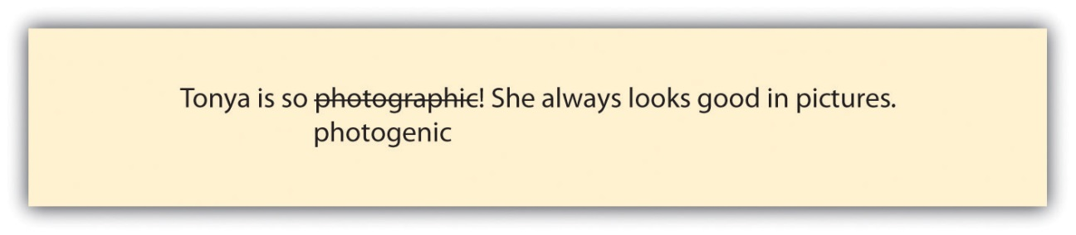

Equipment and memories can be photographic, but to look good in pictures is to be photogenic. To catch an error of this nature, you clearly have to realize the word in question is a problem. The truth is, your best chance at knowing how a wide range of words should be used is to read widely and frequently and to pay attention to words as you read.
KEY TAKEAWAYS
- Words have both denotations and connotations, and you need to focus on both of these meanings when you choose your words.
- Specific words, such as “fork” or “spoon” instead of “silverware,” and concrete words, such as a “piercing siren” instead of a “loud sound,” create more interesting writing.
- Figurative language, including alliteration, analogies, hyperbole, idioms metaphors, onomatopoeia, personification, and similes, helps make text more interesting and meaningful.
- Both clichés and improperly used words detract from your writing. Reword clichés using straightforward language. Eliminate improperly used words by researching words about which you are not sure.

EXERCISES
- Fill in the blank in this sentence with a word that carries a connotation suggesting Kelly was still full of energy after her twenty laps:
Kelly ____ out of the pool at the end of her twenty laps.
- Identify the general word used in this sentence and replace it with a specific word:
I put my clothes somewhere and can’t find them.
- Identify the abstract word used in this sentence and replace it with a concrete word:
I smelled something strong when I opened the refrigerator door.
- Identify the cliché used in the following sentence and rewrite the sentence using straightforward language:
We should be up and running by ten o’clock tomorrow morning.
- Identify the misused word in the following sentence and replace it with a correct word:
I’d rather walk then have to wait an hour for the bus.
- Write a sentence using one of the types of figurative language presented in .
- Over the course of a week, record any instances of clichés or trite, overused expressions you hear in conversations with friends, coworkers, or family; in music, magazines, or newspapers; on television, film, or the Internet; or in your own language. Share your list with members of your group or the class as a whole.

17.4 Using the Dictionary and Thesaurus Effectively
LEARNING OBJECTIVES
- Understand the information available in a dictionary entry.
- Understand the benefits and potential pitfalls of a thesaurus.
- Use dictionaries and thesauruses as writing tools.

Dictionaries and thesauruses provide writing assistance for writers of all levels of experience and ability. Think of them as tools that will help you to do your very best writing. A dictionary can help you determine the precise denotations of words, while a thesaurus, used responsibly, can help you to capture subtle differences in the connotations of words.

Using Dictionaries

Technology is changing the face of dictionaries. A short twenty or thirty years ago, a good graduation gift for a college-bound student was a hardcover dictionary. Today very few college students even own one because online dictionaries are so readily available. Using an online dictionary, you can look up a word in the time it takes to type it, as opposed to taking the time to flip pages and scan through a page of words in a print dictionary. On the other hand, a hard-copy dictionary is still a great backup if you’re unable to get online, and it can lead to some surprising discoveries of other words on the same page, just as browsing through a shelf of library books can put you in contact with books you might not have otherwise encountered.

The important issue is that you use a dictionary of some kind and that you understand what it can provide for you. Whether you use a print or online dictionary, the entries offer a wealth of information. Figure 17.2 includes some of the most common dictionary entry components. Following the list is a color-coded entry for “elementary” (from Dictionary.com, based on the Random House Unabridged Dictionary) showing where various parts of the entry can be found:

Figure 17.2
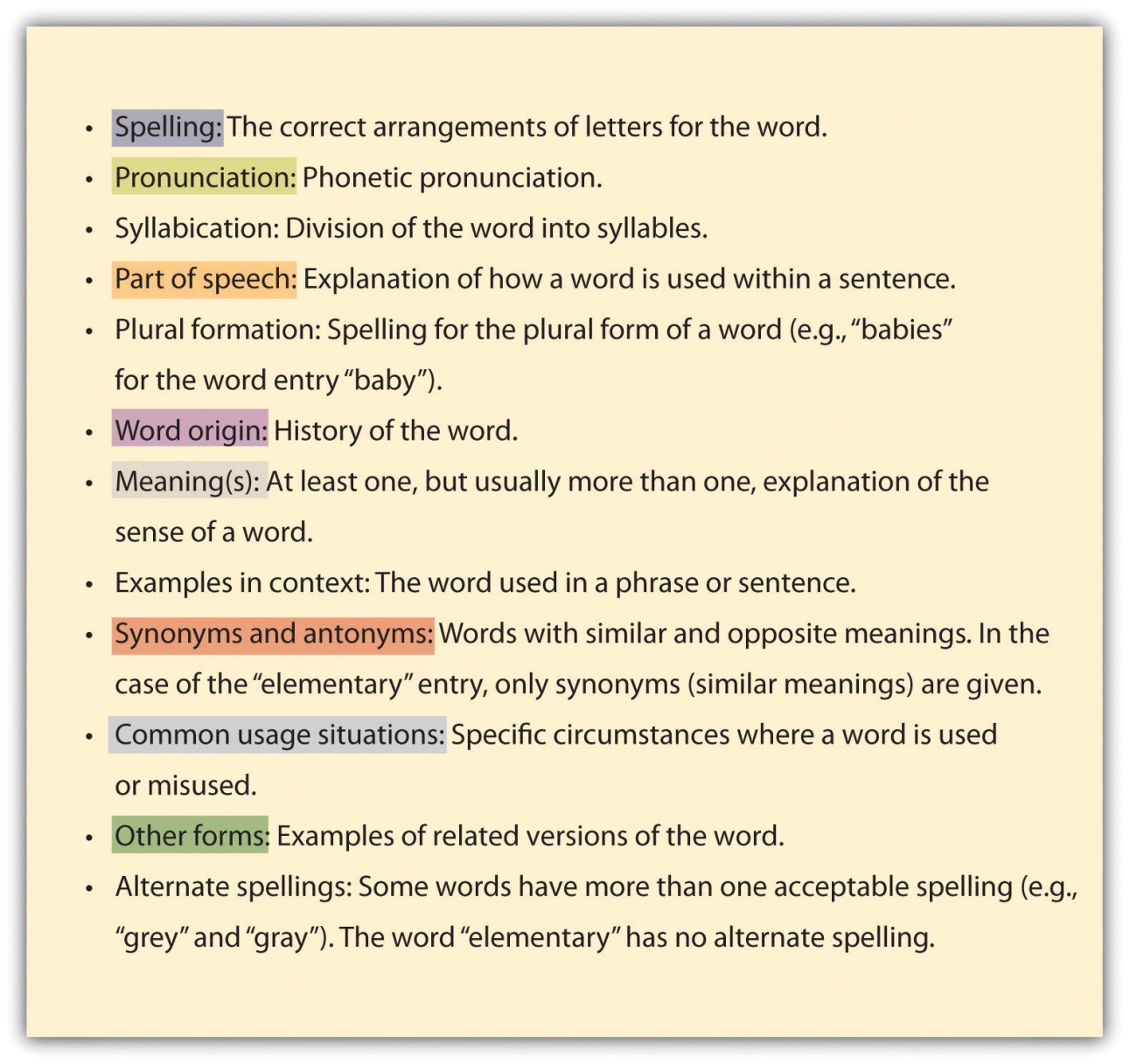

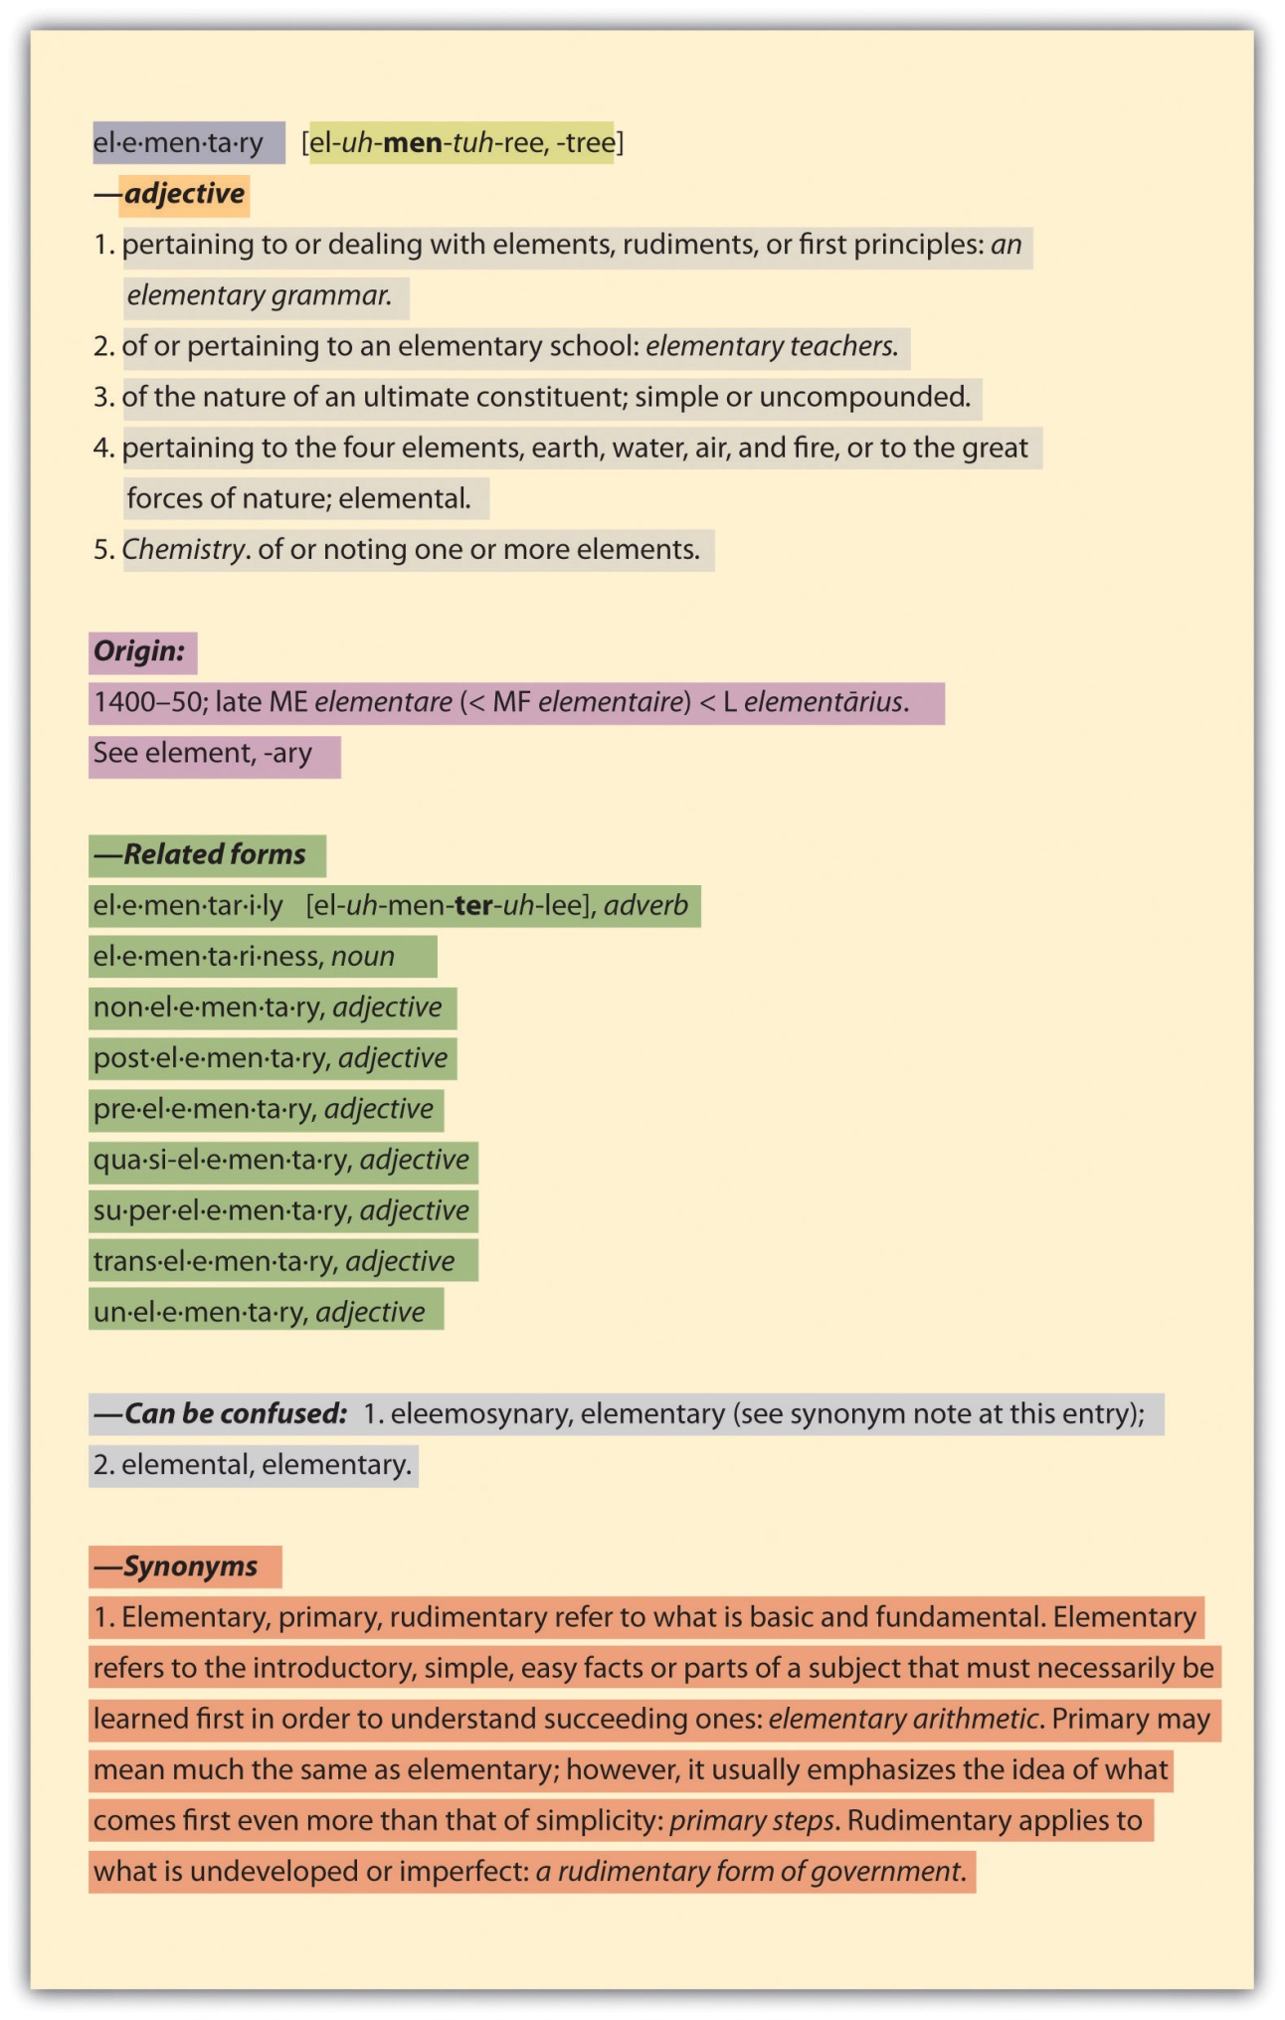
Using a Thesaurus Effectively

Like dictionaries, thesauruses are available in both print and online media. And as with dictionaries, the convenience of modern technology dictates that online thesauruses are the preferred choice of most college students these days. One warning about thesauruses: they can be overused or used out of context. You might be tempted to use a “fancier” synonym or antonym for a word when a simple and direct approach might be best.

Whether you use an online or hard-copy thesaurus, you will encounter the following features.
Figure 17.4
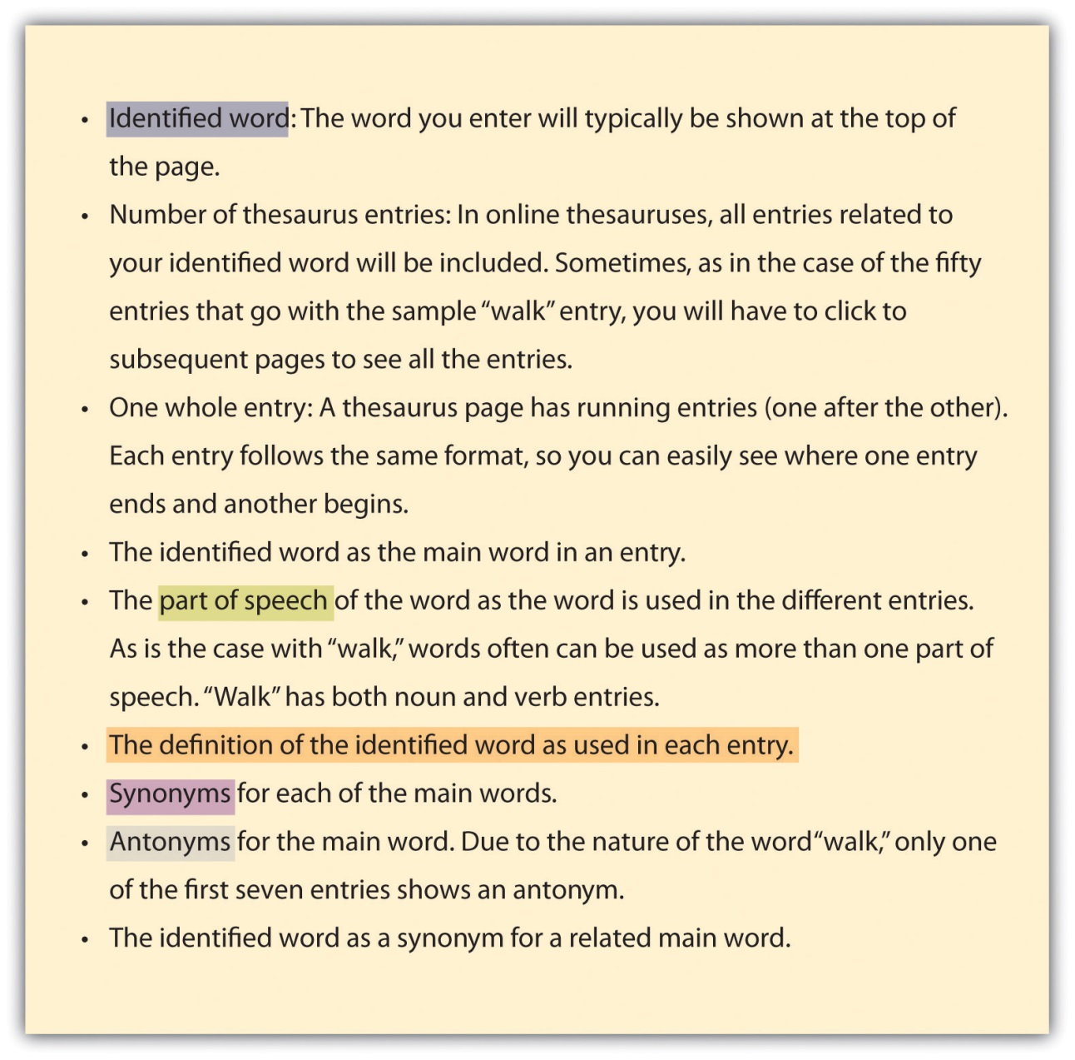

Figure 17.5 shows four color-coded entries for the word “walk” (out of fifty) at Thesaurus.com (based on Roget’s Thesaurus).

Figure 17.5
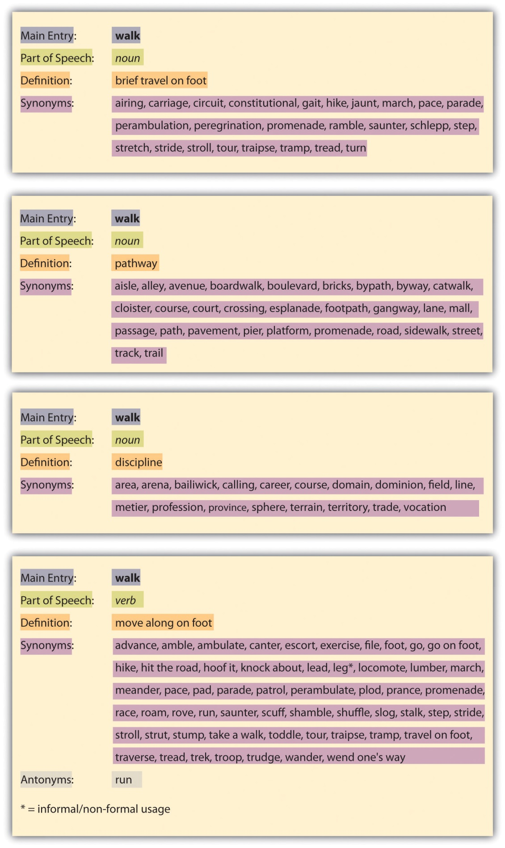

KEY TAKEAWAYS
- Dictionary entries include much information in addition to the correct spelling of the words.
- Thesauruses provide synonyms and antonyms for different parts of speech and different meanings of an identified word and for words related to the identified word.
- Dictionaries and thesauruses (when used judiciously) are helpful tools for all writers.

EXERCISES
- Use a dictionary to answer these questions:
  - What is the origin of the word “margin”?
  - How many different definitions does your dictionary have for the word “best”?
  - What, if any, related forms of the word “subject” are provided in your dictionary?
  - What parts of speech are listed in your dictionary for “close”?
  - What, if any, common usage situations are given in your dictionary for the word “scale”?
- Use a thesaurus to write five versions of the following sentence that mean roughly the same thing. Change at least two words in each version:
Hannah considered accepting a job with Bellefor Inc. but decided against it.

Chapter 18
Punctuation
A Universal Challenge
Almost everyone finds punctuation challenging at least occasionally. Although it might be unrealistic to know the correct punctuation in every situation, you can certainly learn to make the correct choice most of the time. When you are uncertain, don’t guess. Handbooks such as this one, as well as a variety of websites, are close at hand. Take the time to look up a rule when you are not sure.

Sometimes, as with many other features of grammar and mechanics, you may look up a rule and find more than one answer or even a raging debate about what is currently acceptable. That’s because usage (the way people actually use a living language) changes over time, thus muddying the rules. But by doing your research, at least the choices you make will be within an accepted range of options.

18.1 Using Commas Properly
LEARNING OBJECTIVES
- Use introductory, series, and compound-sentence commas correctly.
- Use commas to isolate words that are not essential to a sentence.
- Use commas with adjectives, quotations, and details.

Commas are to readers as road signs are to drivers. Just as a driver might take a wrong turn if a sign is missing or misplaced, a reader cannot traverse a sentence meaningfully when commas are not properly in place.

Using Commas with Introductory Words, Phrases, and Clauses

Commas set introductory words, phrases, and clauses apart from the rest of a sentence. This separation serves to signal a reader to pause and to give words a chance to have meaning without interference from other words.

Examples
Single-word example: Afterward, fans came backstage and surrounded the actors and actresses.

Phrase example: Without an invitation, fans swarmed backstage in excitement.

Clause example: After the fans began to head to their cars, the actors and actresses took their first break in two hours.

Using Commas in a Series

A series is a list embedded in a sentence with a conjunction, typically the word “and,” between the last two items in the list. Without the commas, a series can be quite confusing.
Example
Series in a sentence without commas: Penny’s costume included a long blue dress a red bonnet black lace-up shoes a heavy gold pendant on a chain and a very-full petticoat.

With a little work, a reader can possibly identify the five items that made up Penny’s costume. But the sentence is confusing and requires too much work to read. Inserting commas makes reading this sentence very easy and clear.

Example
Series in a sentence with commas: Penny’s costume included a long blue dress, a red bonnet, black lace-up shoes, a heavy gold pendant on a chain, and a very-full petticoat.

Some usage experts promote the idea that the comma immediately before the conjunction is optional since it has fallen out of universal use. However, it is still wise to use it to avoid inadvertent confusion.

Using Commas in Compound Sentences

When a sentence is made up of two independent clauses joined by a coordinating conjunction (and, but, for, nor/or, so, yet), a comma is needed between the two clauses. Remember that an independent clause must have both a subject and a verb and be able to serve as a stand-alone sentence. (See Chapter 15 "Sentence Building", Section 15.1 "Incorporating Core Sentence Components (Avoiding Fragments)" for more on sentence components.)

Examples
Example of a compound sentence with two independent clauses: Mitch arrived an hour early for the first rehearsal, and he spent the time looking through the costume closets.

Example of a sentence with two clauses, one of which is not independent: Mitch arrived an hour early for the first rehearsal and spent the time looking through the costume closets.

Using Commas to Isolate Nonessential Words within a Sentence

To create interest and increase clarification, you may want to add words and phrases to basic sentences. These additional pieces often function as add-ons that are not essential to the core meaning of the sentence and do not change the meaning of the sentence. You should separate such words and phrases from the rest of the sentence. Some examples of nonessential words include adjective phrases and clauses, words of direct address, interjections, and appositives.

Adjective Phrases and Clauses

Some adjective phrases and clauses are essential to the meaning of a sentence and some are not. If they are essential, no comma is needed. If the meaning of the sentence would be intact if the phrase or clause were removed, a comma is needed. You can identify adjective clauses since they often begin with the relative pronouns where, when, which, who, whom, whose, or that.

Example
Comma needed: To Kill a Mockingbird, which was Malik’s first play, lasted almost two hours.

A comma is needed because, even without the adjective phrase, the reader would know that the play lasted for two hours.

Example
Commas not needed: Actors who give constant effort can inspire others in the cast to do well.

A comma is not needed because the phrase “who give constant efforts” clarifies which actors are being referenced within the sentence. Since the sentence meaning would not be complete without the phrase, no comma is needed.

Words of Direct Address

Some sentences name the person being spoken to. A person’s name that is used in this way is called a noun in direct address. Since naming the person does not change the meaning of the sentence, you should separate such a name from the rest of the sentence.

Example
Your performance, Penny, was absolutely amazing!

Interjections

Some words interrupt the flow of a sentence but do not actually change the meaning of the sentence. Such words are known as interjections and should be set apart from the rest of the sentence with commas. Aside from “yes” and “no,” most interjections express a sudden emotion.

- Yes, I am going to the Saturday matinee performance.
- I suppose you will think it is a problem if I don’t arrive until a few minutes before the curtain goes up, huh?
- There is a chance, drat, that I might miss the first few minutes.

Appositives

Appositives are nouns or noun phrases that restate an immediately preceding noun or noun phrase.

Malik’s first play, To Kill a Mockingbird, had six performances.

Malik only has one “first” play, so the title of the play is a restatement of “Malik’s first play.” Since this sentence is complete with all meaning intact even if the words “To Kill a Mockingbird” were removed, the words need to be separated with commas.

My husband, Kyle, has visited the To Kill a Mockingbird museum in Monroeville.

Since “my husband” identifies a single person, the name “Kyle” merely restates his identity and thus adds no new information. Therefore, “Kyle” should be set apart with commas.

Using Commas with Coordinate Adjectives

You should place a comma between coordinate adjectives that are not joined with the word “and.” Coordinate adjectives are double adjectives and can be joined with the word “and,” rearranged, or both and still work fine.

Example
Sentence with coordinate adjectives: Atticus is a good role for Malik since Malik is a tall, stately guy.

This sentence requires commas since Malik could be “a stately, tall guy,” or he could be “tall and stately,” or he could be “stately and tall.”
Do not use commas between cumulative adjectives.

Cumulative adjectives build on each other, modify the next one in line, and do not make sense if rearranged.

Example
Sentence with cumulative adjectives: Atticus Finch is a dedicated defense attorney.

This is a cumulative adjective situation because it would not work to rearrange the adjectives to say “defense dedicated attorney” or “dedicated and defense attorney.” Therefore, no commas are needed in this example; the adjective “defense” modifies “attorney” and the adjective “dedicated” modifies “defense attorney.”

Using Commas with Dialogue and Direct Quotations

You should use a comma prior to or just after the quotations in dialogue. Also, use a comma before a direct quotation when preceded by a verb such as declares, says, or writes.

Example
Comma before dialogue: Jem said, “There goes the meanest man that ever took a breath of life.”

Comma after dialogue: “The one thing that doesn’t abide by majority rule is a person’s conscience,” said Atticus Finch.

No comma needed before or after a direct quotation that is not preceded by a verb: According to Miss Maudie Atkinson, Atticus “can make somebody’s will so airtight you can’t break it.”

No comma needed before or after an indirect quotation: Atticus told Jem that it was a sin to kill a mockingbird.

Using Commas When Inserting Details into Text

Details such as dates, addresses, geographic names, company names, letter and e-mail components, titles that go with names, and numbers all require commas when used in text and sometimes when used alone.

Dates

When a date is written in month–day–year order in isolation, you need to use a comma between the day and year.

December 25, 1962

When a date is written in month–day–year order within a sentence and does not fall at the end of the sentence, you need to use a comma between the day and year and between the year and the rest of the sentence.
On December 25, 1962, the movie To Kill a Mockingbird opened in theaters.

Addresses

When an address is written in mailing format, commas are needed between the city and state.

Old Courthouse Museum
Courthouse Square
31 N. Alabama Ave.
Monroeville, AL 36460

When an address is written within running text, commas are needed between the city and state as well as between each of the “lines” of the address and between the address and the rest of the sentence if the address does not fall at the end of the sentence.

Annual performances of To Kill a Mockingbird are performed in the Old Courthouse Museum, Courthouse Square, 31 N. Alabama Ave., Monroeville, AL 36460, near where author Harper Lee grew up.

Geographic Names

Use a comma after each item within a place name when the place name is used in running text, even when it is not part of a complete address.
Atticus Finch lived and worked in the fictitious city of Maycomb, Alabama, which many assume is patterned somewhat after Monroeville, Alabama, where the author grew up.

Company Names

Company names that include “incorporated” or “limited” (or the like) require a comma between the name and “Inc.” or “Ltd.” only when a comma is placed there as part of the official company name. Check for letterhead or the company’s website for clarification on its preferred usage.

Invesco Ltd.
Replacements, Ltd.
Citigroup, Inc.
Citizens Inc.

When “incorporated” or “limited” is part of a company name within a sentence, a comma is needed between the word and the rest of the sentence only when a comma precedes it.

Citigroup, Inc., is making some noise in the banking industry lately.
Invesco Ltd. started out slowly in that sector of the market.

Letter and E-mail Greetings and Closings
Commas are used to separate letter and e-mail components both in isolation and within running text.

Dear Alice,
Sincerely,
Hi, Jerry,
Later,

Titles That Go with Names
Use commas to set off descriptive titles that follow names. However, don’t use a comma before “Jr.” or “III” (or the like) unless you know the person prefers a comma.

Atticus Finch, attorney-at-law
John Hale Finch, MD
Walter Cunningham Jr.

Within text, include a comma both before and after the descriptive title to set it off from the whole sentence.

Atticus Finch, attorney-at-law, at your service.

Numbers

In numbers with more than four digits, begin at the right and add a comma after every third digit. In a four-digit number, a comma is omitted in page and line numbers, addresses, and years, and it is optional in other cases. No commas are used in numbers with less than four digits. Numbers are treated exactly the same when used in text.

335,353,235
8,302 (as number, comma is optional) (as year, no comma)
38,231
200 (no comma)

Example
In an Internet search for “reviews of To Kill a Mockingbird,” 2,420,000 results surfaced.

Using Commas to Avoid Confusion

Sometimes you simply have to use a comma to avoid confusion. For example, when a word is removed for effect, a comma can sometimes make up for the missing word.

To perform is a skill; to transform, art.
When two like or nearly like words are placed side by side, a comma can sometimes help clarify the intended meaning.

The whole cast came walking in, in full costume.

Sometimes you will need to use a comma so the reader understands how the words are to be grouped to attain the author’s desired meaning. Read the following example without the comma and note the difference.

Fans who can, come each year to see the annual To Kill a Mockingbird performance.

KEY TAKEAWAYS
- You must use commas with introductory words, phrases, and clauses; between the words in a series; and between compound sentences.
- You should use commas to separate from the rest of a sentence words that are not essential to the sentence, such as adjective phrases and clauses, words of direct address, interjections, and appositives.
- You should place commas between side-by-side adjectives that independently and interchangeably modify a noun, between quotations and the rest of the sentence, and in a variety of detail-specific situations, such as dates, addresses, geographic names, company names, letter and e-mail greetings and closings, titles that go with names, and numbers.

EXERCISE
- Add commas as needed to write each of these sentences correctly.
  - If you are right Darcy you and I will have amazing front-row seats.
  - Tonight I am going with Allen Beth Daryl Salome and Tommy.
  - When Malik jumped off the stage I naturally jumped about forty-five thousand feet in the air.
  - I grew up in Stockton Illinois on a farm and my friend grew up in Fort Madison Iowa in town.
  - If you arrive before I do save me a seat.
- When I called she said “Mark Lucster Jr. wants to come with us.”

18.2 Avoiding Unnecessary Commas
LEARNING OBJECTIVES
- Identify some categories of unnecessary commas.
- Avoid using unnecessary commas.

To use or not to use? That is the question when it comes to commas. Just as you want to be sure to use commas in all the correct places, you also want to make sure to avoid using commas when you don’t need them.

- Do not use commas before a conjunction when the sentence is not compound. No comma: Scout thinks Calpurnia is harshX and unfairly gets Atticus on her side.
- Do not use a comma before the first and after the last word in a series. No comma: The actorsX Gregory Peck, Phillip Alford, Estelle Evans, Robert Duvall, and Mary BadhamX play some of the main characters in the To Kill a Mockingbird movie.
- Do not use commas around an appositive if it adds clarity, or new information, to the sentence. For example, in the following sentence, “Joey” identifies which cousin played the part. No comma: My cousinX JoeyX once played the part of Atticus Finch.
- Do not use a comma to set off an adverb clause that is essential to the sentence’s meaning. Adverb clauses are usually essential when they begin with after, as soon as, because, before, if, since, unless, until, or when. No comma: Scout was surprised when Calpurnia kissed herX because she didn’t think Calpurnia liked her much.
- Do not use a comma around a word that could be viewed as an interjection if using the comma would cause confusion or interruption in the sentence. No comma: Scout isX basicallyX a tomboy.
- Do not use a comma after although, such as, or like. No comma: Mayella didn’t seem believable because of her actions, such asX changing her mind on the stand.
- Do not use a comma after a coordinating conjunction (and, but, for, nor, or, so, and yet). No comma: Jem called Atticus by his first name, soX it seemed natural for Jem to do it as well.
- Do not use a comma along with a period, question mark, or exclamation point inside of a quotation. No comma: “Don’t you remember me, Mr. Cunningham?X” asked Scout.

KEY TAKEAWAYS
- A comma is not needed before a conjunction if the sentence is not compound, before the first word in a series or after the last word in a series, or after an information-adding appositive.
- Do not use a comma to set apart an adverb clause that is essential to the meaning of a sentence or an interjection when the comma would interfere with the sentence.
- A comma should not be used after although, such as, or like; after a coordinating conjunction; or along with end punctuation inside a quotation.

EXERCISE
- For each sentence, add and/or remove commas (replacing a comma with X) or indicate that no changes are needed.
  - I had lasagna for dinner and, it was absolutely great!
  - My friend Alice is coming over after work.
  - My mother is going to pick me up, because my father had to work late.
  - Tony bought a green skirt, some red shoes, a blue shirt, and a pink belt.
  - “The lake water is very cold!,” said Megan through shivering teeth.
  - Carrie skated around the room repeatedly and acted like she had been skating her whole life.

18.3 Eliminating Comma Splices and Fused Sentences
LEARNING OBJECTIVES
- Use commas correctly in compound sentences.
- Use semicolons correctly in compound sentences.
- Recognize comma splices and fused sentences.

Two of the most common problems people have with compound sentences are comma splices and fused sentences. The key to understanding these problems is to recognize the possible compound sentence formats:

- two independent clauses separated with a comma and coordinating conjunction (and, but, so, for, nor, or, yet);
- two independent clauses separated with a semicolon by itself;
- two independent clauses separated with a semicolon and a conjunctive adverb (however, therefore, consequently, moreover, etc.), used to clarify a specific logical relationship between the two independent clauses.

Figure 18.1
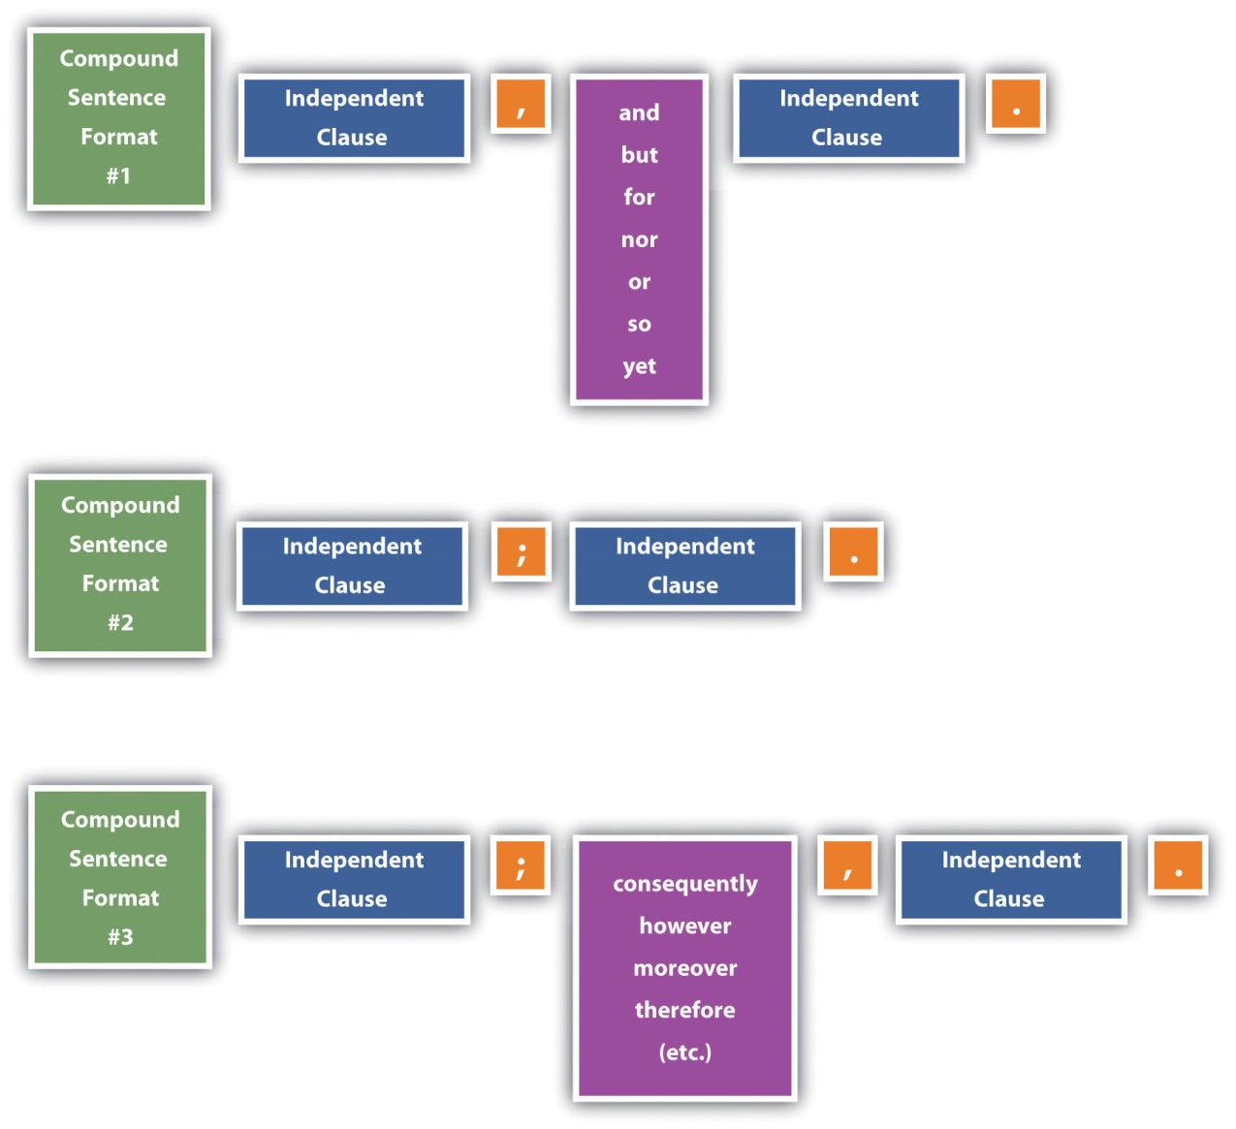

Understanding and Avoiding Comma Splices

Two different situations can result in comma splices.

Examples
Problem: A comma joins independent clauses instead of the clauses being joined by a comma followed by a coordinating conjunction.

Example: Her name was Jean Louise Finch, she wanted everyone to call her “Scout.”

Correction: Her name was Jean Louise Finch, but she wanted everyone to call her “Scout.”

Problem: A comma joins two independent clauses when a semicolon should be used.

Example: Atticus didn’t want Scout to fight, however, she could not ignore injustices.

Correction: Atticus didn’t want Scout to fight; however, she could not ignore injustices.

Understanding and Avoiding Fused Sentences

A fused sentence is also called a run-on sentence and occurs when two independent clauses are joined without any punctuation.

Example
Mr. Cunningham is very poor he cannot pay Atticus for legal services.
Correction option 1: Add a coordinating conjunction and a comma: Mr. Cunningham is very poor, so he cannot pay Atticus for legal services.

Correction option 2: Place the independent clauses into two separate sentences: Mr. Cunningham is very poor. He cannot pay Atticus for legal services.

Correction option 3: Place a semicolon between the two clauses: Mr. Cunningham is very poor; he cannot pay Atticus for legal services.

Correction option 4: Place a semicolon between the two clauses, and use a conjunctive adverb for further clarification: Mr. Cunningham is very poor; therefore, he cannot pay Atticus for his legal services.

Correction option #5: Turn one of the independent clauses into a dependent clause: Mr. Cunningham cannot pay Atticus for his legal services because he is very poor.
OR
Because he is very poor, Mr. Cunningham cannot pay Atticus for his legal services.

KEY TAKEAWAYS
- When you use a coordinating conjunction in a compound sentence, you should place a comma before the conjunction.
- You can use a semicolon between two independent clauses without using a conjunctive adverb.
- If you use conjunctive adverbs, such as however or therefore, place a semicolon before the conjunctive adverb and a comma after it.

EXERCISES
- Read each compound sentence. Identify each as correctly written, a comma splice, or a fused sentence. For the comma splices and fused sentences, write a corrected version.
  - The Gormans bought a new television, and they had it installed over the fireplace.
  - We are supposed to get a blizzard tonight we can’t go to the movie.
  - My psychology teacher is leaving on a cruise on Monday; the psychology midterm has been canceled.
  - The wind was blowing like crazy, it grabbed my bag right out of my hand.
  - I didn’t go to sleep until after 3:00 a.m., therefore I am exhausted today.
  - Donna traded her hours with Luke last night consequently, she has to work tonight.
- Write three different versions of a correctly punctuated compound sentence made up of the following pairs of independent clauses, using each of the three formats described in this section (comma plus coordinating conjunction, semicolon only, and semicolon plus conjunctive adverb). Then write a comma splice and a fused sentence using the same pair of independent clauses. Finally, make one of the clauses dependent on the other, use a subordinating conjunction (see Chapter 16 "Sentence Style", Section 16.3 "Using Subordination and Coordination"), and punctuate the sentence accordingly.
  - He was very hungry / He ate a big lunch
  - Thunder rumbled in the distance / The skies opened up
- The candidate ran an excellent campaign / He won the election by ten points

18.4 Writing with Semicolons and Colons
LEARNING OBJECTIVES
- Understand when to use semicolons.
- Understand when to use colons.
- Recognize when semicolons and colons are used incorrectly.

By the time you were taught how to use semicolons and colons in eighth grade or so, you were likely already set in your ways regarding punctuation. Here’s the good news: it isn’t too late to add these marks to your commonly used list and to appreciate how much they can do for your writing.

Using Semicolons

A semicolon is a punctuation mark that signals a pause that is stronger than a comma but weaker than a period. Appropriately, a semicolon (;) looks like a period on top of a comma. The standard uses for semicolons are to separate two independent clauses instead of using coordinating conjunctions, to separate two independent clauses along with a conjunctive adverb, or to clarify a series that includes other punctuation.

Compound Sentences without Coordinating Conjunctions or with Conjunctive Adverbs

Compound sentences with conjunctive adverbs or without coordinating conjunctions require a semicolon. Review Section 18.3 "Eliminating Comma Splices and Fused Sentences" for additional information.

Examples
Compound sentence with a coordinating conjunction: Scout and Jem do not know much about Boo Radley, but they are afraid of him anyhow.
Compound sentence without a coordinating conjunction: Scout and Jem do not know much about Boo Radley; they are afraid of him anyhow.
Compound sentence with a conjunctive adverb: Scout and Jem do not know much about Boo Radley; nevertheless, they are afraid of him anyhow.

Items in a Series with Commas
Typically, commas separate items in a series. Sometimes multiple-word series items include commas. In these cases, the commas within the items would be easily confused with the commas that separate the items. To avoid this confusion, you should use semicolons between these series items. You should not use semicolons to separate items in a series when the items do not include commas.

Examples

Sentence with series that results in comma confusion: In To Kill a Mockingbird, Atticus Finch defends justice, the underprivileged, and his children, teaches his kids values, and stands up to the people of the town.

Sentence rewritten using semicolons to avoid comma confusion: In To Kill a Mockingbird, Atticus Finch defends justice, the underprivileged, and his children; teaches his kids values; and stands up to the people of the town.

Using Colons

A colon is used to separate parts or to signal that some related information or words are coming.

Introductions

Colons are used to introduce a variety of text components, including explanations and examples.

- To Kill a Mockingbird won three Oscars: Best Actor; Best Art Direction-Set Decoration, Black-and-White; and Best Writing, Screenplay Based on Material from Another Medium.
- There is a good reason no one has ever visited Maycomb, Alabama: it is a fictitious city.

Independent Clauses Where One Restates or Supports the Other

Most sets of independent clauses require a comma and a conjunction or a semicolon between them. An exception is when the second clause clearly restates or supports the first clause.

The movie To Kill a Mockingbird was very well received in Hollywood: it was nominated for eight Academy Awards.

Salutations and Isolated Elements

- A variety of elements call for colons to separate the details.
- Time: 5:30 p.m.
- Letter or e-mail openings: Dear Ms. Moore:
- Ratios: 4:7
- Chapters and verses: 7:2–3
- Titles: Spark Notes: To Kill a Mockingbird
- Bibliographies: New York: Random House
- Arrangements of categories and examples (such as this list)

Quotations

When the lead-in to a quotation is a complete sentence, you can use a colon between the lead-in and the quotation.

Scout spoke with her usual frankness and wisdom beyond her years: “Until I feared I would lose it, I never loved to read. One does not love breathing.”

KEY TAKEAWAYS
- Use semicolons instead of commas between items in a series when the series items have commas.
- Use a semicolon in compound sentences that do not have coordinating conjunctions.
- When you use a semicolon to separate two independent clauses, you may also elect to use a conjunctive adverb to clarify the relationship between the two clauses.
- Use colons as a way to introduce text components, such as explanations and examples, and to separate two independent clauses where one restates or supports the other.
- Use colons in salutations, time, letter or e-mail openers, ratios, chapters and verses, titles, bibliographies, arrangements of categories and examples, and quotations.

EXERCISES
- Use a semicolon in each of these situations:
  - items in a series with commas
  - compound sentence without a coordinating conjunction
  - compound sentence with a conjunctive adverb
- Use a colon in each of these situations:
  - to introduce a quotation
  - to write the current time
  - to write a ratio
  - to introduce a list
- Read three pages of one of your textbooks. Highlight all colons and semicolons, and then determine why they are being used and whether they are being used appropriately.

18.5 Using Apostrophes
LEARNING OBJECTIVES
- Use apostrophes with nouns to show possession.
- Know when to use apostrophes to show possession in pronouns.
- Know how to use apostrophes to form contractions.

Apostrophes are a tool for making English more streamlined. Instead of saying, “the book that belongs to Elizabeth,” you can say, “Elizabeth’s book.” Instead of saying, “I cannot come,” you can say, “I can’t come.” Although you could avoid using apostrophes, your writing will be more natural if you learn the rules for using possessives and contractions appropriately. Some people also opt to use apostrophes to form plurals in certain situations, but many usage experts continue to warn against this practice.

Using Apostrophes with Nouns to Show Possession

You form a possessive when you want to show a noun or pronoun in a sentence has ownership of another noun or pronoun.

Standard Singular and Plural Nouns

As shown in the following table, most nouns follow standard patterns for forming plurals.

Situation | Rule | Example 1 | Example 2
Singular noun | Add apostrophe + -s. | dog’s collar | class’s assignment
Plural noun ending in s | Add only an apostrophe. | dogs’ collars | classes’ assignments
Plural noun ending in any letter other than s | Add apostrophe + -s. | people’s plans | women’s plans
Proper nouns | Follow the regular noun rules. | Finches’ family home | Atticus’s glasses
Business names | Use the format the company has chosen whether or not it matches possessive formation guidelines. | McDonald’s employees | Starbucks stores

Compound Nouns

When forming the possessive of a compound noun, form the possession only on the last word. Use standard guidelines for that word.

- sister-in-law’s hair
- six-year-olds’ growth patterns
- wallpapers’ patterns
- courthouse’s aura

Two or More Nouns

When two or more nouns both possess another noun, form the possession only with the second noun if you are noting joint ownership. Form a possession on both nouns if each possession is independent.

- Jem and Scout’s escapades (the joint escapades of the two children)
- Jem’s and Scout’s escapades (the separate escapades of the two children)

Understanding Apostrophes and Possessive Pronouns

Possessive pronouns (his, her, hers, its, my, mine, our, ours, their, theirs, your, yours) show possession without an apostrophe.

- Is this hat yours?
- Those are his shoes.
- The dress is hers.

Indefinite pronouns (another, anybody, anyone, anything, each, everybody, everyone, everything, nobody, no one, nothing, one, other, others, somebody, someone, something) require an apostrophe to show possession.

- another’s problem
- everyone’s problems

Using Apostrophes to Form Contractions

Contractions are shortened versions of two or more words where an apostrophe marks the missing letters. English has a wide range of common contractions, including those in the following table.

Words in Contraction | Contraction | Words in Contraction | Contraction
I am | I’m | what will | what’ll
we are | we’re | they will | they’ll
what is | what’s | what has | what’s
can not | can’t | should not | shouldn’t
does not | doesn’t | do not | don’t

In addition to the many standard contractions, people often create custom, on-the-spot contractions.

My husband’s (husband is) also coming.

As a reader, you have to use context to know if the use of “husband’s” is possessive or a contraction since the two are visually the same.

My husband’s also coming.
My husband’s watch is on the table.

Using Apostrophes to Form Plurals

Some people choose to form plurals of individual letters, numbers, and words referred to as terms. Many usage experts frown on this practice and instead choose to form the plurals by simply adding an -s. Here are some examples of the two options, as well as methods of avoiding having to choose either option.

Examples
Situation: more than one of the letter t

Plurals using apostrophes: There are two t’s in Atticus.

Plurals without using apostrophes: There are two ts in Atticus.

Avoiding the choice: The letter t shows up in Atticus twice.

Situation: more than one of the number 5

Plurals using apostrophes: If I remember right, the address has three 5’s in it.

Plurals without using apostrophes: If I remember right, the address has three 5s in it.

Avoiding the choice: If I remember right, the number 5 shows up three times in the address.

Situation: more than one “there” in a sentence

Plurals using apostrophes: This sentence has five there’s.

Plurals without using apostrophes: This sentence has five theres.

Avoiding the choice: The word “there” is used five times in this sentence.

KEY TAKEAWAYS
- Form possessives of most singular noun by adding apostrophe + -s and of most plural nouns by adding just an apostrophe. For plural nouns ending in letters other than -s add apostrophe + -s.
- In compound nouns, form the plural on the last word.
- When two or more nouns possess another noun jointly, form the possession only on the last noun. If the two nouns have independent ownership, form the possession on each noun.
- Possessive pronouns indicate possession without the use of an apostrophe. Indefinite pronouns need an apostrophe to show possession.
- In contractions, apostrophes are used to indicate omitted letters.
- It is an increasingly acceptable option to use an apostrophe to form the plurals of letters, numbers, and words referred to as terms, but many usage experts still frown on the practice.

EXERCISES
- Use apostrophes to create contractions for these words:
  - we have
  - he will
  - could have
- Use apostrophes to rewrite the following possessive situations:
  - a bag of apples that belong to Pete and Polly
  - a car that belongs to my sister-in-law
  - a soda that is being shared by two women
  - a pen that belongs to somebody in the room
  - a sock that belongs to him
  - the opinions of the students

18.6 Using Quotation Marks
LEARNING OBJECTIVES
- Properly place quotation marks around dialogue and borrowed words.
- Use quotation marks with titles of short works, definitions, words used in special ways, and original words.
- Correctly incorporate other punctuation with quotations.

Quotation marks are used to mark dialogue, to indicate words that are borrowed, to emphasize certain details, and to help when giving credit for written works.

Using Quotation Marks to Signal Dialogue and Borrowed Words

Quotation marks are a key component of written dialogue. All words of a dialogue must be enclosed within quotation marks to indicate that these words are the exact words of the speaker.

“The one thing that doesn’t abide by majority rule is a person’s conscience,” Atticus said.

When you talk about or summarize spoken words rather than presenting them as dialogue, you should not put quotation marks around them since you are not necessarily saying that they are the exact words the person said.

Jem once said that Boo’s dad was the meanest man alive.

As with dialogue, you also should use quotation marks to mark the exact words that you borrow from someone else.

About Harper Lee’s first interview since 1964, Paul Harris writes, “Lee has regularly turned down every interview request for decades but now, aged 79, has been tempted out of her shell by the University of Alabama.” ^{[1]}

An exception to using quotation marks around borrowed words is that lengthier quotations of others’ work (those of more than four lines of text) are set in indented block format for the sake of easier readability. Also, if you paraphrase another’s ideas in your words, you need to cite the source of the ideas, but you should not use quotation marks since the words are your own. For more on quoting and paraphrasing sources, see Chapter 22 "Appendix B: A Guide to Research and Documentation", Section 22.2 "Integrating Sources".
Use single quotation marks around a quotation within a quotation.

Example
According to Paul Harris, Lee “did have warm words about the screenplay of her book, which was turned into the hit film starring Gregory Peck in the 1960s. ‘I think it is one of the best translations of a book to film ever made,’ she said.” ^{[2]}

Using Quotation Marks to Enclose Titles of Short Works

Italics indicate titles of full-length books and other lengthy, completed works. To separate short works from these longer works, short works are enclosed in quotation marks rather than being placed in italics. Some examples of short works that should be included in quotation marks are articles in periodicals, book chapters or sections, essays, newspaper and magazine articles and reviews, short poems and stories, song titles, titles of television episodes, and titles of unpublished works, such as dissertations, papers, and theses.

Examples
Treatment for full-length books: I first read To Kill a Mockingbird in eighth grade.

Treatment for short works: In “A Child Shall Lead Them,” Michael Richardson suggests that Lee presents justice through the innocent eyes of a child in an effort to show its true form.

Using Quotation Marks to Identify Definitions

Using quotation marks is the accepted technique for identifying definitions that are used in running text.

Characters in To Kill a Mockingbird visit the apothecary, which means “drugstore.”

Using Quotation Marks to Draw Attention to Words
Used in a Special or Original Way

Quotation marks can help clarify that a word is being used in an unusual rather than in a straightforward manner. Without the quotation marks, readers might get a totally different meaning from a sentence.

That course was really challenging.
That course was really “challenging.” (Putting the word challenging in quotation marks lets us know that the sentence is probably using irony to say that the course was not challenging at all.)

If you create an original word to fit your specific needs, put the word in quotation marks to indicate to readers that the word is not a standard word.

Many accounts suggest that Harper Lee was very “Scout-like.”

Using Other Punctuation with Quotation Marks

It helps to know rules of using other punctuation marks in conjunction with quotation marks.

Rules

Rule: Put question marks and exclamation marks inside the quotation marks if the marks relate directly and only to the text within quotation marks. If, on the other hand, the marks relate to the whole sentence, put the marks outside the quotation marks.
Example 1: A girl in the back of the room asked, “What character did Robert Duvall play?”
Example 2: Did Mary Richards really “make it after all”?

Rule: Periods and commas always go inside the quotation marks, even if the quotation marks are only around the last word in the sentence.
Example 1: Scout asked Jem how old she was when their mother died, and Jem answered, “Two.”
Example 2: Even as an adult years later, Scout was likely to say that the summer of the trial lasted “forever,” due to the many life lessons she learned.

Rule: Place colons and semicolons outside quotation marks.
Example 1: I remember my first impression after reading Frost’s “Death of a Hired Man”: confusion.
Example 2: We had tickets to see the one-act play “Masks”; however, the blizzard hit just as we were trying to leave.

Guarding against Using Unneeded Quotation Marks

Special word usage, such as irony and made-up words, are placed in quotation marks. But do not use quotation marks just to make regular-use words stand out.

Example
When Jem met Dill, Jem said that Dill was awfully “puny.” (The word puny should not be put in quotation marks since it is a standard word being used with its straightforward meaning.)
If you choose to use slang or colloquialisms, do not give a sense that you are apologizing for the words by putting them inside quotation marks. Choose the slang words and colloquialisms you want to use and let them stand on their own.

Example
Calpurnia was very “down-to-earth.” (Do not put quotation marks around down-to-earth.)

KEY TAKEAWAYS
- Use quotation marks to identify exact words spoken words and words borrowed from another person.
- Use quotation marks with titles of short works, such as articles in periodicals, book chapters or sections, essays, newspaper and magazine articles and reviews, short poems and stories, song titles, titles of television episodes, and titles of unpublished works, such as dissertations, papers, and theses.
- Place quotation marks around definitions, words used in special ways, and words you make up to fill a particular need.
- Place all periods and commas inside of quotation marks.
- Place question marks and exclamation marks inside when they refer only to the content of the text inside the quotation marks and outside when they refer to the whole sentence.
- Place colons and semicolons outside quotation marks.

EXERCISE
- Read each sentence. If a sentence should have quotation marks, add them in the correct place. If a sentence does not need quotation marks, write “no quotation marks.”
  - Oh, right, I forgot Shanda was too sick to go to work today. I saw her out shopping.
  - Doug asked, Were you in the gym when Ben broke his arm?
  - Ellen McPeek Glisan’s dissertation was entitled The Effect of Classmate Photographs on Online Community and Connectedness.
  - I wasn’t very happy when George said I was calm.
  - FDR showed his sense of humor when he said Be sincere; be brief; be seated.
  - You are very funny; remember that funny also means impertinent.
  - Annie said, I’ll see you at 5:00 p.m.
  - Keep in mind that I’m a sew-happy girl!

18.7 Incorporating Dashes and Parentheses
LEARNING OBJECTIVES
- Learn the various uses for dashes.
- Learn the various uses for parentheses.
- Learn how to punctuate dashes and parentheses.

Dashes and parentheses are both used to give more importance to a word or group of words. The information enclosed by dashes and parentheses often supports the information directly before or after it.

Using Dashes

Dashes separate emphasis-adding text from the rest of the words in a sentence. You can use one long dash to set apart text at the end of a sentence. You can use dashes before and after the text to set it apart in the middle of a sentence. Here are some uses for dashes:

- Creating a sudden change in tone, thought, or ideas Example: We had predicted that the storm would come soon—but not this soon!
- Suggesting hesitation in dialogue Example: The old lady said to the man working the register, “I’ve got an extra nickel for the little girl’s candy—that is, if she’ll take it.”
- Providing a summary, an explanation, or an example Example: The book, To Kill a Mockingbird, is narrated by Scout Finch—a character who has much in common with the tomboy childhood of the author, Harper Lee.

Using Parentheses

Parentheses allow you to interrupt the flow of your text to give additional information. They can be used in the middle of a sentence or at the end. Some uses of parentheses include the following:

- Enclosing numbers in an in-text list. Example: My mother asked me to stop on the way to visit and pick a few things up at the store: (1) a half gallon of milk, (2) a dozen eggs, and (3) a loaf of bread.
- Setting apart citation components in in-text references and in reference lists. Example: “You never really understand a person until you consider things from his point of view—until you climb into his skin and walk around in it” (Lee, p. 34).
- Separating nonessential but helpful information. Example: My dog (some sort of a terrier-spaniel mix) has a unique personality.

Specific rules guide using punctuation with parentheses. End punctuation can be placed inside parentheses if the content of the parentheses is a complete sentence. If the content inside the parentheses is part of a larger sentence, the end punctuation should go outside the parentheses. If a comma is needed, it should always be placed outside the closing parenthesis. A comma should not be used immediately before an opening parenthesis, except in the case of in-text lists (e.g., “We need to (1) go to the bank, (2) buy some cereal at the store, (3) pick up the tickets, and (4) get to the party by 7:00 p.m.”

KEY TAKEAWAYS
- You can use dashes to create a sudden change in tone; mark hesitation in speech; or provide a summary, an explanation, or an example.
- You can use parentheses to number items in an in-text list, enclose citation components in in-text references and in reference lists, or separate nonessential but helpful information from the rest of the sentence.

EXERCISES
- Write a sentence that uses a dash to show a change in tone.
- Write a sentence that uses a dash to show hesitation in dialogue.
- Write a sentence that uses a dash to provide an example.
- Write a sentence that uses parentheses to enclose numbers in an in-text list.
- Write a sentence that uses parentheses to set apart citation components.
- Write a sentence that uses parentheses to separate nonessential but helpful information.

18.8 Choosing Correct End Punctuation
LEARNING OBJECTIVES
- Use periods correctly.
- Use question marks correctly.
- Use exclamation points correctly.

You have three choices for end punctuation: periods, question marks, and exclamation points. End punctuation gives readers information about how to read a sentence and how to interpret the sentence.

Using Periods

Periods have three main uses: punctuating many abbreviations, marking the end of many sentences, and separating components in reference citations.
Some abbreviations take periods all the time, while some never take periods. You simply have to learn the category of each abbreviation or look them up as you use them.

Examples
Examples of abbreviations that end in periods: approx., Ave., Dr., etc., Jr., Mrs., Univ.

Examples of abbreviations that do not include periods: LBJ, MLK, N/A, NV, TV, DVD, IBM, UK, USA, CEO, COD, RSVP
Periods end sentences that are not questions or exclamations, such as statements, commands, and requests.

- Statements To Kill a Mockingbird is set in the early 1930s.
- Commands Over the weekend, read the first four chapters.
- Requests Please let me know at what parts of the book you get confused.

In reference citations, use periods to separate components. (For much more on documentation, see Chapter 22 "Appendix B: A Guide to Research and Documentation".)

Examples
MLA: Lee, Harper. To Kill a Mockingbird. New York: HarperCollins, 2002. Print.
OR
APA: Lee, H. (2002). To Kill a Mockingbird. New York: HarperCollins.
CMS: Lee, Harper. 2002. To Kill a Mockingbird. New York: HarperCollins.

Using Question Marks

Question marks have one main use: to end sentences that ask direct questions. They are also sometimes used to indicate questions in a series.

Question mark at the end of a sentence Do you think Atticus encouraged Scout to be mature beyond her years, or do you think it just came naturally to Scout?

Question marks in a series We should go to the city council meeting with three basic questions: should the housing development be placed so close to the wildlife preserve?, could a better location be found?, and how much time do we have to come up with alternatives?

When you choose to use a question mark at the end of a sentence, make sure the sentence is actually a sentence since some sentences give a sense of being a question when they are not. Such sentences are called indirect questions.

Example
Jem asked Scout what she was thinking?
Correction: Jem asked Scout what she was thinking.

Using Exclamation Points

Exclamation points are a method of showing surprise or strong emotions in writing. To preserve the impact of an exclamation point, you should use them sparingly. Besides lessening their impact, the use of too many exclamation points is distracting for readers.

Examples
Overuse of exclamation points: This course has been very engaging! There’s never been a dull moment! The instructor has always been very helpful! She’s always there when you need her!

Proper use of exclamation points: The national debt stacked in dollar bills would be high enough to reach the moon—and back!

KEY TAKEAWAYS
- Use periods to punctuate many abbreviations; to end sentences that are statements, commands, and requests; and to separate components of a reference citation.
- Use question marks to end sentences that ask direct questions or to indicate questions in a series. Do not use question marks to end indirect questions or to show irony or sarcasm (except in casual situations).
- Use exclamation points sparingly as a means of showing surprise or strong emotions.

EXERCISE
- Write two sentences in the following categories with different, but appropriate, end punctuation:
  - a declarative statement
  - a command
  - a request
  - a question
- a statement showing surprise, emotion, or emphasis

18.9 Knowing When to Use Hyphens
LEARNING OBJECTIVES
- Recognize compound words that require hyphens all the time and those that require hyphens due to specific situations.
- Learn how to use hyphens in writing numbers.
- Learn which prefixes and suffixes require the use of a hyphen.

Some hyphen usage rules are set requirements, such as in certain compound words and fractions and numbers. Other hyphen usage rules are subjective or situation-specific, such as with certain compound words, prefixes, confusing situations, and continuations to the next line of text.
Using Hyphens with Compound Words

Some standing compound words are written with hyphens, some as one word without a hyphen, and some as two words without a hyphen.

Examples
Examples of compound words that are written with hyphens: merry-go-round, over-the-counter, six-year-old, son-in-law

Examples of compound words that are written as one word with no hyphen: drywall, firefly, softball, toothpaste

Examples of compound words that are written as two separate words without a hyphen: high school, middle class, peanut butter, post office

Other rules for hyphens in compound words include the following:

- Hyphenate compound words when they are used together to modify the same word (e.g., “Scout was a quick-witted child”).
- Do not turn words into a hyphenated compound adjective if words are placed after the word they modify (e.g., “Scout was a child who was quick witted”).
- Do not hyphenate -ly adverbs and adjectives (e.g., “Georgie has a highly coveted first-run copy,” not “Georgie has a highly-coveted first-run copy”).

Using Hyphens to Write Fractions and Numbers

Fractions and numbers are actually compound words and as such, could be included in Section 18.9.1 "Using Hyphens with Compound Words". But just to be clear, let’s review them briefly here.

Use hyphens to write all two-word numbers between twenty-one and ninety-nine. Also, use hyphens when writing those numbers within larger numbers. Hyphenate a fraction you are expressing as a single quantity, regardless of whether you are using it as a noun or as an adjective.

Examples
- twenty-one
- four hundred twenty-one
- two-thirds of the pie
- a one-quarter share of the profits

Using Hyphens with Prefixes and Suffixes

Use hyphens in certain situations to add prefixes and suffixes to words.

- To join a capitalized word to a prefix anti-American post-Renaissance
- To join a number to a prefix pre-1960
- To join a single capital letter to a word A-team T-shirt
- To join the prefixes all-, ex-, quasi-, and self- to words ex-neighbor self-aware
- To join the suffixes -elect, -odd, and -something to words president-elect fifty-odd

Using Hyphens to Avoid Confusion

Sometimes a hyphen can separate two visually alike words from each other. Consider that the use of the hyphen in the first of the following two sentences helps to avoid confusion that would be generated without the hyphen.

- I think the assistant prosecutor should re-sign.
- I think the assistant prosecutor should resign.

KEY TAKEAWAYS
- Some compound words are always in compound form and some are hyphenated. Writers create other hyphenated compound words for situational needs when two or more words modify the same word and are placed before that word in a sentence.
- Hyphens are used to separate the words in the numbers twenty-one through ninety-nine and in fractions.
- You should use a hyphen when adding prefixes to proper nouns or numbers. Also, use a hyphen to join a capital letter to a word and to join certain prefixes (all-, ex-, quasi-, and self-) and suffixes (-elect, -odd, and -something).

EXERCISES
- Try these exercises without using any words that were given as examples in this section.
  - Make a list of ten compound words that are always written with hyphens.
  - Write two sentences that include situational compound adjectives that modify nouns.
- Write these numbers in words: 42, 89, 265, 1725.
- Write these fractions in words: ¾, 7½.
- Write three words that each use one of these prefixes and suffixes: all-, ex-, quasi-, -self, -elect, -odd, -something.

Chapter 19
Mechanics
General Mechanics Overview
It’s likely that you have a fair sense of proper mechanics in written texts, but even the best writers can benefit from a quick brushup or a quick reference now and then. This chapter provides an overview of writing issues involving spelling, capitalizing, and abbreviating words; using symbols; writing numbers; and using italics.

19.1 Mastering Commonly Misspelled Words
LEARNING OBJECTIVES
- Recognize ways to become a better speller.
- Implement methods of monitoring your common spelling problems.

Regardless of how good a speller you are, knowing the type of spelling errors you are likely to make can help you correct the errors.

Common Causes of Spelling Errors | Examples | Ways to Deal with the Problems
Some words do not follow common spelling rules. | i before e except after c, so is it height or hieght? | Know the rules, know some of the exceptions, and use a dictionary or spell checker (see Section 19.1.1 "Spell Check") if you have the slightest hesitation.
You interchange homophones without realizing it. | I want to go to. | Be extra careful with each homophone you use; learn the commonly confused pairs of homophones.
You often do not recognize that a word has a homophone or you do not know which homophone to use. | The cat chased its tale for an hour. | Read through your work once (preferably aloud) looking (and listening) only for homophone issues. Ask someone to proofread your work.
You misspell some words almost every time you use them. | I can’t make a comittment today. | Keep a list of your problem words where you can easily glance at them.
You find words from other languages confusing since they do not follow standard English spellings. | I’m going to make an orderve for the party. | Add foreign words you often use to your list of problem words. Look the others up each time you use them.

Spell Check

The combination of extensive computer use and spell checkers have changed the way we look at spelling. Today’s software programs often provide both manual and automatic spell checking. Manual spell checking lets you go through the entire document or selected text from it and checks for spellings not present in the dictionary of reference. Automatic spell checking underlinines spelling errors for you (usually in red). By right-clicking on the misspelled word, you’ll be given one or more correctly spelled alternatives. When you find the spelling you think is correct, clicking on that word will change the text automatically. Sometimes automatic spell checking underlines words that aren’t misspelled, but it rarely misses words that are. So if you check all the marked words, you can “spell check as you write.”

Just make sure you don’t rely on spell check to have a human eye. Consider the following sentence: “It was sunny win I drove of this mourning, so I lift my umbrela in the car port.” If you use a spell checker on this sentence, you will be alerted to fix the problem with “umbrela.” You won’t, however, be given any indication that “win,” “mourning,” “of,” “lift,” and “car port” are problems. Spell checkers have no way to tag misspelled words if the misspelling forms another word, incorrectly used homophones, or compound words that are presented as two words. So even though spell checkers are great tools, do not give them the sole responsibility of making sure your spelling is accurate.

Spell checkers can also suggest the wrong first choice to replace a misspelled word. Consider the following sentence: “My shert was wet cleer thrugh to my skin, and my shos sloshed with every step.” A spell checker might list “though” as a first-choice for “thrugh” and “through” as the second choice, thus forcing you to know that “though” is not right and to look on down the list and choose “through.”

As a rule, only very common proper nouns are part of the dictionaries on which a spell checker is based. Consequently, you are left to check your spelling of those words. Many software programs allow users to add words to the dictionary. This permission lets you incorporate proper nouns you use often into the dictionary so you will not have to address them during a spell check. You might, for example, add your name or your workplace to the dictionary. Besides adding proper nouns, you can also add your list of other words you’ve commonly misspelled in the past.

Common Spelling Rules

Although they all have exceptions, common spelling rules exist and have become known as common rules because they are true most of the time. It is in your best interest to know both the rules and the common exceptions to the rules.

Common Spelling Rules

Rule: i before e
Examples: belief, chief, friend, field, fiend, niece
Exceptions: either, foreign, height, leisure

Rule: …except after c
Examples: receive, ceiling
Exceptions: conscience, financier, science, species

Rule: …and in long-a words like neighbor and weigh
Examples: eight, feint, their, vein

Rule: In short-vowel accented syllables that end in a single consonant, double the consonant before adding a suffix that begins with a vowel.
Examples: beginning, mopped, runner, sitting, submitting
Exceptions: boxing, buses (“busses” is also acceptable), circuses, taxes

Rule: There is no doubling if the syllable ends in two consonants, the last syllable is not accented, or the syllable does not have a short vowel.
Examples: asking, curling; focused, opening; seated, waited

Rule: With words or syllables that end in a silent e, drop the e before adding a suffix that begins with a vowel.
Examples: achieving, baking, exciting, riding, surprising

Rule: If the suffix doesn’t start with a vowel, keep the silent e.
Examples: achievement, lately

Exceptions: hoeing, mileage, noticeable, judgment, ninth, truly
Rule: With syllables that end in y, change the y to i before adding a suffix (including the plural -es).
Examples: carries, cities, dries, enviable, ladies, luckiest, beautiful, bountiful
Exceptions: annoyance, babyish

Rule: Keep the final y when it is preceded by a vowel.
Examples: keys, monkeys, plays

Rule: …and when the suffix begins with i, since English words do not typically have two i’s in a row.
Examples: babyish, carrying, marrying
Exceptions: skiing

Rule: When forming the plural of a proper noun, just add -s unless the proper noun ends in ch, s, sh, x, or z.
Examples: Bartons, Blairs, Hubbards, Murphys, Bushes, Collinses, Lynches, Martinezes, Wilcoxes

Rule: When forming plurals of hyphenated nouns, use the plural form of the main word, regardless of where it falls within the word.
Examples: brothers-in-law, clearing-houses, ex-wives, not-for-profits, runners-up, T-shirts

Rule: Add -es to words ending in s, sh, ch, x, or z.
Examples: classes, dishes, couches, quizzes, taxes
Exceptions: epochs, monarchs (ch spelling makes k sound)

Rule: For words ending in a consonant and an o, add -es.
Examples: heroes, potatoes, tomatoes, zeroes
Exceptions: memos, photos, zeros (also acceptable)

Rule: For words ending in a vowel and an o, add -s.
Examples: patios, radios, zoos

Rule: For words ending in f or fe, either change the f to v and add -s or -es or just add -s with no changes.
Examples: knives, leaves OR cuffs, roofs

Rule: Some words have whole word changes for the plural forms.
Examples: children, feet, geese, mice, women

Rule: Some words have the same spellings for singular and plural forms.
Examples: deer, fish, sheep

Homophones

Homophones are words that sound alike but have different spellings and different meanings. The best way to handle these words is to view them as completely separate words by connecting the spellings and the meanings rather than relying totally on the sounds. You can make mnemonics (memory clues) to use with words that are a problem for you. Here’s a small sampling of the thousand or more homophones in the English language:

ad/add | him/hymn | rose/rows
ant/aunt | hole/whole | sail/sale
band/banned | hour/our | scene/seen
be/bee | in/inn | sew/so/sow
beat/beet | knead/need | sight/site
billed/build | knew/new | soar/sore
bold/bowled | knight/night | some/sum
bridal/bridle | lead/led | son/sun
ceiling/sealing | lessen/lesson | suite/sweet
cents/scents/sense | loan/lone | tail/tale
chews/choose | maid/made | tea/tee
clothes/close | might/mite | their/there/they’re
creak/creek | miner/minor | throne/thrown
crews/cruise | none/nun | toe/tow
days/daze | pail/pale | time/thyme
dear/deer | pain/pane | to/too/two
die/dye | pair/pare/pear | undo/undue
ewe/yew/you | passed/past | vain/vane/vein
feat/feet | patience/patients | very/vary
fairy/ferry | peace/piece | wail/wale/whale
flour/flower | pedal/peddle/petal | ware/wear/where
for/fore/four | plain/plane | weather/whether
genes/jeans | poor/pore/pour | weak/week
groan/grown | principal/principle | which/witch
guessed/guest | rain/reign/rein | whine/wine
hair/hare | read/red | wood/would
heal/heel/he’ll | ring/wring | yoke/yolk
hear/here | road/rode/rowed | your/you’re

Commonly Misspelled Words

The following list includes some English words that are commonly used and often misspelled. You, personally, might or might not have problems with many of the words in the list. The important issue is for you to identify your problem words and negate the problems. You can handle your spelling problems by keeping a list of those words handy. Another way to deal with spellings that puzzle you is to use mnemonics such as those shown for the words in bold italics on this list:

abscess | deterrent | innocence | once | scissors
accidentally | diaphragm | Innovate | ounce | seize
accommodate | disastrous | Inoculate | paraffin | separate
acquaintance | discipline | Insistence | parliament | separately
acquiesce | disguise | iridescence | parallel | sergeant
acquire | dissipate | Irrelevant | particularly | serviceable
acquit | ecstasy | irresistible | pastime | several
allotted | effervescence | judgment | pavilion | shriek
all right | efficiency | Knowledgeable | permanent | siege
amateur | embarrass | Legible | permissible | sieve
anoint | euphemism | Leisure | perseverance | silhouette
apologize | exercise | Liaison | personnel | similar
argument | exhilarated | Library | pharaoh | sincerely
beautiful | existence | License | phenomenon | sophomore
benefited | exorcise | lieutenant | pigeon | souvenir
bicycle | extraordinary | Lightning | playwright | spatial
bookkeeper | familiar | Liquefy | precede | subtle
bureau | fascinate | Llama | precedent | succeed
bourgeois | fatigue | loneliness | prejudice | suffrage
business | February | maintenance | prevalent | supersede
calendar | foreign | manageable | privilege | surprise
camaraderie | forest | maneuver | proceed | symmetry
camouflage | forty | Massacre | propaganda | therefore
canoeing | fourth | mayonnaise | questionnaire | thorough
changeable | friend | Mediocre | queue | through
chauffeur | frolicking | millennium | quiet | tomorrow
chauvinism | gauge | Miniature | quite | tragedy
collectible | genealogy | Minimum | quizzes | transferable
colonel | government | Miniscule | rarefy | truly
column | grateful | Miscellaneous | raspberry | tyranny
commitment | guarantee | mischievous | receipt | ukulele
committee | guard | misspell | receive | unfortunately
competitive | guinea | mnemonic | recommend | unmistakable
completely | harass | Moccasin | reconciliation | unnecessarily
conceivable | hemorrhage | Month | reference | usually
conciliate | heresy | Mortgage | referred | vacuum
conscience | heroes | Nauseous | remember | variety
conscientious | hierarchy | Necessary | reminisce | vehicle
conscious | humorous | Ninth | reparable | vengeance
contemptible | hygiene | noticeable | restaurant | vicious
convenience | hypocrisy | Nuclear | resuscitator | villain
courageous | icicle | obedience | rhythm | Wednesday
criticism | immediate | Occasion | riveted | weird
criticize | incidentally | Occurred | sacrilegious | whether
daiquiri | incredible | occurrence | salve | whose
descendant | indispensable | Odyssey | sarcasm
desperate | inevitable | Omitted | schedule

Selected Mnemonics

calendar: Remember that a calendar is made up of many days.
conscience: If you con people about your science work, your conscience should bother you.
forty: Forty people are hiding in the fort.
icicle: “Icy Icy Ellie” (“IC IC LE”) is a cold cold woman.
gauge: You use a gas gauge.
judgment: The general manager might pass judgment, but the lowly employee won’t even be there.
ninth: Nineth…Take the e out so you can use it for the tenth.
quiet: You need to be qui(end)(talking).
scissors: She used some sharp s(cut)iss(off)rs.
tomorrow: There’s only one morning, but every day there are two rred skies (sunrise and sunset).
weird: Halloween last year was wild and eerie

Of course, these mnemonics are not universal. Some of the suggestions on this list might seem corny or even incomprehensible to you. The point is to find some that work for you.

Words from Other Languages

English is an ever-evolving language. Part of this ongoing evolution is the incorporation of words from other languages. These words often do not follow typical English spelling rules, and thus require extra attention. This chart shows a very small portion of such words that are used in English.

Borrowed Word | Source | Borrowed Word | Source
ad hoc | Latin | en route | French
adios | Spanish | et cetera (etc.) | Latin
armadillo | Spanish | faux pas | French
art deco | French | fiancé | French
attaché | French | frankfurter | German
ballet | French | garbanzo | Spanish
bon appétit | French | gourmet | French
bratwurst | German | homo sapiens | Latin
burrito | Spanish | hors d’oeuvre | French
café | French | incommunicado | Latin
chauffeur | French | jalapeño | Spanish
Chihuahua | Spanish | kaput | German
concierge | French | kindergarten | German
cul-de-sac | French | margarita | Spanish
curriculum vitae | Latin | megahertz | German
Dachshund | German | née | French
déjà vu | French | per capita | Latin
diesel | German | résumé | French

Many common words in British and American English are spelled differently. For example, American English words ending in -er are often spelled with -re in British English. American English tends to use -yze or -ize while British English prefers -yse or -ise. Words that include the letter o in American English are often spelled with an ou in British English. American English uses -ck or -tion as word endings, whereas British English often uses -que or -xion.

American English | British English | American English | British English
anemia | anaemia | fetus | foetus
analyze | Analyse | humor | humour
anesthetic | anaesthetic | judgment | judgement
apologize | apologise | inflection | inflexion
canceled | cancelled | labor | labour
center | Centre | licorice | liquorice
check | Cheque | mold | mould
civilization | civilisation | mustache | moustache
color | Colour | pajamas | pyjamas
connection | connexion | realize | realise
cozy | Cosy | smolder | smoulder
criticize | Criticize | theater | theatre
defense | defence | traveled | travelled

Some words from other languages have plural formations that appear unusual within the English language. A good approach is to simply memorize these plural formations. If you don’t want to memorize them, remember that they are unusual and that you will need to look them up.

Singular Spelling | Plural Spelling | Singular Spelling | Plural Spelling
alumnus | Alumni | datum | data
analysis | analyses | medium | media
antenna | antennae | memorandum | memoranda
appendix | appendices | phenomenon | phenomena
basis | Bases | radius | radii
chateau | chateaux | stimulus | stimuli
criterion | Criteria | syllabus | syllabi (Americanized: syllabuses)
crisis | Crises | thesis | theses

KEY TAKEAWAYS
- The English language includes some general spelling rules, but most of these rules have at least some exceptions.
- You need to take personal responsibility for dealing with the words that are spelling problems for you. Spell checkers can help handle spelling problems, but you cannot completely rely on them.
- Words from other languages have been incorporated into English and require special spelling attention.

EXERCISES
- Using words from the lists in this section and other words you know you have trouble spelling, make a personal spelling checklist. Include only words that you find yourself having trouble spelling.
- Write a two-page essay on a topic of your choosing. Then use spell check on the document. Finally, proofread the essay to find errors that the spell checker missed.
- Choose ten words that you routinely use and struggle to spell correctly. Create clues to help you remember how to spell the words. Post your clues to a common site so that you can share them with your classmates.

19.2 Using Capital Letters
LEARNING OBJECTIVES
- Recognize standard capitalization conventions.
- Utilize capitalization in proper situations.

With the advent of new social networking structures, such as text messaging, IM (instant messaging), and Facebook, the reliance on traditional standard capital letters has been relaxed in informal settings. This laxity got its start as a means of expediency since the use of capital letters required additional efforts for people using only a couple of fingers or thumbs for typing words. Rather quickly, the use of abbreviations and lack of capital letters became fashionable—almost like a status symbol indicating a person’s social networking awareness. Despite this now common exclusion of capital letters in personal situations, capital letters are still the proper choice in professional and academic settings. If you are someone who writes far more often on a cell phone than on a computer, you are likely to benefit from a brush up on capitalization rules for those occasions when you are composing more official documents.

Proper Nouns, Trade Names, I, and O

Some words are capitalized whenever they are used. Proper nouns, trade names, the pronoun “I,” and “O” when used as an interjection make up this category of words.

Proper nouns include names of specific persons, places, or things. Words that are typically common nouns can become proper nouns when they are used as part of a name.

People

Proper Nouns
- Mike Smith
- Mrs. Fenora
- Judge Halloway
- Slick (used as a name)
- President Abraham Lincoln
- Mom (used as a name)
- Methodist
- Kelly

Common Nouns (Not Proper)
- girl
- teacher
- mom (my mom)
- friend
- judge
- president

Places

Proper Nouns
- Florida
- Disney World
- Tampa
- Africa
- Stockton High School
- Winnie’s Grocery Store
- 1432 W. Cherry Ave.
- Museum of Modern Art
- Atlantic Ocean

Common Nouns (Not Proper)
- state
- city
- street
- park
- town
- store
- kitchen
- museum

Things

Proper Nouns
- Washington Monument (a monument)
- Great Wall of China (a landmark)
- Chico (a dog)
- USS California (a ship)
- US History 101 (a course)
- University of Arizona (a university)
- Renaissance (an era)
- Bible (a book)
- Tuesday (a day)
- April (a month)

Common Nouns (Not Proper)
- boat
- newspaper
- dog
- house
- book
- history
- university
- century

Trade Names
Trade names include names of specific companies and products.

Proper Nouns
- Kellogg’s
- Panasonic
- Starbucks
- BlackBerry
- Chevrolet
- Land’s End

Common Nouns (Not Proper)
- cereal
- television
- doll
- phone
- car
- company

I and O

The letters “I” and “O” each represent words that are always capitalized.

- I (as a proper noun): If you have time, I will go with you.
- O (as a vocative in direct address): O you who are about to enter here, beware!

First Word in a Sentence

Capitalizing the first word in a sentence appears fairly straightforward at first glance. But there are actually some variations you should keep in mind.

Capitalize the first word of a standard, simple sentence. | We usually start mowing our lawn in March.
Capitalize the first word in a sentence of dialogue. | Beth said, “Please help me lift this box.”
Do not capitalize the first word of dialogue that continues after the speaker’s name when the sentence has not yet ended. | “Please,” Beth said, “help me lift this box.”
Capitalize the first word in a quoted sentence when it is written in dialogue formation. | Ellery Jones noted, “Online education is here to stay.”
Do not capitalize the first word in quoted text when it is imbedded in an existing sentence. | Ellery Jones agrees that online education is “here to stay.”
Do not capitalize the first word of a sentence that follows a colon, unless the colon introduces two or more sentences. | Sports carry a lot of weight at our school: the football program is the only program that is funded at 100 percent each year.
Capitalize stand-alone sentences within parentheses. | Order your binders ahead of time. (You’ll need one for each course.)
Do not capitalize sentences within parentheses if they are included as part of another sentence. | Order your binders ahead of time (one for each course).
Capitalize the first word of continuation questions. | Are you attending on the eighth? The ninth? The tenth?
Do not capitalize the first letter of a noncapitalized proper noun even if it falls at the beginning of a sentence. (Generally try not to place such words at the beginning of sentences.) | iPhones took the market by storm.  OR  The iPhone took the market by storm.
Defer to the capitalization used in poetry or in other sources. (In some cases, the poem will not capitalize the first word of each line.) | I think that I shall never see  A poem lovely as a tree  A tree whose hungry mouth is prest  Against the earth’s sweet flowing breast…  from “Trees” by Joyce Kilmer

Key Words in Titles and Subtitles

In titles and subtitles, capitalize key words, including first words, last words, nouns, verbs, pronouns, adverbs, and adjectives. Do not capitalize articles, conjunctions, or prepositions unless they are in the initial position (either at the beginning of the entire title or at the beginning of the phrase after a colon if there is one). Look at the Figure 19.1 and consider why each word is capitalized or not.

Figure 19.1
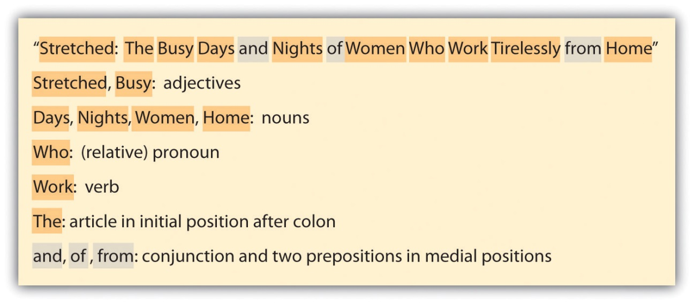

Abbreviations

Capitalize abbreviations of proper nouns, such as the following:

- Schools: UNL, ISU, U of I
- Government agencies: USDA, CIA, FBI
- Countries and states: USA, NY, TX
- Organizations: BSA, AFS
- Corporations: IBM, AT&T
- Television and radio stations: NBC, CBS, WLS

Bulleted Items

If the items in a bulleted list are sentences, capitalize the first word of each item, as follows:

Semester exam schedule:
- Semester exams for M-W-F classes will be given on December 12.
- Semester exams for T-Th classes will be given on December 13.
- Semester exams for once-a-week classes will be given as arranged by the professor.

If the items are not sentences and are not continuations of a sentence stem, capitalize the first word of each item, as follows:

Semester exam schedule:
- Classes held on M-W-F: December 12
- Classes held on T-Th: December 13
- Classes held once-a-week: As arranged by instructor

If the items are continuations of a sentence stem, do not capitalize the first word unless it happens to be a proper noun.

Semester exams will be held on
- December 12 for M-W-F classes,
- December 13 for T-Th classes,
- a date arranged by the professors for once-a-week classes.

Common Misuse of Capital Letters

Avoid the unnecessary use of capital letters. As a rule, you can avoid capitalization errors by adhering to the rules for capitalization. But the following “don’t capitalize” suggestions can help you to avoid making some common mistakes.

- Capitalize names of holidays and months but not seasons: winter, spring, summer, fall
- Do not capitalize words such as “mom” and “dad” when they are used to talk about someone as opposed to when used as a name: Capitalize: “What did you say, Mom?” Don’t capitalize: “My mom and dad came with me.”
- Do not capitalize words that are often used as part of a name when they are used in other ways: “My family tree includes a general, a US president, and a princess.”
- Only capitalize direction words that designate a specific location: Capitalize: “I live out West.” Don’t capitalize: “I live west of Nebraska.”
- You can choose to capitalize a word for emphasis, but avoid overusing this technique since it will lessen the effect.

Entire words and sentences written in capital letters are hard to read. Also, in online situations, this type of typing is referred to as shouting. So except in very rare situations, avoid typing in all capitals.

KEY TAKEAWAYS
- Capitalize proper nouns, trade names, the word “I,” and the interjection “O.”
- Capitalize the first word in a sentence and key words in titles and subtitles.
- Capitalize abbreviations of proper nouns and the first word of items in a bulleted list.

EXERCISES
- Write a (short) short story that uses five capitalization rules in this section. Use a color-coded key and word highlighting to identify where the capitalization rules are satisfied.
- Make a copy of a page from a textbook. Assign each capital letter on the page to one of the capitalization rules by placing a letter from a through f (representing Section 2.1 through Section 2.6) next to each capital letter. Make sure to use a color of ink that will stand out. Circle any missing or misused capitalization.

19.3 Abbreviating Words and Using Acronyms
LEARNING OBJECTIVES
- Be familiar with common abbreviations.
- Understand when to use and not to use abbreviations.
- Recognize common symbols when you see them and learn to use them.

Abbreviations are shortened forms of words that are used for convenience or to manage space. In its purest form, an abbreviation includes initial letters of a word followed by a period, such as “in.” for “inches.” However, many abbreviations skip over letters, such as “yd.” for “yard,” and are still written with a period. Some multiword terms are abbreviated by using the first letter of each word and are called acronyms rather than abbreviations. An example of an acronym is “FBI” for “Federal Bureau of Investigation.”

Some abbreviations or acronyms require a period (etc.), but quite a few never take periods (IBM or FBI). You simply have to learn these differences through the experience of seeing specific examples in print.

You need to know two main things about abbreviations: when to use them and how to write them appropriately. The following sections will clarify these two points.

Common Abbreviations for Titles with Names

Titles that are used with names are often abbreviated—in fact, they are almost always abbreviated. You should spell out religious, academic, and government titles in academic writing, but otherwise, use the standard abbreviations.

Common Abbreviations

Use these standard abbreviations before names: Mrs. Jones, Mr. Hernandez, Ms. Fieldston, Sen. Brown, Rev. Arles, Gen. Bradford, Dr. Borray, Rep. Anderson, Prof. Cruz, St. Francis, Sgt. Appleby

Use these standard abbreviations after names: Alex Jones, DDS; Arnold Wilson, PhD; George A. Ortiz, Jr.; George A. Ortiz, Sr.; Hannah Borray, MD; Phil Horace, BA; Millie Mance, MA; Gloria Wills, MBA; Fred Flores, CPA

Do not use an abbreviation both before and after a name: Write Dr. Joseph Pfeiffer or Joseph Pfeiffer, MD, but do not write Dr. Joseph Pfieffer, MD.

Spell out these titles in academic writing: Professor Robert Jones, Reverend Martin Luther King, General Dwight D. Eisenhower, Senator John Smith

Do not use these title abbreviations if not attached to a name: Do not use any of these abbreviations on their own without a name. Instead spell the titles out, as in “I’m going to see the doctor after my meeting with my professor.”

Commonly Used Stand-Alone Abbreviations and Acronyms

Many abbreviations and acronyms are widely used as stand-alone words. A small sampling of these abbreviations and acronyms is listed in the following tables.

Word | Abbreviation
Avenue | Ave.
Boulevard | Blvd.
chapter | ch.
company | co.
Incorporated | Inc.
January | Jan.
Katherine | Kathy
maximum | max.
miscellaneous | misc.
months | mos.
North | N.
Ohio | OH
package | pkg.
page | p.
pages | pp.
paid | pd.
Robert | Bob
September | Sept.
Southwest | SW
Tuesday | Tues.
University | Univ.

Phrase | Acronym
Alcoholics Anonymous | AA
Bachelor of Arts | BA
Central Intelligence Agency | CIA
digital video disk | DVD
Environmental Protection Association | EPA
Food and Drug Administration | FDA
Internal Revenue Service | IRS
Parent-Teacher Association | PTA
World Wide Web | www

Abbreviations with Numbers

Some abbreviations are used almost exclusively to describe or clarify numbers. These abbreviations should not be used as stand-alone abbreviations. In other words, you can use the dollar-sign abbreviation to write “$5.00” but not to write “I earned several $ last night.” Some of these abbreviations can be used within text, such as BC, p.m., and CST. Measurement abbreviations, however, should be used only in tables, graphs, and figures and should be spelled out within continuous text. Some of these abbreviations will be addressed as symbols later in this section.

Abbreviation | Purpose/Meaning
300 BC | Before Christ
300 BCE | Before the Christian Era or Before the Common Era
1900 AD | Anno Domini (in the year of the lord)
34 m | meters
28 in. | inches
5¢ | cents
6:00 p.m. | post meridiem (after noon)
1:00 a.m. | ante meridiem (before noon)
15 cm | centimeters
No. 8 | number
85 lbs. | pounds
#5 | number
11:30 a.m. EST | Eastern Standard Time
4 hr. 10 min. 30 sec. | hours, minutes, and seconds
4 + 3 | plus
½ = .5 | equals
7 ft. | feet
7n < 21 | is less than
432 ≠ 430 | does not equal
44 cu. in. | cubic inches

Abbreviations in Academic Writing

Academic citations include their own set of common abbreviations. They vary somewhat depending on the citation style you’re using, so always follow your specific style guidelines. Some typical academic citation abbreviations are provided here. (For much more on documentation, see Chapter 22 "Appendix B: A Guide to Research and Documentation".)

Abbreviation | Purpose/Meaning
anon. | anonymous
b. | Born
c. or ca. | circa; about (used with dates)
ch. or chap. | Chapter
d. | Died
ed., eds. | editor, editors
et al. | et alia (Latin: “and others”)
illus. | illustrated
n.d. | no date available
n.p. | no publisher information available
p., pp. | page, pages
vol., vols. | volume, volumes

Topic- or Profession-Specific and Incident-Specific Abbreviations

If you are writing for an audience that is familiar with a specific vocabulary that incorporates abbreviations—for example, readers with a strong military base—you can use those abbreviations freely. But be aware when you are writing for readers who do not share that common knowledge base that you will have to spell out abbreviations.

Incident-specific abbreviations are created for use in one specific situation and thus require obvious references so the audience can understand their meaning. For example, say you are writing a story about a teacher named Mr. Nieweldowskilty. If you refer to him by his full name once and then note that students call him Mr. Niews for short and then refer to him as Mr. Niews the rest of the time, your audience can easily understand that Mr. Niews is short for Mr. Nieweldowskilty. But if you write a second story about him, you cannot assume that readers will know the abbreviated name, Mr. Niews.

Recognizing and Using Symbols

Symbols are actually a form of abbreviating and are used widely in mathematics, on maps, and in some other situations. Here’s a small sample:

75% | Percent sign
#5 | Number sign
4 + 3 | Plus sign
@ | At sign
$5.00 | Dollar sign
5¢ | Cents sign
½ = .5 | Equals sign
432 ≠ 430 | Not equal to sign
> | Greater than
7n ≤ 21 | Less than or equal sign
© | Copyright
98.6º | Degrees

KEY TAKEAWAYS
- You should become familiar with common abbreviations so you can use them in casual situations and in tables and figures.
- As a rule, do not use abbreviations in formal writing except within citations.
- Keep your audience in mind when you decide whether to use abbreviations.
- Many symbols are used in mathematics, on maps, and in other situations.

EXERCISES
- Write a short poem using as many abbreviations as possible.
- Make a copy of a scholarly paper. Highlight all the abbreviations.
- Make a list of twenty abbreviations or symbols that are not included in the lists in this section.

19.4 Inserting Numbers into Text
LEARNING OBJECTIVES
- Understand general rules for using numbers in text.
- Recognize exceptions to the general rules for using numbers in text.

Proper writing of numbers in text is rather simple as long as you are familiar with the general guidelines and the exceptions to those guidelines.

General Guidelines for Using Numbers in Text

APA style calls for writing out numbers from one to nine in words and using numerals for all other numbers. The Chicago Manual of Style calls for spelling out zero through one hundred as well as certain round multiples such as five thousand or six hundred.

MLA style, however, requires that all numbers that are composed of one or two words be written out in words (e.g., one hundred, thirty-six, five million), and all numbers with more than two words be written in numerals (137; 6,482; 3,500,000). There are two general exceptions in MLA:

- If a number falls at the beginning of a sentence, it should be written out in words.
- If both large and small numbers are used within a single sentence or passage, all should be written as numerals in order to be consistent.

Exceptions to the General Guidelines for Using Numbers in Text

Exceptions to the general guidelines are logical, and they help avoid awkward situations. These exceptions are in place in all citation formats and style sheets.

Numerals with Abbreviations

In a situation where abbreviations are used, use numerals, not number words, with the abbreviations.

- 6 in.
- 25 cm
- 125 lbs.
- 4 mos.

Numerals for Time of Day

Within text, you can use either words or numbers to write the time of day. Within a document, be consistent in your choice.

- 4:30 in the morning
- four thirty in the morning
- (but) 4:30 a.m.

Numerals in Dates

Use words to write months and numerals to write years. When the month, day, and year are all included, also use a numeral to write the day. If the year is not included, you can use either a numeral or a word to write the day. Express decades in numerals or words.

- July 23, 1985
- July 23 or July twenty-third
- the sixties or the 1960s

Numerals in Sports’ Scores and Statistics

Use numerals to write sports’ scores and sports’ statistics.

- The Bulls have a 34–6 record.
- The score was 4 to 3.

Numerals Used Side by Side

To avoid confusion when using two numbers side by side, spell out one of the numbers and use a numeral for the other one. Generally, you should write out the number with fewer letters and leave the longer one as a numeral.

- Two 20-page papers
- 24 three-pound bags

Numerals in Addresses and Phone Numbers

Generally, you should use numerals in addresses and phone numbers. One exception is that, when a street is a numeral, you can either use the numeral or spell out the word.

- 3545 N. Willow
- Denver, CO 80202
- Fifth Street or 5th Street
- 210-555-7485

Numerals as Part of Proper Nouns

Numbers that are part of proper nouns should always be written as they appear.

- Psychology 101
- Room 222
- 7-Up
- Fifth Third Bank
- Second City

Numerals as Divisions of Books and Documents

Use numerals to indicate page, volume, chapter, unit, and section numbers as well as other divisions that are used to organize written text.

- Section 2, Chapter 4
- page 8
- Act 2, Scene 7
- Volume 2, Unit 7, Item 12

Numerals in Decimals and Percentages

As a rule, numerals are used to express decimals and percentages.
- 34.72
- 75 percent

Numerals Used for Identification

Use numerals when writing identification numbers, such as the serial number for a computer, a driver’s license number, or a social security number.

- Serial: 25485359243642
- Driver’s license: 245Y823

Numerals in Money Amounts

When a money amount is briefly mentioned in a piece of writing that is not necessarily about money, spell the money amount out. However, if you are writing about money or are writing text that will reference money amounts on multiple occasions, use numerals and symbols.

- Offhand reference: ten dollars
- Repeated reference: $10 or $10.00

Punctuating Numerals

When writing numerals, use a decimal point to separate dollars and cents and use a comma to divide numbers of one thousand or more into units of three digits. Do not use these punctuation marks when writing numbers in words.

45,329 | forty-five thousand three hundred twenty-nine
$12.43 | twelve dollars and forty-three cents

KEY TAKEAWAYS
- Consult the style manual you are following to determine which numbers to write out in words and which to express as numerals.
- The Chicago Manual of Style calls for numbers to be written out from zero through one hundred.
- Be aware of special situations where numbers are written other than by the general rule.

EXERCISES
- Write five sentences using as many of the number rules and exceptions as possible. Write all the numbers in words. Trade papers with a partner and edit the numbers according to the guidelines in this section.
- Make a copy of a newspaper or magazine article that includes numbers. In the margins, jot the rules that guide the use of each number.
- Create a bookmark using all the number-writing guidelines from this section.

19.5 Marking Words with Italics
LEARNING OBJECTIVES
- Know when to use italics versus quotation marks in titles of works.
- Review other circumstances when italics are appropriate.
- Understand how to use italics in moderation for emphasis.

Traditionally, underlining was used as a means of emphasis in handwritten text. Since the advent of the personal computer, italics have replaced underlining. If you are creating text by hand or by some other means where italics are not available, use underlining instead of italics.

Italicize Titles of Published Texts, Lengthy Works, and Legal Cases

As a rule, you should italicize the titles of published works, but you should not italicize parts of published works, such as a poem within a book, or unpublished works. Some exceptions that should be italicized include lengthy works, such as a very long poem within a book, and legal cases. Some exceptions that should not be italicized include titles of published short stories and titles of television shows. Works that are not italicized are typically placed in quotation marks. Some other exceptions that should not be italicized include long religious works, such as the Bible and the Koran, and easily recognizable texts, such as the US Constitution.

Italicize Titles of Books, Magazines, and Newpapers

- The Runaway Jury
- People
- The New York Times

Italicize Titles of Long Poems, Plays, and Television Series (but Not Individual Television Shows)

- The Odyssey
- Billy Elliot the Musical
- The Mentalist

Italicize Names of Spacecraft, Aircraft, and Ships

- Apollo 13
- Boeing 777
- the Niña, Pinta, and Santa María

Italicize Foreign Words Used in English Sentences

- We would like to develop a very positive esprit de corps within the company.
- His actions over the past month have made him persona non grata within my group of friends.

Italicize Words, Letters, and Numbers That Are Called Out or Emphasized

- She is, by the very definition, irascible.
- Make a list of words that begin with hu.
- The numbers 36, 84, and 300 are all divisible by 6.

Italicize Scientific Names

- Homo sapiens are members of the Animalia kingdom.

Do Not Overitalicize

You might be tempted to use italics to emphasize a key phrase, word, or idea even though it doesn’t fall into any these categories. Fight off the temptation since an overuse of italics is distracting for readers.

KEY TAKEAWAYS
- Italics have replaced underlining, thanks to word processing.
- Know the rules for what should and should not be italicized.
- Do not overitalicize by italicizing assorted words just to make them stand out.

EXERCISES
- Write sentences demonstrating your choice of five of the guidelines given in Section 19.5 "Marking Words with Italics" for using italics.
- In a textbook, find as many examples of the different italicizing guidelines as possible. Copy the pages and identify each guideline you find.
- Complete these sentences:
  - If you use the word “magnum opus” in a sentence, you should italicize it because…
  - Read this sentence: The word city has a soft c. The two italics rules used in this sentence are…
- Read this sentence: A Canis familiaris is a dog. The problems with this sentence are…

Chapter 20
Grammar
Rules of English
People who are new to the English language frequently encounter rules of grammar that cause confusion, and those struggles are to be expected. But even native English users know that most everyone has issues with grammar sometimes. In this chapter, you will have a chance to review all the basic grammar rules. The first two sections address subject and verb issues. The next three sections cover noun cases and a variety of pronoun rules. The final section presents guidelines for using adverbs and adjectives.

20.1 Making Sure Subject and Verbs Agree
LEARNING OBJECTIVES
- Recognize typical subject/verb agreement.
- Learn how to match the subject and verb when other words come between them, how to work with compound subjects, how to use titles involving collective subjects, and how to use indefinite subjects.
- Learn the rules for matching subjects coming after the verb, relative pronouns, gerunds, infinitives, and singular subjects that look plural.

Subjects and verbs must agree in two ways: number (singular or plural) and person (first, second, or third). These two general rules hold through all the different subject/verb guidelines. As a rule, plural subjects end in -s and plural verbs do not end in -s. In this section, the noun is in bold and the verb is in italic.

Pairing Verbs with Singular and Plural Subjects

Many sentences have subjects and verbs that appear side by side. The subjects in these sentences are often clearly singular or plural, and they clearly determine the needed verb form.

Situation | Example | Watch Out For
Typical singular subject followed directly by the verb | The US government establishes national parks on an ongoing basis, such as the six parks formed in Alaska in 1980. | Don’t get confused into thinking that a singular subject needs a verb without an -s. The plural version would be “governments establish.”
Typical plural subject followed directly by the verb | National parks provide wonderful opportunities for people to commune with nature. | The subject “parks” is plural and it agrees with “provide.” The singular version would be “park provides.”

Matching Subjects and Verbs That Are Separated by Other Words

When words fall between a subject and verb, the singular/plural state of the subject is sometimes confusing. Always make sure you are matching the verb to the subject and not to one of the words between the two.

Situation | Example | Watch Out For
Words fall between subject and verb | Six national parks in Alaska were formed in 1980. | Mistaking “Alaska” for the subject would make it seem as if the verb should be “was formed.”

Joining Plural Verbs to Compound or Double Subjects

Compound subjects joined by the word “and” are plural since there is more than one of them. Double subjects joined by “or” or “nor” match to a verb based on the status of the subject closest to the verb.

Situation | Example | Watch Out For
Compound subject with plural verb | Rock and grass combine to make Badlands National Park amazing. | “Rock and grass” is a plural subject formed by two singular words. Don’t get confused and use “combines” for the verb because the individual subjects are singular.
Noncompound double subject functioning as a singular subject | Depending on where you look, rock or grass dominates your view. | Since the subjects are joined by “or,” they do not automatically become plural because there are two of them.

Pairing Singular Verbs with Titles and Collective Subjects

Regardless of the singular or plural nature of the words within a title, the title is considered one unit; thus it is a singular noun. Similarly, collective nouns, such as “committee,” function as singular nouns regardless of how many people or things might actually make up the collective noun.

Situation | Example | Watch Out For
Title with singular verb | Everglades National Park preserves thousands of acres of wetlands. | This title isn’t plural just because word “Everglades” is plural. The park is one thing and, therefore, is singular.
Collective subject with singular verb | The team meets twice a year at Far View Lodge in Mesa Verde National Park. | Although you know that the “team” is made up of more than one person, you must view “team” as a single unit.

Teaming Singular Verbs with Indefinite Subjects

Whether an indefinite subject is singular or plural depends on whether the indefinite noun has a singular or plural meaning on its own or based on the rest of the sentence.

Situation | Example | Watch Out For
Indefinite subject with singular meaning on its own | Each of the fossils in the Petrified Forest National Park tells a story. | Even though there is more than one fossil, the word “each” is always singular. Many indefinite subjects are always singular. Examples include another, anyone, anything, each, everybody, everything, neither, nobody, one, other, and something.
Indefinite subject with singular meaning based on the rest of the sentence | All of Arizona was once located in a tropical region. | Since “Arizona” is singular, “all” is singular. Some indefinite subjects can be singular or plural. Examples include all, any, more, most, none, some, and such.
Indefinite subject with plural meaning based on the rest of the sentence | All the petrified trees in the Petrified Forest National Park are millions of years old. | Since “trees” is plural, “all” is plural.
Indefinite subject with plural meaning on its own | Both scrubland and rock formations are common in desert settings. | Some indefinite subjects are always plural. Examples include both, few, fewer, many, others, several, and they.

Choosing Verbs When the Subject Comes after the Verb

The standard sentence format in English presents the subject before the verb. In reversed sentences, you need to find the subject and then make sure it matches the verb. To find the subject, fill the following blank with the verb and then ask the question of yourself: who or what _____?

Situation | Example | Watch Out For
Subject comes after the verb | Throughout Mammoth Cave National Park run passages covering over 367 miles. | Who or what runs? The passages do. Even though you might be tempted to think “Mammoth Cave National Park” is the subject, it is not doing the action of the verb. Since “passages” is plural, it must match up to a plural verb.

Deciding If Relative Pronouns Take a Singular or Plural Verb

Relative pronouns, such as who, which, that, and one of, are singular or plural based on the pronoun’s antecedent. You have to look at the antecedent of the relative clause to know whether to use a singular or plural verb.

Situation | Example | Watch Out For
Relative pronoun that is singular | The Organ, which rises up seven hundred feet, is so named for its resemblance to a pipe organ. | The word “organ” is singular and is the antecedent for “which.” So the word “which” is also singular. The word “which” is the subject for the relative clause “which rises up seven hundred feet” and, therefore, requires a singular verb (rises).
Relative pronoun that is plural | Arches National Park in Utah offers sites that mesmerize the most skeptical people. | The word “sites” is plural and is the antecedent for “that.” The word “that” is the subject for the relative clause “that mesmerize the most skeptical people.” So “that” is plural in this case and requires a plural verb (mesmerize).

Matching Singular Subjects to Gerunds and Infinitives

Gerunds are nouns formed by adding -ing to a verb. Gerunds can combine with other words to form gerund phrases, which function as subjects in sentences. Gerund phrases are always considered singular.

Infinitives are the “to” forms of verbs, such as to run and to sing. Infinitives can be joined with other words to form an infinitive phrase. These phrases can serve as the subject of a sentence. Like gerund phrases, infinitive phrases are always singular.

Situation | Example | Watch Out For
Gerund phrase as singular subject | Veering off the paths is not recommended on the steep hills of Acadia National Park. | Don’t be fooled by the fact that “paths” is plural. The subject of this sentence is the whole gerund phrase, which is considered to be singular. So a singular verb is needed.
Infinitive phrase as singular subject | To restore Acadia National Park after the 1947 fire was a Rockefeller family mission. | All words in an infinitive phrase join together to create a singular subject.

Recognizing Singular Subjects That Look Plural and Then Choosing a Verb

Some subjects appear plural when they are actually singular. Some of these same subjects are plural in certain situations, so you have to pay close attention to the whole sentence.

Situation | Example | Watch Out For
Singular subjects that look plural | Politics plays a part in determining which areas are named as national parks. | Many subjects are or can be singular, but look plural, such as athletics, mathematics, mumps, physics, politics, statistics, and news. Take care when matching verbs to these subjects.
Subject that looks plural, and is sometimes singular and sometimes plural | State and national politics sway Congress during national park designation talks. | Just because words such as “politics” can be singular doesn’t mean that they always are. In this case, the adjectives “state and national” clarify that different sources of politics are involved (“state politics” and “national politics”), so “politics” is plural in this case.

KEY TAKEAWAYS
- A typical English sentence has a clear singular or plural subject followed by an equally clear singular or plural verb.
- Take extra care to match subjects and verbs when other words come between them by not using those extra words in your determination.
- Compound subjects always use a plural verb.
- Titles and collective subjects always require singular verbs.
- Indefinite subjects are singular or plural based on their own meaning, the rest of the sentence, or both.
- When a subject comes after the verb, locate the subject by identifying who or what completed the action. Then apply the appropriate subject/verb agreement guideline.
- Use antecedents to decide whether relative pronouns are singular or plural. Then match them to verbs.
- Gerunds and infinitives are always singular and take singular verbs.
- Some subjects look plural whether they are singular or plural. With such subjects, take special care when making sure the subjects and verbs agree.

EXERCISE
- Write sentences to meet each of the following criteria. For each sentence, be sure that the subjects and verbs agree.
  - Write a sentence that has words between the subject and verb.
  - Write a sentence with a compound subject.
  - Write a sentence that has a title of a song, movie, television show, or national park for a subject.
  - Write a sentence that has a collective noun for a subject.
  - Write a sentence that has an indefinite subject (another, anyone, anything, each, everybody, everything, neither, nobody, one, other, or something).
  - Write a sentence where the subject comes after the verb.
  - Write a sentence that uses a relative pronoun as a singular subject.
  - Write a sentence that uses a relative pronoun as a plural subject.
  - Write a sentence that has a gerund phrase for the subject.
  - Write a sentence that has an infinitive phrase for the subject.
  - Write a sentence that has a subject that looks plural but is actually singular.
  - Write a sentence that has a subject that looks plural and is sometimes singular but is plural in this situation.

20.2 Avoiding General Verb Problems
LEARNING OBJECTIVES
- Understand the difference between regular verbs and irregular verbs and use both versions correctly.
- Use verb tenses accurately and completely.
- Match infinitives and participles to verb tenses.

What if all coffee makers worked the same way, all vehicles had the exact same dashboard setup, and all verbs followed the exact same format? Life would simply be easier all the way around! But we live in a world of variety, and just as you take the needed steps to become familiar with the coffee maker and car you own, you should also take the effort to become familiar with the language you speak. This section presents an overview of common issues that impede the proper use of English verbs. To get ready to understand the possible problems, study the following chart that shows the five main forms of verbs. Notice that for verbs other than be, the present tense for all but third-person singular pronouns is the base verb (third-person singular uses the base verb + -s). The present participle is usually a form of “to be” + the base word + -ing, and the past tense and past participle follow irregular patterns.

Table 20.1 Five Forms of English Verbs
Base | Present Tense (+ -s for Third-Person Singular) | Past Tense | Past Participle (Preceded by Form of “to Have”) | Present Participle (Preceded by Form of “to Be”)
run | run | ran | run | running
smile | smile | smiled | smiled | smiling
sing | sing | sang | sung | singing
beat | beat | beat | beaten | beating
see | see | saw | seen | seeing

Using Irregular Verbs Correctly

Since the present tense of irregular verbs is almost always the same as the base and since the present participle is almost always a form of “to be” + the base + -ing, those two columns are not included in this table. Take note of some underlying patterns in the other three main verb forms for each set of irregular verbs.

Regular Verbs
Base |  | Past Tense |  | Past Participle (Preceded by Form of “to Have”)
accept |  | accepted |  | accepted
bump |  | bumped |  | bumped
dry |  | dried |  | dried
hop |  | hopped |  | hopped
observe |  | observed |  | observed
print |  | printed |  | printed
shrug |  | shrugged |  | shrugged
wobble |  | wobbled |  | wobbled
Irregular Verbs
Base | Past Tense |  | Past Participle (Preceded by Form of “to Have”)
Break | broke |  | broken
bite | bit |  | bitten
catch | caught |  | caught
teach | taught |  | taught
Awake | awoke |  | awoke/awakened
arise | arose |  | arisen
bear | bore |  | borne
bring | brought |  | brought
Choose | chose |  | chosen
come | came |  | come
do | did |  | done
eat | ate |  | eaten
fall | fell |  | fallen
Freeze | froze |  | frozen
get | got |  | got/gotten
give | gave |  | given
go | went |  | gone
run | ran |  | run
drink | drank |  | drunk
ring | rang |  | rung
have | had |  | had
hear | heard |  | heard
know | knew |  | known
lay | laid |  | laid
lead | led |  | led
Lie | lay |  | lain
ride | rode |  | ridden
rise | rose |  | risen
say | said |  | said
see | saw |  | saw
shine* | shone |  | shone
shine* | shined |  | shined
take | took |  | taken
*Note that some words have more than one conjugation based on meaning. For example, the sun and lights shine/shone/shone, but when we deal with shoes, we shine/shined/shined.

Check out Table 15.1 "Verb Tenses for the Regular Verb “Look” and the Irregular Verb “Eat”" in Chapter 15 "Sentence Building", Section 15.2 "Choosing Appropriate Verb Tenses" for an overview of how to use these verb forms.

Handling Specific Problematic Verbs

Some verbs are especially problematic either because their meanings are confused or because some of their forms sound alike. Handle these verbs by knowing which ones give you trouble and then focusing on the conjugation of those specific verbs. Some of these most commonly troublesome verbs are in the following table. You need to know two key verb types to read this table: transitive (when an object receives the action of the verb; in other words, something is done to something) and intransitive (a verb that does not act on an object).

Problematic Verb Set (Base, Past, P. Part.) | Guidelines | Examples
borrow…lend | The verb borrow means “to temporarily get from someone else,” and lend means “to temporarily give to someone else.” | I borrowed Kyle’s backpack since I had lent mine to Alice.
borrow, borrowed, borrowed
lend, lent, lent
bring…take | The starting point of the action causes the confusion between these two verbs. If you bring something, you have to start somewhere else and end up at the common location. If you take something, you have to start at the common location and end up somewhere else. | He brought his clean life jacket to the river and took away a filthy life jacket.
bring, brought, brought
take, took, taken
feel…think | The verb feel is emotion based and the verb think is logic based. | I feel excited about the tree-top ride, but I think it might cost more than I can afford.
feel, felt, felt
think, thought, thought
lay…lie | The verb lay is transitive and means “to put,” so whenever you put something down, use lay. If you could replace the verb with put or place, you should use lay. The verb lie means “to rest” or “to tell a falsehood.” | I laid my sunglasses down on a rock.
lay, laid, laid |  | I lay on the rock myself for twenty minutes.
lie, lay, lain (rest) |  | The ranger jokingly lied about the trail being a short one.
lie, lied, lied (fib)
learn…teach | The verb learn always means to “take in information” and to teach always means to “give out information.” | I learned that Yellowstone was the first national park in the United States. When we go there this summer, I’m going to see what Old Faithful can teach me about geysers.
learn, learned, learned
teach, taught, taught
raise…rise | The verb raise is transitive, so you always have to raise something. The verb rise means to “go up” or “get up.” | We are planning to rise early so that we are ready to start hiking when the sun rises, so raise your hand now if you have a problem with that plan.
raise, raised, raised
rise, rose, risen
set…sit | The verb sit is always intransitive and set usually transitive. The most common confusion is when referring to putting something down. Whenever the meaning is to put, use set. | The squirrel set his nut on the ground and sat looking at me.
set, set, set
sit, sat, set

Adding -s and -es for the Third Person

Many verbs require the addition of -s or -es when used in the third-person singular present tense. Although these verbs are slightly different from the present tense form of the verb, they are not considered a separate verb form.

Example
Present tense verb: walk
Present tense verb used in first person: I walk for hours looking at the trees and plants.
Present tense verb used in second person: You walk too quickly for me.
Present tense verb used in third person: He walks around as if he knows where he’s going.

Using Verb Tenses Accurately and Completely

Verb tenses allow you to attach timing to sentences you write and say. To make your meaning clear, you need to choose the correct tense for the timing and you need to be sure to include all the needed words for that tense.

Verb Tenses | Timing of Action | Additional Words and Endings Needed to Complete Verb | Examples
Simple present | Taking place right now | None | I hike.
 |  |  | You hike.
 |  |  | She hikes.
Simple past | Started and finished in the past | Add -ed to verb. | I hiked.
 |  |  | You hiked.
 |  |  | She hiked.
Simple future | Will take place after now | Add will or shall to the present-tense verb | I will hike.
 |  |  | You will hike.
 |  |  | She will hike.
Present progressive | Taking place right now and will continue to take place | Add am, is, or are to the verb + -ing | I am hiking
 |  |  | You are hiking.
 |  |  | He is hiking.
Past progressive | Took place in the past at the same time that another action took place | Add was or were to the verb + -ing | I was hiking.
 |  |  | You were hiking.
 |  |  | He was hiking.
Future progressive | Will take place in the future and will continue on indefinitely | Add will be or shall be to the verb + -ing | I will be hiking.
 |  |  | You will be hiking.
 |  |  | He will be hiking.
Present perfect | Happened at an indefinite time in the past or started in the past and continues now | Add has or have to the past participle of the verb (usually-ed) | I have hiked this trail before. (in the past)
 |  |  | I have hiked this trail since I was five years old. (in the past and continues)
Past perfect | Took place before some other past action | Add had to the past participle of the verb (usually -ed) | By the time I saw Jenny, I had hiked past the food station.
Future perfect | Will take place some time in the future before some other action | Add will have to the past participle of the verb (usually-ed) | I will have hiked for two hours before you even wake up.
Present perfect progressive | Began in the past, continues now, and might continue into the future | Add has or have been to the verb + ing | I have been hiking for a while.
Past perfect progressive | Took place on an ongoing basis in the past and was completed before another past action | Add had been to the verb + -ing | You had been walking for an hour when you saw the swans.
Future perfect progressive | Takes place in the future on an ongoing basis | Add will have been to the verb + -ing | They will have been hiking once a week by then.

Matching Infinitives and Participles to Verb Tenses

Verbals are words formed from verbs that function as other parts of speech. One type of verbals, gerunds (laughing, eating), always function as nouns (e.g., “Laughing is good for you”). Present, past, and present perfect participles are verbals that function as adjectives (e.g., “The sound of laughing children always cheered him up,” “The sight of the broken tricycle left in the rain made him gloomy”). Infinitives (to laugh, to have eaten) are another main type of verbals that function as nouns, adjectives, or adverbs. When using any of these verbals, make sure you match the tense of the verb in the sentence.

Infinitives

When the action of the infinitive takes place after or at the same time as the action of the main verb, use the present tense:

We plan to camp in the National Redwood Forest this week.

When the action of the infinitive takes place before the action of the main verb, present the infinitive in perfect tense:

We planned to have been camping in the National Redwood Forest last week.

Participle Phrases

Participle phrases can begin with the present participle, past participle, or present perfect participle.

The present participle is the correct choice when the action of the participle is happening at the same time as the action of the main verb:

Resulting in large openings called goosepen scars, fire ravages redwood trees without killing them.

When the action of the participle takes place before the action of the main verb, you can use either a past participle or a present perfect participle:

Scarred by a fire years ago, the large redwood tree still stands tall and awesome. (past participle in participle phrase)

Having posed for several pictures inside the redwood trunk, we climbed out and previewed the shots.

KEY TAKEAWAYS
- The present and past participles of regular verbs are formed by adding -ing and -ed to the base verb. Irregular verbs do not follow a set pattern, so you have to fix them in your mind so you use them correctly.
- Verbs have twelve tenses that indicate different timings. Due to the complexity of the complete set of tenses, you simply have to memorize the uses for the different tenses and the methods of constructing each.
- You should match both infinitives and participle phrases to the main verb in a sentence.

EXERCISES
- Write a set of three sentences each using one of the verbs go, went, and gone.
- Write a sentence using the verb freeze in present progressive tense.
- Write a sentence using the verb ride in past perfect progressive tense.
- Write a sentence using the verb lie in simple future tense.
- Write a sentence using the verb learn in past perfect tense.
- Write three sentences using each of the following verbs as gerunds, infinitives, and participle phrases. Identify the part of speech in each case.
  - love
  - kick
  - play
  - eat
  - drive

20.3 Choosing the Correct Pronoun and Noun Cases
LEARNING OBJECTIVES
- Recognize pronoun cases.
- Recognize noun cases.
- Learn tips for handling pronoun case situations that confuse you.

One feature that is easier in English than in many other languages is noun cases. While other languages have changes for the objective case as well as changes based on gender, English nouns do not change form except for the formation of plurals and possessives.

Pronouns in English, on the other hand, have different forms for the subjective, possessive, and objective cases. The subjective case refers to words as they are used in the subject position, while the possessive and objective cases designate words that are used in the possessive and object positions, respectively. Study the following table for an overview of the noun and pronoun cases.

 | Subjective Case | Possessive Case | Objective Case
Nouns
Singular
 | car | car’s | car
 | Jordy | Jordy’s | Jordy
Plural
 | apples | apples’ | apples
 | children | children’s | children
Pronouns
Singular
First person | I | my | me
 |  | mine
Second person | you | your | you
 |  | yours
Third person | he | His | him
 | she | her, hers | her
 | it | Its | it
Plural
First person | we | our, ours | us
Second person | you | your, yours | you
Third person | they | their, theirs | them
Indefinite Pronouns
 | anybody | anybody’s | anybody
 | everybody | everybody’s | everybody
 | someone | someone’s | someone
Relative and Interrogative Pronouns
 | that |  | that
 | which |  | which
 | who | whose | whom
 | whoever | whoever’s (slang) | whomever

Tips for Avoiding Pronoun Case Problems

If you have trouble choosing between “I” and “me” in compound subject and object situations, remove the other subject or object, and try “I” or “me” alone.

Example: Which of these two choices are correct? At Bryce Canyon, Carol took thirty pictures of Anna and I.
OR
At Bryce Canyon, Carol took thirty pictures of Anna and me.

Test: At Bryce Canyon, Carol took thirty pictures of (I, me).

Result: Since the correct choice alone is “me,” the correct choice within the compound object is also “me”—At Bryce Canyon, Carol took thirty pictures of Anna and me.

If you are confused about whether to use who or whom in a dependent clause, try isolating the clause that includes who or whom. Then reword the clause as a sentence and substitute a personal pronoun (subjective case: he, she, they; objective case: him, her, them) for who or whom. If he, she, or they sounds right, use who. If him, her, or them sounds right, use whom.

Example: I don’t know (who, whom) to ask about where to stay at the Grand Tetons.

Test: Possible rewording—I don’t know if I should ask (he, she, they, him, her, them).

Result: Since him, her, or them are the choices that work, the correct choice in the first sentence is whom—I don’t know whom to ask about where to stay at the Grand Tetons.

If you are confused about whether to use who or whom at the beginning of a sentence, think of an answer for the sentence using a personal pronoun. Then mimic the case of the answer pronoun in the original sentence.

Example 1: (Who, Whom) is getting up at sunrise to watch the sun come up over these magnificent trees?

Test: They will get up. Result: Since they is subjective case, you should use who, which is also subjective case.

Example 2: (Who, Whom) did you ask to watch the fire?

Test: I asked her to watch the fire.

Result: Since her is objective case, you should use whom, which is also objective case.

In casual usage, some words are sometimes left out, thus requiring a pronoun to do extra work. If you are confused about which pronoun case to use in these situations, think about how the sentence would be written if it were totally complete. Considering the whole sentence meaning should help clarify the pronoun choice.

Example 1: Harry likes camping more than (her, she).

Test: Harry likes camping more than she (likes camping).
Result: The pronoun she is the subject of the assumed verb likes. So subjective case is needed.

Example 2: Harry likes camping more than (her, she). Test: Harry likes camping more than (he likes) her.

Result: The pronoun her is the object of the assumed verb likes. So objective case is needed.

If you are unsure whether to use we and us before a noun or noun phrase, say the sentence without the noun or noun phrase in place. Whichever pronoun works without the noun or noun phrase is also the correct pronoun to use with the noun.

Example 1: Even (us, we) people who like our creature comforts fall in love with nature when viewing the Grand Tetons.

Test: Even we fall in love with nature when viewing the Grand Tetons.

Result: Once people who like our creature comforts is dropped out, it becomes clear that the pronoun needs to be subjective case.

Example 2: Don’t wait for (us, we) creature-comfort people to come up with a plan.

Test: Don’t wait for us to come up with a plan.

Result: Once creature-comfort people is dropped, it becomes clear that the pronoun needs to be objective case.

KEY TAKEAWAYS
- The correct pronoun choice changes based on the usage in the sentence because pronouns have subjective, objective, and possessive cases.
- In English, nouns are the same in the subjective and objective case. So all you have to know to write a noun correctly is whether it is singular or plural and possessive or not.
- You can memorize tips and clues to help you remember pronoun case issues with which you struggle.

EXERCISE
- Choose the correct pronoun for each sentence. Then, for each choice, indicate whether it is subjective, objective, or possessive case.
  - I don’t know (her, she).
  - (Us, We) girls are meeting at 7:00 p.m.
  - (Who, Whom) do you think will show up first?
  - That car is (theirs, their’s).
  - We aren’t sure (who, whom) got here first.
  - (Its, It’s) about time we clear the air.
  - The jacket fits him better than (I, me).

20.4 Making Pronouns and Antecedents Agree
LEARNING OBJECTIVES
- Understand the different types of pronouns.
- Recognize pronoun antecedents.
- Make sure pronouns and antecedents are relatively close together and match in person, number, gender, and human versus nonhuman state.

Pronouns can be somewhat confusing, but they can help make your use of language smoother and more compact. For example, if your name were Pete Rando, you could write, “Pete Rando is going back to wait to go back to Pete Rando’s camper until Pete Rando’s friends have seen the sunset at the Grand Canyon.” Or you could say, “I’m going to wait to go back to my camper until my friends have seen the sunset at the Grand Canyon.” A first step in understanding how and when to use pronouns properly is having an overall picture of pronouns. Study the following table for an overview of the different types of pronouns. Note that some pronouns, such as possessive pronouns and interrogative pronouns, show up on more than one list.

Demonstrative pronouns | Refer to things | that  these  this  those |  | This trail is the longest one.
Indefinite pronouns | Refer to nonspecific people or things | Singular:  anybody  anyone  everybody  everyone  everything  nothing  one  someone  somebody | Singular or plural:  all  any  more  most  none  some | Do you know anyone who has hiked to the bottom of the Grand Canyon?
Plural:
both
few
many
Interrogative pronouns | Are used in questions | that  what  whatever  which  whichever  who  whoever  whom  whose |  | Who wants to sign up to ride the mules down into the Grand Canyon?
Personal pronouns | Refer to people or things | Subjective case:  he  I  it  she  they  we  you | Objective case:  her  him  it  me  them  us  you | If you ask Alicia, she will tell you that I am too chicken to ride the mules even though none of them has ever gone over the edge.
Possessive case:
his
her(s)
its
my
mine
our(s)
their(s)
your(s)
Possessive pronouns | Show ownership without using an apostrophe | his  her(s)  its  my  mine  our(s)  their(s)  your(s) |  | Regardless of the expense, a helicopter ride is my choice for seeing the Grand Canyon.
Reciprocal pronouns | Refer to separate parts of a plural antecedent | each other  one another |  | The mules calmly follow each other all the way up and down.
Reflexive and intensive pronouns | End in -self or -selves. Reflexive pronouns are needed for a sentence to make sense, and intensive pronouns are optional within a sentence | herself  himself  itself  myself  oneself  ourselves  themselves  yourself  yourselves |  | The guides themselves put their lives in the hands, or rather hooves, of the mules every day.
Relative pronouns | Show how dependent clause relates to a noun | that  what  whatever  which  whichever  who  whoever  whom  whomever  whose |  | As long as I get to see the Grand Canyon from a vantage point other than the edge, I am happy to choose whichever option you want.

Another step in properly using pronouns is to recognize a pronoun’s antecedent, which is the noun or pronoun to which a pronoun refers, and make sure the pronoun and antecedent match in number, person, gender, and human versus nonhuman state. Also, to make the antecedent-pronoun match clear, the pronoun should follow relatively soon after the antecedent, and no other possible antecedent should fall between the antecedent and the pronoun.

Antecedent Situations | Example in a Sentence | Pronoun Antecedent Guidelines
Compound antecedents | Joey and Hannah spent the weekend with their parents at the Grand Teton National Park. | As an antecedent, “Joey and Hannah” is plural, non-gender-specific, human, and third person, so the pronoun must match. Hence their works, but, for example, our, his, her, and them would not work.
Indefinite pronouns that act as an antecedent for other pronouns | Some of the moose left their footprints in our campsite. | Since “of the moose” is a nonessential phrase, the antecedent for their is some. The pronoun some can be singular or plural, so it agrees with their, which is plural.
Collective noun antecedents | The Teton Range is quite regal as it protrudes upwards nearly seven thousand feet. | Teton Range is a collective noun and, therefore, is considered single (multiple mountains within the range, but only one range). It is nonhuman, so it agrees with it. Collective nouns are sometimes an exception to the human versus nonhuman guideline since a noun, such as “crew” or “audience,” can match to the pronoun its.
Antecedents and gender-biased pronouns | Everyone should make his or her own choice about hike lengths. | Years ago, acceptable writing included using male pronouns to refer to all unknown- or collective-gender antecedents. Today such usage is considered sexist (see Chapter 16 "Sentence Style", Section 16.5 "Avoiding Sexist and Offensive Language"). Some people opt to use their with singular antecedents instead of using his or her. Such usage should never be used in formal writing because it is technically incorrect since everyone is singular and their is plural.
Ambiguous antecedents | Ambiguous: The trails wind high into the mountains where they seem to disappear into the sky. | When a pronoun antecedent is unclear, such as in this situation where readers do not know if the trails or the mountains seem to disappear into the sky, you should reword the sentence by either (1) eliminating or (2) moving the pronoun (and probably other words).
 |  | Example #1: The trails wind high into the mountains where the trails seem to disappear into the sky.
 |  | Example #2: High in the mountains, the trails wind as they seem to disappear into the sky.
Vague or implied antecedents | Vague or implied: The Grand Teton park wetland trails go past areas where deer, elk, and moose are often seen, so it should be a lot of fun. | The antecedent of it is not clear because the writer used a shortcut. Instead of referring to any of the nouns that preceded it in the sentence, it refers to an unstated antecedent, such as the experience or the hike. A better way to write the sentence: The Grand Teton park wetland trails go past areas where deer, elk, and moose are often seen, so the hike should be a lot of fun.
Antecedents in previous sentences | The Grand Teton National Park was formed in 1929. In 1950, it was sort of re-formed when additional land was added. | Antecedents should be present within the same sentence unless the flow of the sentences is such that the antecedent/pronoun connection is very clear.

KEY TAKEAWAYS
- Take care to use these eight types of pronouns correctly: demonstrative, indefinite, interrogative, personal, possessive, reciprocal, reflexive/intensive, and relative.
- For every pronoun, you should be able to easily identify a matching antecedent.
- As a rule, a pronoun’s antecedent should be nearby, in the same sentence, and matching in person, number, gender, and human versus nonhuman state.

EXERCISE
- For each sentence, fill in the blank with an appropriate pronoun(s) and circle the antecedent.
  - Everybody heard us sing _______________ version.
  - The pit crew did _______________ job like clockwork.
  - A small child should not be left to fend for _______________.
  - Beagles and Labradors often show off _______________ natural hunting tendencies.
  - Allie and Bethany are planning to help _______________ with their projects.
  - Ask each student to upload _______________ papers into the drop box.
  - Anyone can get _______________ transcripts by filling out the proper form.

20.5 Using Relative Pronouns and Clauses
LEARNING OBJECTIVES
- Recognize noun and adjective clauses that begin with relative pronouns.
- Use appropriate relative pronouns in noun and adjective clauses.

Noun clauses can serve as subjects or objects and often begin with one of these relative pronouns: that, what, whatever, which, whichever, who, whoever, whom, whomever, whose. Logically, you should use subjective case pronouns in noun clauses that function as subjects and objective case pronouns in noun clauses that function as objects. See Chapter 20 "Grammar", Section 20.3 "Choosing the Correct Pronoun and Noun Cases" for a review of pronoun cases.

Examples
Subjective Case Example: Joshua Tree National Park, which is in California, is named after a tree that is actually a member of the lily family.

Objective Case Example: A Joshua tree looks like neither its relative, the lily, nor the biblical figure, Joshua, whom the tree is said to be named after.

Adjective clauses modify nouns and pronouns that usually immediately precede the clauses. Adjective clauses often begin with these relative pronouns: that, which, who, whom, whose.

Example
The Mohave and the Colorado are the two deserts that meet in Joshua Tree National Park.

Often adjective clauses leave the relative pronoun implied, as in the following example: I couldn’t get the stain out of the pants (that) I wore to the party.

For more on how to punctuate clauses properly, see Chapter 18 "Punctuation", Section 18.1 "Using Commas Properly".

KEY TAKEAWAYS
- Many noun clauses begin with these relative pronouns: that, what, whatever, which, whichever, who, whoever, whom, whomever, whose.
- Noun clauses that begin with relative pronouns can serve as subjects or objects and require subject and object pronouns, respectively.
- Many adjective clauses begin with these relative pronouns: that, which, who, whom, whose.

EXERCISE
- Complete these steps for the following sentences:
  - Use one of these relative pronouns to fill in each of the following blanks: that, what, whatever, which, whichever, who, whoever, whom, whomever, whose.
  - Determine whether the clause that each relative pronoun introduces is a noun clause or an adjective clause.
  - For each noun clause, indicate whether it is subjective or objective case.
  - The swimmer _______________ won the race had been sick all last week.
  - Caley, _______________the coach thought would win her race, defaulted in the first lap.
  - The dog _______________ ate your hot dog is behind the hose.
  - The boy _______________ you saw is my brother.

20.6 Using Adverbs and Adjectives
LEARNING OBJECTIVES
- Use general adverbs and adjectives correctly.
- Use comparatives and superlatives correctly.
- Recognize how incorrect usage of adverbs and adjectives can result in double negatives.
- Learn the correct use of good and well and bad and badly.

Many adverbs and adjectives are paired with slight changes in spelling (usually adverbs are formed by adding -ly to the adjective). A few adverbs and adjectives have the same spelling (like best, fast, late, straight, low, and daily), so it is only their use that differentiates them.

Table 20.2 Common Adverb and Adjective Pairs
Adjectives | Adverbs
bad | badly
beautiful | beautifully
quick | quickly
quiet | quietly
slow | slowly
soft | softly
sudden | suddenly

Using Adverbs to Modify Verbs, Adjectives, and Adverbs

Adverbs tell when, how, why, where, under what condition, to what degree, how often, and how much. Many adverbs end in -ly, but certainly not all them. Adverbs modify verbs, adjectives, and other adverbs. In the following sentences, the adverbs are in bold font and the words they modify are in italic font.

- About a quarter million bats leave Carlsbad Caverns nightly. When do they leave? nightly; modifies a verb
- The bats flew above our heads. Where did they fly? above; modifies a verb
- The bats are incredibly dense. To what degree are they dense? incredibly; modifies an adjective
- Each little bat can change directions amazingly fast! How do they change directions? fast; modifies a verb AND To what degree do they change directions fast? amazingly; modifies an adverb

Using Adjectives to Modify Nouns and Pronouns

Adjectives modify nouns and pronouns and answer the questions what kind? how many? and which one? In the following sentences, the adjectives are in bold font and the words they modify are in italic font.

It takes crazy people to go to a cave at 4:00 a.m. to wait for the bats to leave! What kind of people? crazy ones; modifies a noun
A few bats seemed to circle above as the rest flew off. How many bats? a few; modifies a noun
That one almost got in my hair. Which one? that one; modifies a pronoun

Using Comparatives and Superlatives

Most adjectives and adverbs have three levels of intensity. The lowest level is the base, or positive, level, such as tall. The second level is the comparative level (taller), and the top level is the superlative level (tallest). You use the base, or positive, level when you are talking about only one thing. You use the comparative level when you are comparing two things. The superlative level allows you to compare three or more things.

With short adjectives, the comparative and superlative are typically formed by adding -er and -est, respectively. If an adjective has three or more syllables, use the words more or less (comparative) and most or least (superlative) in front of the adjectives instead of adding suffixes. When you are unsure whether to add the suffix or a word, look up the word.

Table 20.3 Sample Comparative and Superlative Adjectives
Formed with -er and -est
big | bigger | biggest
old | older | oldest
wise | wiser | wisest
Formed by Using More or Less and Most or Least
ambitious | more ambitious | least ambitious
generous | less generous | least generous
simplistic | more simplistic | most simplistic

With adverbs, only a few of the shorter words form superlatives by adding the -er or -est suffixes. Rather, most of them use the addition of more or less and most or least.

Table 20.4 Sample Comparative and Superlative Adverbs
Formed with -er and -est
early | earlier | earliest
fast | faster | fastest
late | later | latest
Formed by Using More or Less and Most or Least
happily | more happily | most happily
neatly | more neatly | most neatly
quickly | more quickly | most quickly

Some adjectives and adverbs form superlatives in irregular patterns instead of using the -er or -est suffixes or adding more or less and most or least.

Table 20.5 Sample Adjectives That Form Superlatives Using Irregular Patterns
good | better | best
bad | worse | worst
far | farther | farthest
many | more | most

Table 20.6 Sample Adverbs That Form Superlatives Using Irregular Patterns
badly | worse | worst
little | less | least
much | more | most
well | better | best

Avoiding Double Negatives

One negative word changes the meaning of a sentence to mean the opposite of what the sentence would mean without the negative word. Two negative words, on the other hand, cancel each other out, resulting in a double negative that returns the sentence to its original meaning. Because of the potential for confusion, double negatives are discouraged.

Example
Example of a sentence with one negative word: I have never been to Crater Lake National Park.

Meaning: Crater Lake is a place I have not visited.

Example of a sentence with two negative words: I have not never been to Crater Lake National Park.

Meaning: I have been to Crater Lake National Park.

Using Good and Well and Bad and Badly Correctly

Two sets of adverbs and adjectives that are often used erroneously are good and well and bad and badly. The problem people usually have with these two words is that the adverb forms (well and badly) are often used in place of the adjective forms (good and bad) or vice versa. In addition, well can be used as an adjective meaning “healthy.” If you have problems with these two sets of words, it could help to keep the following chart taped to your computer until you change your habits with these words.

Situations | Correct Examples | Explanation
The word well is typically used as an adverb. | I wasn’t feeling very well on the day we first drove through Theodore Roosevelt National Park. | The words very and well are both adverbs. The word very modifies well, and well modifies feeling.
Sometimes forms of the verbs feel, be, and look can be used to describe a person’s health. In such cases, the word well can serve as an adjective that means “healthy” and refers back to the noun. | Watching buffalo roam always makes me feel strong and well. | The word well is used as an adjective just like strong. Both words modify me. The four sentences with well refer to physical health.
 | I am well.
 | I feel well.
 | I’m feeling well.
 | The buffaloes looked well.
 | I am good. | The four sentences with good refer to emotional state but not physical health.
 | I feel good.
 | I’m feeling good.
 | The buffalo looked good with the cliffs behind them.
The word good is an adjective. It is never used as an adverb. | A trip through Theodore Roosevelt National Park is a good chance to see herds of buffalo in their natural state. | The word good is an adjective modifying chance.
People often make statements such as “I run real good.” In reality, “real good” is never a really good combination of words! | I run really well. | In the first sentence, the word really is an adverb modifying another adverb. Since adjectives modify neither adverbs nor adjectives, you cannot use the combination real well or real good.
 | My running is a really good example of my ability to dedicate myself to an activity. | In the second sentence, really is an adverb modifying good, which is an adjective that is modifying example.
The word bad is an adjective. | That’s a bad picture of me with the buffalo since I look like I am afraid for my life. | The adjective bad modifies the noun picture.
Sometimes a sentence seems like it should take the adverb badly when it actually needs the adjective bad. The linking verbs be, feel, look, and sound can all be followed by the adjective bad. | I am bad when it comes to being on time. | Each of these sentences uses bad correctly since their verbs are linking verbs.
 | I felt bad about missing the first herd of buffalo.
 | The land looks bad, but the buffalo seem to be able to find food.
 | Buffalo might sound bad, but they are really calm animals.
The word badly is an adverb. | I chose badly when I walked between a mother buffalo and her baby. | The adverb badly modifies the verb chose. The adverb badly usually answers the question how?, as it does in this case—How did I choose? (badly)

KEY TAKEAWAYS
- The key to using adverbs and adjectives correctly is paying attention to standard adverb and adjective rules, such as the fact that adverbs modify verbs, adjectives, and other adverbs and adjectives modify only nouns and pronouns.
- The comparatives and superlatives of most one- and two-syllable adjectives are formed by adding -er and -est. For adjectives with three or more syllables, the words more, less, most, and least are used with the adjective. Some smaller adverbs form comparatives and superlatives by adding -er and -est, but most of the comparative and superlatives of adverbs are formed by using the words more, less, most, and least with the adverbs. Some adjectives and some adverbs have irregularly formed comparatives and superlatives that you simply must learn, such as good, better, and best.
- Double negatives within a sentence reverse the negative state and turn the negative connotation into a positive one.
- It is wise to pay close attention to the guidelines for using the adverbs and adjectives good, well, bad, and badly since their use is both irregular and somewhat ambiguous.

EXERCISE
- Use each of the following words in a sentence and identify the usage as adjective or adverb:
  - beautiful
  - quietly
  - low
  - luckily
  - sweetly
  - better
  - finest
  - never
  - good
  - well
  - bad
  - badly

Chapter 21
Appendix A: Writing for Nonnative English Speakers
Multilingual Writers
If you learned English as a second language and you regularly speak a language other than English, this appendix is for you. It also provides a refresher course on many of the elements in Chapter 15 "Sentence Building", Chapter 16 "Sentence Style", Chapter 17 "Word Choice", Chapter 18 "Punctuation", Chapter 19 "Mechanics", and Chapter 20 "Grammar".

21.1 Parts of Speech
In English, words are used in one of eight parts of speech: noun, pronoun, adjective, verb, adverb, conjunction, preposition, and interjection. This table includes an explanation and examples of each of the eight parts of speech.

Noun | Person, place, or thing | Wow! After the game, silly Mary ate her apples and carrots quickly. | Iowa | book | arm
 |  |  | horse | idea | month
Pronoun | Takes the place of a noun | Wow! After the game, silly Mary ate her apples and carrots quickly. | he | it | I
 |  |  | her | my | theirs
Adjective | Describes a noun or pronoun | Wow! After the game, silly Mary ate her apples and carrots quickly. | sticky | funny | crazy
 |  |  | long | cold | round
Verb | Shows action or state of being | Wow! After the game, silly Mary ate her apples and carrots quickly. | run | jump | felt
 |  |  | think | is | gone
Adverb | Describes a verb, another adverb, or an adjective and tells how, where, or when something is done | Wow! After the game, silly Mary ate her apples and carrots quickly. | slowly | easily | very
 |  |  | often | heavily | sharply
Conjunction | Joins words, phrases, and clauses | Wow! After the game, silly Mary ate her apples and carrots quickly. | and | because | but
 |  |  | since | or | so
Preposition | First word in a phrase that indicates the relationship of the phrase to other words in the sentence | Wow! After the game, silly Mary ate her apples and carrots quickly. | in | on | to
 |  |  | after | at | over
Interjection | A word that shows emotion and is not related to the rest of the sentence | Wow! After the game, silly Mary ate her apples and carrots quickly. | Hey | Wow | Look
 |  |  | Super | Oh | Yuck

21.2 English Word Order
The simplest level of English word order within a sentence is that subjects come first followed by verbs and then direct objects.
Figure 21.1
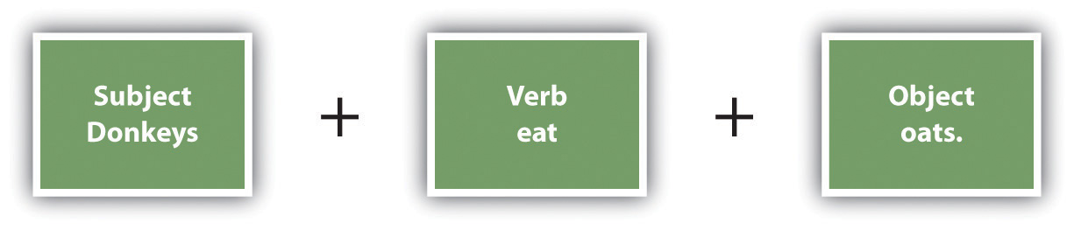

When you have more complicated sentences, use the following general order.

Figure 21.2
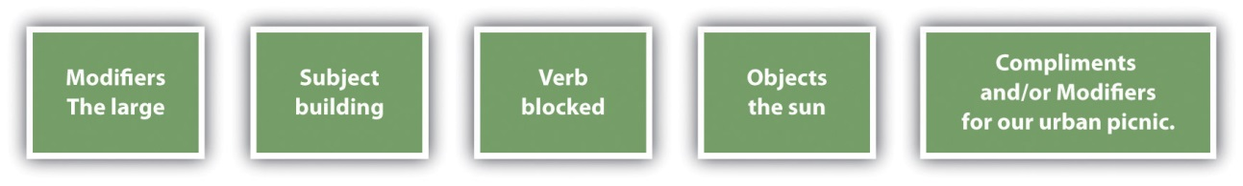

When an English sentence includes more than one adjective modifying a given noun, the adjectives have a hierarchy you should follow. The adjectives that modify the noun within Table 21.1 "Hierarchical Order of Adjectives" show that hierarchical order. You should, however, keep a string of adjectives to two or three. The example includes a longer string of adjectives simply to clarify the word order. Using this table, you can see that “the small thin Methodist girl…” would be correct but “the young French small girl…” would be incorrect.

Some languages, such as Spanish, insert “no” before a verb to create a negative sentence. In English, the negative is often indicated by placing “not” after the verb or in a contraction with the verb.

Example
I can’t make it before 1:00 p.m.

Incorrect example: I no can make it before 1:00 p.m.

21.3 Count and Noncount Nouns
Nouns that name separate things or people that you can count are called count nouns. Nouns that name things that cannot be counted unless additional words are added are called noncount nouns. You need to understand count and noncount nouns in order to use the nouns correctly with articles, in singular and plural formations, and in other situations. Some nouns can serve as either count or noncount nouns.

Examples of Count Nouns
- box(es)
- dog(s)
- house(s)
- leaf (leaves)
- moon(s)
- peach(es)
- sheep
- women

Examples of Noncount Nouns
- advice
- cheese
- equipment
- furniture
- information
- Internet
- mail
- weather

Examples of Nouns That Can Be Either Count or Noncount Nouns
- baseball (play baseball vs. throw a baseball)
- love (He is my love! vs. two loves: poetry and basketball)
- marble (play with a marble vs. a floor made of marble)

21.4 Articles
In English, nouns are identified or quantified by determiners. Articles, such as a, an, and the, are one type of determiner. Use the following guidelines to alleviate confusion regarding whether to use an article or which article to use.
Use a and an with nonspecific or indefinite singular count nouns and some proper nouns where you do not have enough information to be more specific. Use a before nouns beginning with a consonant sound and an before nouns beginning with a vowel sound.

Example 1
I have a dog at home, also. (The word “dog” is a nonspecific noun since it doesn’t refer to any certain dog.)

Example 2
(before a vowel): Carrie gave everyone an apple at lunch.

Example 3
(before a consonant; with proper noun): He was wearing a Texas shirt.

Use every and each with singular count nouns and some proper nouns.

Example 1
I heard every noise all night long.

Example 2
I tried each Jell-O flavor and liked them all.

Use this and that with singular count and noncount nouns.

Example 1
(with count noun): I am going to eat that apple.

Example 2
(with noncount noun): I am not too excited about this weather.

Use any, enough, and some with nonspecific or indefinite plural nouns (count or noncount).

Example 1
I didn’t have any donuts at the meeting because he ate them all.

Example 2
Do you have enough donuts for everyone?

Example 3
He ate some donuts at the meeting.

Use (a) little and much with noncount nouns.

Example 1
I’d like a little meatloaf, please.

Example 2
There’s not much spaghetti left.

Use the with noncount nouns and singular and plural count nouns.

Example 1
(with noncount noun): The weather is beautiful today.

Example 2
(with singular count noun): Who opened the door?

Example 3
(with plural count noun): All the houses had brick fronts.

Use both, (a) few, many, several, these, and those with plural count nouns.

Example 1
I have a few books you might like to borrow.

Example 2
Daryl and Louise have been traveling for several days.

Example 3
Are those shoes yours?

21.5 Singulars and Plurals
English count nouns have singular and plural forms. Typically, these nouns are formed by adding -s or -es. Words that end in -ch, -sh, or -s usually require the addition of -es to form the plural. Atypical plurals are formed in various ways, such as those shown in the following table.

Singular Nouns | Plural Nouns
dog | dogs (-s added)
table | tables (-s added)
peach | peaches (-es added)
wish | wishes (-es added)
kiss | kisses (-es added)
man | men (atypical)
sheep | sheep (atypical)
tooth | teeth (atypical)
child | children (atypical)
alumnus | alumni (atypical)
leaf | leaves (atypical)

Proper nouns are typically either singular or plural. Plural proper nouns usually have no singular form, and singular proper nouns usually have no plural form.

Noncount nouns typically have only one form that is basically a singular form. To quantify them, you can add a preceding phrase.

Noncount Nouns | Sentences with Noncount Nouns and Quantifying Phrases
gas | We put twelve gallons of gas in the car this morning.
anguish | After years of anguish, he finally found happiness.

21.6 Verb Tenses
You can practice conjugating many English verbs to increase your awareness of verb tenses. Use this format for the basic conjugation:

- I laugh at Millie.
- You laugh at Millie.
- He/She/It laughs at Millie.
- We laugh at Millie.
- You laugh at Millie.
- They laugh at Millie.

You can also practice completing these five forms of English. A mixture of tenses is used to show that you can practice the different forms with any tense.

Affirmative Usage
- I play ball.
- You play ball.
- She plays ball.
- We play ball.
- You play ball.
- They play ball.

Negative Usage
- I do not play ball.
- You do not play ball.
- She does not play ball.
- We do not play ball.
- You do not play ball.
- They do not play ball.

Yes/No Questions
- Do you play ball?
- Does she play ball?
- Do we play ball?
- Do they play ball?

Short Answers
- Yes, I do.
- Yes, she does.
- No, they do not.
- No, you do not.

Wh- Questions
- Who is she?
- Where did you find it?
- When are you coming?
- Why won’t it work?
- What are you going to do?

See Chapter 15 "Sentence Building", Section 15.2 "Choosing Appropriate Verb Tenses" for an in-depth overview of verb tenses.

21.7 Correct Verbs
People who are new to English often experience confusion about which verb forms can serve as the verb in a sentence. An English sentence must include at least one verb or verb phrase and a tense that relays the time during which the action is taking place.

Verbals (such as gerunds and infinitives) should not be confused with verbs.

A sentence with a gerund must also have another verb.

Example
Correct example: Roger enjoys driving the RV.

Incorrect example: Roger driving the RV.

A sentence with an infinitive must have another verb.

Example
Correct example: Kyle decided to write a long message.

Incorrect example: Kyle to write a long message.

Verbs must match the timing indicated by the other words in a sentence.

Example
Past tense correct example: Yesterday, I called you at 5:00 p.m.

Past tense incorrect example: Yesterday, I call you at 5:00 p.m.

Future tense correct example: The next time it rains, I will bring my umbrella.

Future tense incorrect example: The next time it rains, I bring my umbrella.

Present tense correct example: Come in and get warm.

Present tense incorrect example: Come in and got warm.

See Chapter 15 "Sentence Building", Section 15.2 "Choosing Appropriate Verb Tenses" for a more extensive overview of verb tenses.

21.8 Modal Auxiliary Verbs
Figure 21.3
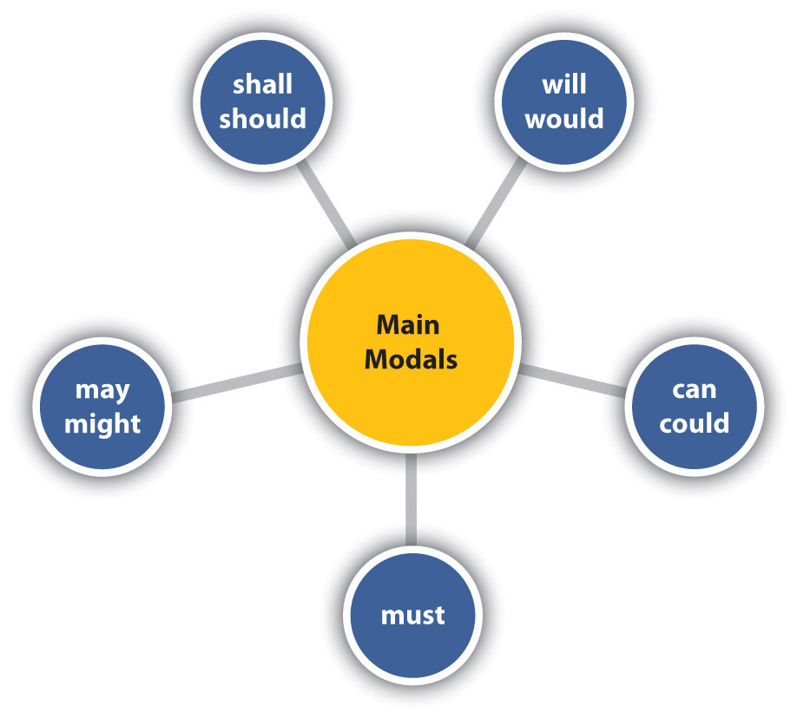

The English language includes nine main modal auxiliary verbs that are used with other verbs. These modals, shown in the wheel in four pairs and a single, can refer to past, present, or future tense based on the verbs that are used with them. The modals themselves do not change form to change tense. As shown in the following table, you can use modals to express an attitude in regard to the action or general situation of the sentence.

Modal Function | Format for Present or Future Tense | Format for Past Tense
Advisability | should or ought to + base verb | should or ought to + have + past participle
 | You should take the time to visit Yellowstone. | You ought to have taken the time to visit Yellowstone.
Capability | can, am able to, is able to, or are able to + base verb | could, was able to, were able to + base verb or past participle
 | Aisha can tell you who was at the party. | Saul was able to walk on the beam without falling off.
Deduction | must, has to + base verb | must + have + past participle
 | Hank must know Spanish and French. | Lucy must have driven through the night.
Forbiddance | must + not + base verb | N/A
 | You must not take his food.
Expectation | should + base verb | should + have + past participle
 | The sun should set about 7:15 today. | The boys should have finished their ball game by now.
Intention | will or shall + base verb | would + base verb
 | I will meet you at the theater. | I said I would finish sometime today.
Necessity | must or have to + base verb | had to+ base verb
 | I must finish cleaning before they arrive. | Greg had to get gas before we started the trip.
Past habit | N/A | would or used to + base verb
 |  | When I worked there, I used to eat at Marvy’s every day.
Permission request | can, could, may, or might + base verb (in question format) | might or could + base verb
 | Could I go with you? | My parents said I could use their car next week.
Polite request | could or would + base verb (in question format) | N/A
 | Would you please hand me page 45?
Possibility/uncertainty | may or might + base verb | might + have + past participle
 | Alice might be at work by 6:00 a.m. | I don’t remember, but I might have been the one sitting next to him that night.
Speculation | could, might, or would + base verb | could, might, or would + have + past participle
 | If he conditions enough, he could win his race. | There could have been some real money in that deal we almost made.

21.9 Gerunds and Infinitives
Gerunds are nouns formed by adding -ing to a verb, such as running. Infinitives are nouns formed from the “to” form of a verb, such as to run. These two noun forms are called verbals, because they are formed from verbs. Experience with English will teach you which form to use in which situation. In the meantime, the following lists provide a brief overview.

Verbs That Should Be Followed Only by Gerunds and Not by Infinitives

These Verbs Could Fill This Blank: _______ (His) Walking

- admit
- avoid
- complete
- consider
- delay
- deny
- dislike
- finish
- imagine
- miss
- postpone
- quit
- recommend
- resist
- stop
- suggest
- understand

Verbs That Should Be Followed Only by Infinitives and Not by Gerunds

These Verbs Could Fill This Blank: ________ to Walk

- agree
- appear
- ask
- beg
- claim
- decide
- demand
- desire
- fail
- happen
- hesitate
- intend
- manage
- offer
- plan
- pretend
- struggle

Verbs That Can Be Followed by Either Gerunds or Infinitives

These Verbs Could Fill Either of These Blanks: ________ (His) Walking or ________ to Walk

- begin
- can(’t) afford
- can(’t) bear
- cease
- commence
- continue
- dread
- hate
- intend
- like
- loathe
- love
- neglect
- prefer
- start
- try
- undertake

See Chapter 20 "Grammar", Section 20.1.7 "Deciding If Relative Pronouns Take a Singular or Plural Verb" for more information regarding gerunds and infinitives.

21.10 Forming Participles
Participles are verb forms that combine with auxiliary verbs to create different tenses.

To form perfect tenses, use had, has, or have with the past participle. Example: My dog has eaten twice today.

To form progressive tenses, use a form of the verb to be with the present participle, or gerund. Example: My dog is eating a treat.

To write in passive voice, use a form of the verb to be with the past participle. Example: The treat was eaten by my dog.
See Chapter 15 "Sentence Building", Section 15.2 "Choosing Appropriate Verb Tenses" for a more extensive overview of the relationships between participles and verb tenses, and see Chapter 16 "Sentence Style", Section 16.3 "Using Subordination and Coordination" for more on passive voice constructions.

21.11 Adverbs and Adjectives
Adverbs often end in -ly and modify verbs, other adverbs, and adjectives. As a rule, you should place an adverb next to or close to the word it modifies, although adverbs can be placed in different positions within a sentence without affecting its meaning.

Example
Before the verb: “He slowly walked to the store.”

After the verb: “He walked slowly to the store.”

At the beginning of the sentence: “Slowly, he walked to the store.”

At the end of the sentence: “He walked to the store slowly.”

Between an auxiliary and main verb: “He was slowly walking to the store.”

Some adverbs, however, have a different meaning based on where they are placed. You should check to make sure that your placement carries the intended meaning.

Example
“She only loved him.”

Translation: “The only emotion she felt toward him was love.”
“Only she loved him.”

Translation: “The only person who loved him was her.”
“She loved only him.” or “She loved him only.”

Translation: “The only person she loved was him.”
Some adverbs simply do not work between the verb and the direct object in a sentence.

Example
Acceptable adverb placement: She barely heard the noise.
Unacceptable adverb placement: She heard barely the noise.

Adjectives modify nouns and in some more heavily inflected languages, the endings of adjectives change to agree with the number and gender of the noun. In English, adjectives do not change in this way. For example, within the following sentences, note how the spelling of the adjective “eager” remains the same, regardless of the number or the gender of the noun it modifies.

The eager boy jumped the starting gun.
The eager boys lined up.
The eager girls eyed the starter.

As in these sentences, adjectives usually are placed before a noun.
The noun can be the subject, as in the preceding example, or a direct object, as in the following sentence.

Harold admired his shiny red car.

Adjectives can also be placed after a linking verb. The adjective still modifies a noun but is not placed next to the noun, as in the following example.

The weather was miserable.

When two or more adjectives are used to modify a single noun, they should be used in a set order, as shown in Table 21.1 "Hierarchical Order of Adjectives". Even though the table shows ten levels within the hierarchy, you should limit your adjectives per noun to two or three.

Table 21.1 Hierarchical Order of Adjectives
Determiner | Opinion or Assessment | Physical Description |  |  |  | Nationality | Religion | Material | Noun
 |  | Size | Shape | Age | Color
The | pretty | small | thin | young | white | French | Methodist | plastic | girl

When using an adverb and adjective together with a noun, you should typically place the adverb first, followed by the adjective, and then the noun.

the strikingly golden tree

For more information about adverbs and adjectives, see Chapter 20 "Grammar", Section 20.6 "Using Adverbs and Adjectives".

21.12 Irregular Adjectives
In English, adjectives have comparative and superlative forms that are used to more exactly describe nouns.

Example
Joey is tall, Pete is taller than Joey, and Malik is the tallest of the three boys.

One common way to form the comparative and superlative forms is to add -er and -est, respectively, as shown in the preceding example. A second common method is to use the words more and most or less and least, as shown in the following example.

Example
Lucy is eager to start, Callie is more eager, and Shannon is the most eager.

Some adjectives do not follow these two common methods of forming comparatives and superlatives. You will simply have to learn these irregular adjectives by heart. Some of them are listed Table 21.2 "Sample Adjectives That Form Superlatives Using Irregular Patterns". Notice that some are irregular when used with a certain meaning and not when used with a different meaning. See Chapter 20 "Grammar", Section 20.6.3 "Using Comparatives and Superlatives" for more examples of irregular adjectives.

Table 21.2 Sample Adjectives That Form Superlatives Using Irregular Patterns
much (noncount nouns) | more | most
many (count nouns) | more | most
little (size) | littler | littlest
little (number) | less | least
old (people and things) | older | oldest
old (family members) | elder | eldest

Some adjectives’ comparatives and superlatives can be formed with either -er and -est or with more and most (or less and least). In these cases, choose the version that works best within a given sentence.

Table 21.3 Sample Adjectives That Can Form Superlatives Using -er and -est or More and Most
Clever | cleverer | cleverest
Clever | more clever | most clever
Gentle | gentler | gentlest
Gentle | more gentle | most gentle
Friendly | friendlier | friendliest
Friendly | more friendly | most friendly
Quiet | quieter | quietest
Quiet | more quiet | most quiet
Simple | simpler | simplest
Simple | more simple | most simple

Some adjectives do not have comparative and superlative forms since the simplest form expresses the only possible form.

Sample Adjectives That Do Not Have Comparative and Superlative Forms

- blind
- dead
- fatal
- final
- left
- right
- unique
- universal
- vertical
- wrong

21.13 Indefinite Adjectives
Indefinite adjectives give nonspecific information about a noun. For example, the indefinite article few indicates some, but not an exact amount. Indefinite adjectives are easily confused with indefinite pronouns since they are the same words used differently. An indefinite pronoun replaces a noun. An indefinite adjective precedes a noun or pronoun and modifies it. It is important for you to understand the difference between indefinite adjectives and pronouns to assure you are saying what you mean. Some common indefinite adjectives include all, any, anything, each, every, few, many, one, several, some, somebody, and someone.

Example
Indefinite adjective: We are having some cake for dessert.

Indefinite pronoun: I like cake. I’ll have some, please.

Indefinite adjective: You can find a state name on each quarter.

Indefinite pronoun: I have four Illinois quarters, and each is brand new.

21.14 Predicate Adjectives
Since linking verbs express a state of being instead of an action, adjectives are used after them instead of adverbs. An adjective that follows a linking verb is referred to as a predicate adjective. Be careful not to use an adverb simply because of the proximity to the verb.

Example
Correct (adjective follows linking verb): Kelly is selfish.
Incorrect (adverb follows linking verb): Kelly is selfishly.

Correct (adjective follows linking verb): Beth seems eager.
Incorrect (adverb follows linking verb): Beth seems eagerly.

Linking Verbs That Can Be Followed by Adjectives
- appear
- be
- become
- feel
- get
- grow
- keep
- look
- prove
- remain
- seem
- smell
- sound
- stay
- taste
- turn

21.15 Clauses and Phrases
Clauses include both subjects and verbs that work together as a single unit. When they form stand-alone sentences, they’re called independent clauses. An independent clause can stand alone or can be used with other clauses and phrases. A dependent clause also includes both a subject and a verb, but it must combine with an independent clause to form a complete sentence.

Types of Dependent Clauses | Descriptions | Examples
Adverb clause | Serves as an adverb; tells when, how, why, where, under what condition, to what degree, how often, or how much | To avoid sunburn, she plastered her body with sunscreen.
Noun clause | Serves as a noun when attached to a verb | That she would win the race seemed quite likely.
 |  | She thought that she would win the race.
Adjective clause (also called a relative clause) | Begins with a relative pronoun (that, who, whom, whose, which) or a relative adverb (when, where, why); functions as an adjective; attaches to a noun; has both a subject and a verb; tells what kind, how many, or which one | The day that he lost his watch was an unlucky day.*
 |  | The house where they lived is gone.
Appositive clause | Functions as an appositive by restating a noun or noun-related verb in clause form; begins with that; typical nouns involved include possibilities such as assumption, belief, conviction, idea, knowledge, and theory | The idea that Josie will someday be taller than me is crazy.
*In some instances, the relative pronoun or adverb can be implied (e.g., “The day he lost his watch was an unlucky day”).

Phrases are groups of words that work together as a single unit but do not have a subject or a verb. English includes five basic kinds of phrases.

Types of Phrases | Descriptions | Examples
Noun phrase | Multiple words serving as a noun | Darcy ate a ham sandwich.
Verb phrase | Used as the verb in sentences that are in the progressive and perfect tenses | The class should have started a half-hour earlier.
Prepositional phrase | Begins with a preposition (covered in more depth in Section 21.9 "Gerunds and Infinitives") | Work will be easier after the holiday rush.
Adjective phrase | Functions as an adjective; might include prepositional phrases and/or nouns | My brother is very tall and handsome.
Adverb phrase | Functions as an adverb; might include prepositional phrases and/or multiple adverbs | Let’s go walking after dinner.
 |  | Ignacia walked wearily and unsteadily.

21.16 Relative Pronouns and Clauses
An adjective clause gives information about a preceding noun in a sentence. Look at the following examples.

The car that Richie was driving was yellow.
Des Moines, where I live, is in Iowa.
Mr. Creeter, whose brother I know, is the new math teacher.

Like many other adjective clauses, these begin with a relative adjective (which, who, whom, whose, that) or a relative adverb (when or where). When you use a relative clause to describe a noun, make sure to begin it with one of the seven relative adjectives and adverbs listed in the previous sentence.

21.17 Prepositions and Prepositional Phrases
Prepositions are words that show the relationships between two or more other words. Choosing correct prepositions can be challenging, but the following examples will help clarify how to use some of the most common prepositions.

Types of Prepositions | Examples of Prepositions | How to Use | Prepositions Used in Sentences
Time | at | Use with hours of the day and these words that indicate time of day: dawn, midnight, night, and noon | We will eat at 11:30.
 |  |  | We will eat at noon.
 | by | Use with time words to indicate a particular time | I’ll be there by 5:00.
 |  |  | I’ll be finished by October.
 | in | Use with the and these time-of-day words: afternoon, evening, and morning | We’ll start in the morning.
 |  | Use on its own with months, seasons, and years | The rainy season starts in June.
 | on | Use with days of the week | I’ll see you on Friday.
Location | at | Use to indicate a particular place | I’ll stop at the dry cleaners.
 | in | Use when indicating that an item or person is within given boundaries | My ticket is in my pocket.
 | by | Use to mean “near a particular place” | My desk is by the back door.
 | on | Use when indicating a surface or site on which something rests or is located | Place it on the table, please.
 |  |  | My office is on Lincoln Boulevard.
Logical relationships | of | Use to indicate part of a whole | I ate half of the sandwich.
 |  | Use to indicate contents or makeup | I brought a bag of chips.
 | for | Use to show purpose | Jake uses his apron for grilling.
State of being | in | Use to indicate a state of being | I am afraid that I’m in trouble.

21.18 Omitted Words
Some languages, especially those that make greater use of inflection, do not include all the sentence parts that English includes. Take special care to include those English parts that you might not be used to including in your native language. The following table shows some of these words that are needed in English but not in other languages.

Sentence Parts | Language Issues
Articles | Neither Chinese nor Arabic includes articles, such as a and an, so people with Chinese or Arabic as a first language have to take great care to learn to use articles correctly.
Verbs | Many languages have verb tense setups that vary from English, so most new English learners have to be very careful to include auxiliary verbs properly. For example, Arabic does not include the verb “to be,” so native speakers of Arabic who learn English have to take special care to learn the usage of “to be.” An Arabic speaker might say, “The girl happy,” instead of, “The girl is happy.”
Subjects | Spanish and Japanese do not include a subject in every sentence, but every English sentence requires a subject (except in commands where the subject you is understood: “Go get the box”).
Expletives | Inverted English sentences can cause problems for many new English speakers. For example, you could say, “An apple is in the refrigerator.” But in typical English, you would more likely say, “There is an apple in the refrigerator.” This version is an inverted sentence, and “there” is an expletive. Many new English learners might invert the sentence without adding the expletive and say, “Is an apple in the refrigerator.”
Plurals | Neither Chinese nor Thai includes plurals, but English does. So many new English learners have to take great care to differentiate between singular and plural forms and to use them at the appropriate times.
Subject pronouns | In Spanish, the subject pronoun is often not used, so Spanish speakers learning English will often omit the subject pronoun, saying, “Am hungry,” instead of, “I am hungry.”

21.19 Not and Other Negative Words
Figure 21.4
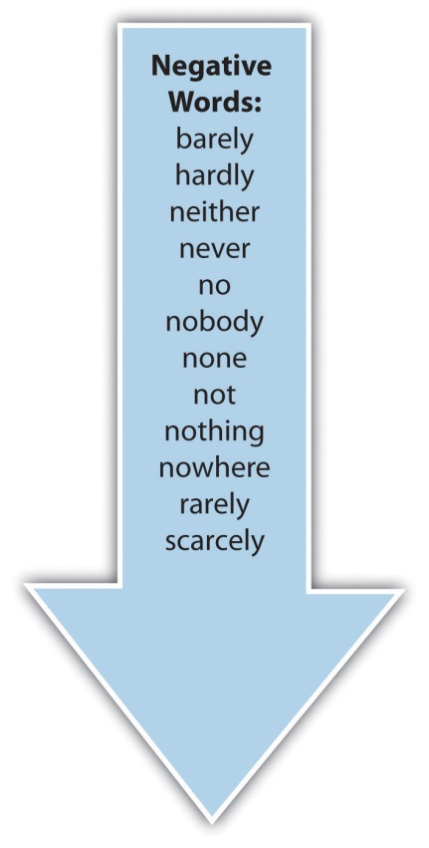

To form a negative in English, you have to add a negative word to the sentence. Some of the negative words in English are shown in the blue arrow. Typically, you should place the negative word before the main verb.

I was barely awake when I heard you come home.
Kurt is not going with us.

In casual English, it is common to form contractions, or shortened combined words, with the auxiliary or linking verb and the word not. Contractions are typically not acceptable in very formal writing but are becoming more and more common in certain academic and public contexts.

I haven’t heard that before.
Jill isn’t my cousin.

Using two negative words in the same sentence changes the meaning of the negative words to positive, thus supporting the common saying “Two negatives make a positive.” Think of it as being similar to multiplying two negative numbers and getting a positive number. Double negatives are often used in extremely casual talk but never in professional or academic settings.

Example
Correct: I didn’t hear anything.
Incorrect: I didn’t hear nothing. (The two negatives change to a positive, so the sentence technically means “I heard something.”)

21.20 Idioms
Idioms are informal, colorful language. Although their intent is to add interest to the English language, they also add a lot of confusion since their intended meanings are not aligned with their literal meanings. In time, you will learn the idioms that your acquaintances use. Until then, reading lists of idioms, such as the following, might prove helpful. Just remember that when a person says something that seems to make no sense at all, an idiom might be involved. Also, keep in mind that this list is just a very small sampling of the thousands of idiomatic expressions that occur in English, as happens with any language.

Idiom | Intended Meaning
A little bird told me. | I know some information, and I’d rather not say where I heard it.
Don’t count your chickens before they hatch. | Don’t decide before you have all the facts.
Don’t jump out of your skin. | Don’t get overly excited.
Go fly a kite. | What you are saying doesn’t make sense.
Hank’s got some major-league problems. | Hank has some serious problems.
Nothing ventured, nothing gained. | You can’t succeed if you don’t try.
People who live in glass houses should not throw stones. | You should not criticize others for faults that you also have, or since you aren’t perfect, you should not criticize others.
They are joined at the hip. | They are always together and/or think alike.
We’ve got it made in the shade. | Everything is working out just right.
What does John Q. Public say? | What does the average person think?
You’re crazy. | Your words do not make sense.

21.21 Spelling Tips
Spelling is a vital part of your written English skills. Your spelling needs to include both an understanding of general spelling rules and a mastery of common words that you will use often. You can visit Chapter 19 "Mechanics", Section 19.1 "Mastering Commonly Misspelled Words" for an overview of general English spelling rules. The following are some of the most common words you will need to spell listed in categories.

Days and Months |  | Time | Directions
Monday  Tuesday  Wednesday  Thursday  Friday  Saturday  Sunday | - January  - February  - March  - April  - May  - June  - July  - August  - September  - October  - November  - December | - second  - minute  - hour  - day  - week  - month  - year  - decade  - century  - millennium  - moment | - left  - right  - straight  - east  - west  - north  - south  - far  - near  - next to  - up  - down

Grocery Lists |  | General Shopping Lists | Family Words
apples  asparagus  bananas  beans  bread  butter  cabbage  carrots  celery  cheese  chicken  cucumber | - eggs  - ham  - hamburger  - fish  - lamb  - lettuce  - milk  - pork chops  - roast  - soda  - tortillas | - bath soap  - deodorant  - dish soap  - floss  - shampoo  - toilet bowl cleaner  - toothpaste  - window cleaner | - aunt  - brother  - father/dad  - grandfather  - grandmother  - husband  - mother/mom  - sister  - uncle  - wife

Services | Words for Packing to Move | Math Words | Measurement
barber  dentist  doctor  hair dresser  lawyer  nurse  pharmacist  teacher | - bathroom  - bedroom  - dining room  - family room  - garage  - kitchen  - laundry room  - living room | - add  - subtract  - multiply  - divide  - more  - less  - sum  - difference  - equals  - plus  - total | - inch (in.)  - foot (ft.)  - yard (yd.)  - mile (mi.)  - millimeter (mm)  - centimeter (cm)  - kilometer (km)  - cup  - quart (qu.)  - gallon (gal.)  - teaspoon (tsp.)  - tablespoon (tb.)

Holidays | Common Names
New Year’s Day  Martin Luther King Jr. Day  Valentine’s Day  St. Patrick’s Day  Mother’s Day  Memorial Day  Flag Day  Father’s Day  Fourth of July  Labor Day  Halloween  Columbus Day  Thanksgiving  Christmas | - Barbara  - Elizabeth  - Jennifer  - Linda  - Maria  - Mary  - Patricia  - Susan  - Adam  - David  - James  - John  - Michael  - Richard  - Robert  - William | - Anderson  - Brown  - Davis  - Garcia  - Harris  - Jackson  - Johnson  - Jones  - Martin  - Miller  - Moore  - Smith  - Taylor  - Thomas  - White  - Wilson

21.22 American Writing Styles, Argument, and Structure
Your original language has its own structures, formats, and cultural assumptions that are likely natural to you but perhaps different from those of English. The following broad guidelines underlie basic American English and US academic writing.

- Citing sources: Some languages and cultures do not consider citing sources of ideas to be of paramount importance. In US academic situations, however, failing to cite sources of ideas and text is referred to as plagiarism and can result in serious ramifications, including failing grades, damaged reputations, school expulsions, and job loss.
- Introducing the topic early: Unlike some languages, American English typically presents the topic early in a paper.
- Staying on topic: Although some languages view diversions from the topic as adding interest and depth, American English is focused and on topic.
- Writing concisely: Some languages hold eloquent, flowing language in high esteem. Consequently, texts in these languages are often long and elaborate. American English, on the other hand, prefers concise, to-the-point wording.
- Constructing arguments: US academic writing often involves argument building. To this end, writers use transitions to link ideas, evidence to support claims, and relatively formal writing to ensure clarity.

Chapter 22
Appendix B: A Guide to Research and Documentation
Research Documentation Guidelines
This appendix provides general guidelines for documenting researched information. See Chapter 7 "Researching" for more on the research process.

22.1 Choosing a Documentation Format
As a rule, your assignments requiring research will specify a documentation format. If you are free to use the style of your choice, you can choose any format you want as long as you are consistent, but you should know that certain disciplines tend to use specific documentation styles:

- business and social sciences: American Psychological Association (APA)
- natural and applied sciences: Council of Science Editors (CSE)
- humanities: Modern Language Association (MLA) or the Chicago Manual of Style (CMS)

For the purposes of this appendix, we will confine ourselves to the three documentation formats that will be the most common in your undergraduate courses: the style manuals from APA and MLA, as well as CMS. (Other formats are listed at the end of this appendix. Also, note this appendix explains the “Notes-Bibliography” system of CMS, used more often in history, the arts, and humanities, rather than the “Author-Date” system, used in the sciences and social sciences.)

These three systems of documentation have been refined over many generations so that academics can rely on certain standards of attribution when they cite each other’s work and when their work is cited. When you enter into an academic conversation in a given discipline, it’s imperative that you play by its rules. It’s true that popular, nonacademic forms of attribution exist. Making a link to another website in a blog or a Twitter post works quite well, but in an academic context, such a form of attribution is not sufficient. Of course it should go without saying that stealing someone else’s words or borrowing them without attribution, whether you do it casually on the web or in an academic context, is simply wrong.

22.2 Integrating Sources
Your goal within a research paper is to integrate other sources smoothly into your paper to support the points you are making. As long as you give proper credit, you can ethically reference anyone else’s work. You should not, however, create a paper that is made up of one reference after another without any of your input. You should also avoid using half-page or whole-page quotations. Make sure to write enough of your material so that your sources are integrated into your work rather than making up the bulk of your paper.

Think of yourself as a kind of museum docent or tour guide when you are integrating sources into your work. You’ll usually want to take some time to set up your use of a source by placing it in a proper context. That’s why in most cases, before you even launch into quotation, paraphrase, or summary, you will have probably already used what’s called a “signal phrase” that identifies the author of the source, and often the specific publication (whether web or print) from which it is taken. After your use of the source, you’ll need to follow up with analysis and commentary on how you think it fits into the larger context of your argument.

22.3 Quoting, Paraphrasing, and Summarizing
When you quote another writer’s exact words, you will have to identify the page number within the source where you found the quotation or the paragraph number if the source is taken from an online format or database that does not indicate the original print pagination. Note that only APA allows the use of “p.” or “pp.”

Table 22.1 Citing Quotations
 | APA | MLA | CMS
Explanation | Short Quotations: Place within quotation marks and follow with page number in parentheses (p. #). Include the author’s name and date either in a signal phrase before the quotation or at the end (name, year, p. #). | Short Quotations: Place within quotation marks and follow with page number in parentheses (#). Include the author’s name either in a signal phrase before the quotation or at the end (name #) | Short Quotations: Place within quotation marks and follow with page number in parentheses (#). Include the author’s name and date either in a signal phrase before the quotation or at the end (name year, #)
 | Long Quotations (forty words or more): Place in an inset block of text without quotations. Include the author’s name and date either in a signal phrase before the quotation or at the end (name, year, p. #). | Long Quotations (more than four lines): Place in an inset block of text without quotations. Include the author’s name either in a signal phrase before the quotation or at the end (name #). | Long Quotations (one hundred words or eight lines): Place in an inset block of text and do not use quotations. Include the author’s name and date either in a signal phrase before the quotation or at the end: (name year, #).
Example #1 | According to Fullan (2001), “Educational change depends on what teachers do and think—it’s as simple and complex as that” (p. 107). | According to Fullan, “Educational change depends on what teachers do and think—it’s as simple and complex as that” (107). | According to Fullan (2001), “Educational change depends on what teachers do and think—it’s as simple and complex as that” (107).
Example #2 | “Educational change depends on what teachers do and think—it’s as simple and complex as that” (Fullan, 2001, p. 107). | “Educational change depends on what teachers do and think—it’s as simple and complex as that” (Fullan 107). | “Educational change depends on what teachers do and think—it’s as simple and complex as that” (Fullan 2001, 107).

Paraphrased and summarized text is cited within text in the same way that quoted material is cited except that quotations are not used. In APA style, you do not need to include page numbers in this case, but MLA and CMS, on the other hand, do still require page numbers, when they are available.

Table 22.2 Citing Paraphrased or Summarized Text
 | APA | MLA | CMS
Explanation | In a signal phrase before the paraphrase or summary, include the author’s last name immediately followed by the date in parentheses (year) OR, if no signal phrase is used, include the author’s last name at the end of the paraphrase or summary followed by a comma and the year (name, year). No quotation marks or page numbers are needed. | In a signal phrase before the paraphrase or summary, include the author’s last name and, at the end of the summary or paraphrase, include the page number in parentheses (#). If no signal phrase is used, include the author’s last name at the end of the paraphrase or summary followed by the page number (name #). No quotation marks or dates are needed. | In a signal phrase before the paraphrase or summary, include the author’s last name immediately followed by the date in parentheses (year) and the page number at the end of the sentence (#). OR, if no signal phrase is used, include the author’s last name at the end of the paraphrase or summary followed by a comma, the year, a comma, and the page number (name, year, #). No quotation marks are needed.
Example #1 | As Rosenfeld (2008) states, teachers have to both understand and be comfortable with technology before they will be able to take technology into their classrooms. | As Rosenfeld (2008) states, teachers have to both understand and be comfortable with technology before they will be able to take technology into their classrooms (159). | As Rosenfeld (2008) states, teachers have to both understand and be comfortable with technology before they will be able to take technology into their classrooms (159).
Example #2 | Teachers have to both understand and be comfortable with technology before they will be able to take technology into their classrooms (Rosenfeld, 2008). | Teachers have to both understand and be comfortable with technology before they will be able to take technology into their classrooms (Rosenfeld 159). | Teachers have to both understand and be comfortable with technology before they will be able to take technology into their classrooms (Rosenfeld, 2008, 159).

22.4 Formatting In-Text References
When you use others’ ideas, you have a variety of options for integrating these sources into your text. The main requirement is that you make it clear within your in-text reference that the information is not yours and that you clearly indicate where you got the idea. The following box shows some alternate phrases for signaling that the ideas you are using belong to another writer. Using a variety of wording makes writing more interesting. Note: Past tense is used in these examples. You may elect to use present tense (“writes”) or past perfect tense (“has written”), but keep your tense use consistent.

Phrases That Signal an Idea Belongs to Another Writer (Shown in APA style)

- According to Starr (2010)…
- Acknowledging that…
- Starr (2010) stated…
- As Starr (2010) noted…
- In 2010, Starr reported…
- In the words of Starr (2010)…
- It is obvious, according to Starr (2010), that…
- Starr (2010) argued that…
- Starr (2010) disagreed when she said…
- Starr (2010) emphasized the importance of…
- Starr (2010) suggested…
- Starr observed in 2010 that…
- Technology specialist, Linda Starr, claimed that…(2010).
- …indicated Starr (2010).
- …wrote Starr (2010)

Table 22.3 "Integrating Sources (Summarized or Paraphrased Ideas)" shows some actual examples of integrating sources within the guidelines of the three most common documentation formats. You should weave the cited details in with your ideas.

Table 22.3 Integrating Sources (Summarized or Paraphrased Ideas)
 | APA | MLA | CMS
Explanation | Author’s name: Either within a signal phrase or in parentheses before the period at the end of the sentence. | Author’s name: Either within a signal phrase or in parentheses before the period at the end of the sentence. | Author’s name: Either within a signal phrase or in parentheses at the end of the sentence.
 | Year: Either within parentheses after the name that is used in a signal phrase or after the name and a comma within the parentheses before the period at the end of the sentence (name, year). | Page number: Either alone before the period at the end of the sentence or after the name within the parentheses before the period at the end of the sentence (name #). | Year: Either within parentheses after the name that is used in a signal phrase or at the end of the sentence (name year, #).
 |  |  | Page number: Either alone within parentheses before the period at the end of the sentence or after the name and year and a comma within parentheses at the end of the sentence (name year, #).
Example #1 | Many school staffs discuss integrating technology without making significant progress in that direction. Starr (2010) indicated that teachers’ lack of personal understanding of technology could cause roadblocks to integrating technology into classrooms. | Many school staffs discuss integrating technology without making significant progress in that direction. Starr indicated that teachers’ lack of personal understanding of technology can cause road blocks to integrating technology into classrooms (1). | Many school staffs discuss integrating technology without making significant progress in that direction. Starr (2010) indicated that teachers’ lack of personal understanding of technology could cause roadblocks to integrating technology into classrooms (1).
Example #2 | Many school staffs discuss integrating technology without making significant progress in that direction. Teachers’ lack of personal understanding of technology can cause roadblocks to integrating technology into classrooms (Starr, 2010). | Many school staffs discuss integrating technology without making significant progress in that direction. Teachers’ lack of personal understanding of technology can cause roadblocks to integrating technology into classrooms (Starr 1). | Many school staffs discuss integrating technology without making significant progress in that direction. Teachers’ lack of personal understanding of technology can cause roadblocks to integrating technology into classrooms (Starr 2010, 1).

Table 22.4 Two Authors
 | APA | MLA | CMS
Example #1 | Merriman and Nicoletti (2008) suggest that US K–12 education must take on a structure that is globally acceptable. | Merriman and Nicoletti suggest that US K–12 education must take on a structure that is globally acceptable (9). | Merriman and Nicoletti (2008) suggest that US K–12 education must take on a structure that is globally acceptable (9).
Example #2 | US K–12 education must take on a structure that is globally acceptable (Merriman & Nicoletti, 2008). | US K–12 education must take on a structure that is globally acceptable (Merriman and Nicoletti 9). | US K–12 education must take on a structure that is globally acceptable (Merriman & Nicoletti 2008, 9).

Table 22.5 Multiple Authors
 | APA | MLA | CMS
Explanation | Three to five Authors: List all three authors at first reference (name, name, and name) and the first name plus “et al.” for subsequent references (name et al.). | Three authors: Treat in same manner as two authors: (name, name, and name). | Three authors: Treat in same manner as two authors: (name, name, and name).
 | Six or more authors: For all references, list the first name plus “et al.” (name et al.). | Four or more authors: You can choose to list all authors or to use the first author name plus “et al.” (name et al.). | Four or more authors: You can choose to list all authors or to use the first author name plus “et al.” (name et al.).
Example #1 | Borsheim, Merritt, and Reed (2008) suggest that teachers do not have to give up traditional curricula in order to integrate technology. | Borsheim, Merritt, and Reed (2008) suggest that teachers do not have to give up traditional curricula in order to integrate technology (87). | Borsheim, Merritt, and Reed (2008) suggest that teachers do not have to give up traditional curricula in order to integrate technology (87).
Example #2 | In fact, it has been argued that technology has become part of education without a great deal of effort from teachers (Borsheim et al., 2008). | Some have argued that technology has become part of education without a great deal of effort from teachers (Borsheim et al. 87). | In fact, some have argued that technology has been incorporated into education without a great deal of effort from teachers (Borsheim et al. 2008, 87).

Table 22.6 Personal Communication
 | APA | MLA | CMS
Example #1 | Stanforth (personal communication, July 17, 2010) indicated she had been using a computer board in her classroom for three years and could not imagine giving it up. | Stanforth indicated she had been using a computer board in her classroom for three years and could not imagine giving it up. | Sue Stanforth (telephone interview by the author, July 17, 2010) indicated she had been using a computer board in her classroom for three years and could not imagine giving it up.
Example #2 | Many teachers are angry that they are being pushed to include technology because they like the way their classrooms work without it (Kennedy, personal e-mail, June 25, 2009). | Many teachers are angry that they are being pushed to include technology because they like the way their classrooms work without it (Kennedy). | Many teachers are angry that they are being pushed to include technology because they like the way their classrooms work without it (Greg Kennedy, e-mail to author, June 25, 2009).

22.5 Developing a List of Sources
This appendix provides a general overview of some of the most common documentation guidelines for different types of sources. For situations not described in this appendix, such as types of sources not described in this chapter or situations where you elect to use footnotes or endnotes in addition to in-text, parenthetical citations, check the complete guidelines for the style you are using:

APA: http://www.apastyle.org
MLA: http://www.mla.org
CMS: http://www.chicagomanualofstyle.org

Some general online searches, especially those conducted on your library databases, are also likely to generate guidelines for a variety of documentation styles. Look for an opportunity to click on a “citation” or “documentation” icon, or ask a member of your college library staff for guidance. You can even get help through the word processing program you typically use. Microsoft Word, for instance, has an entire tab on the taskbar devoted to managing and documenting sources in all three of the styles featured here. Also, don’t forget the tip from Chapter 7 "Researching" about the free resources that abound on the web from various online writing labs (OWLs) managed by writing programs at colleges and universities across the country.

Each different documentation style has its own set of guidelines for creating a list of references at the end of the essay (called “works cited” in MLA, “references” in APA, and “bibliography” in CMS). This section includes citations for the sources included in other parts of this appendix. For additional citation styles, consult complete citation guidelines for the style you are using.

Source lists should always be in alphabetical order by the first word of each reference, and you should use hanging indentation (with the first line of each reference flush with the margin and subsequent lines indented one-half inch). Here are some of the most common types of entries you will be using for your references at the end of your research essays. These lists are by no means exhaustive, but you will note from the examples some of the most important differences in conventions of punctuation, font, and the exact content of each style.

Table 22.7 APA References
Citation Description | Citation
Printed book | Fulla Fullan, M. (2001). The new meaning of educational change, 3rd edition. New York: Teachers.
Article accessed through an online database | Aikm Aikman, T. (2009). The NFL should proceed with caution on head injuries. Sporting News, 233(28), 71. Retrieved from Academic Search Complete database.
Article in a print periodical | Rose Rosenfeld, B. (2008). The challenges of teaching with technology: From computer idiocy to computer competence. International Journal of Instructional Media, 35(2), 157–166.
Article by two authors in a print periodical | Baro Barowy, B., & Laserna, C. (1997). The role of the Internet in the adoption of computer modeling as legitimate high school science. Journal of Science Education and Technology 6, 3–13.
Article by three authors in a print periodical | Borsh Borsheim, C., Merritt, K., & Reed, D. (2008). Beyond technology for technology’s sake: Advancing multiliteracies in the twenty-first century. The Clearing House, 82(2), 87–90.
Article by more than three authors in a periodical accessed on the web | Rosc Roschelle, J., Pea, R., Hoadley, C., Gordin, D., & Means, B. (2000). Changing how and what children learn in school with computer-based technology. Children and Computer Technology, 10(2), 76–101. Retrieved from http://www.futureofchildren.org/information2826/information_show.htm?doc_id=69809
Article from website with no specific author | Why I Why Integrate technology into the curriculum?: The reasons are many. (2008). Eutopia. Retrieved from http://www.edutopia.org/technology-integration-introduction
Article from website with no date | Kelly, Melissa. (n.d.). Integrating the Internet. About.com: Secondary Education. Retrieved from http://712educators.about.com/cs/technology/a/integratetech_2.htm
Personal communication (e-mail) | [Presented in text, but usually not included in bibliography.]  G. Ke G. Kennedy, personal communication, June 25, 2009.
Personal communication | [Presented in text, but usually not included in bibliography.]  S. Sta S. Stanforth, personal communication, July 17, 2010.

Table 22.8 MLA Works Cited
Citation Description | Citation
Printed book | Fulla Fullan, Michael. The New Meaning of Educational Change. 3rd ed. New York: Teachers, 2001. Print.
Article accessed through an online database | Aikm Aikman, Troy. “The NFL Should Proceed with Caution on Head Injuries.” Sporting News 233.28 (2009): 71. Academic Search Complete. EBSCO. Web. 11 Nov. 2010.
Article in a print periodical | Rose Rosenfeld, Barbara. “The Challenges of Teaching with Technology: From Computer Idiocy to Computer Competence.” International Journal of Instructional Media 35.2 (2008): 157–66. Print.
Article by two authors in a print periodical | Baro Barowy, Bill, and Catalina Laserna. “The Role of the Internet in the Adoption of Computer Modeling as Legitimate High School Science.” Journal of Science Education and Technology 6 (2000): 3–13. Print.
Article by three authors in a print periodical | Borsh Borsheim, Carlin, Kelly Merritt, and Dawn Reed. “Beyond Technology for Technology’s Sake: Advancing Multiliteracies in the Twenty-first Century.” The Clearing House 82.2 (2008): 87–90. Print.
Article by more than three authors in a periodical accessed on the web | Rosc Roschelle, Jeremy M., Roy D. Pea, Christopher M. Hoadley, Douglas N. Gordin, and Barbara M. Means. “Changing How and What Children Learn in School with Computer-Based Technology.” Children and Computer Technology, 10.2 (2000): 76–101. Web. 13 Sept. 2010.
Article from website with no specific author | “Why Why Integrate Technology into the Curriculum?: The Reasons Are Many.” Eutopia. 17 Mar. 2008. Web. 13 Sept. 2010.
Article from website with no date | Kelly, Kelly, Melissa. “Integrating the Internet.” About.com: Secondary Education, n.d. Web. 13 Sept. 2010.
Personal communication (e-mail) | Kenn Kennedy, Greg. “Integrating Technology.” Message to the author. 25 June 2009. E-mail.
Personal communication | Stanf Stanforth, Sue. Personal interview. 17 July 2010.

Table 22.9 CMS Bibliography
Citation Description | Citation
Printed book | Fulla Fullan, Michael. The New Meaning of Educational Change. 3rd ed. New York: Teachers, 2001.
Article accessed through an online database | Aikm Aikman, Troy. “The NFL Should Proceed with Caution on Head Injuries.” Sporting News 233, no. 28 (2009). Academic Search Complete, EBSCOhost.
Article in a print periodical | Rose Rosenfeld, Barbara. “The Challenges of Teaching with Technology: from Computer Idiocy to Computer Competence.” International Journal of Instructional Media 35, no. 2: 157–66.
Article by two authors in a print periodical | Baro Barowy, Bill, and Catalina Laserna. “The Role of the Internet in the Adoption of Computer Modeling as Legitimate High School Science.” Journal of Science Education and Technology 6 (2000): 3–13.
Article by three authors in a print periodical | Borsh Borscheim, Carlin, Kelly Merritt, and Dawn Reed. “Beyond Technology for Technology’s Sake: Advancing Multiliteracies in the Twenty-First Century.” The Clearing House 82, no. 2 (2008): 87–90.
Article by more than three authors in a periodical accessed on the web | Rosc Roschelle, Jeremy M., Roy D. Pea, Christopher M. Hoadley, Douglas N. Gordin, and Barbara M. Means. “Changing How and What Children Learn in School with Computer-Based Technology.” Children and Computer Technology 10, no. 2 (2000): 76–101. http://ctl.sri.com/publications/displayPublication.jsp?ID=114.
Article from a website with no specific author | “Why Why Integrate Technology into the Curriculum?: The Reasons Are Many.” Eutopia. http://www.edutopia.org/technology-integration-introduction.
Article from a website with no date | M Melissa Kelly. “Integrating the Internet.” About.com: Secondary Education. http://712educators.about.com/cs/technology/a/integratetech_2.htm.
Personal communication (e-mail) | [Presented in text, but usually not included in bibliography.]  Greg Greg Kennedy, e-mail to author, June 25, 2009.
Personal communication | [Presented in text, but usually not included in bibliography.]  Sue S Sue Stanforth, telephone interview by the author, July 17, 2010.

22.6 Using Other Formats
Although APA, MLA, and Chicago are the most widely used documentation styles, many other styles are used in specific situations. Some of these other styles are listed in Table 22.10 "Other Documentation Formats". You can find more about them by searching online.

Table 22.10 Other Documentation Formats
Documentation Format | Typical Use and Website with More Information
American Anthropological Association (AAA) | Used by researches in anthropology (http://www.aaanet.org/publications/guidelines.cfm)
American Chemical Society (ACS) | Used by researchers in the sciences (http://chemistry.library.wisc.edu/writing/acs-style-guidelines.html)
American Medical Association (AMA) | Used by researchers in medicine, health, and biology (http://www.amamanualofstyle.com/oso/public/index.html)
American Political Science Association (APSA) | Used by researchers in the political sciences (http://library.stmarytx.edu/acadlib/subject/misc/eldoapsa.htm)
Columbia Online Style (COS) | Used by researchers in the humanities and the sciences (http://faculty.ccp.edu/dept/resourceguide/CGuideCOS.html)
Council of Science Editors (CSE) | Used by researchers in the science and math fields (http://writing.colostate.edu/guides/researchsources/documentation/cbe_citation)
Institute of Electrical and Electronics Engineers (IEEE) | Used by researchers in the engineering field (http://www.ieee.org/index.html)
Legal Style (The Redbook) | Used by researchers in the legal field (http://west.thomson.com/productdetail/136164/40045944/productdetail.aspx)
National Library of Medicine (NLM) | Used by researchers in the medical field (http://www.nlm.nih.gov/pubs/formats/recommendedformats.html)
Turabian | Designed for college students to use in all subjects (http://www.press.uchicago.edu/books/turabian/turabian_citationguide.html)
Vancouver | Used by researchers in the biological sciences (http://www.michener.ca/lrc/lrcvanco.php)

